|  |
| --- |
| 3GPP TR 38.869 V18.0.0 (2023-12) |

|  |
| --- |
| *Technical* *Report* |

|  |
| --- |
| 3rd Generation Partnership Project;  Technical Specification Group Radio Access Network;  Study on low-power wake-up signal and receiver for NR  (Release 18) |

|  |  |
| --- | --- |
|  | |
|  |  |
|  | |
| The present document has been developed within the 3rd Generation Partnership Project (3GPP TM) and may be further elaborated for the purposes of 3GPP. The present document has not been subject to any approval process by the 3GPPOrganizational Partners and shall not be implemented. This Specification is provided for future development work within 3GPPonly. The Organizational Partners accept no liability for any use of this Specification. Specifications and Reports for implementation of the 3GPP TM system should be obtained via the 3GPP Organizational Partners' Publications Offices. | |

|  |
| --- |
|  |
| ***3GPP***  Postal address  3GPP support office address  650 Route des Lucioles - Sophia Antipolis  Valbonne - FRANCE  Tel.: +33 4 92 94 42 00 Fax: +33 4 93 65 47 16  Internet  https://www.3gpp.org |
| ***Copyright Notification***  No part may be reproduced except as authorized by written permission. The copyright and the foregoing restriction extend to reproduction in all media.  © 2023, 3GPP Organizational Partners (ARIB, ATIS, CCSA, ETSI, TSDSI, TTA, TTC).  All rights reserved.  UMTS™ is a Trade Mark of ETSI registered for the benefit of its members  3GPP™ is a Trade Mark of ETSI registered for the benefit of its Members and of the 3GPP Organizational Partners LTE™ is a Trade Mark of ETSI registered for the benefit of its Members and of the 3GPP Organizational Partners  GSM® and the GSM logo are registered and owned by the GSM Association |

Contents

1 Scope 10

2 References 10

3 Definitions of terms, symbols and abbreviations 12

3.1 Terms 12

3.2 Symbols 13

3.3 Abbreviations 13

4 Introduction 14

5 Use cases & KPI 15

6 Evaluation methodology 16

6.1 General performance metrics 16

6.2 Evaluation assumptions 17

6.2.1 General evaluation assumptions 17

6.2.2 Coverage evaluation assumptions 18

6.2.3 Link performance evaluation assumptions 20

6.3 Power consumption model 23

6.3.1 Power model for Main Radio (MR) 23

6.3.2 Power model for LP-WUR (LR) 24

7 LP-WUR and LP-WUS design 25

7.1 LP-WUS receiver architectures 25

7.1.1 General description of receiver types 25

7.1.1a Analysis of LP-WUR architectures 32

7.1.1a.1 OOK-1/2/4 33

7.1.1a.1.1 RF envelope detection 33

7.1.1a.1.2 Heterodyne architecture with IF envelope detection 33

7.1.1a.1.3 Homodyne/zero-IF architecture with baseband envelope detection 33

7.1.1a.2 FSK 34

7.1.1a.2.1 Parallel RF envelope detection 34

7.1.1a.2.2 Parallel heterodyne architecture 34

7.1.1a.2.3 Parallel homodyne architecture 34

7.1.1a.2.4 Heterodyne architecture with frequency to amplitude conversion 35

7.1.1a.2.5 Homodyne architecture with frequency to amplitude conversion 35

7.1.1a.3 OFDMA-based signal 35

7.1.1a.3.1 Time-domain correlation (without FFT) 35

7.1.1a.3.2 Frequency-domain correlation (with FFT) 35

7.1.2 RAN4 studies of the receiver 36

7.1.2.1 General 36

7.1.2.2 ACS evaluation 37

7.1.2.3 ASCS evaluation 56

7.1.2.4 Phase noise 66

7.1.2.5 gNodeB RF impacts 66

7.1.2.6 Multi-band capability 67

7.1.2.7 Noise Figure 67

7.1.2.8 Band operation for LP-WUS 67

7.2 LP-WUS design and L1 procedure 67

7.2.1 Signal design 68

7.2.1.1 Waveform 68

7.2.1.1.1 MC-ASK waveform 69

7.2.1.1.2 FSK waveform 71

7.2.1.1.3 OFDM waveform 71

7.2.1.2 Bandwidth and location 71

7.2.1.3 LP-WUS content 72

7.2.2 L1 procedures 73

7.2.2.1 RRM measurements 73

7.2.2.2 Synchronization of LP-WUR 74

7.2.2.3 LP-WUS monitoring 75

7.2.2.4 Activation/Deactivation procedures of LP-WUS 75

7.2.2.5 Coverage 75

7.2.2.6 Additional L1 procedures for RRC CONNECTED mode 76

7.2.2.7 Additional L1 procedures for RRC IDLE/INACTIVE modes 77

7.2.2.8 Others 77

7.3 Higher-layer aspects 77

7.3.1 RRC\_IDLE/INACTIVE mode 77

7.3.1.1 RRC\_IDLE/INACTIVE mode procedures 77

7.3.1.2 LP-WUS monitoring and wake up procedure 77

7.3.1.3 LP-WUS coverage and trigger condition 79

7.3.1.4 Configuration 80

7.3.1.5 System information update and PWS 80

7.3.1.6 Mobility and RRM 80

7.3.2 RRC\_CONNECTED mode 81

7.3.2.1 RRC\_CONNECTED mode procedures 81

7.3.2.2 LP-WUS monitoring 81

7.3.2.3 LP-WUS use options 82

7.3.2.4 Configuration 85

7.3.2.5 LP-WUS coexistence with DCP 86

7.4 RAN4 RRM study 86

8 Evaluation results 87

8.1 Power and latency evaluation 87

8.1.1 RRC IDLE/INACTIVE mode 87

8.1.1.1 Duty cycled LP-WUS 87

8.1.1.1.1 Collection of the results 88

8.1.1.1.2 Observations 92

8.1.1.2 Continuous monitoring results and results with duty cycle ratio = 50% LP-WUS 94

8.1.1.2.1 Collection of the results 94

8.1.1.2.2 Observations 97

8.1.1.3 Various LP-WUR relative power for duty-cycled monitoring 99

8.1.1.3.1 Collection of the results 101

8.1.1.3.2 Observations 104

8.1.1.4 Compared with eDRX 106

8.1.1.4.1 Collection of the results 107

8.1.1.4.2 Observations 109

8.1.1.5 RRM for LP-WUR duty-cycled monitoring 110

8.1.1.5.1 Collection of the results 110

8.1.1.5.2 Observations 111

8.1.1.6 RRM for LP-WUR continuously monitoring 113

8.1.1.6.1 Collection of the results 113

8.1.1.6.2 Observations 114

8.1.1.7 Impact by various MR sync/re-sync assumptions 115

8.1.1.7.1 Collection of the results 115

8.1.1.7.2 Observations 117

8.1.1.8 Impact by various MR ramp-up time/transition energy assumptions and sleep state 118

8.1.1.8.1 Collection of the results 118

8.1.1.8.2 Observations 120

8.1.2 RRC CONNECTED mode 122

8.1.2.1 XR traffic model 122

8.1.2.1.1 Collection of the results 123

8.1.2.1.2 Observations 127

8.1.2.2 FTP 3 and IM traffic model 129

8.1.2.2.1 Collection of the results 130

8.1.2.2.2 Observations 135

8.2 Coverage 138

8.2.1 Comparison between LP-WUS and NR reference channel 138

8.2.1.1 Summary of the performance gap between LP-WUS and NR reference channel 138

8.2.1.2 NR Coverage for comparison 143

8.2.2 Results for urban 145

8.2.2.1 OOK, Urban, normal UE, PDCCH 146

8.2.2.2 OOK, Urban, Redcap UE, PDCCH 149

8.2.2.3 OOK, Urban, Normal UE, Msg.3 151

8.2.2.4 OOK, Urban, Redcap UE, Msg.3 153

8.2.2.5 FSK, Urban, Normal UE, PDCCH 155

8.2.2.6 FSK, Urban, Redcap UE, PDCCH 158

8.2.2.7 FSK, Urban, Normal UE, Msg.3 160

8.2.2.8 FSK, Urban, Redcap UE, Msg.3 161

8.2.2.9 OFDM, Urban, Normal UE, PDCCH 162

8.2.2.10 OFDM, Urban, Redcap UE, PDCCH 167

8.2.2.11 OFDM, Urban, Normal UE, Msg.3 169

8.2.2.12 OFDM, Urban, Redcap UE, Msg.3 170

8.2.3 Results for rural 170

8.2.3.1 OOK, Rural, normal UE, PDCCH 171

8.2.3.2 OOK, Rural, Redcap UE, PDCCH 174

8.2.3.3 OOK, Rural, Normal UE, Msg.3 176

8.2.3.4 OOK, Rural, Redcap UE, Msg.3 177

8.2.3.5 FSK, Rural, normal UE, PDCCH 178

8.2.3.6 FSK, Rural, Redcap UE, PDCCH 178

8.2.3.7 FSK, Rural, Normal UE, Msg.3 179

8.2.3.8 FSK, Rural, Redcap UE, Msg.3 180

8.2.3.9 OFDM, Rural, normal UE, PDCCH 181

8.2.3.10 OFDM, Rural, Redcap UE, PDCCH 184

8.2.3.11 OFDM, Rural, Normal UE, Msg.3 187

8.2.3.12 OFDM, Rural, Redcap UE, Msg.3 189

8.3 LLS results observations 190

8.3.1 Timing error 190

8.3.1.1 Results for timing error (without sliding window) 190

8.3.1.1A Observation for timing error (without sliding window): 194

8.3.1.2 Results for timing error (with sliding window) 194

8.3.1.2A Observation for timing error (with sliding window): 197

8.3.2 Frequency error 197

8.3.2.1 Results for frequency error 197

8.3.2.1A Observation for frequency error 203

8.3.3 Spectral efficiency 203

8.3.4 RSRP RRM measurement accuracy 208

8.3.4.1 Results for LP-SS RSRP RRM measurement, TDL-C 208

8.3.4.1A Observation RSRP LP-SS, TDL-C: 210

8.3.4.2 Results for LP-SS RSRP RRM measurement, AWGN 210

8.3.4.2A Observation RSRP LP-SS, AWGN: 212

8.3.4.3 Results for SSS RSRP RRM measurement, TDL-C 212

8.3.4.3A Observation for SSS RSRP RRM measurement, TDL-C 213

8.3.5 RSRQ RRM measurement accuracy 213

8.3.5.1 Results LP-SS, AWGN 213

8.3.5.1A Observation RSRQ LP-SS, AWGN: 214

8.3.5.2 Results LP-SS, TDL-C 215

8.3.5.2A Observation RSRQ LP-SS, TDL-C: 216

8.4 Network power consumption 216

8.4.1 Collection of the results 216

8.4.2 Observations 217

8.5 System overhead 218

8.5.1 Collection of the results 218

8.5.1.1 RRC IDLE/INACTIVE 218

8.5.1.1.1 LP-WUS 218

8.5.1.1.2 LP-SS 232

8.5.1.2 RRC CONNECTED 234

8.5.2 Observations 235

9 Conclusions 237

9.1 Power/latency/coverage/overhead/network energy 237

9.2 LP-WUR architecture 240

9.3 LLS performance and LP-WUS design/L1 procedure 240

9.4 RAN4 RF study 242

9.5 RAN4 RRM aspects for serving cell RSRP/RSRQ measurement offloading to LP-WUR 243

9.6 Higher-layer aspects 243

Annex 243

Annex 7.1.1a Analysis of LP-WUR architectures 243

Annex 8.1 Power evaluation 243

Annex 8.2 Coverage 244

Annex 8.3 LLS results 244

Annex 8.4 Network power consumption 244

Annex8.4.1 [8A-11] 244

Annex8.4.2 [8A-13] 246

Annex8.4.3 [8A-3] 247

Annex8.4.4 [8A-5] 248

Annex 8.5 System Overhead 248

Annex 8.5.1 [8A-11] 248

Annex 8.5.2 [8A-13] 250

Annex 8.5.3 [8A-5] 252

Annex 8.5.4 [8A-16] 252

Annex 8.5.5 [8A-4] 254

Annex 8.5.6 [8A-3] 257

Annex 8.5.7 [8A-9] 259

Annex X: Change history 261

Foreword

This Technical Report has been produced by the 3rd Generation Partnership Project (3GPP).

The contents of the present document are subject to continuing work within the TSG and may change following formal TSG approval. Should the TSG modify the contents of the present document, it will be re-released by the TSG with an identifying change of release date and an increase in version number as follows:

Version x.y.z

where:

x the first digit:

1 presented to TSG for information;

2 presented to TSG for approval;

3 or greater indicates TSG approved document under change control.

y the second digit is incremented for all changes of substance, i.e. technical enhancements, corrections, updates, etc.

z the third digit is incremented when editorial only changes have been incorporated in the document.

In the present document, modal verbs have the following meanings:

**shall** indicates a mandatory requirement to do something

**shall not** indicates an interdiction (prohibition) to do something

The constructions "shall" and "shall not" are confined to the context of normative provisions, and do not appear in Technical Reports.

The constructions "must" and "must not" are not used as substitutes for "shall" and "shall not". Their use is avoided insofar as possible, and they are not used in a normative context except in a direct citation from an external, referenced, non-3GPP document, or so as to maintain continuity of style when extending or modifying the provisions of such a referenced document.

**should** indicates a recommendation to do something

**should not** indicates a recommendation not to do something

**may** indicates permission to do something

**need not** indicates permission not to do something

The construction "may not" is ambiguous and is not used in normative elements. The unambiguous constructions "might not" or "shall not" are used instead, depending upon the meaning intended.

**can** indicates that something is possible

**cannot** indicates that something is impossible

The constructions "can" and "cannot" are not substitutes for "may" and "need not".

**will** indicates that something is certain or expected to happen as a result of action taken by an agency the behaviour of which is outside the scope of the present document

**will not** indicates that something is certain or expected not to happen as a result of action taken by an agency the behaviour of which is outside the scope of the present document

**might** indicates a likelihood that something will happen as a result of action taken by some agency the behaviour of which is outside the scope of the present document

**might not** indicates a likelihood that something will not happen as a result of action taken by some agency the behaviour of which is outside the scope of the present document

In addition:

**is** (or any other verb in the indicative mood) indicates a statement of fact

**is not** (or any other negative verb in the indicative mood) indicates a statement of fact

The constructions "is" and "is not" do not indicate requirements.

# 1 Scope

The present document is intended to capture the output of study item for " Study on low-power wake up signal and receiver for NR" [2].

The study includes investigations to

- the impact of low-power wake-up signal and receiver , including power saving benefit, coverage, system overhead impact, network energy impact and other related aspects.

- the receiver architecture for low-power wake-up receiver and provide analysis for power consumption, noise figure and etc.

- L1 designs and procedures changes needed to support the wake-up signal and evaluations for the link performances.

- higher layer protocol changes needed to support the wake-up signals

- related RAN4 impacts

# 2 References

The following documents contain provisions which, through reference in this text, constitute provisions of the present document.

- References are either specific (identified by date of publication, edition number, version number, etc.) or non‑specific.

- For a specific reference, subsequent revisions do not apply.

- For a non-specific reference, the latest version applies. In the case of a reference to a 3GPP document (including a GSM document), a non-specific reference implicitly refers to the latest version of that document *in the same Release as the present document*.

[1] 3GPP TR 21.905: "Vocabulary for 3GPP Specifications".

[2] 3GPP RP-222644: " Study on low-power wake up signal and receiver for NR".

[3] 3GPP TR38.840: "Study on User Equipment (UE) power saving in NR"

[4] 3GPP TR38.830: "Study on NR coverage enhancements"

[5] 3GPP TR38.838: "Study on XR (Extended Reality) evaluations for NR"

[6] 3GPP TR38.875: "Study on support of reduced capability NR devices"

[7A-1] 3GPP R1-2306549: "Discussion on architecture of LP-WUS receiver", Huawei, HiSilicon.

[7A-2] 3GPP R1-2306692: " Discussion on LP-WUS receiver architectures", InterDigital, Inc.

[7A-3] 3GPP R1-2308472: "Remaining issues on low power wake-up receiver architecture", vivo.

[7A-4] 3GPP R1-2307063: "Low-power WUS receiver architectures and its performance", CATT.

[7A-5] 3GPP R1-2307143: "LP-WUS receiver architectures", ZTE, Sanechips.

[7A-6] 3GPP R1-2307700: "Receiver architecture for LP-WUS", Samsung.

[7A-7] 3GPP R1-2307990: "Low power WUS receiver architectures", Ericsson.

[7A-8] 3GPP R1-2307949: "Receiver architecture for LP-WUS", Qualcomm Incorporated.

[7A-9] 3GPP R1-2307300: "On low power wake-up receiver architectures", Apple, Inc.

[7A-10] 3GPP R1-2308068: "Low power WUS receiver architectures", MediaTek, Inc.

[7B-1] 3GPP R4-2314665: " Discussions on low-power wake-up receiver architectures", vivo.

[7B-2] 3GPP R4-2311502: " Evaluation of Low power wake-up receiver architectures", Nokia, Nokia Shanghai Bell.

[7B-3] 3GPP R4-2315194: " Discussion on LP-WUS ACS and ASCS requirements", CMCC.

[7B-4] 3GPP R4-2312248: " Further consideration on LP-WUS/WUR", Huawei, HiSilicon.

[7B-5] 3GPP R4-2311902: " TP to TR 38.869: Low-power wake-up receiver RF aspects", Qualcomm Inc.

[7B-6] 3GPP R4-2316697: " TP to TR 38.869: Low-power wake-up receiver RF aspects", Qualcomm Inc.

[7B-7] 3GPP R4-2313476: " LS reply on low-power wake-up receiver architectures ", Ericsson.

[7B-8] 3GPP R4-2316280: " TP on WUS guard RB", Ericsson.

[7B-9] 3GPP R4-2320546: " TP on ADC impairment", Ericsson.

[7B-10] 3GPP R4-2315206: " Low-power wake-up receiver RF aspects", Nokia, Nokia Shanghai Bell.

[8A-1] 3GPP R1-2307299 On performance evaluation for low power wake-up signal APPLE

[8A-2] 3GPP R1-2307062 Remaining issues of Deployment scenarios and evaluation methodologies and preliminary performance results of LP-WUR CATT

[8A-3] 3GPP R1-2308438 Low power WUS evaluations Ericsson

[8A-4] 3GPP R1-2306428 Evaluation of LP-WUS and Performance Results FUTUREWEI

[8A-5] 3GPP R1-2306548 Evaluations for LP-WUS Huawei, HiSilicon

[8A-6] 3GPP R1-2306691 Discussion on evaluation on LP-WUS InterDigital

[8A-7] 3GPP R1-2308067 Evaluation on low power WUS MediaTek

[8A-8] 3GPP R1-2307699 Evaluation on LP-WUS/WUR Samsung

[8A-9] 3GPP R1-2308563 Evaluation for lower power wake-up signal OPPO

[8A-10] 3GPP R1-2306665 Discussion on evaluation on low power WUS Spreadtrum

[8A-11] 3GPP R1-2308249 Evaluation results for R18 LP-WUS/WUR vivo

[8A-12] 3GPP R1-2306921 Evaluation of low-power WUS Sony

[8A-13] 3GPP R1-2307142 Evaluation on LP-WUS ZTE, Sanechips

[8A-14] 3GPP R1-2307356 Evaluation on low power WUS xiaomi

[8A-15] 3GPP R1-2308234 Low power WUS Evaluation Methodology Nokia, Nokia Shanghai Bell

[8A-16] 3GPP R1-2307948 Evaluation methodology for LP-WUS Qualcomm

[8A-17] 3GPP R1-2304803 Evaluations on LP WUS Intel

[8B-1] 3GPP R1-2306429 LP-WUS Physical Signal Design and Performance FUTUREWEI

[8B-2] 3GPP R1-2306550 Further details on signal design and procedure for LP-WUS Huawei, HiSilicon

[8B-3] 3GPP R1-2306626 Discussion on L1 signal design and procedure for low power WUS EURECOM

[8B-4] 3GPP R1-2306666 Discussion on L1 signal design and procedure for low power WUS Spreadtrum Communications

[8B-5] 3GPP R1-2306682 L1 signal design and procedure for low power WUS TCL

[8B-6] 3GPP R1-2306693 Discussion on L1 signal design and procedure for LP-WUS InterDigital, Inc.

[8B-7] 3GPP R1-2306771 Discussion on physical signal and procedure for low power WUS vivo

[8B-8] 3GPP R1-2306805 Discussion on low power wake up signal design Panasonic

[8B-9] 3GPP R1-2306922 On L1 signal design and procedures for LP-WUS Sony

[8B-10] 3GPP R1-2306927 WUS Design Considerations and Impact on WUR Power Everactive

[8B-11] 3GPP R1-2307064 Physical layer signals/procedures and higher layer protocol for Low-Power WUR CATT

[8B-12] 3GPP R1-2307116 Discussion on L1 signal design and procedure for LP-WUS NEC

[8B-13] 3GPP R1-2307144 LP-WUS design and related procedure ZTE, Sanechips

[8B-14] 3GPP R1-2307216 Discussion on L1 signal design for low power WUS CMCC

[8B-15] 3GPP R1-2308469 On the L1 signal design and procedures for low power wake-up signal Apple

[8B-16] 3GPP R1-2307357 Discussions on L1 signal design and procedure for low power WUS xiaomi

[8B-17] 3GPP R1-2307420 L1 signal design and procedures for low power WUS Nokia, Nokia Shanghai Bell

[8B-18] 3GPP R1-2307491 L1 signal design and procedure for low power WUS NTT DOCOMO, INC.

[8B-19] 3GPP R1-2307557 Design consideration on lower power wake-up signal and procedure OPPO

[8B-20] 3GPP R1-2307625 Discussion on signal design and procedure for LP-WUS China Telecom

[8B-21] 3GPP R1-2307701 Signal design and procedure for LP-WUS Samsung

[8B-22] 3GPP R1-2307795 Discussion on L1 signal design and procedure for LP-WUS LG Electronics

[8B-23] 3GPP R1-2307856 Discussion on L1 signal design and procedure for low power WUS Sharp

[8B-24] 3GPP R1-2307950 L1 signal design and procedures for LP-WUR Qualcomm Incorporated

[8B-25] 3GPP R1-2307991 L1 signal design and procedure for low power WUS Ericsson

[8B-26] 3GPP R1-2308022 On LP-WUS signal design Nordic Semiconductor ASA

[8B-27] 3GPP R1-2308069 L1 signal design and procedure for low power WUS MediaTek Inc.

[8B-28] 3GPP R1-2308102 Discussion on the L1 signal design and procedure for low power WUS Lenovo

[8B-29] 3GPP R1-2308647 R18 SI LLS results Moderator (Nordic Semiconductor ASA)

# 3 Definitions of terms, symbols and abbreviations

## 3.1 Terms

For the purposes of the present document, the terms given in TR 21.905 [1] and the following apply. A term defined in the present document takes precedence over the definition of the same term, if any, in TR 21.905 [1].

## 3.2 Symbols

For the purposes of the present document, the following symbols apply:

<symbol> <Explanation>

## 3.3 Abbreviations

For the purposes of the present document, the abbreviations given in TR 21.905 [1] and the following apply. An abbreviation defined in the present document takes precedence over the definition of the same abbreviation, if any, in TR 21.905 [1].

ACS Adjacent Channel Selectivity

ADC Analog to Digital Converter

ASCS Adjacent Subcarrier selectivity

ASK Amplitude Shift Keying

BB Base Band

BLER Block Error Rate

BPF Band Pass Filter

BWP Bandwidth part

CFO Center frequency offset

CORESET Control resource set

CRC Cyclic redundancy check

CP-OFDMA Cyclic Prefix-Orthogonal Frequency-Division Multiple Access

CSI Channel state information

DCI Downlink Control Information

DCP DCI with CRC scrambled by PS-RNTI

DRX Discontinuous Reception

DFT-S-OFDMA Discrete Fourier Transform-Spread-Orthogonal Frequency-Division Multiple Access

eDRX Extended DRX

EPRE Energy Per Resource Element

FAR False Alarm Rate

FCS Frame Check Sequence

FSK Frequency Shift Keying

FLL Frequency Locked Loop

FFT Fast Fourier Transform

FR1 Frequency range 1

FR2 Frequency range 2

ICS In-channel Selectivity

IF Intermediate Frequency

LP-WUS Low Power-Wake Up Signal

LP-WUR Low Power-Wake Up Receiver

LP-SS Low Power- Synchronization Signal

LO Local Oscillator

LNA Low Noise Amplifier

LPF Low Pass Filter

LR LP-WUR

MDR Miss Detection Rate

MC-ASK Multiple Carrier-Amplitude Shift Keying

MC-FSK Multiple Carrier-Frequency Shift Keying

MR Main Radio

NF Noise Figure

OOK On-Off keying

OFDM Orthogonal Frequency Division Multiplexing

PDCCH Physical Downlink Control Channel

PUCCH Physical Uplink Control Channel

PUSCH Physical Uplink Shared Channel

PDSCH Physical Downlink Shared Channel

PRACH Physical Random Access Channel

PEI Paging Early Indication

PO Paging Occasion

PTW Paging Time Window

PLL Phase Locked Loop

PAPR Peak to Average Power Ratio

RRC Radio Resource Control

RRM Radio Resource Management

RLM Radio Link Monitoring

RS Reference Signal

RSRP Reference Signal Received Power

RSRQ Reference Signal Received Quality

RTC Real Time Clock

RF Radio Frequency

SSB Synchronization Signal Block

SSSG Search Space Set Group

SINR Signal to Interference plus Noise Ratio

SNR Signal to Noise Ratio

SC Subcarrier

UE User Equipment

XR Extended reality

# 4 Introduction

5G systems are designed and developed targeting for both mobile telephony and vertical use cases. Besides latency, reliability, and availability, UE energy efficiency is also critical to 5G. Currently, 5G devices may have to be recharged per week or day, depending on individual's usage time. In general, 5G devices consume tens of milliwatts in RRC idle/inactive state and hundreds of milliwatts in RRC connected state. Designs to prolong battery life is a necessity for improving energy efficiency as well as for better user experience.

Energy efficiency is even more critical for UEs without a continuous energy source, e.g., UEs using small rechargeable and single coin cell batteries. Among vertical use cases, sensors and actuators are deployed extensively for monitoring, measuring, charging, etc. Generally, their batteries are not rechargeable and expected to last at least few years as described in TR 38.875. Wearables include smart watches, rings, eHealth related devices, and medical monitoring devices. With typical battery capacity, it is challenging to sustain up to 1-2 weeks as required.

The power consumption depends on the configured length of wake-up periods, e.g., paging cycle. To meet the battery life requirements above, eDRX cycle with large value is expected to be used, resulting in high latency, which is not suitable for such services with requirements of both long battery life and low latency. For example, in fire detection and extinguishment use case, fire shutters shall be closed and fire sprinklers shall be turned on by the actuators within 1 to 2 seconds from the time the fire is detected by sensors, long eDRX cycle cannot meet the delay requirements. eDRX is apparently not suitable for latency-critical use cases. Thus, the intention is to study ultra-low power mechanism that can support low latency in Rel-18, e.g. lower than eDRX latency.

Currently, UEs need to periodically wake up once per DRX cycle, which dominates the power consumption in periods with no signalling or data traffic. If UEs are able to wake up only when they are triggered, e.g., paging, power consumption could be dramatically reduced. This can be achieved by using a wake-up signal to trigger the main radio and a separate receiver which has the ability to monitor wake-up signal with ultra-low power consumption. Main radio works for data transmission and reception, which can be turned off or set to deep sleep unless it is turned on.

The power consumption for monitoring wake-up signal depends on the wake-up signal design and the hardware module of the wake-up receiver used for signal detecting and processing.

The study should primarily target low-power WUS/WUR for power-sensitive, small form-factor devices including IoT use cases (such as industrial sensors, controllers) and wearables. Other use cases are not precluded, e.g.XR/smart glasses, smart phones.

As opposed to the work on UE power savings in previous releases, this study will not require existing signals to be used as WUS. All WUS solutions identified shall be able to operate in a cell supporting legacy UEs. Solutions should target substantial gains compared to the existing Rel-15/16/17 UE power saving mechanisms. Other aspects such as detection performance, coverage, UE complexity, should be covered by the evaluation.

**The study item includes the following objectives:**

- Identify evaluation methodology (including the use cases) & KPIs [RAN1]

- Primarily target low-power WUS/WUR for power-sensitive, small form-factor devices including IoT use cases (such as industrial sensors, controllers) and wearables

- Other use cases are not precluded

- Study and evaluate low-power wake-up receiver architectures [RAN1, RAN4]

- Study and evaluate wake-up signal designs to support wake-up receivers [RAN1, RAN4]

- Study and evaluate L1 procedures and higher layer protocol changes needed to support the wake-up signals [RAN2, RAN1]

- Study potential UE power saving gains compared to the existing Rel-15/16/17 UE power saving mechanisms, the coverage availability, as well as latency impact of low-power WUR/WUS. System impact, such as network power consumption, coexistence with non-low-power-WUR UEs, network coverage/capacity/resource overhead should be included in the study [RAN1]

- Note: The need for RAN2 evaluation will be triggered by RAN1 when necessary.

Use the following terminology for future discussion,

- Main radio (MR): the Tx/Rx module operating for NR signals/channels apart from signals/channel related to low-power wake-up

- LP-WUR (LR): The Rx module operating for receiving/processing signals/channel related to low-power wake-up.

# 5 Use cases & KPI

*Editor's note: The following SI Objective is included in this clause.*

- Identify evaluation methodology (including the use cases) & KPIs [RAN1]

- Primarily target low-power WUS/WUR for power-sensitive, small form-factor devices including IoT use cases (such as industrial sensors, controllers) and wearables

- Other use cases are not precluded

The following characteristics for target use cases are considered in the study item:

- IoT cases including e.g., industrial wireless sensors, controllers, actuators and etc, including the following characteristics,

- primary for small form devices

- power-sensitive

- static, nomadic or limited mobility

- Wearable cases including e.g., smart watches, rings, eHealth related devices, and medical monitoring devices etc.,

- primary for small form devices,

- power-sensitive

- low/medium speed, FFS: high speed

- eMBB cases including e.g., XR/smart glasses, smart phones and etc.,

- devices form is various and not restricted

- power-sensitive

- low/medium speed, FFS: high speed

Note: other use cases/characteristics are not precluded if any.

The latency for LP-WUS/WUR are considered as follows

- Latency for RRC CONNECTED mode can be up to tens of milliseconds.

- Latency for RRC IDLE/INACTIVE mode can be in the order of seconds, for I-DRX use cases, and the latency can be larger for eDRX use cases.

Both RRC IDLE/INACTIVE and CONNECTED modes were studied as part of the LP-WUS/WUR SI.

# 6 Evaluation methodology

*Editor's note: The clause includes evaluation methodology for this SI*

## 6.1 General performance metrics

For system impact analysis, the following performance metrics are considered to be provided,

Table 6.1-1: Performance metrics for system impact analysis

|  |  |
| --- | --- |
| Performance Metric | Note |
| System overhead | expressed as percentage of used part of all REs for LP-WUS (including guard band or time or others resource used for LP-WUR if any) among all resources  Other assumptions related to the system overhead analysis can be reported, e.g., the LP-WUR raw data rate evaluated in the coverage evaluations. |
| Capacity impact | Evaluate the system capacity impact due to introducing of LP-WUS  Note: it is for UEs which are in connected mode. Definition is the same as in XR TR. |
| NW power consumption / Energy Efficiency | Impact of LP-WUS/WUR operation on gNB energy consumption as performance metric in system impact analysis. |

For power and latency evaluation of the LP-WUS, the following performance metrics definitions provided for future study

Table 6.1-2: Performance metrics for power and latency evaluation

|  |  |
| --- | --- |
| Performance Metric | Note |
| Power consumption | Relative power consumption in units. The power consumption includes main radio and LP-WUR. For comparison, the relative power consumption and evaluation period for baseline schemes should also be provided, as well as the power saving gain (i.e., percentage of power consumption reduction of the proposed power saving scheme from the baseline scheme). |
| Latency | For IDLE/INACTIVE state,  - the latency is the time interval between the data arrival time at the gNB and the time of the first PO UE can monitor the paging message  - alternatively, if UE is not required to monitor a PO after wake-up, company to report detailed procedure and definition of the latency  - sync/re-sync for main radio is included |
| UPT | The definition is the same as in TR38.840  Note: it is for connected mode purpose. |

- Companies to report baseline scheme, e.g., PO monitoring with i-DRX, e-DRX, with or without PEI

- Companies to report the power consumption / power saving gain considering the FAR impact, latency considering MDR impact

- Other performance metrics (e.g., mobility) can be reported by companies (if any)

## 6.2 Evaluation assumptions

### 6.2.1 General evaluation assumptions

RRC IDLE/INACTIVE evaluation assumptions

The following is assumed for RRC IDLE/INACTIVE evaluation,

Table 6.2-1: RRC IDLE/INACTIVE evaluation assumptions

|  |  |
| --- | --- |
| Parameters | Value |
| i-DRX cycle length | 1.28s and other values not precluded and reported by companies, consider both with PEI/ without PEI |
| e-DRX cycle length | 20.48s, 61.44s and other values not precluded, company to report which value(s) are used.  *Note: 'ultra-deep sleep' state can be assumed for eDRX whenever necessary for baseline UE* |
| Number of POs in Paging Frame | 1 |
| Number of DRXs per PTW | 4 |
| Number of SSB before PO / PEI | 1, 2 or 3, (used for e.g., AGC adjustment, T/F tracking, serving cell and intra-F measurement)  company to report which value(s) are used  Note: the assumptions is for MR wakes from 'Deep sleep' |
| Sync/re-sync after ultra-deep sleep | companies to report the timeline of sync/re-sync and X value, X is the time for sync/re-sync |
| RRM Measurement | Company to report whether and how the RRM measurement is assumed, e.g., whether RRM performed by main radio or LP-WUR, whether RRM is relaxed or not. |
| LP-WUS monitoring | Option 1: continuously monitoring  Option 2: discontinuously monitoring, with [T] ms as the period for complete an on-and-off cycle, and [D] ms as the active time for monitoring LP-WUS every cycle. |
| Traffic | Option 1 (baseline):  - The traffic arrival is modelled as a Poisson Arrival Process where inter-arrival times are exponentially distributed, the mean arrival time is P = YREF / RE, REF, where  - RE, REF= 1%, 0.1%, 0.01% or 0.001% and YREF = 1.28s  - Per group paging probability RG = 1 – (1 – RE)N, where N is the number of UEs in the group  - FFS: Value of N  - For LP-WUS  - Both per group and UE paging can be assumed.  Note:  - For i-DRX with cycle duration Y second,  - Per UE paging probability RE = 1 – (1 – RE, REF )Y/YREF  - For e-DRX with K i-DRX cycles duration, PTW duration of L i-DRX cycles, and an i-DRX cycle duration Y second  - Per UE paging probability is  - RE = 1 – (1 – RE, REF )(K-L+1)Y/YREF for the first i-DRX cycle within the PTW  - RE = 1 – (1 – RE, REF )Y/YREF for each of the remaining L-1 i-DRX cycles within the PTW  - L=4  Other options are not precluded can be reported by companies. |
| Others | Reported by companies |

The period of synchronization signal that LP-WUR used for at least power evaluation can be

- Existing SSB periodicity can be used from gNB transmission perspective for evaluations assuming SSB, companies to report how often used for LP-WUR

- For evaluations assuming LP-SS

- {320ms, 640ms, 1280ms, 2560ms, 5120ms, 10240ms}

- Companies to report other important assumptions if any, e.g., durations of LP-SS to achieve enough T/F accuracy

- Other values are not precluded

Note: companies to report the purpose of the synchronization signal along with evaluations, e.g. can be for LR synchronization (i.e., time and/or frequency tracking) and/or measurement.

For reference setting for further study on LP-SS performance and resource overhead (including sync and/or measurement), companies to report the following used in their evaluations

- the number of slots or symbols per period

- the periodicity

- the functionality of the LP-SS

RRC CONNECTED mode evaluation assumptions

For R18 LP-WUS/WUR power evaluation in RRC connected mode, the following can be considered,

- XR traffic model with evaluation methodologies and assumptions captured in TR 38.838.

- eMBB traffic model with evaluation methodologies and assumptions captured in TR 38.840

- Heartbeat traffic models in TR 38.875.

- Other models are not precluded.

Company to further provide the followings,

- Parameters (e.g., frame rate, data rate, jitter range, DRX configurations and etc if needed.)

- How to use LP-WUS, e.g., LP-WUS to trigger/adapt PDCCH monitoring

- Other details if any

For all RRC IDLE/INACTIVE/CONNECTED mode,

- Power pooling between OFDM symbols is not assumed for evaluation purposes. Average EPRE is defined per OFDM symbol.

### 6.2.2 Coverage evaluation assumptions

For evaluation of the coverage of LP-WUS, the methodology and assumptions in R17 CovEnh SI (described in TR38.830) are reused as baseline.

- MIL is used as the metric for LP-WUS coverage evaluation

- urban (2.6GHz/4GHz), rural(700MHz) scenario for FR1 are considered to be evaluated, others (e.g., FR2) are not precluded.

Note: For IoT/wearables devices, refer to R17 Redcap SI TR38.875 if the assumptions differ from TR38.830.

Companies report any other assumptions which differ from the TR38.875/ TR38.830, e.g., Tx and Rx loss

Companies are encouraged to compare LP-WUS with at least PDCCH for paging, PUSCH, others are not precluded. FFS: Target coverage of LP-WUS

For LP-WUS coverage evaluation, the noise figure of LP-WUR is

- Options : 9, 12, 15, 18, 21, 24 dB, Other values can be reported by companies

FFS: how to determine the NF option.

The values provided are for the purpose of studying coverage of LP-WUS, and they can be further revisited depending on the receiver architecture discussion.

For evaluation, 1 Rx chain for LP-WUS receiver is baseline.

For coverage evaluation, the following is used,

Table 6.2-2: Coverage evaluation assumptions

|  |  |  |
| --- | --- | --- |
| Number of RX chains at the UE's MR | Case 1: 1 Rx for Redcap  Case 2: 2 Rx  Case 3: 4 Rx  Company to report which case is being used. | |
| Number of RX chains for LP-WUR | 1 Rx | |
| Scenario and frequency | Urban: 4GHz (TDD), 2.6GHz (TDD)  Rural: 700MHz (FDD) | |
| Reference data rates for MR | Urban: PDSCH 10Mbps, PUSCH 1Mbps  Rural: PDSCH 1Mbps, PUSCH 100kbps | |
| Reference PDCCH configuration | SCS | 30kHz for TDD, 15kHz for FDD. |
| Aggregation level | 8, 16  Company to report which case is being used. Further decision on aggregation level for coverage is FFS. |
| Payload | 40 bits |
| CORESET size | 2 symbols, 48 PRBs |
| Tx Diversity | Reported by companies |
| BLER | 1% BLER, |
| Pathloss model (select from LoS or NLoS) | Urban: NloS  Rural: NloS | |
| Bandwidth | 100MHz for 4GHz and 2.6GHz.  20MHz (optional for 10MHz) for 700MHz. (FDD) | |
| Channel model for link-level simulation | TDL-C for NLOS | |
| Delay spread | Urban: 300ns, optional: 1000ns and companies to provide descriptions for such scenarios  Rural: 300ns | |
| UE velocity | Urban: 3km/h  Rural: 3km/h, FFS: 120km/h (optional 30km/h) for outdoor | |
| Number of antenna elements for BS | - Urban: 192 antenna elements for 4GHz and 2.6GHz,  (M,N,P,Mg,Ng) = (12,8,2,1,1)  (optional) 128 antenna elements for 4GHz,  (M,N,P,Mg,Ng) = (8,8,2,1,1)  - Rural: 16 antenna elements for 700MHz  (M,N,P,Mg,Ng) = (4,2,2,1,1) | |
| Number of TxRUs for BS | gNB architectures to study:  - 2 or 4 TXRUs for700 MHz  - 64TxRUs for 2.6 and 4 GHz. | |

RAN1 further study the designs [target]/techniques of LP-WUS to have a comparable coverage as NR channel X. The NR channel X is

- Option #1: PDCCH for paging

- Option #2: PUSCH for message3

- FFS other options, e.g., between option1and option2 (better than PUSCH, worse than PDCCH)

- The final design will jointly consider the coverage with other KPIs

Use the same channel specific assumptions as defined in TR38.830 for reference PUSCH for message3, i.e.,

|  |  |
| --- | --- |
| Parameter | Value |
| Frequency hopping | w/ or w/o frequency hopping |
| Number of UE transmit chains | 1, 2 (optional) |
| Number of DMRS symbol | w/o frequency hopping: 3,  w/ frequency hopping: 2 for each hop |
| Waveform | DFT-s-OFDM |
| SCS | 30kHz for TDD, 15kHz for FDD. |
| HARQ configuration | Whether HARQ is adopted is reported by companies. |
| PUSCH duration | 14 OS |
| Number of PRBs | 2 |
| TBS | 56 bits |
| Other parameters | Reported by companies. |

### 6.2.3 Link performance evaluation assumptions

For link-level simulation of LP-WUS, the following table is used as starting point,

- Note: The assumptions are not intended to limit the scope of the study or the design.

Table 6.2-3: Simulation assumptions for LP-WUS

|  |  |
| --- | --- |
| Attributes | Assumptions |
| Carrier Frequency | 2.6GHz/4GHz/700MHz |
| Waveform | OOK , FSK , OFDM  Company to report which option for OOK /FSK /OFDM is used |
| Channel structure | - Option 1: Sync signal /sequence+ payload + CRC,  - Option 2: Sequence only,  - Option 3: Payload+CRC,  - Other options are not precluded  - Company to report the sequence length, payload size, CRC length (may or may not be presence). |
| SCS of OFDM generator for NR signal | 30kHz/15KHz |
| Configuration for LP-WUS signal | For OOK/FSK waveform,  - Option 1a: M=1 and SCSs = 15kHz (same as NR signal)  - Option 1b: M=1 and SCSs = 30kHz (same as NR signal)  - Option 2a: M =2/4/8 for SCS = 15KHz (same as NR signal)  - Option 2b: M =2/4/8 for SCS = 30 kHz (same as NR signal)  - Option 3: M=1 and SCSs = 60kHz/120kHz/240kHz  - Note: M is referred to the definition of "M" in the agreements for OOK-1/2/3/4 and FSK-1/2  For OFDM: FFS, e.g., ZC sequence.  Other options are up to companies to report |
| WUS duration | Number of OFDM symbols: e.g., 1,2,4, 8, 16,24 symbols |
| MDR/FAR assumption | The miss-detection rate (MDR) of LP-WUS 1%,  The false-alarm rate (FAR) of LP-WUS  - 0.1%, 1%  - Other values are not precluded for studying, reported by companies  Note: if LP-WUS for wake-up indication consists of two parts or even multiple parts, the proposed MDR/FAR should take into account the reception performance of the two or more parts jointly  The above values are applied in both RRC CONNECTED and IDLE/INACTIVE mode.  FFS FAR requirement based on the study outcome of the impact of FAR on power consumption / power saving gain / system overhead.  The FAR definition does NOT include the impact of the falsely alarmed for wake-up due to the detection of a LP-WUS which is intended to wake-up/alarm the LP-WUR of another UE within the same UE group.  For evaluation purpose, FAR target is determined across a reference time duration T of one or multiple LP-WUS attempts/trials,  - UE has N attempts within T,  - Company to report (FAR target, T, N)  - For example,  - if UE makes a single decision based on multiple correlations for a sequence in the monitor occasion, these correlations are considered as UE implementation in ONE trial/attempt.  - if UE performs decoding in a monitor occasion, a single decoding is considered as ONE trial/attempt.  - If UE performs N non-overlap attempts within the reference time duration, the false alarm event for the attempts are assumed as independent.  Companies to provide the assumed side conditions to attain the used FAR over T or per one attempt e.g. CRC/sequence length in LP-WUS design. |
| Code scheme | Companies to report, if any, the coding scheme (e.g., Manchester code or any other schemes) and the code rate (e.g., 1/2, 1/4, ….) |
| gNB Channel BW | 20MHz, FFS other values |
| LP-WUS BW | Option 1:  - 5MHz including subcarriers for guard band  - 4.32MHz (i.e.,12 RBs) for LP-WUS transmission for 30kHz SCS  Option 2:  - {2.16, 4.32} MHz including subcarriers for guard band  - 1.44MHz, 2.88MHz (i.e.{4, 8} RBs) for LP-WUS transmission for 30kHz SCS  Other options are up to companies to report  GB is symmetrically placed on each side of LP-WUS |
| Filter | X-th Order filter (e.g. Butterworth, Chebyshev, …) with Y MHz bandwidth,  - X = {3, 5}  - Companies to report Y  Companies to report any other assumptions if needed |
| Adjacent subcarrier interference | PDSCH mapped on resources other than that for WUS and guard band;  EPRE of LP-WUS / EPRE of PDSCH =ρ, where ρ=0 dB as baseline, ρ= {3, 6} dB as optional |
| Sampling Rate | Companies to report. |
| ADC bit width | 1-bit, 4-bit, 8-bit, ideal and other options are not precluded |
| Channel Model | See link coverage assumption table (Refer to Table 6.2-2) |
| Impairment modelling | Frequency and time error model is referred to Tables 6.2-4 and 6.2-5  Phase noise up to company report, e.g. the modelling used for 802.11ba  Other cell interference is up to company to report |

For evaluation of LP-WUR frequency and time errors, the following is used,

Table 6.2-4: Frequency error/drifting

|  |  |
| --- | --- |
| ****Parameter**** | ****Value**** |
| **Oscillator max frequency error [ppm], Oscillator frequency drift [ppm/s]** | option 1: (200, 0.1)  option 2: (50, 0.1)  option 3: (10, 0.05)  option 4: (5, 0.05)  Other values are not precluded for studying, reported by companies |
| **RTC max frequency error [ppm]** | 20  RTC drift report by company |

- Company to report how to use the clocks for LR on/off state**s**

- The above clock assumptions for LR assume the MR is in 'ultra-deep sleep' power state.

- Note: Assumptions important for achieving performance by option 1/2/3/4 clock for LR should be declared, including active on/off power, transition energy/ ramp-up time TLR, ramp-up for LR and etc.

- If MR is in other states than 'ultra-deep sleep state', the clock running for MR can be used for LR.

- assumptions important for achieving performance by using MR clock for LR should be declared

- Other clock accuracy options are not precluded. Companies to report options based on a feasibility analysis of clock power consumption and UE power consumption to use the clock accuracy option

- Company to report the frequency error assumption for the detection of LP-WUS/synchronization signal,

- The following are examples for consideration, other approaches are not precluded,

- Model 1:

- The relationship between a drifted frequency error(ΔF), frequency drift ( F') over a time (T1) is ΔF = ±F' \* T1

- When frequency displacement [Fd] reaches max frequency error, it is assumed to be equaled to max frequency error

- T1 is the time from the previous frequency synchronization. T1 may take different values depending on the chosen frequency synchronization approach.

- For Model 1 of frequency error, Frequency displacement (Fd), defined as the difference between ideal frequency and frequency due to 1) clock drifting (ΔF); and 2) residual frequency error from previous synchronization/calibration (Fr), is given as Fd (ppm)=ΔF (ppm) +Fr(ppm),

- Companies to report Fr and important assumptions for achieving Fr, e.g., if MR can assist to calibrate LP-WUR to correct the frequency error or if LP-WUR can only correct the frequency error based on LP-WUS synchronization signal

- Company to report the timing drifting error assumption for the detection of LP-WUS/synchronization signal,

- The following are examples for consideration, other approaches are not precluded,

- Model 1 [R1-2301438] [R1-2301558][R1-1714993]:

- The relationship between the maximum frequency error(Fe) and corresponding timing drift( ΔT) over a time(T) is ΔT = ±Fe \* T (linear region)

- The relationship between a frequency drift( F'), and corresponding timing drift(ΔT) over a time(T) is ΔT = Fr\*T ±0.5 \* F' \*T2 (transient region)

- The transition between transient and linear region (from synchronization or calibration point/time) occurs at time [Ts= (Fe-Fr)/( F')]

-

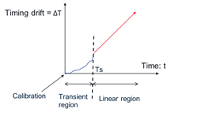

- T is the time from the previous time synchronization. T may take different values depending on the chosen synchronization approach

- FFS: Time error (Te) before detection of a current sync signal is defined as the difference between ideal time of the current sync signal and the time error due to 1) clock time drift (ΔT); and 2) residual time error from previous synchronization/calibration (Tr); Te= ΔT+ Tr

**The following for usage of the clock is assumed for LP-WUR OFF/ON.**

Table 6.2-5: Assumptions for the usage of the LP-WUR clock

|  |  |
| --- | --- |
| Assumption on LP-WUR OFF power | Assumptions on the clock usage |
| 0.001 | When LP-WUR is OFF  - Time offset cumulated in the off period cannot be calculated based on the parameters of the oscillator option 1/2/3/4. RTC should be used(Only RTC is running during sleep.)  When LP-WUR is ON, frequency offset and time offset calculation can follow the parameters of the oscillator option 1/2/3/4 (cumulating based on the frequency drift and not exceeding maximum frequency error)  - The initial frequency offset when LP-WUR switches on can be set to the [FFS: maximum frequency error or a random value within the maximum frequency error] following the parameters of the oscillator option 1/2/3/4.  - When LP-WUR is synced with LP-SS/SSB or MR is used to assist to calibrate LP-WUR to correct the time/frequency error, residual frequency error Fr is assumed at the time when the synchronization/calibration is done. |
| >0.001 | For both LP-WUR OFF and ON  - Time offset cumulated in the off period can be calculated based on the parameter of the oscillator option 1/2 or option 3/4. RTC can be used too.  - Frequency offset calculation can follow the parameter of the oscillator option 1/2 or option 3/4 (cumulating based on the second value in the value pair and not exceeding maximum frequency error).  When at the time point after LP-WUR is synced with LP-SS/SSB or if MR can assist to calibrate LP-WUR to correct the frequency error  - Frequency offset is the Fr, which is residual frequency error from previous synchronization/calibration |

Note1: Any additional LO/FLL/PLL could start running during LP-WUR On duration. The power consumption of any of those LO/FLL/PLL is captured in LP-WUR On power

Note3: The clock error (of both RTC and LO) could be improved to be less than max ppm error of option 1,2,3,4 with clock calibation based on sync signal such as LP-SS or preamble.

## 6.3 Power consumption model

### 6.3.1 Power model for Main Radio (MR)

Take the following power model for main radio for evaluation in LP-WUS/WUR SI,

- For IoT and wearable cases, reuse TR38.875 power model as baseline.

- For eMBB and other cases, reuse TR38.840 power model as baseline.

- Introduce '*Ultra-deep sleep*' power state for main radio of UEs with LP-WUS receiver

The following power models are used for '*Ultra-deep sleep*' power state for main radio for evaluation.

Table 6.3-1: Power model for Main Radio

|  |  |  |  |  |
| --- | --- | --- | --- | --- |
| Power State | Relative Power (unit) | Ramp-up and down transition energy (Note1):  (unit multiplied by ms) | Ramp-up time | Time for sync/re-sync |
| Ultra-deep sleep | 0.015 | For evaluation, at least for FR1 MR ultra-deep sleep state, (Ramp-up and down transition energy, ramp-up time) is as follows,  - Alt 1: (15000, 400ms) as baseline  - Alt 2: (40000, 800ms)  Company to report which alternative they use for which use cases. | | For MR, at least for FR1 evaluation,  - Number of SSBs for sync/re-sync for MR is up to 10  - Companies to report timeline and energy consumption |

Note1:

- Ramp-up time may consist of the procedure for main radio hardware tune on e.g., boot, memory load and etc.,

- Time for sync/re-sync consists of the procedure for main radio to re-synchronization with the serving gNB etc.,

- Companies can report the assumption of X in the initial evaluation.

- Ramp up and down energy includes power for ramp-up and ramp-down. Energy consumption for sync/re-sync is separately calculated.

The total time for main radio transition from ultra-deep sleep to active/micro sleep state is the sum of ramp-up time and time for sync/re-sync.

Note 2: The power state transitions in this table refer to transitions between ultra deep sleep state and active / micro sleep state.

### 6.3.2 Power model for LP-WUR (LR)

The following power model for LP-WUR is used for evaluation for FR1.

Table 6.3-2: Power model for LP-WUR

|  |  |  |  |
| --- | --- | --- | --- |
| Power State | Relative Power (unit) | Additional transition energy:  (unit multiplied by ms) | Ramp-up time TLR, ramp-up (ms) |
| Off[1] | 0.001/ 0.02/ 0.1,  For 0.1, [oscillator option 3/4] are not used for envelope detection based receiver | TLR, ramp-up \*(PON-POFF)/2  Note: this assumes the power consumption during the transition time is sum of additional transition energy and LP-WUR OFF energy, e.g., similar definition as the additional transition energy in TR38.840 | company to report TLR, ramp-up |
| **On[2]** | 0.01/0.05/0.1/0.2/0.5/1/2/4/10/20/30 |
| [1] Relative power unit for LP-WUR 'off' state, i.e., the LP-WUR does not perform monitoring  [2] Relative power unit for LP-WUR 'on' state, i.e., the LP-WUR performs monitoring | | | |

- FFS: whether further categorization/sub-categorization is needed and how.

- FFS: Mapping from values to a LP-WUR architecture or LP-WUR mode of operation

- For evaluation, 10/20/30 for LP-WUR ON power state are not used for envelope detection based receiver for LP-WUS monitoring.

- For evaluation, 10/20/30 for LP-WUR ON power state are used for OFDM receiver when noise figure is less than [MR noise figure + 2.5dB], [0.2/0.5/1/2/4] for LP-WUS can be assumed for other NF values larger than [MR noise figure + 2.5dB]

- FFS: LP-WUR power consumption values for FR2.

Note1: A unit of power is defined to be the same for main receiver and LP-WUS receiver.

Note2: The values provided are for the purpose of studying power saving gain, and the values can be further revisited and categorized depending on the receiver architecture discussion.

Note3: For LP-WUR 'on' state, more than one value within the above range may be used for evaluation (e.g. for a single LP-WUR architecture)

Note4: For WUR Off value 0.001, oscillator options 1, 2, 3, 4 are not assumed and only RTC is maintained;

[For WUR Off value 0.02, oscillator options 1, 2 and RTC can be maintained; ]

Note5: Up to companies to report whether same or different values are assumed for WUS monitoring and time/frequency synchronization.

# 7 LP-WUR and LP-WUS design

## 7.1 LP-WUS receiver architectures

This clause includes the studies for LP-WUR architectures. It does not intend to mandate the implementation of any specific type(s) of LP WUR architecture at the UE. Note this does not prevent RAN4 from defining requirements for LP WUR in the normative phase.

For the study on LP WUR architecture, power consumption relative to the deep sleep state of the MR is provided.

- Deep sleep state of non-RedCap UE should be assumed

For the LP WUR architectures analysis, in addition to LP-WUS detection, consider the following functions when necessary:

- Synchronization signal processing and time/frequency synchronization for LP-WUR

- RRM measurement at least for the serving cell

### 7.1.1 General description of receiver types

Study at least the following three types of receiver architectures for LP-WUR:

- Architecture with RF envelope detection

- Heterodyne architecture with IF envelope detection

- Homodyne/zero-IF architecture with baseband envelope detection

- Note: The details of each type of receiver architecture are discussed separately.

- Note: Above receiver architectures are considered suitable for OOK modulation. Some of the architectures can be applicable for other modulations such as FSK.

A) RF envelope detection

The architecture with RF envelope detection is based on at least the following diagram for LP-WUR.

- The RF signal is converted into baseband signal directly via an RF envelope detector.

- There is no Local Oscillator (LO) and no Phase-Locked Loop (PLL).

- 1 bit or multi-bit ADC is applied.

- Some component(s), e.g., RF LNA and/or BB AMP, can be optionally applied.

- High-Q matching network and/or RF BPF [and/or BB LPF] can be used to suppress adjacent channel interference or interference from legacy NR signals and/or other LP WUS on adjacent subcarriers.

- FFS the support of band and/or carrier tuning

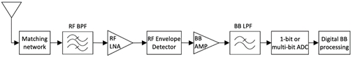

Figure 7.1.1-1: RF envelope detection based LP-WUR diagram

For the architecture with RF envelope detection,

- It can achieve relatively low power consumption due to the removal of LO/PLL.

- Interference suppression for adjacent channel interference requires very high-Q matching network and/or RF BPF, which is challenging due to the high Q values and may require off-chip components.

- Interference suppression for interference from legacy NR signals and/or other LP WUS on adjacent subcarriers, if performed in RF, requires very high-Q matching network and/or RF BPF, which is challenging due to the high Q values and may require off-chip components.

- The support of multiple bands and/or carriers may require multiple high-Q matching networks and/or RF BPFs or multiple off-chip components.

- RF LNA can be applied to improve sensitivity, with the cost of additional power consumption.

- The noise figure can be relatively high.

B) Heterodyne architecture with IF envelope detection

The heterodyne architecture with IF envelope detection is based on at least the following diagram for LP-WUR.

- The RF signal is down converted into IF signal via an RF mixer with a LO. The IF signal is converted into baseband signal via an IF envelope detection.

- There may be one or multiple IF stages depending on design.

- The choice of the LO is one of the major factors that determine the power consumption.

- Lower power consumption can be achieved by relaxing the accuracy and stability requirements of the LO. However, such increased frequency offset and phase noise should be taken into account in the design and evaluation.

- FLL (frequency locked loop) may replace PLL for non-coherent detection.

- 1-bit or multi-bit ADC is applied.

- High-Q matching network and/or RF BPF and/or IF BPF [and/or BB LPF] can be used to suppress adjacent channel interference or interference from legacy NR signals and/or other LP WUS on adjacent subcarriers.

- Some component(s), e.g., RF LNA and/or IF AMP and/or BB AMP, can be optionally applied.

- Image rejection filter or an image rejection mixer is required.

- FFS the support of band and/or carrier tuning

- FFS the choice of IF frequency range

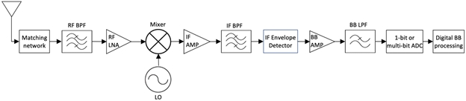

Figure 7.1.1-2: Heterodyne architecture with IF envelope detection based LP-WUR diagram

For heterodyne architecture with IF envelope detection,

- For the support of band and/or carrier tuning, the band and/or carrier tuning can be achieved via tuning the LO frequency.

- The matching network and RF BPF for LP WUR may or may not reuse those of the main radio.

- It is more effective and less complex to use IF BPF instead of high-Q matching network and/or RF BPF to suppress adjacent channel interference or interference from legacy NR signals and/or other LP WUS on adjacent subcarriers.

- Using FLL instead of PLL consumes less power, but it may result in larger frequency error.

- The IF frequency can be properly selected to avoid LO leakage (DC offset) and flicker (1/f) noise.

- Image rejection can be done via either image rejection filter or image rejection mixer.

- Image rejection filter can be done in either RF or IF, which may require high-Q filter.

- Image rejection mixer requires two-branch (I/Q) mixing with good matching in gain and phase, which consumes additional power.

- RF LNA and/or IF AMP can be applied to improve sensitivity, with the cost of additional power consumption.

C) Homodyne/zero-IF architecture with baseband envelope detection

The homodyne/zero-IF architecture with baseband envelope detection is based on at least the following diagram for LP-WUR.

- The RF signal is directly down converted into baseband signal via an RF mixer with a LO.

- Baseband envelope detection can be done either in analog domain or in digital domain depending on design, which is not explicitly shown in the diagram.

- The choice of the LO is one of the major factors that determine the power consumption.

- Lower power consumption can be achieved by relaxing the accuracy and stability requirements of the LO. However, such increased frequency offset and phase noise should be taken into account in the design and evaluation.

- FLL (frequency locked loop) may replace PLL for non-coherent detection.

- 1-bit or multi-bit ADC is applied.

- High-Q matching network and/or RF BPF and/or BB BPF [and/or BB LPF] can be used to suppress adjacent channel interference or interference from legacy NR signals and/or other LP WUS on adjacent subcarriers.

- No image rejection filter is required.

- Some component(s), e.g., RF LNA and/or BB AMP, can be optionally applied.

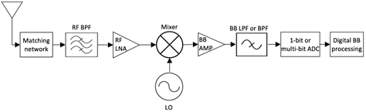

Figure 7.1.1-3: Homodyne/zero-IF architecture with baseband envelope detection based LP-WUR diagram

For homodyne/zero-IF architecture with baseband envelope detection,

- For the support of band and/or carrier tuning, the band and/or carrier tuning can be achieved via tuning the LO frequency.

- The matching network and RF BPF for LP WUR may or may not reuse those of the main radio.

- It is more effective and less complex to use BB BPF/LPF instead of high-Q matching network and/or RF BPF to suppress adjacent channel interference or interference from legacy NR signals and/or other LP WUS on adjacent subcarriers.

- Using FLL instead of PLL consumes less power, but it may result in larger frequency error.

- It can suffer from LO leakage (DC offset) and flicker (1/f) noise. The impact may be alleviated by using BB BPF in some cases.

- RF LNA can be applied to improve sensitivity, with the cost of additional power consumption.

- The baseband envelope detection can be done in either analog domain (before ADC) or digital domain (after ADC).

D) FSK receiver

Two examples for FSK receiver architectures are shown below:

- Example 1: parallel OOK receivers and a comparator circuit, e.g.,

- Each path can be implemented using either of [the architecture with RF envelope detection,] heterodyne architecture with IF envelope detection, or homodyne/zero-IF architecture with baseband envelope detection.

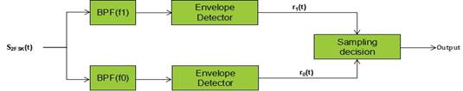

Figure 7.1.1-4: FSK receiver with parallel OOK receivers and a comparator circuit based LP-WUR diagram

Study the parallel receiver architectures (as examples that can be captured in the TR) for FSK based on the following diagrams:

- Parallel homodyne architecture

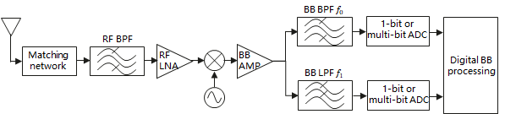

Figure 7.1.1-5: Parallel homodyne architecture

- The observations made for homodyne/zero-IF architecture with baseband envelope detection in clause 7.1.1-(C) are also applicable here.

- Parallel heterodyne architecture

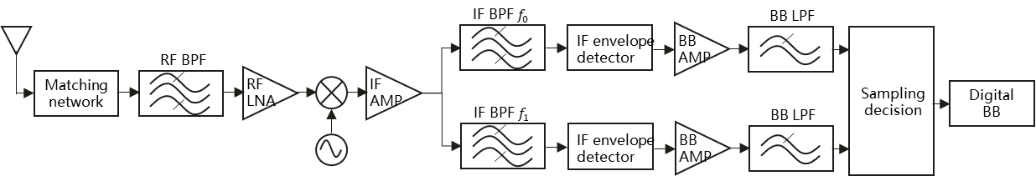

Figure 7.1.1-6: Parallel heterodyne architecture

- The observations made for heterodyne architecture with IF envelope detection in clause 7.1.1-(B) are also applicable here.

- Note: Other architectures are not precluded.

- The OOK receiver architectures agreed for study in RAN1#110bis-e are also examples that can be captured in the TR

For FSK receiver based on parallel OOK receivers with heterodyne or zero-IF architecture,

- If no interference between the segments' detectors is allowed, the frequency gap between two adjacent frequency segments should not be smaller than two times the maximum frequency offset, and at least two times of the max frequency offsets within the frequency gap should not be used by other DL signals/channels or other WUS signals.

- If some interference between the segments' detectors is allowed, it can be possible to have frequency gap between two adjacent frequency segments smaller than two times the maximum frequency offset, where the gap is not used by other DL signals/channels or other WUS signals.

- Example 2: using an FM-to-AM detector [or an FM detector]

- Alt 1: Use an analog FM-to-AM detector with a similar architecture as for OOK (e.g. heterodyne or zero-IF architecture), except that the envelope detector is replaced by a FM-to-AM detector.

- Analog FM-to-AM detector can be implemented at least in BB or low-IF.



Figure 7.1.1-7: FSK LP-WUS receiver with FM-AM detector- Alt 1

- Alt 2: Use a FM-to-AM detector [or an FM detector] implemented in digital domain after ADC, with a heterodyne or zero-IF architecture.

- Digital FM-to-AM detector implementation can be considered as part of digital baseband processing.

- Here is an example of using zero-IF architecture:

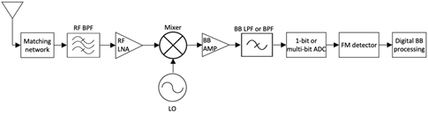

Figure 7.1.1-8: FSK LP-WUS receiver with FM-AM detector - Alt 2

- The FM-AM detector can be implemented using a frequency discriminator, which converts frequency variations into amplitude changes. It can be implemented in either analog domain (as in Alt 1) or digital domain (as in Alt 2).

- One example, as shown in the figure below, is a conventional quadrature FM discriminator. It multiplies received frequency modulated signal with a phase shifted version, followed by a low pass filter. The amplitude of the output signal is proportional to the frequency of the input signal.

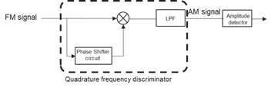

Figure 7.1.1-9: FSK LP-WUS receiver with FM-AM detector by using a frequency discriminator

- Note: Other architectures are not precluded.

Study the receiver architectures (as examples that can be captured in the TR) for FSK with frequency to amplitude conversion based on the following diagrams:

- Homodyne architecture with frequency to amplitude conversion

- I/Q branches are required for frequency to amplitude conversion in digital BB.

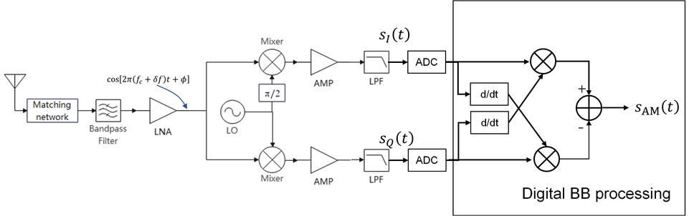

Figure 7.1.1-10: Homodyne architecture with frequency to amplitude conversion

- Heterodyne architecture with frequency to amplitude conversion

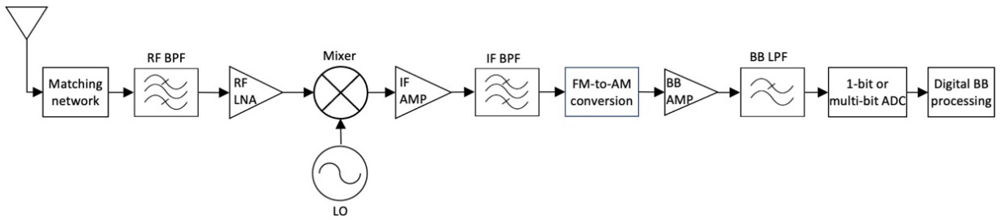

Figure 7.1.1-11: Heterodyne architecture with frequency to amplitude conversion

- Companies provide the exact type of frequency to amplitude conversion being studied.

- Note: Other architectures are not precluded.

Observation for FSK with frequency to amplitude conversion:

- The FSK architectures with frequency to amplitude conversion is applicable to single-SC FSK, but it may be challenging to make the frequency to amplitude conversion work well with multi-subcarrier FSK.

- Note: single-SC FSK refers to the waveform where each frequency segment has a single subcarrier, and multi-subcarrier FSK refers to the waveform where each frequency segment has multiple subcarriers, as described in the agreements for FSK-1 and FSK-2.

For the FSK architectures with frequency to amplitude conversion, the bandwidth between the frequency segments used for FSK transmissions may not be used for other LP-WUSs or legacy NR transmission in order to allow frequency to amplitude conversion to work properly.

E) OFDMA-based signals/channels detection

For OFDMA-based signals/channels, study the receiver architectures based on the following diagrams:

- I/Q branches are required for digital BB processing.

- Digital BB processing may or may not include FFT (companies to provide details on how).

- For sequence-based OFDM signals/channels, digital BB processing includes sequence correlation in either time domain (without FFT) or frequency domain (after FFT).

- Proponent companies should at least provide details on power consumption reduction compared to the MR regarding the RF and digital BB processing.

- Companies are encouraged to provide the break-down for the components.

- The potential power reduction compared to the main radio may come from e.g.:

- Lower performance LNA/amplifier

- Oscillator/PLL with relaxed performance requirements

- ADC with lower sampling rate and smaller bit-width

- Reduced BB processing complexity compared to the MR

- Companies are encouraged to provide the performance analysis corresponding to the considered power consumption considering the impact of e.g. phase noise, I/Q mismatch.

- Companies to report whether the LP WUR is assumed to share components with MR. In case of component sharing, the potential impact on the MR ultra-deep sleep state should be considered.

- Companies to report the possible number of information bits

- In addition, companies should consider the power consumption in the OFF state and the transition energy.

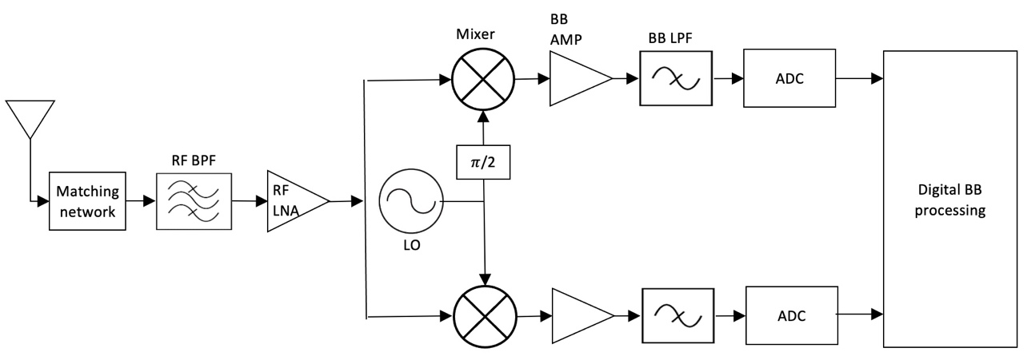

Figure 7.1.1-12: OFDMA-based signals/channels detection

For the receiver architecture for OFDMA-based signals/channels,

- The receiver architectures for OFDMA-based signals/channels can be used for OOK/ASK and FSK modulated LP-WUS

- For sequence-based OFDM signals/channels, one example diagram with time domain correlator (without FFT) for LP-WUS detection is shown below:

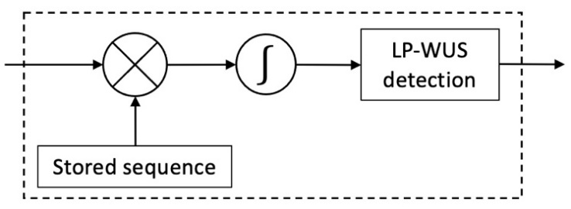

Figure 7.1.1-13 Example for time domain correlator (without FFT) for LP-WUS detection

F) Additional LP-WUR related designs

For the baseband processing of the LP WUR architectures,

- The baseband processing may use Goertzel filters as an alternative for FFT to compute the signals for one or more tones. Tone energy is computed and a detection algorithm is used to detect the presence of LP-WUS. One example diagram is shown below:

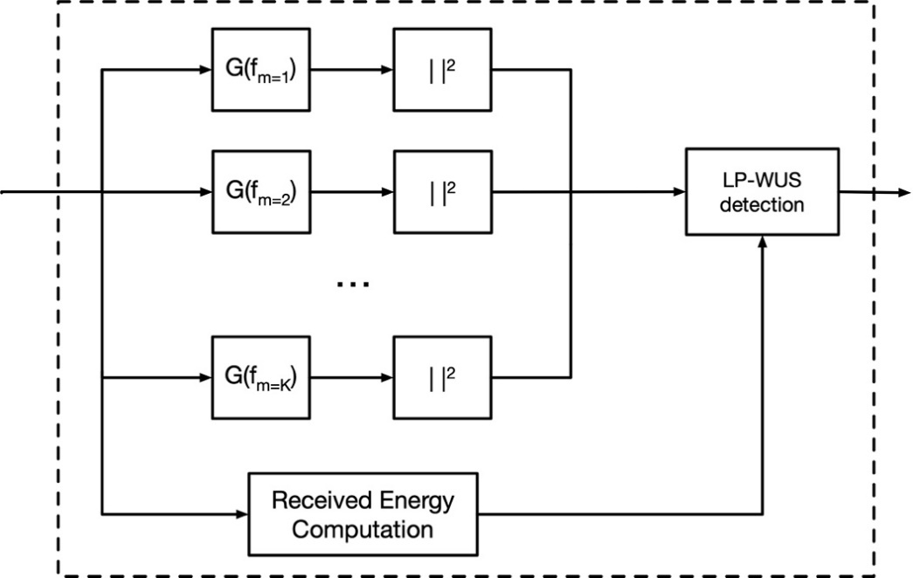

Figure 7.1.1-14: Example for using Goertzel filters as an alternative for FFT to compute the signals for one or more tones

- This can be used with the receiver architecture for OFDMA-based signals/channels for OOK-3.

- This can be used with heterodyne receiver architecture with IF envelope detection or the homodyne receiver architecture with baseband envelope detection for [OOK-1]/FSK-2.

### 7.1.1a Analysis of LP-WUR architectures

For the analysis of different LP-WUR receiver types, at least the following aspects have been considered, and the corresponding power consumption and noise figure have been estimated.

- Assumed modulation/waveform/coding

- Presence of a RF LNA / IF AMP / BB AMP, and the corresponding gain, if any

- Local oscillator

- Type of oscillator and the corresponding frequency accuracy/drifting

- Handling of time/frequency impairments (e.g. synchronization signal processing and time/frequency synchronization for LP-WUR)

- Presence of PLL or FLL

- ADC: sampling rate, bit-width

- Assumed signal bandwidth and guard band, and frequency location within a carrier (including whether it is fixed or can be flexible)

- RF/IF/BB filter characteristics (e.g. type of filter, order, cut-off frequency/frequencies), if any

- Baseband processing (e.g., sequence correlation detection / decoding, other signal processing, if any)

- Assumed frequency band(s) and the support of band and/or carrier tuning

- Duty cycle handling of WUS and other signals (if any)

- Interference rejection capability (including both adjacent-channel interference and interference from adjacent subcarriers occupied by legacy NR signals or other LP WUS)

- Handling of inter-cell interference

- Whether there is any mobility support function, e.g. measurement capability

The results are summarized for each receiver architecture considering different waveform candidates (more details can be found in Annex 7.1.1a and the references are in 7.1.1a.4). The analysis is very high level, and the actual power consumption and noise figure are very implementation specific. Note that the power consumption is provided in relative unit, relative to the deep sleep state of the MR for a non-RedCap UE following the non-RedCap UE power model defined in clause 8.1 of TR 38.840.

For the analysis,

- FR1 is considered.

- Most sources assumed RF LNA is present for improved sensitivity.

- For LP-WUS bandwidth, most sources consider at least 5MHz. Some sources think the analysis is also applicable to bandwidth up to 20MHz.

#### 7.1.1a.1 OOK-1/2/4

##### 7.1.1a.1.1 RF envelope detection

For OOK-1/2/4 with RF envelope detection, some sources ([7A-1] [7A-2] [7A-3] [7A-4] [7A-5] [7A-6]) provided analysis, with relative power consumption and noise figure summarized in Table 7.1.1a-1.

- The relative power consumption for ON state is in the range of 0.01~0.2.

- The noise figure is in the range of 12~22 dB.

Table 7.1.1a-1: Relative power consumption and noise figure for OOK-1/2/4 with RF envelope detection

|  |  |  |  |  |  |  |
| --- | --- | --- | --- | --- | --- | --- |
| Source reference | [7A-1] | [7A-2] | [7A-3] | [7A-4] | [7A-5] | [7A-6] |
| Power consumption  (ON state) | 0.05 for single-branch, 0.01 for each additional branch | 0.01 | 0.01~0.1 | 0.01 | 0.01~0.1 | 0.05~0.2 |
| Noise figure (dB) | 20 | 17~22 | [12-18] | 20 | 15 | 20 |

##### 7.1.1a.1.2 Heterodyne architecture with IF envelope detection

For OOK-1/2/4 with heterodyne architecture with IF envelope detection, some sources ([7A-1] [7A-2] [7A-3] [7A-4] [7A-5] [7A-6] [7A-7] [7A-8]) provided analysis, with relative power consumption and noise figure summarized in in Table 7.1.1a-2.

- The relative power consumption for ON state is in the range of 0.1~4.

- The noise figure is in the range of 9~15 dB.

Table 7.1.1a-2: Relative power consumption and noise figure for OOK-1/2/4 with heterodyne architecture with IF envelope detection

|  |  |  |  |  |  |  |
| --- | --- | --- | --- | --- | --- | --- |
| Source reference | [7A-1] | [7A-2] | [7A-3] | [7A-4] | [7A-5] | [7A-6] |
| Power consumption  (ON state) | 0.1 for single-branch, 0.01 for each additional branch | 0.5 | 0.1~1 | 0.1 | 0.1~1 | 1~4 |
| Noise figure (dB) | 15 | 10~15 | [9-15] | 15 | 12 | 12~15 |

##### 7.1.1a.1.3 Homodyne/zero-IF architecture with baseband envelope detection

For OOK-1/2/4 with homodyne/zero-IF architecture with baseband envelope detection, some sources ([7A-1] [7A-2] [7A-3] [7A-4] [7A-5] [7A-6] [7A-7] [7A-8] [7A-9] [7A-10]) provided analysis, with relative power consumption and noise figure summarized in in Table 7.1.1a-3.

- The relative power consumption for ON state is in the range of 0.05~4.

- The noise figure is in the range of 10~16 dB.

Table 7.1.1a-3: Relative power consumption and noise figure for OOK-1/2/4 with homodyne/zero-IF architecture with baseband envelope detection

|  |  |  |  |  |  |  |  |  |  |  |
| --- | --- | --- | --- | --- | --- | --- | --- | --- | --- | --- |
| Source reference | [7A-1] | [7A-2] | [7A-3] | [7A-4] | [7A-5] | [7A-6] | [7A-7] | [7A-8] | [7A-9] | [7A-10] |
| Power consumption  (ON state) | 0.09 for single-branch, 0.01 or 0.02 for each additional branch | 0.5 | 0.1~1 | 0.1 | 0.05~  0.5 | 0.5~1 | 0.1~0.5 | 4 | ~1 | 0.1~0.5 |
| Noise figure (dB) | 15 | 10~15 | [10-16] | 15 | 12 | 15 | 12~15 | 15 | ~15 | 12 |

#### 7.1.1a.2 FSK

##### 7.1.1a.2.1 Parallel RF envelope detection

For FSK with parallel RF envelope detection, some sources ([7A-1] [7A-4]) provided analysis, with relative power consumption and noise figure summarized in Table 7.1.1a-4.

Table 7.1.1a-4: Relative power consumption and noise figure for FSK with parallel RF envelope detection

|  |  |  |
| --- | --- | --- |
| Source reference | [7A-1] | [7A-4] |
| Power consumption  (ON state) | 0.05 for single-branch, 0.01 for each additional branch | 0.01 |
| Noise figure (dB) | 20 | 20 |

##### 7.1.1a.2.2 Parallel heterodyne architecture

For FSK with parallel heterodyne architecture, some sources ([7A-1] [7A-2] [7A-3] [7A-4]) provided analysis, with relative power consumption and noise figure summarized in Table 7.1.1a-5.

- The relative power consumption for ON state is in the range of 0.1~1.

- The noise figure is in the range of 9~15 dB.

Table 7.1.1a-5: Relative power consumption and noise figure for FSK with parallel heterodyne architecture

|  |  |  |  |  |
| --- | --- | --- | --- | --- |
| Source reference | [7A-1] | [7A-2] | [7A-3] | [7A-4] |
| Power consumption  (ON state) | 0.1 for single-branch, 0.01 for each additional branch | 0.5 | 0.1~1 | 0.1 |
| Noise figure (dB) | 15 | 10~15 | [9~15] | 15 |

##### 7.1.1a.2.3 Parallel homodyne architecture

For FSK with parallel homodyne architecture, some sources ([7A-1] [7A-2] [7A-3] [7A-4]) provided analysis, with relative power consumption and noise figure summarized in Table 7.1.1a-6.

- The relative power consumption for ON state is in the range of 0.1~1.

- The noise figure is in the range of 10~16 dB.

Table 7.1.1a-6: Relative power consumption and noise figure for FSK with parallel homodyne architecture

|  |  |  |  |  |
| --- | --- | --- | --- | --- |
| Source reference | [7A-1] | [7A-2] | [7A-3] | [7A-4] |
| Power consumption  (ON state) | 0.09 for single-branch, 0.01 or 0.02 for each additional branch | 0.5 | 0.1~1 | 0.1 |
| Noise figure (dB) | 15 | 10~15 | [10~16] | 15 |

##### 7.1.1a.2.4 Heterodyne architecture with frequency to amplitude conversion

For FSK with heterodyne architecture with frequency to amplitude conversion, some sources ([7A-1] [7A-3]) provided analysis, with relative power consumption and noise figure summarized in Table 7.1.1a-7.

Table 7.1.1a-7: Relative power consumption and noise figure for FSK with heterodyne architecture with frequency to amplitude conversion

|  |  |  |
| --- | --- | --- |
| Source reference | [7A-1] (for SC-FSK) | [7A-3] |
| Power consumption  (ON state) | 0.1 | 1 |
| Noise figure (dB) | 15 | TBD |

##### 7.1.1a.2.5 Homodyne architecture with frequency to amplitude conversion

For FSK with homodyne architecture with frequency to amplitude conversion, 1 source ([7A-1]) estimated that for SC-FSK, the relative power consumption for ON state is 0.1, and the noise figure is 15dB.

#### 7.1.1a.3 OFDMA-based signal

For OFDMA-based signal, companies have considered sequence-based signal, where the LP WUR performs either time-domain correlation without FFT or frequency-domain correlation after FFT.

##### 7.1.1a.3.1 Time-domain correlation (without FFT)

For OFDM-based signal with time-domain correlation, some sources ([7A-1] [7A-3] [7A-5] [7A-6] [7A-7] [7A-8] [7A-9]) provided analysis, with relative power consumption and noise figure summarized in Table 7.1.1a-8.

- The relative power consumption for ON state is in the range of 0.15~30.

- The noise figure is in the range of 7~25 dB.

Table 7.1.1a-8: Relative power consumption and noise figure for OFDM-based signal with time-domain correlation

|  |  |  |  |  |  |  |  |
| --- | --- | --- | --- | --- | --- | --- | --- |
| Source reference | [7A-1] | [7A-3] | [7A-5] | [7A-6] | [7A-7] | [7A-8] | [7A-9] |
| Power consumption  (ON state) | 0.15~0.2 | 10 | 10~20 | 10~30 | 1~5 | 10~20 | ~5 |
| Noise figure (dB) | 15 | 9.5 | 9.5 or 12 | 9 | 7~10 | 9 | 15~25 |

##### 7.1.1a.3.2 Frequency-domain correlation (with FFT)

For OFDM-based signal with frequency-domain correlation, some sources ([7A-2] [7A-3] [7A-5] [7A-7] [7A-10]) provided analysis, with relative power consumption and noise figure summarized in Table 7.1.1a-9.

- The relative power consumption for ON state is in the range of 1~30.

- The noise figure is in the range of 7~12 dB.

Table 7.1.1a-9: Relative power consumption and noise figure for OFDM-based signal with frequency-domain correlation

|  |  |  |  |  |  |  |
| --- | --- | --- | --- | --- | --- | --- |
| Source reference | [7A-2] | [7A-3] | [7A-5] | [7A-7] | [7A-10] | [7A-10] |
| Power consumption  (ON state) | 10 | 30 | 20~30 | 1~5 | 10 | 4 |
| Noise figure (dB) | 7~12 | 7 | 9.5 or 12 | 7~10 | 9 | 12 |

### 7.1.2 RAN4 studies of the receiver

#### 7.1.2.1 General

This Clause captures the study outcome of LP-WUR RF impacts. RAN4 focus on FR1 frequency ranges as first priority, 2.6GHz is selected as an example band for evaluation purpose.

For evaluation purpose, RAN4 defines a new term named as guard RB for LP-WUS, which is Granularity of RB for ACS/ASCS protection. Meanwhile, the traditional guardband for NR channel bandwidth defined in Clause 5.3, TS 38.101-1 is unchanged. The LP-WUS guard RB definition can be described differently for ASCS and ACS as following:

- For ASCS guard RB, the required guard RB(s) should be blanked RB(s), which belong to WUS carrier/BW (i.e., WUS signal plus ASCS guard RB(s))

- For ACS guard RB, the required guard RB(s) are RB(s) between WUS signal edge and nearest edge of guardband of channel bandwidth

- It includes ASCS guard RB(s) (if allocated) and RBs (which could be blanked RBs or RBs used for NR transmission) between WUS carrier/BW edge and nearest edge of guardband of channel bandwidth as defined in spec TS 38.101-1

RAN4 agrees there is no need to restrict symmetric guard RBs for interference rejection of WUS, both ACS and ASCS.

RAN4 suggests overall bandwidth of the wake-up signal in the NR channel i.e., desired signal along with all the required guard RBs shall fit in the maximum transmission bandwidth configuration as defined in Table 5.3.2-1 of TS 38.101-1.



(case 1: LP-WUS within large channel)



(case 2: WUS within narrow channel, WUS bandwidth is comparable with channel bandwidth)

Figure 7.1.2.1-1: Definition of the guardband of NR channel and guard RBs for both LP-WUS ACS and ASCS

#### 7.1.2.2 ACS evaluation

Adjacent channel selectivity (ACS) is a measure of a receiver's ability to receive an NR signal at its assigned channel frequency in the presence of an adjacent channel signal at a given frequency offset from the centre frequency of the assigned channel. ACS is the ratio of the receive filter attenuation on the assigned channel frequency to the receive filter attenuation on the adjacent channel(s).

In general, NR ACS requirement is derived based on co-existence study to meet max 5% throughput loss metric. While for LP-WUS, the purpose in the study of ACS is not for justification of co-existence between contained LP-WUS and adjacent NR carrier, but to evaluate the required guard RBs in-between the different signals. Given the WUS waveform would be different from NR signal, the traditional throughput loss metric can not be reused. Therefore, RAN4 agrees to focus on the evaluation of required guard RB rather than ACS requirements with co-existence simulation.

Framework in RAN4 to evaluate ACS and ASCS vs guard RBs:

- ACS and ASCS guard RB can be evaluated based on the following aspects:

- Typical filter characteristic, e.g., filter order, pass BW, cut-off frequency

- Guard RB size

- RF impairment can also be considered

- RAN4 adopts two approaches for guard RB evaluation, i.e., filter suppression level analysis and link level simulation

- Averaged power attenuation at ACS or ASCS frequency range

- FFS whether SINR of the wanted signal at detector input is needed

- FFS whether to use ICS instead of ASCS

- FFS Coexistence-simulation-based framework can also be considered

- FFS on details of coexistence study (if needed) of LP-WUS

- Coverage should be considered

RAN4 Considers a limited set of LP-WUS scenarios for study purpose in RAN4, as shown in Table 7.1.2.2-1.

Table 7.1.2.2-1: Common LP-WUS evaluation parameters for ACS

|  |  |
| --- | --- |
| NR RF channel BW | 20MHz/100MHz for 5MHz WUS |
| Guardband of NR channel | Unchanged, defined in Clause 5.3.3 in TS 38.101-1.  810kHz for wanted cell1 20MHz (5MHz WUS at edge), and 510kHz for interference cell2 5MHz. |
| WUS BW within NR channel | Max 5.04 MHz |
| WUS RB allocation (Note 1) | 24 RB (15kHz SCS) or 12 RB (30kHz SCS) within 5.04 MHz; |
| WUS placement within NR channel | Edge of channel, i.e., close to guardband |
| Guard RB size of LP-WUS | 0 RB, 0.5RB,1RB, 2RB, 3RB |
| ACS interferer (cell 2) | 5MHz with guardband |
| Filter characteristic | 2nd to 5th order Butterworth  lowpass@ baseband  bandpass@100 MHz  bandpass@2.6 GHz |
| Filter passband BW | Same as WUS bandwidth (number of RBs) |
| Target ACS | TBD; reuse NR value as starting point |
| Target WUS SNR | TBD |
| WUS SNR condition | TBD |
| NR power level | TBD |
| RF impairment | Max. Center frequency offset based on companies report |
| Note 1: For easy evaluation, the number of allocated WUS RBs is fixed. The number of Guard RBs is changed. | |

The frequency response of 2nd to 5th order Butterworth filters are shown as below:

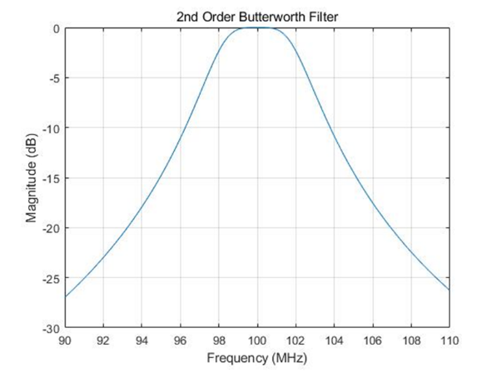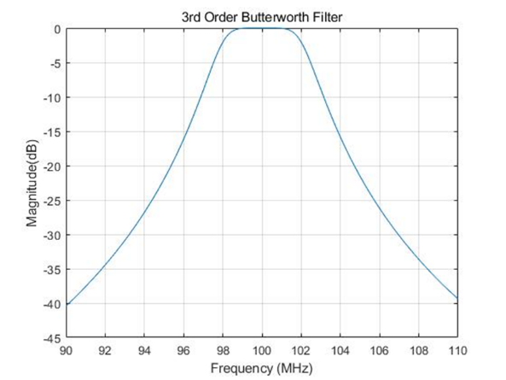

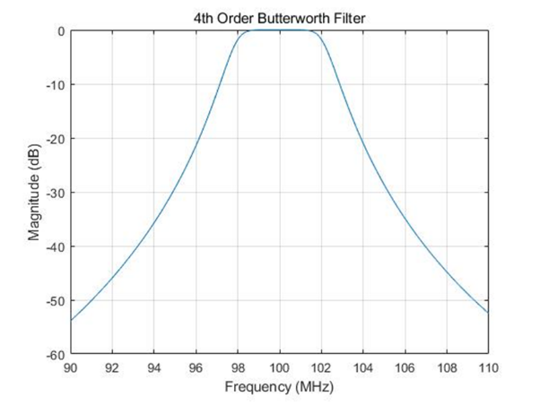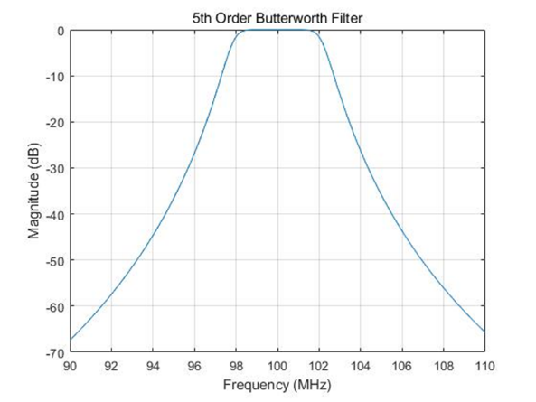

Figure 7.1.2.2-1: Frequency response of Butterworth filters

For ACS guard RB evaluation, RAN4 focuses on the LP-WUS at the edge of NR channel case, as shown in Figure 7.1.2.2-2.



Figure 7.1.2.2-2: LP-WUS at the edge of NR channel

**Conclusions for RAN4 ACS guard RB analysis:**

Based on the analysis above, RAN4 observed that for 5th order filter, the guard RB number for LP-WUS ACS is in the range of 1RB ~ 6RBs for 30kHz SCS, or 2RBs ~12RBs for 15kHz SCS. For lower power, i.e., lower order filters, the required guard RBs may increase. There is no recommendation on which filter order should be considered to the baseline in SI phase.

- As the analysis from companies did not comprehensively consider all impairments, and individual results are missing the impact of one or many of the following: phase noise, non-linearity, frequency error, implementation margin. For the evaluation, companies have used OOK waveform and FSK waveform, other type of WUS signals are not used. Final conclusion on the number of guard RB is left to WI discussion.

Companies' input on simulation analysis of ACS have been presented as following:

**Filter suppression level analysis:**

For filter suppression level calculation, the suppression level is calculated with averaged power attenuation at ACS frequency range.

[7B-1]

The parameter assumption is aligned with that in Table 7.1.2.2-1. The required guard RB is provided in the Table 7.1.2.2-2 below. CFO from 0ppm~200ppm is considered as RF impairment impacts.

Table 7.1.2.2-2: Required number of guard RBs for 5MHz ACS

|  |  |  |  |  |  |  |  |
| --- | --- | --- | --- | --- | --- | --- | --- |
| Filter order |  | | ACS, BWinterference = 5MHz | | | | |
| Guard RB  CBW | Frequency  Offset | 0RB | 0.5RB | 1RB | 2RB | 3RB |
| 5th | 20MHz, SCS = 15kHz | 0 ppm | -28.20 | -29.51 | -30.37 | -32.43 | -34.40 |
| 5 ppm | -27.95 | -29.26 | -30.11 | -32.18 | -34.14 |
| 10 ppm | -27.69 | -29.01 | -29.86 | -31.92 | -33.88 |
| 50 ppm | -25.73 | -27.02 | -27.87 | -29.92 | -31.87 |
| 200 ppm | -19.35 | -20.52 | -21.31 | -23.24 | -25.13 |
| 100MHz, SCS = 30kHz | 0 ppm | -34.51 | -36.33 | -38.07 | -41.33 | -44.33 |
| 5 ppm | -34.25 | -36.07 | -37.81 | -41.07 | -44.07 |
| 10 ppm | -33.99 | -35.81 | -37.55 | -40.81 | -43.81 |
| 50 ppm | -31.97 | -35.53 | -33.79 | -38.79 | -41.79 |
| 200 ppm | -25.21 | -27.00 | -28.72 | -31.97 | -34.97 |
| 4th | 20MHz, SCS = 15kHz | 0 ppm | -23.71 | -24.70 | -25.35 | -26.92 | -28.42 |
| 5 ppm | -23.51 | -24.50 | -25.15 | -26.72 | -28.22 |
| 10 ppm | -23.31 | -24.30 | -24.94 | -26.51 | -28.01 |
| 50 ppm | -21.75 | -22.73 | -23.37 | -24.92 | -26.41 |
| 200 ppm | -16.73 | -17.61 | -18.20 | -19.65 | -21.08 |
| 100MHz, SCS = 30kHz | 0 ppm | -28.35 | -29.76 | -31.11 | -33.64 | -35.97 |
| 5 ppm | -28.14 | -29.55 | -30.90 | -33.43 | -35.77 |
| 10 ppm | -27.94 | -29.34 | -30.69 | -33.22 | -35.56 |
| 50 ppm | -26.34 | -27.74 | -29.08 | -31.61 | -33.95 |
| 200 ppm | -20.98 | -22.34 | -23.67 | -26.17 | -28.50 |
| 3rd | 20MHz, SCS = 15kHz | 0 ppm | -18.80 | -19.49 | -19.94 | -21.04 | -22.10 |
| 5 ppm | -18.65 | -19.34 | -19.79 | -20.89 | -21.94 |
| 10 ppm | -18.50 | -19.19 | -19.64 | -20.74 | -21.79 |
| 50 ppm | -17.36 | -18.04 | -18.48 | -19.56 | -20.61 |
| 200 ppm | -13.68 | -14.29 | -14.69 | -15.70 | -16.69 |
| 100MHz, SCS = 30kHz | 0 ppm | -21.90 | -22.90 | -23.87 | -25.70 | -27.39 |
| 5 ppm | -21.75 | -22.75 | -23.72 | -25.54 | -27.24 |
| 10 ppm | -21.59 | -22.60 | -23.56 | -25.39 | -27.09 |
| 50 ppm | -20.41 | -21.41 | -22.37 | -24.19 | -25.88 |
| 200 ppm | -16.46 | -17.43 | -18.36 | -20.14 | -21.82 |
| 2nd | 20MHz, SCS = 15kHz | 0 ppm | -13.43 | -13.84 | -14.11 | -14.77 | -15.41 |
| 5 ppm | -13.34 | -13.75 | -14.02 | -14.68 | -15.31 |
| 10 ppm | -13.25 | -13.65 | -13.92 | -14.58 | -15.22 |
| 50 ppm | -12.52 | -12.92 | -13.18 | -13.83 | -14.45 |
| 200 ppm | -10.16 | -10.53 | -10.77 | -11.36 | -11.95 |
| 100MHz, SCS = 30kHz | 0 ppm | -15.18 | -15.80 | -16.40 | -17.54 | -18.62 |
| 5 ppm | -15.08 | -15.70 | -16.30 | -17.44 | -18.52 |
| 10 ppm | -14.98 | -15.60 | -16.20 | -17.34 | -18.41 |
| 50 ppm | -14.22 | -14.83 | -15.42 | -16.56 | -17.62 |
| 200 ppm | -11.70 | -12.28 | -12.85 | -13.94 | -14.98 |

[7B-2]

The evaluation parameters are listed in Table 7.1.2.2-3 below.

Table 7.1.2.2-3: Evaluation assumptions.

|  |  |
| --- | --- |
| WUS signal bandwidth | 4.32 MHz |
| Interferer power level | 0 dBc |
| F0 | 2.6 GHz |
| Filter Type | Butterworth |

Table 7.1.2.2-4: Guard required in kHz for a target interference level of -10 dBc.

|  |  |  |  |  |  |
| --- | --- | --- | --- | --- | --- |
| CFO | Filter order | | | | |
|  | 1 | 2 | 3 | 4 | 5 |
| ± 0 ppm | 4320.0 | 1598.4 | 972.0 | 691.2 | 540 |
| ± 5 ppm | 4346.0 | 1608.0 | 977.9 | 695.4 | 543.3 |
| ± 50 ppm | 4580.0 | 1694.6 | 1030.5 | 732.8 | 572.5 |
| ± 100 ppm | 4840.0 | 1790.8 | 1089.0 | 774.4 | 605.0 |
| ± 200 ppm | 5360.0 | 1983.2 | 1206.0 | 857.6 | 670.0 |

Based on the results in Table 7.1.2.2-4, it is suggested that for 5th order filter, the guard RB number for LP-WUS can be 2RBs for 30kHz SCS, or 3RBs ~ 4RBs for 15kHz SCS.

[7B-3]

Following list our filter evaluation analysis assumption.

Table 7.1.2.2-5: LP-WUS evaluation scenarios

|  |  |
| --- | --- |
| NR RF channel BW | 20MHz/100MHz for 5MHz WUS |
| Guardband of NR channel | Unchanged, defined in Clause 5.3.3 in TS 38.101-1, i.e.  For 15kHz SCS, 242.5kHz guardband for 5MHz CBW and 452.5kHz guard band for 20MHz CBW  For 30kHz SCS, 505kHz guardband for 5MHz CBW and 845kHz guard band for 100MHz CBW |
| WUS BW within NR channel | 5.04 MHz |
| WUS RB allocation (Note 1) | 24 RB, i.e. total 4.32MHz |
| WUS placement within NR channel | Carrier edge for ACS and carrier center for ASCS |
| Guard RB size of LP-WUS | 0 RB, 0.5 RF, 1RB, 2RBs, 3RB at each side.  Only symmetric guard RB has been considered |
| ACS interferer | 5MHz |
| Filter characteristic | 2rd and 5th order Butterworth  Both analog and digital filter can be considered |
| Filter passband BW | 4.32/2=2.16MHz for low-pass filter  4.32MHz for band-pass filter |

Following list the S21 of 2nd and 5th order butterworth filters and related parameters.

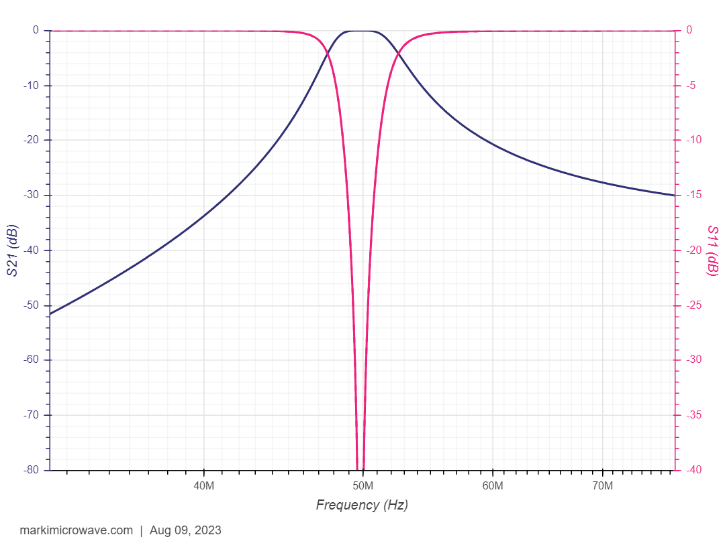

Figure 7.1.2.2-3: Frequency response of 2nd Butterworth filters



Figure 7.1.2.2-4: Frequency response of 5th Butterworth filters

Following table list ACS value based on low-pass filter for zero-IF envelop detector architecture, in which pass bandwidth is 4.32/2=2.16MHz.

Table 7.1.2.2-6: Evaluated ACS based on low-pass filter with 2.16MHz pass bandwidth

|  |  |  |  |  |  |  |  |
| --- | --- | --- | --- | --- | --- | --- | --- |
| Filter order |  | | ACS, BWinterference = 5MHz | | | | |
| Guard RB  CBW | Frequency  Offset | 0RB/  30kSCS | 0.5RB/  30kSCS | 1RB/  30kSCS | 2RB/  30kSCS | 3RB/  30kSCS |
| 5th | 20MHz, SCS = 15kHz | 0 ppm | -27.75 | -29.88 | -31.9 | -35.65 | -39.07 |
| 5 ppm | -27.6 | -29.73 | -31.76 | -35.52 | -38.95 |
| 10 ppm | -27.44 | -29.58 | -31.61 | -35.39 | -38.83 |
| 50 ppm | -26.15 | -28.35 | -30.45 | -34.34 | -37.87 |
| 200 ppm | -21.1 | -23.47 | -25.78 | -30.11 | -34.03 |
| 100MHz, SCS = 30kHz | 0 ppm | -35.00 | -36.78 | -38.47 | -41.65 | -44.59 |
| 5 ppm | -34.87 | -36.65 | -38.35 | -41.54 | -44.49 |
| 10 ppm | -34.74 | -36.52 | -38.23 | -41.43 | -44.38 |
| 50 ppm | -33.66 | -35.5 | -37.25 | -40.53 | -43.55 |
| 200 ppm | -29.36 | -31.4 | -33.35 | -36.97 | -40.27 |
| 2nd | 20MHz, SCS = 15kHz | 0 ppm | -12.62 | -13.28 | -13.93 | -15.18 | -16.34 |
| 5 ppm | -12.57 | -13.24 | -13.89 | -15.13 | -16.3 |
| 10 ppm | -12.52 | -13.19 | -13.84 | -15.09 | -16.26 |
| 50 ppm | -12.12 | -12.8 | -13.47 | -14.74 | -15.93 |
| 200 ppm | -10.59 | -11.3 | -12.01 | -13.36 | -14.63 |
| 100MHz, SCS = 30kHz | 0 ppm | -14.96 | -15.56 | -16.13 | -17.24 | -18.28 |
| 5 ppm | -14.91 | -15.51 | -16.09 | -17.2 | -18.24 |
| 10 ppm | -14.87 | -15.47 | -16.05 | -17.16 | -18.21 |
| 50 ppm | -14.51 | -15.13 | -15.72 | -16.85 | -17.91 |
| 200 ppm | -13.12 | -13.77 | -14.41 | -15.62 | -16.76 |

Following table is based on analog band-pass filter for RF/IF envelop detector architecture, in which pass bandwidth is 4.32MHz.

Table 7.1.2.2-7: Evaluated ACS based on analog band-pass filter with 4.32MHz pass bandwidth

|  |  |  |  |  |  |  |  |
| --- | --- | --- | --- | --- | --- | --- | --- |
| Filter order |  | | ACS, BWinterference = 5MHz | | | | |
| Guard RB  CBW | Frequency  Offset | 0RB/  30kSCS | 0.5RB/  30kSCS | 1RB/  30kSCS | 2RB/  30kSCS | 3RB/  30kSCS |
| 5th | 20MHz, SCS = 15kHz | 0 ppm | -17.96 | -19.16 | -20.34 | -22.64 | -24.83 |
| 5 ppm | -17.88 | -19.08 | -20.26 | -22.56 | -24.75 |
| 10 ppm | -17.79 | -18.99 | -20.18 | -22.48 | -24.68 |
| 50 ppm | -17.09 | -18.3 | -19.49 | -21.82 | -24.05 |
| 200 ppm | -14.46 | -15.67 | -16.89 | -19.3 | -21.63 |
| 100MHz, SCS = 30kHz | 0 ppm | -22.23 | -23.35 | -24.44 | -26.55 | -28.56 |
| 5 ppm | -22.15 | -23.27 | -24.36 | -26.47 | -28.49 |
| 10 ppm | -22.07 | -23.19 | -24.29 | -26.4 | -28.42 |
| 50 ppm | -21.41 | -22.54 | -23.66 | -25.8 | -27.84 |
| 200 ppm | -18.86 | -20.05 | -21.22 | -23.47 | -25.63 |
| 2nd | 20MHz, SCS = 15kHz | 0 ppm | -8.18 | -8.56 | -8.94 | -9.7 | -10.43 |
| 5 ppm | -8.15 | -8.53 | -8.92 | -9.67 | -10.4 |
| 10 ppm | -8.12 | -8.51 | -8.89 | -9.64 | -10.38 |
| 50 ppm | -7.9 | -8.28 | -8.67 | -9.43 | -10.17 |
| 200 ppm | -7.05 | -7.44 | -7.83 | -8.6 | -9.36 |
| 100MHz, SCS = 30kHz | 0 ppm | -9.56 | -9.93 | -10.3 | -11.02 | -11.72 |
| 5 ppm | -9.53 | -9.91 | -10.27 | -10.99 | -11.69 |
| 10 ppm | -9.51 | -9.88 | -10.25 | -10.97 | -11.67 |
| 50 ppm | -9.29 | -9.67 | -10.04 | -10.76 | -11.47 |
| 200 ppm | -8.47 | -8.85 | -9.23 | -9.97 | -10.7 |

Less pass bandwidth will lead to better filter suppression capability, so table 7.1.2.2-6 with less pass bandwidth will have better performance.

**Link-level simulation analysis:**

[7B-1]

The detailed parameters are listed in Table 7.1.2.2-8.

Table 7.1.2.2-8: LP-WUS ACS and ASCS simulation parameters

|  |  |  |  |
| --- | --- | --- | --- |
| Attributes | Assumptions | | |
| Carrier Frequency | 2.6GHz | | |
| Case name | OOK-1 waveform | OOK-2 waveform | OOK-4 waveform |
| Channel structure | data: 6 bits CRC: 8 bits | data: 20 bits CRC: 8 bits | data: 20bits CRC: 8 bits |
| Chip rate | M=1 | M=2 | M=2 |
| WUS duration | 28 symbols | | |
| Waveform | OOK -1/OOK-2/OOK-4 | | |
| Coding | 1/2 rate Manchester coding | | |
| Time error | 0 | | |
| residual Frequency error | 0/10/20/50/22700 ppm(for ASCS evaluation) | | |
| SCS | 30kHz | | |
| gNB Channel BW | 20MHz (50 RB) | | |
| WUS BW | 12RB ~4.32MHz | | |
| Guardband of NR channel (ACS) | 27RE~810kHz for wanted cell1 20MHz (5MHz WUS at edge), and 510kHz for interference cell2 5MHz. | | |
| Guard RB | Outer GB:2/1/0.5RB on each side of LP-WUS bandwidth (2 RB for ACS)  Inner GB: 4RE between segments | | |
| Filter | 3th/5th Order lowpass Butterworth with 4.32MHz bandwidth  (2.1 MHz bandwidth for OOK-2 M=2) | | |
| ASCS | PDSCH mapped on RBs not used for LP-WUS and Guard RB;  EPRE of PDSCH /EPRE of LP-WUS = 0 dB  Same PSD with WUS signal | | |
| ACS | PDSCH mapped on RBs(14RB~5MHz), one side;  EPRE of PDSCH /EPRE of LP-WUS = 31.5 dB  31.5dB higher | | |
| Sampling Rate | 7.68MHz | | |
| ADC bit width | 4 bits ADC for ASCS, 8 bits ADC for ACS; | | |
| Phase noise | unable | | |
| Power boosting | 0dB for OOK-1/4  3dB for OOK-2 | | |
| Channel Model | TDL-C 300 | | |
| Performance metric | {FAR, MDR}: {1%, 1%} | | |

The simulation results are in Figure 7.1.2.2-5 for ACS.





Figure 7.1.2.2-5: ACS guard RB evaluation

It can be observed that 1 RB of 30kHz SCS with 5th order filtering is sufficient for OOK-1, OOK-2, and OOK-4 LP-WUS.

[7B-4]

The 5MHz interferer is 31.5dB higher than the wanted signal for ACS simulation. Simulations for the waveforms in Figure 7.1.2.2-6 have been performed.

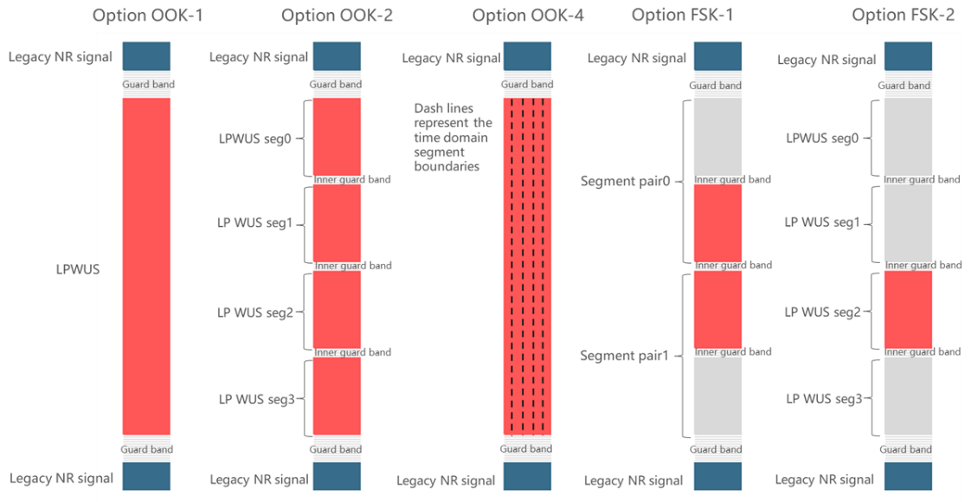

Figure 7.1.2.2-6: Some of the LP-WUS waveform options

For waveform options of OOK-2, FSK-1 and FSK-2, since segmented RB allocations are considered, several narrower filters would be needed to filter out the interference in contrast to a single filter used for OOK-1 and OOK-4.

Figure 7.1.2.2-7 shows the simulation results for the aforementioned waveforms.

 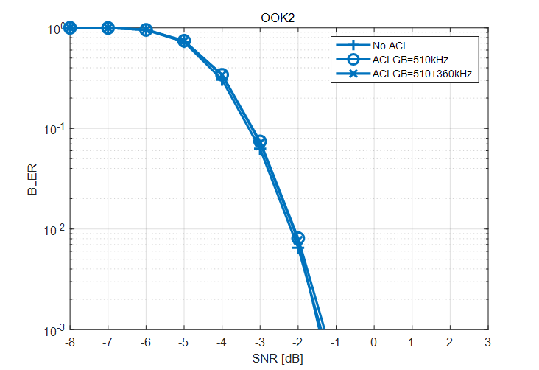

a) Guard RB evaluation of OOK-1 b) Guard RB evaluation of OOK-2

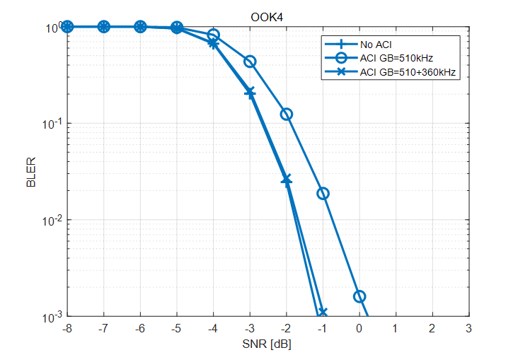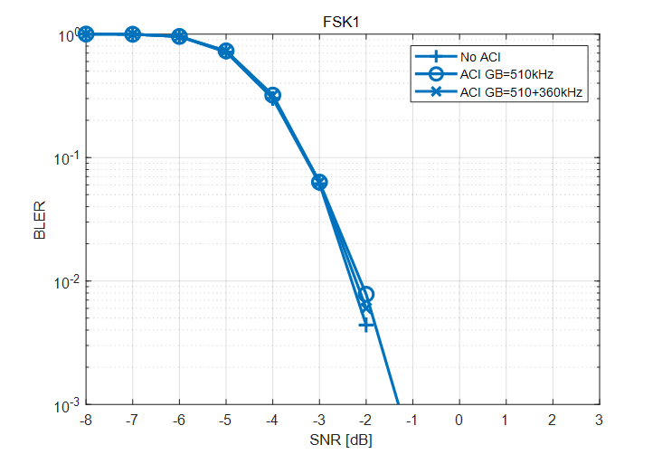

c) Guard RB evaluation of OOK-4 d) Guard RB evaluation of FSK-1

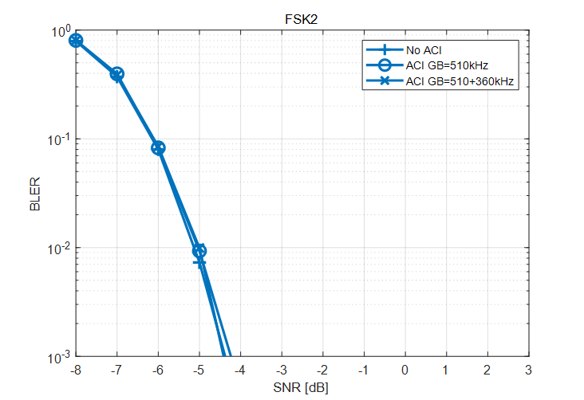

e) Guard RB evaluation of FSK-2

Figure 7.1.2.2-7: ACS guard RB evaluation for several waveforms

For the evaluated waveform options of OOK-1, OOK-2, OOK-4, FSK-1 and FSK-2, guard RB with the size of one 30kHz SCS RB could provide necessary protection of LP-WUS from interference of adjacent NR carrier. For 5th order Butterworth filter assumption, it is proposed to reserve 1 RB for 30kHz SCS or 2RBs for 15kHz SCS for protection of LP-WUS from interference of the adjacent NR carrier.

[7B-5], [7B-6]

Simulations were done to evaluate the impact of adjacent channel and adjacent subcarrier interference. The simulation configuration was created closely match with existing RAN4 minimum requirement for adjacent channel selectivity. Minor adaptations needed to be done as 30 kHz SCS was used. The details of the simulation configuration are provided in Table 7.1.2.2-9.

Table 7.1.2.2-9: Simulation configuration

|  |  |
| --- | --- |
| NR system BW | 20 MHz |
| Subcarrier spacing | 30 kHz |
| Guardband of NR channel | 810 kHz |
| WUS BW within NR channel | 12 RB = 4.32 MHz |
| WUS signal | OOK-4 |
| Guard RB size of LP-WUS | 0 or 1 RB. GB is placed outside of the 12 RB carrying WUS |
| WUS placement within NR channel | 1) Immediately adjacent to system BW edge, NR channel GB is respected  2) Additional 3RB = 1.08 MHz offset from system BW edge compared to case 1)  3) Additional 6 RB = 2.16 MHz offset from system BW edge compared to case 1  4) Additional 12 RB = 4.32 offset from system BW edge compared to case 1  NOTE: Together with 1 RB GB, total offset from system BW edge to first WUS RB is reported offset + 360 kHz |
| ACS interferer signal | 12 RB = 4.32 MHz, center of interferer 2.52 MHz offset from system BW channel edge |
| ACS interferer signal level | Relative difference to signals within system BW aligned with Table 7.5-3 in TS 38.101-1 for 20 MHz channel bandwidth |
| Adjacent subcarrier interference | Except for the Guard RB size of LP-WUS of 0 or 1 RB, all subcarriers within system BW carry OFDM QPSK data |
| Filter characteristic | 2nd to 5th order Butterworth |
| Filter passband BW (-3 dB) | 4.32 MHz  5 MHz  6 MHz |
| LO frequency | In the middle of WUS |
| Frequency error | 0, 50, 100 ppm |
| Phase noise | Not modelled |
| Non-linearities | Not modelled |
| Channel model | TDL-C 300 ns |
| NR system BW | 20 MHz |
| Subcarrier spacing | 30 kHz |
| Guardband of NR channel | 810 kHz |
| WUS BW within NR channel | 12 RB = 4.32 MHz |
| WUS signal | OOK-4 |
| Guard RB size of LP-WUS | 0 or 1 RB. GB is placed outside of the 12 RB carrying WUS |
| WUS placement within NR channel | Immediately adjacent to system BW edge, NR channel GB is respected  Additional 3RB = 1.08 MHz offset from system BW edge compared to case 1)  NOTE: Together with 1 RB GB, total offset from system BW edge to first WUS RB is 4 RB = 1.44 MHz |
| ACS interferer signal | 12 RB = 4.32 MHz, center of interferer 2.52 MHz offset from system BW channel edge |
| ACS interferer signal level | Relative difference to signals within system BW aligned with Table 7.5-3 in TS 38.101-1 for 20 MHz channel bandwidth |
| Adjacent subcarrier interference | Except for the Guard RB size of LP-WUS of 0 or 1 RB, all subcarriers within system BW carry OFDM QPSK data |
| Filter characteristic | 2nd to 5th order Butterworth |
| Filter passband BW (-3 dB) | 4.32 MHz  5 MHz  6 MHz |
| LO frequency | In the middle of WUS |
| Frequency error | Not modelled |
| Phase noise | Not modelled |
| Non-linearities | Not modelled |
| Channel model | TDL-C 300 ns |

Simulation results are also optimistic as no frequency error, phase noise or non-linearities were modelled. For filter passband BW 3 options were used. With the narrowest passband BW the filter already cuts into WUS with 3 dB attenuation at WUS edges. Wider bandwidths are used to model practical implementation imperfections as well as possibility of missing or simplified calibration for filter corner frequency.

First an example of ACI impact and GB impact are presented in Figures 7.1.2.2-8 and 7.1.2.2-9.

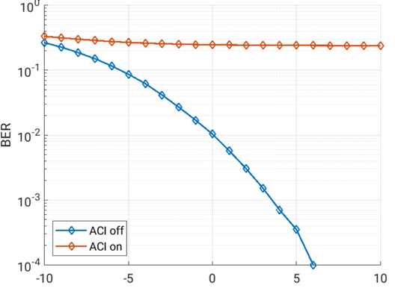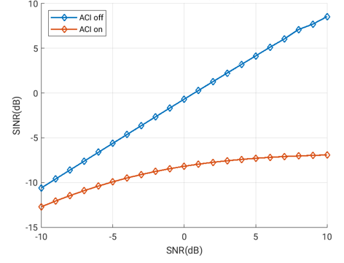

Figure 7.1.2.2-8: Impact of ACI, 3rd order filter, 4.32 MHz filter BW, WUS at system BW edge with GB = 0 RB

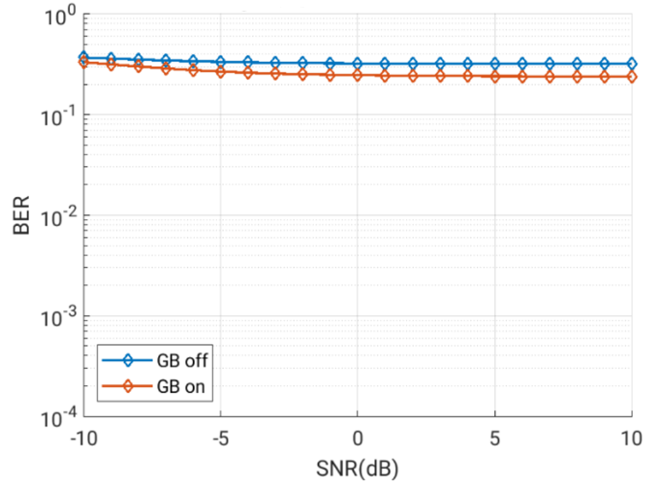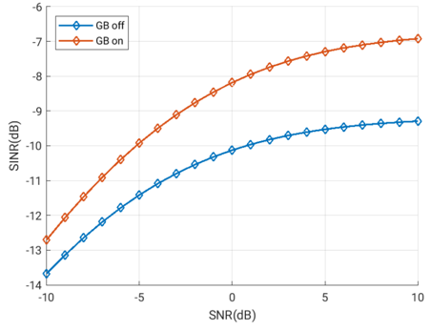

Figure 7.1.2.2-9: Impact of GB, 3rd order filter, 4.32 MHz filter BW, WUS at system BW edge with GBoff meaning GB = 0RB and with GBon meaning 1 RB GB. ACI is on for both curves.

It can be seen that for the chosen example scenario, adding ACI results in extremely poor BER. With no ACI present, there is clear relationship between SNR and BER. Whether guard band of 1 RB = 360 kHz is present or not does not change the results meaningfully. When looking at the SINR vs. SNR, the explanation is clear: when ACI is present, SINR never increase above -7 dB when SNR increases to 10 dB.

Next results are presented for different filter bandwidths and filter orders when ACI is present in Figures 7.1.2.2-10 and 7.1.2.2-11.

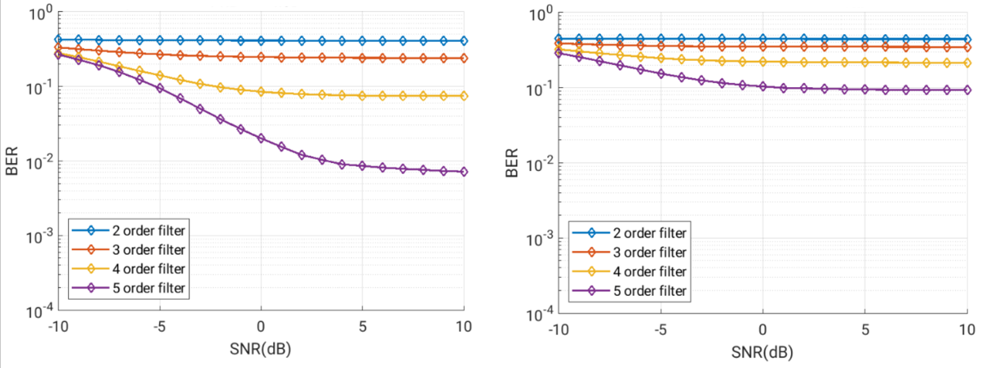

Figure 7.1.2.2-10: Left: BER vs. SNR, 4.32 MHz filter BW, WUS at system BW edge, GB = 1 RB; Right: BER vs. SNR, 5 MHz filter BW, WUS at system BW edge, GB = 1 RB

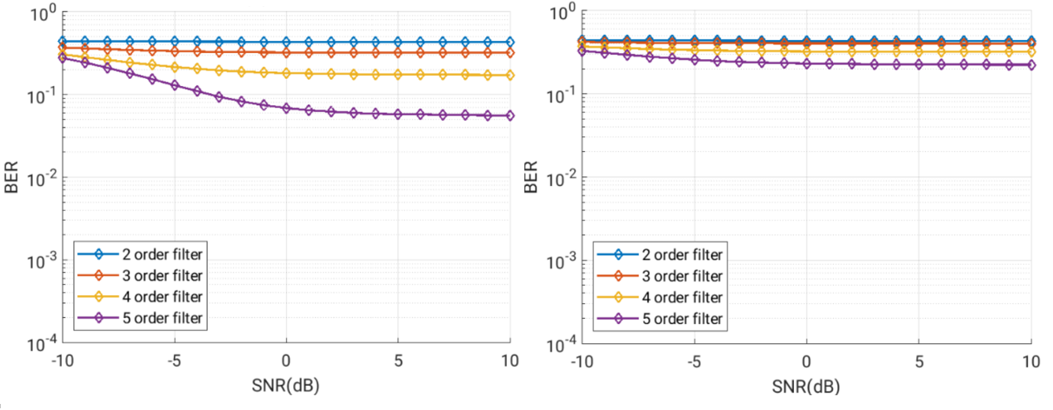

Figure 7.1.2.2-11: Left: BER vs. SNR, 4.32 MHz filter BW, WUS at system BW edge, GB = 0 RB; Right: BER vs. SNR, 5 MHz filter BW, WUS at system BW edge, GB = 0 RB

It can be seen that with 1 RB GB, BER is starting to be borderline acceptable with higher SNR levels only with 5th order filter for which the -3 dB bandwidth is exactly aligned with WUS BW. This is when no phase noise, non-linearities, frequency error, or practical filter implementation aspects are considered. Also with 15 kHz SCS, the NR channel GB would be narrower and performance with the same 360 kHz GB would be worse. Therefore, we conclude that 360 kHz GB at channel edge does not enable low-power low-cost RF implementation of wake-up receiver.

To estimate the required GB we simulated how the performance changes if 3 additional RBs, i.e. additional 1.08 MHz, are used for guard band at channel edge. These RBs carry NR OFDM signal. Together with the WUS GB of 0 or 1 RB, the total separation from system BW edge is up to 1.44 MHz, and this is on top of the NR channel GB of 810 kHz. Results are shown in Figures 7.1.2.2-12 to 7.1.2.2-13.

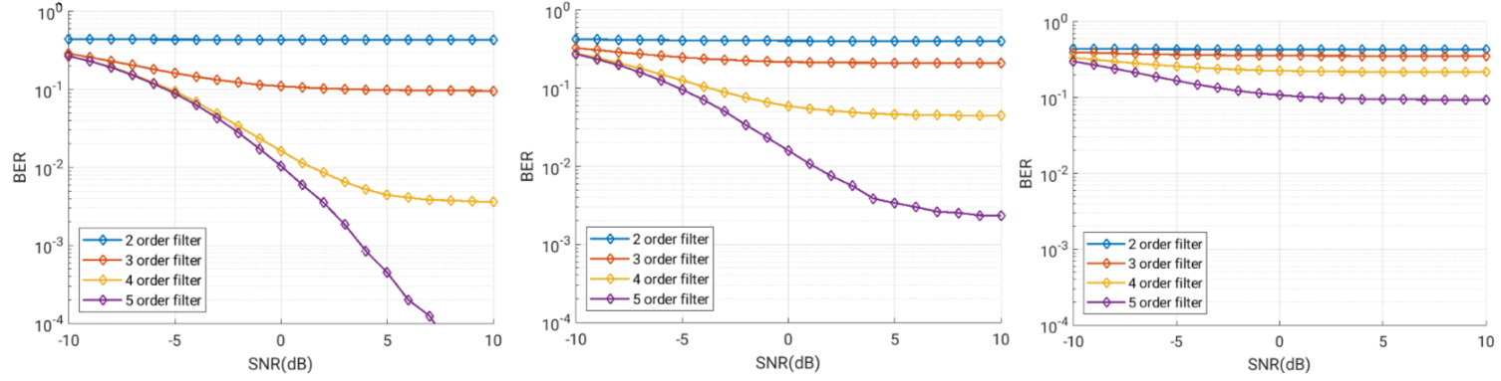

Figure 7.1.2.2-12: Left: BER vs. SNR, 4.32 MHz filter BW, WUS 3 RB offset from system BW edge, GB = 0 RB; Middle: BER vs. SNR, 5 MHz filter BW, WUS 3 RB offset from system BW edge, GB = 0 RB; Right: BER vs. SNR, 6 MHz filter BW, WUS 3 RB offset from system BW edge, GB = 0 RB

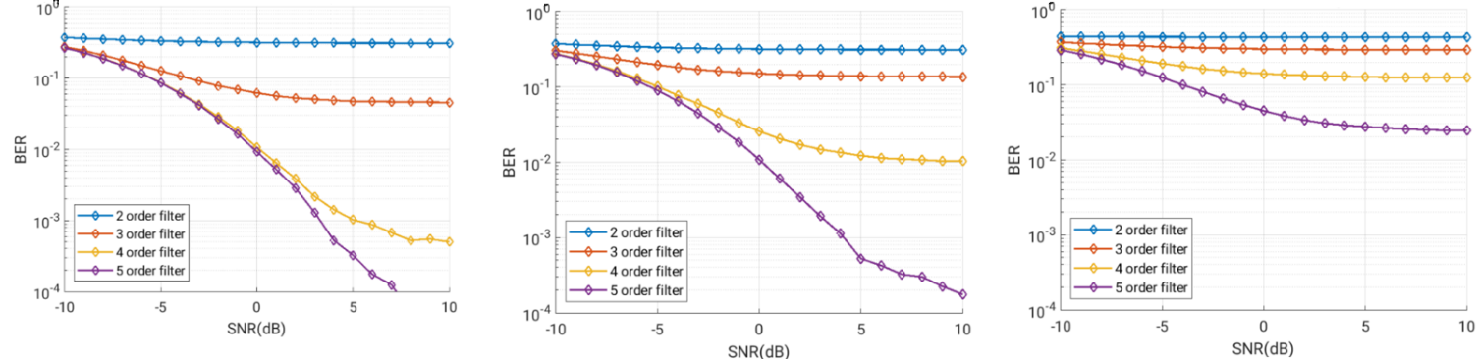

Figure 7.1.2.2-13: Left: BER vs. SNR, 4.32 MHz filter BW, WUS 3 RB offset from system BW edge, GB = 1 RB; Middle: BER vs. SNR, 5 MHz filter BW, WUS 3 RB offset from system BW edge, GB = 1 RB; Right: BER vs. SNR, 6 MHz filter BW, WUS 3 RB offset from system BW edge, GB = 1 RB

In Figure 7.1.2.2-14 and 7.1.2.2-15, BER vs, SNR results are presented for case where LP-WUS is placed 6 RB offset from system BW edge, and when additional 1 RB GB is applied on top of this.

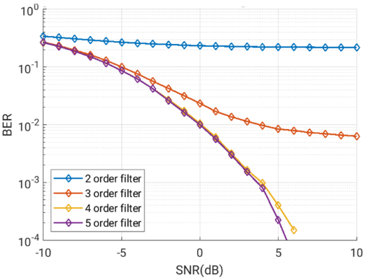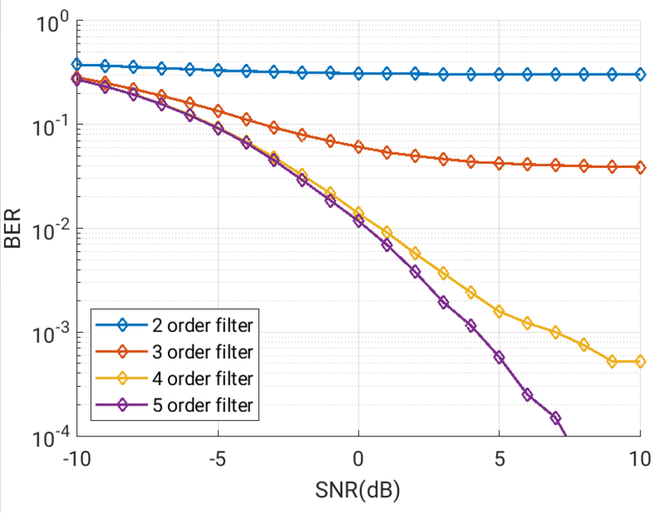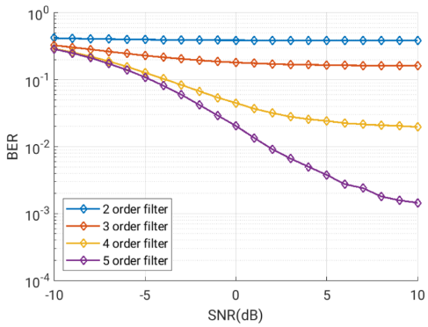

Figure 7.1.2.2-14:

Left: BER vs. SNR with ASCI and ACI, 4.32 MHz filter BW, LP-WUS 6 RB offset from system BW edge with no RB GB towards ASCS.

Middle: BER vs. SNR with ASCI and ACI, 5 MHz filter BW, LP-WUS 6 RB offset from system BW edge with no RB GB towards ASCS.

Right: BER vs. SNR with ASCI and ACI, 6 MHz filter BW, LP-WUS 6 RB offset from system BW edge with no RB GB towards ASCS.

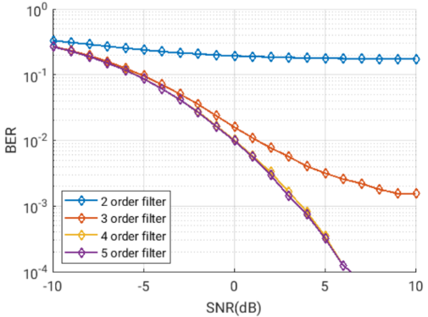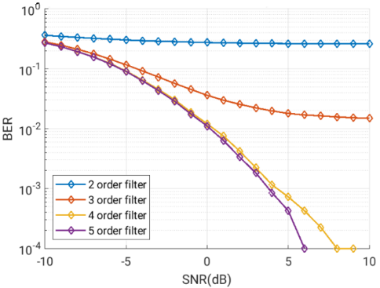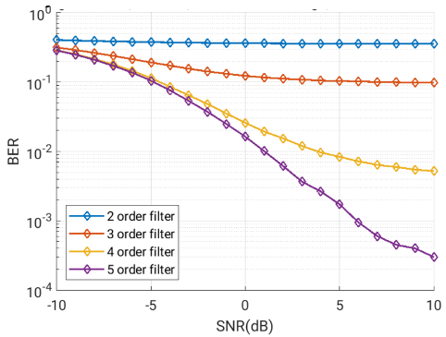

Figure 7.1.2.2-15:

Left: BER vs. SNR with ASCI and ACI, 4.32 MHz filter BW, LP-WUS 6+1 RB offset from system BW edge with no RB GB towards ASCS.

Middle: BER vs. SNR with ASCI and ACI, 5 MHz filter BW, LP-WUS 6+1 RB offset from system BW edge with no RB GB towards ASCS.

Right: BER vs. SNR with ASCI and ACI, 6 MHz filter BW, LP-WUS 6+1 RB offset from system BW edge with no RB GB towards ASCS.

The results in above Figures show that performance is still far from ideal with lower order filters even with 6 RB offset. When looking at the data, there are some things to consider: while frequency error, phase noise and non-linearities will make the performance even worse, RAN4 allows a significant relaxation to wanted signal level in ACS test. Therefore, the correct SNR range to be looked at would be rather towards the right side of the plots.

Finally Figure 7.1.2.2-16 shows performance with 3rd filter with different offsets from system BW edge.

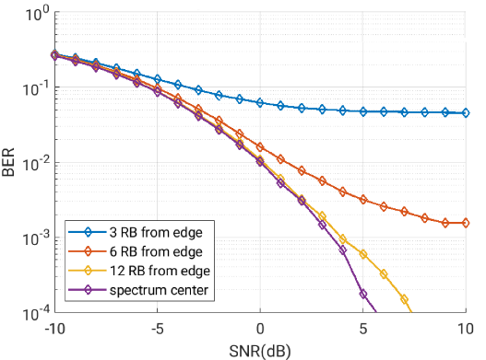

Figure 7.1.2.2-16: Performance with 3rd order filter at different RB offsets from system BW edge with 4.32 MHz filter BW

The results in Figures 7.1.2.2-8 to Figure 7.1.2.2-13 show that even with total of 1.44 MHz separation from system BW edge, on top of the 810 kHz NR channel GB the SINR with 3rd order filter will not rise above 0 dB. This is with the filter BW matched to WUS BW, no nonlinearities, no frequency error and no phase noise present. If some practical filter implementation aspects are considered and therefore 5 MHz filter BW is considered, only 5th order filter reaches acceptable performance. With 15 kHz SCS the NR channel GB would be narrower, and performance would be worse.

The results in Figures 7.1.2.2-14 to Figure 7.1.2.2-16 further show that more than 2.16 MHz offset from system BW edge, on top of the NR channel GB, is preferred for improved system performance with lower complexity implementation.

When frequency error is considered in addition, there is additional negative impact to performance, as exemplified in Figure 7.1.2.2-17.

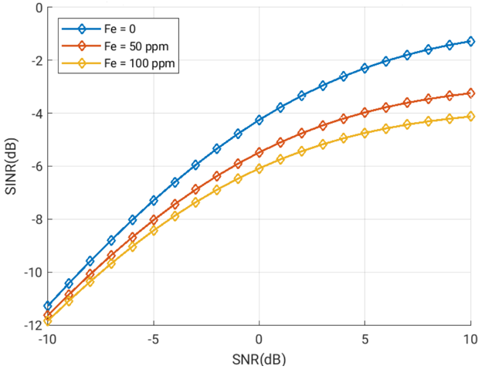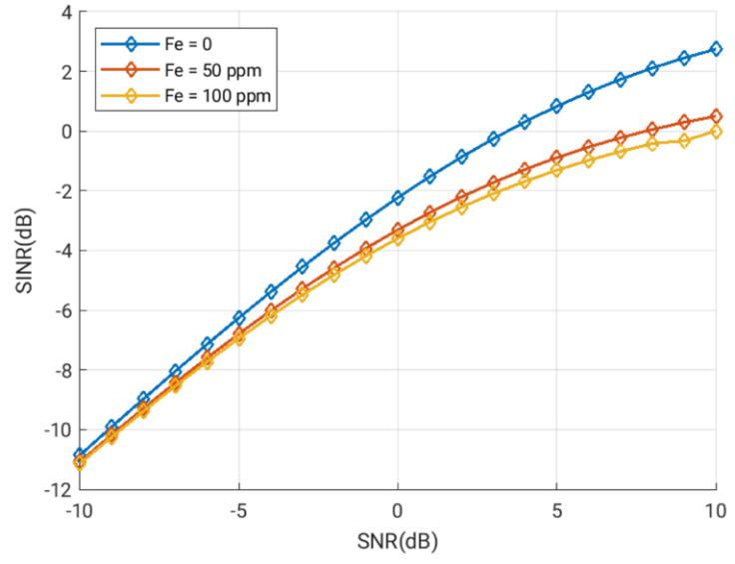

Figure 7.1.2.2-17:

Left: SINR vs. SNR with ASCI and ACI, 3rd order filter with 4.32 MHz filter BW, LP-WUS 3 RB offset from system BW edge with 1 RB GB towards ASCS.

Right: SINR vs. SNR with ASCI and ACI, 3rd order filter with 4.32 MHz filter BW, LP-WUS 6 RB offset from system BW edge with 1 RB GB towards ASCS.

In Figure 7.1.2.2-17 it can be seen that frequency error has a clear negative impact to SINR, and e.g. in case of 6+1 RB offset from adjacent channel, having frequency error in place can result in need of up to 7 dB higher input SNR to reach the same SINR when compared against case with no frequency error. With 3+1RB offset to band edge in left sub-figure, impact of frequency error makes it very difficult to reach SINR range where successful operation would be possible. It should be noted that while LP-WUS receiver is expected to periodically synchronize itself, there will also be long sleep periods during which frequency can drift. Therefore, considering large frequency offsets is not unreasonable.

If full flexibility for WUS location within NR channel bandwidth is needed, the opportunities for low-power implementation are severely limited for envelope detection based RF implementations. Analog filtering is not sufficient if WUS is placed on the RBs closest to channel edge. Even with 4RB, i.e., 1.44 MHz offset with 30 kHz SCS, performance challenges remain unless complex high order filtering with accurate filter BW is used. For 15 kHz, the performance is expected to be worse due to narrower NR channel GB.

To enable digital filtering, analog-to-digital conversion needs to have sufficient dynamic range to digitize also the interfering signal. Increase in ADC complexity results in higher power consumption.

Analog envelope detection architectures will perform poorly or require a complex implementation if WUS is placed immediately adjacent to channel edge. To improve the likelihood of successful operation and allowing possibilities for low-power implementation, greater than 2.16 MHz offset from outermost RB edge at channel edge is preferred, but exact value needs further study. For architectures using digital detection, placing WUS away from channel edge can enable use of simpler RF HW and power savings.

In case only adjacent subcarrier interference is considered, situation is greatly improved. Figure 7.1.2.2-18 shows impact to performance with 3rd order filter (4.32 MHz filter BW) with and without 1 RB GB between WUS and other NR subcarriers:

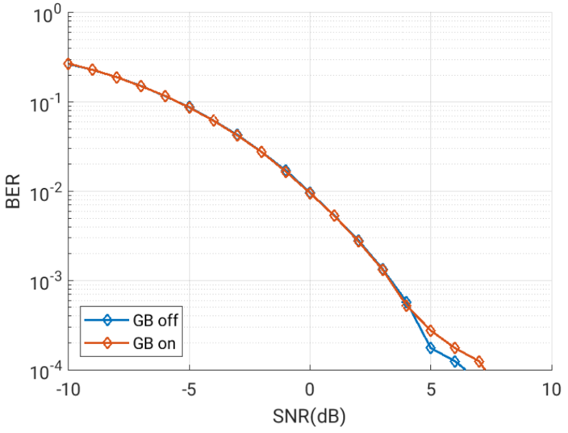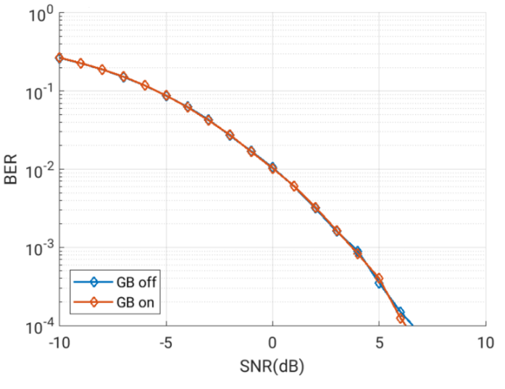

Figure 7.1.2.2-18:

Left: BER vs. SNR with ASCI only, 3rd order filter with 4.32 MHz filter BW, LP-WUS 3 RB offset from system BW edge. Comparison between 0 and 1 RB GB.

Right: BER vs. SNR with ASCI only, 3rd order filter with 4.32 MHz filter BW, LP-WUS 6 RB offset from system BW edge. Comparison between 0 and 1 RB GB.

Based on the results, guard band does not impact the performance and no guard band is required between WUS and other NR subcarriers.

[7B-7],[7B-8]

The simulation parameters are listed in Table 7.1.2.2-10 below.

Table 7.1.2.2-10: LLS parameters

|  |  |  |  |  |
| --- | --- | --- | --- | --- |
| Parameters | Value | | | |
| Carrier frequency | 2.6 GHz | | | |
| Channel | AWGN | | | |
| SCS | 30 kHz | | | |
| UE Rx antennas | 1 for WUR | | | |
| WUR sampling rate | 10 Msps | | | |
| WUS bandwidth | For OOK WUS:  5 MHz (for 30 kHz SCS: 12 PRBs+ ~ 1 PRB guard band each side of WUS) | | | |
| Number of ADC bits | 8 | | | |
| Receiver filter | 4, 6 , 8 and 10th order of chebyshev filter, filter BW is the same as WUS BW | | | |
| Non-WUS transmissions | Adjacent channel interference from other NR transmissions is considered. | | | |
| Max. false alarm due to noise or random symbols | 0.1% | | | |
| Frequency offset (ppm) | For OOK WUS:  50 ppm maximum frequency error | | | |
| Rx approach | Payload based: based on Manchester decoding. | | | |
| RF impairments | Phase noise profile | | | |
|  | Phase noise (dBc/Hz) | | |
| Offset | NF 9 dB | NF 12 dB | NF 15 dB |
| @5MHz | -99.4 | -99.4 | -99.4 |
| @10MHz | -108.1 | -105 | -102.1 |
| @15MHz | -120 | -117 | -114 |

For ASCS case, phase noise has little impact on the needed guard RB. For ACS case, the phase noise may degrade the SNR at least 3 dB for filter order of 8 and 10.

The number of guard RB within the WUS carrier/BW for ASCS case does not need to be greater than 1 as illustrated in Figure 7.1.2.2-19, increasing the number of the guard RB within the WUS carrier/BW may have penalty on the SNR in Figure 7.1.2.2-20.

For ACS case, there is a need to shift the WUS away from the adjacent carrier to get more filter attenuation for the adjacent carrier, the number of the shifted RB depends on the WUR filter order and the number of bits per OFDM symbol. For example, it is preferred placing the WUS signal in the middle of 20MHz channel for OOK-2 for WUR with a filter of order 6. For OOK1 and for WUR with a filter of order 6, the WUS signal should be placed with 6 to 10 RB away from the Adjacent carrier channel edge excluding the NR channel guard band. This is illustrated in Figure 7.1.1.2.2-21.

The observations from ACS simulation impacts the ACS test case design. The ACS is to test the UE receiver selectivity and the requirement is specified with a special test condition, e.g., ACI level, the UL and DL RB placement. From the simulation results, it can be observed that it is necessary to introduce additional offset from the edge of WUS signal to ACI for certain filter design. As it is not clear whether to test OOK1, OOK2 or OOK4 and which filter order WUR should be implemented, the detailed design of ACS test case could be discussed in work item phase.

Observed from the simulation, there is no need to introduce additional guard RB beyond the WUS BW. For ACS, blanking more RB adjacent to the WUS BW does not help to attenuate the leakage power from ACI, shifting the WUS signal away from the ACI helps more to attenuate ACI because the leakage power from ACI much higher than leakage power from adjacent subcarrier.



Figure 7.1.2.2-19: BLER for OOK1 w/wo phase noise for ASCS case

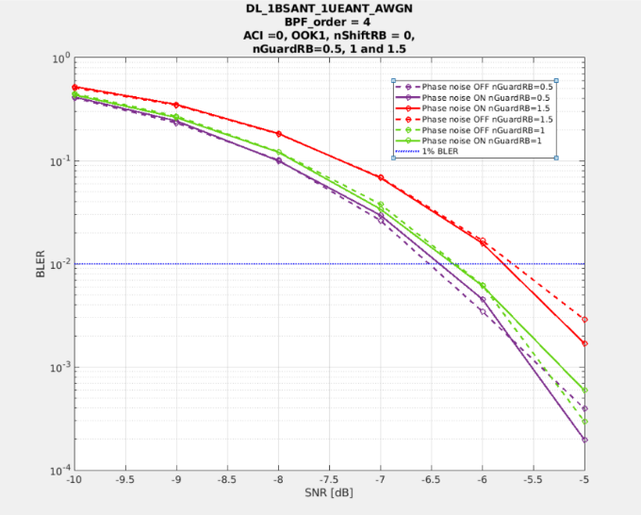

Figure 7.1.2.2-20: BLER for OOK1 with phase noise ON/OFF for ASCS case and Guard RB number =1/2, 1 and 1.5 for filter order 4



Figure 7.1.2.2-21: BLER performance for BFP order =6 and different # of shift RB with ACI = 33 dB

#### 7.1.2.3 ASCS evaluation

To evaluate the in-channel interference, RAN4 has defined a new metric as Adjacent Subcarrier Selectivity (ASCS) for evaluation purpose, which is the ratio of the receive filter attenuation on the assigned channel frequency to the receive filter attenuation on the adjacent sub-carrier(s).

The ACSC BWinterference is set as 5MHz, for both ~5MHz and ~1.4MHz LP-WUS cases, as a starting point for ASCS evaluation. The same PSD of LP-WUS and NR signal is assumed within the channel.

As shown in Figure 7.1.2.3-1, WUS at the center of NR channel would be the worst case of ASCS. For ASCS, the required guard RBs belongs to LP-WUR bandwidth.



Figure 7.1.2.3-1：LP-WUS at the centre of NR channel, only ASCS needs to be considered.

Table 7.1.2.3-1: LP-WUS evaluation parameters for WUS at centre

|  |  |
| --- | --- |
| NR RF channel BW | 20MHz/100MHz for 5MHz WUS |
| Guardband of NR channel | Unchanged, defined in Clause 5.3.3 in TS 38.101-1 |
| WUS BW within NR channel | Max 5.04 MHz |
| WUS RB allocation (Note 1) | 24 RB (15kHz SCS) or 12 RB (30kHz SCS) in 5.04 MHz; |
| WUS placement within NR channel | case 1: Center; |
| Guard RB size of LP-WUS | 0 RB, 0.5RB,1RB, 2RB, 3RB at each side  Symmetric guard RB |
| ASCS interferer | 5MHz |
| Filter characteristic | 2nd to 5th order Butterworth  lowpass@ baseband  bandpass@100MHz  bandpass@2.6GHz |
| Filter passband BW | Same as WUS bandwidth (number of RBs) |
| Target ACS | TBD |
| Target ASCS | TBD |
| Target WUS SNR | TBD |
| NR power level | Same PSD with WUS signal |
| RF impairment | Max. Center frequency offset = 5, 10, 50, 200 ppm. Initial search |
| Note 1: For easy evaluation, the number of allocated WUS RBs is fixed. The number of Guard RBs is changed. | |

**Conclusion for RAN4 ASCS guard RB analysis:**

Based on the following analysis, RAN4 observed that for 5th order filter, the guard RB number for LP-WUS ASCS is in the range of 0RB ~ 1RBs for 30KHz SCS, or 0RBs ~2RBs for 15KHz SCS. Similar number of guard RBs could be applied also with lower filter orders as performance was observed to remain similar with 3rd order filter.

Companies' input on simulation analysis of ASCS have been presented as following:

**Filter suppression level analysis:**

[7B-1]

The parameter assumption is aligned with that in Table 7.1.2.2-1. The required guard RB is provided in the Table 7.1.2.3-2 below.

Table 7.1.2.3-2: 5MHz LP-WUS ASCS results for WUS at center

|  |  |  |  |  |  |  |  |
| --- | --- | --- | --- | --- | --- | --- | --- |
| Filter order |  | | ASCS, BWinterference = 5MHz | | | | |
| Guard RB  CBW | Frequency  Offset | 0RB | 0.5RB | 1RB | 2RB | 3RB |
| 5th | 20MHz, SCS = 15kHz | 0 ppm | -19.25 | -20.67 | -21.63 | -24.04 | -26.39 |
| 5 ppm | -19.04 | -20.45 | -21.40 | -23.79 | -26.13 |
| 10 ppm | -18.83 | -20.22 | -21.17 | -23.55 | -25.89 |
| 50 ppm | -17.26 | -18.54 | -19.42 | -21.68 | -23.95 |
| 200 ppm | -12.73 | -13.63 | -14.26 | -15.96 | -17.81 |
| 100MHz, SCS = 30kHz | 0 ppm | -18.24 | -20.63 | -22.97 | -27.59 | -31.80 |
| 5 ppm | -18.03 | -20.40 | -22.72 | -27.34 | -31.54 |
| 10 ppm | -17.82 | -20.17 | -22.48 | -27.08 | -31.28 |
| 50 ppm | -16.25 | -18.42 | -20.61 | -25.11 | -29.28 |
| 200 ppm | -11.74 | -13.27 | -14.90 | -18.70 | -22.60 |
| 4th | 20MHz, SCS = 15kHz | 0 ppm | -16.99 | -18.06 | -18.78 | -20.58 | -22.34 |
| 5 ppm | -16.82 | -17.88 | -18.60 | -20.39 | -22.14 |
| 10 ppm | -16.56 | -17.71 | -18.42 | -20.20 | -21.95 |
| 50 ppm | -15.37 | -16.36 | -17.03 | -18.73 | -20.42 |
| 200 ppm | -11.54 | -12.28 | -12.80 | -14.15 | -15.57 |
| 100MHz, SCS = 30kHz | 0 ppm | -16.03 | -17.84 | -19.57 | -23.06 | -26.27 |
| 5 ppm | -15.87 | -17.65 | -19.38 | -22.86 | -26.06 |
| 10 ppm | -15.70 | -17.47 | -19.19 | -22.65 | -25.86 |
| 50 ppm | -14.42 | -16.08 | -17.72 | -21.10 | -24.27 |
| 200 ppm | -10.61 | -11.87 | -13.15 | -16.05 | -18.99 |
| 3rd | 20MHz, SCS = 15kHz | 0 ppm | -14.18 | -14.92 | -15.42 | -16.65 | -17.86 |
| 5 ppm | -14.05 | -14.79 | -15.28 | -16.51 | -17.71 |
| 10 ppm | -13.92 | -14.66 | -15.15 | -16.37 | -17.57 |
| 50 ppm | -12.95 | -13.64 | -14.11 | -15.28 | -16.45 |
| 200 ppm | -9.95 | -10.51 | -10.89 | -11.87 | -12.87 |
| 100MHz, SCS = 30kHz | 0 ppm | -13.33 | -14.58 | -15.76 | -18.17 | -20.42 |
| 5 ppm | -13.20 | -14.44 | -15.62 | -18.02 | -20.27 |
| 10 ppm | -13.07 | -14.31 | -15.48 | -17.87 | -20.12 |
| 50 ppm | -12.10 | -13.28 | -14.40 | -16.73 | -18.95 |
| 200 ppm | -9.13 | -10.07 | -10.10 | -13.04 | -15.08 |
| 2nd | 20MHz, SCS = 15kHz | 0 ppm | -10.71 | -11.15 | -11.44 | -12.17 | -12.88 |
| 5 ppm | -10.62 | -11.06 | -11.35 | -12.08 | -12.78 |
| 10 ppm | -10.54 | -10.98 | -11.27 | -11.99 | -12.69 |
| 50 ppm | -9.89 | -10.31 | -10.59 | -11.29 | -11.98 |
| 200 ppm | -7.86 | -8.22 | -8.46 | -9.06 | -9.67 |
| 100MHz, SCS = 30kHz | 0 ppm | -10.05 | -10.79 | -11.49 | -12.92 | -14.27 |
| 5 ppm | -9.97 | -10.71 | --11.40 | -12.82 | -14.18 |
| 10 ppm | -9.89 | -10.62 | -11.31 | -12.73 | -14.08 |
| 50 ppm | -9.25 | -9.96 | -10.62 | -12.00 | -13.33 |
| 200 ppm | -7.24 | -7.85 | -8.42 | -9.65 | -10.87 |

[7B-2]

The evaluation parameters are listed in Table 7.1.2.3-3 below.

Table 7.1.2.3-3: Evaluation assumptions.

|  |  |
| --- | --- |
| WUS signal bandwidth | 4.32 MHz |
| Interferer power level | 0 dBc |
| F0 | 2.6 GHz |
| Filter Type | Butterworth |

Table 7.1.2.3-4: Guard required in KHz for a target interference level of -10 dBc.

|  |  |  |  |  |  |
| --- | --- | --- | --- | --- | --- |
| CFO | Filter order | | | | |
|  | 1 | 2 | 3 | 4 | 5 |
| ± 0 ppm | 4320.0 | 1598.4 | 972.0 | 691.2 | 540 |
| ± 5 ppm | 4346.0 | 1608.0 | 977.9 | 695.4 | 543.3 |
| ± 50 ppm | 4580.0 | 1694.6 | 1030.5 | 732.8 | 572.5 |
| ± 100 ppm | 4840.0 | 1790.8 | 1089.0 | 774.4 | 605.0 |
| ± 200 ppm | 5360.0 | 1983.2 | 1206.0 | 857.6 | 670.0 |

Based on the above table, we suggest that for 5th order filter, the guard RB number for LP-WUS can be 2RBs for 30kHz SCS, or 3RBs ~ 4RBs for 15kHz SCS.

[7B-3]

Following table is based on low-pass filter for zero-IF envelop detector architecture, in which pass bandwidth is 4.32/2=2.16MHz.

Table 7.1.2.3-5: Evaluated ASCS based on low-pass filter with 2.16MHz pass bandwidth

|  |  |  |  |  |  |  |
| --- | --- | --- | --- | --- | --- | --- |
| Filter order |  | | ASCS, BWinterference = 5MHz | | | |
| Guard RB  CBW | Frequency  Offset | 0RB/  15kSCS | 1RB/  15kSC | 2RB/  15kSC | 4RB/  15kSC |
| 5th | 20MHz, SCS = 15kHz | 0 ppm | -20.05 | -22.39 | -24.75 | -29.25 |
| 5 ppm | -19.89 | -22.22 | -24.58 | -29.1 |
| 10 ppm | -19.72 | -22.05 | -24.41 | -28.94 |
| 50 ppm | -18.44 | -20.7 | -23.05 | -27.67 |
| 200 ppm | -14.31 | -16.06 | -18.08 | -22.66 |
| 2nd | 20MHz, SCS = 15kHz | 0 ppm | -10.71 | -11.42 | -12.12 | -13.47 |
| 5 ppm | -10.65 | -11.37 | -12.07 | -13.42 |
| 10 ppm | -10.6 | -11.31 | -12.02 | -13.38 |
| 50 ppm | -10.19 | -10.9 | -11.61 | -12.99 |
| 200 ppm | -8.66 | -9.36 | -10.07 | -11.49 |

Following table is based on analog band-pass filter for RF/IF envelop detector architecture, in which pass bandwidth is 4.32MHz.

Table 7.1.2.3-6: Evaluated ASCS based on analog low-pass filter with 4.32MHz pass bandwidth

|  |  |  |  |  |  |  |  |
| --- | --- | --- | --- | --- | --- | --- | --- |
| Filter order |  | | ASCS, BWinterference = 5MHz | | | | |
| Guard RB  CBW | Frequency  Offset | 0RB/  15kSCS | 1RB/  15kSC | 2RB/  15kSC | 4RB/  15kSC | 0RB/  15kSCS |
| 5th | 20MHz, SCS = 15kHz | 0 ppm | -14.41 | -15.59 | -16.79 | -19.2 | -21.56 |
| 5 ppm | -14.33 | -15.51 | -16.71 | -19.12 | -21.48 |
| 10 ppm | -14.24 | -15.42 | -16.62 | -19.03 | -21.39 |
| 50 ppm | -13.58 | -14.74 | -15.93 | -18.34 | -20.72 |
| 200 ppm | -11.24 | -12.29 | -13.39 | -15.73 | -18.13 |
| 2nd | 20MHz, SCS = 15kHz | 0 ppm | -7.25 | -7.64 | -8.02 | -8.79 | -9.54 |
| 5 ppm | -7.22 | -7.61 | -8 | -8.76 | -9.52 |
| 10 ppm | -7.2 | -7.58 | -7.97 | -8.73 | -9.49 |
| 50 ppm | -6.97 | -7.36 | -7.74 | -8.51 | -9.27 |
| 200 ppm | -6.14 | -6.52 | -6.91 | -7.68 | -8.45 |

Less pass bandwidth will lead to better filter suppression capability, so Table 7.1.2.3-5 with less pass bandwidth will have better performance.

**Link-level simulation analysis:**

[7B-1]

The detailed parameters are listed in Table 7.1.2.2-3. The simulation results are in Figure 7.1.2.3-2 with consideration of CFO RF impairment.







Figure 7.1.2.3-2: ASCS guard RB evaluation with CFO RF impairment

[7B-4]

Different from ACS, for evaluation of ASCS we consider the PSD for all RBs including both LP-WUS and NR signal is flat and no power boosting is considered for LP-WUS signal. Figure 7.1.2.3-3 shows the ASCS guard band evaluation for several different waveforms, all the simulations are based on 5th order Butterworth filter.

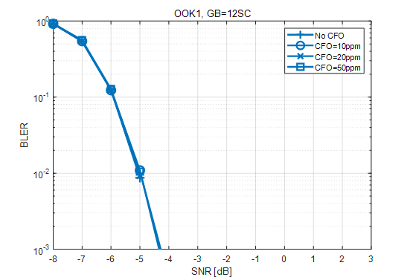

a) ASCS guard RB evaluation for OOK-1

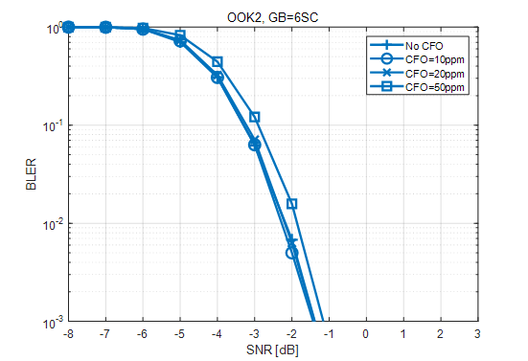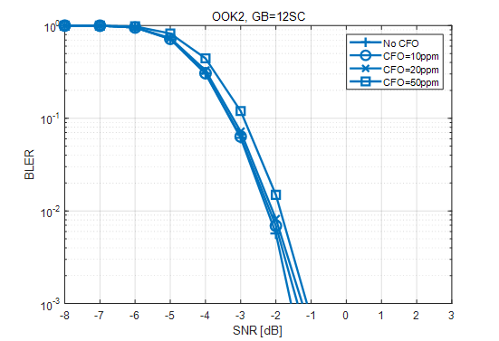

b) ASCS guard RB evaluation for OOK-2

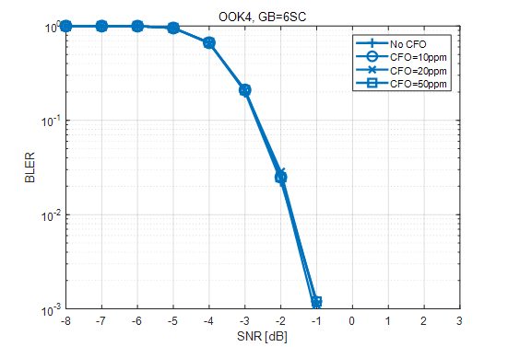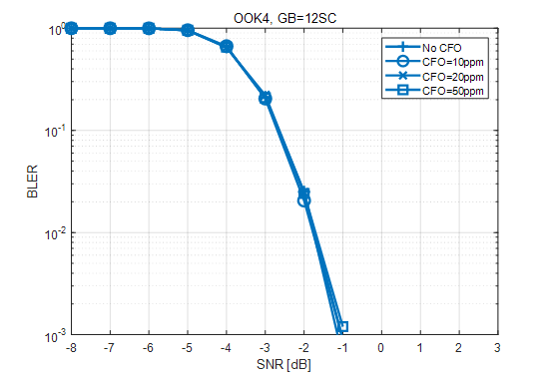

c) ASCS guard RB evaluation for OOK-4

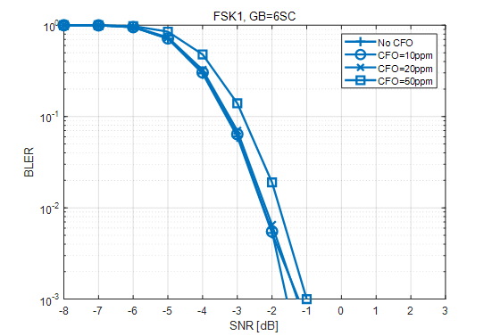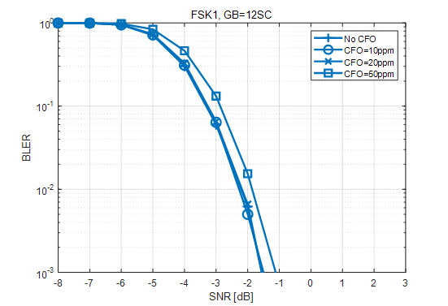

d) ASCS guard RB evaluation for FSK-1

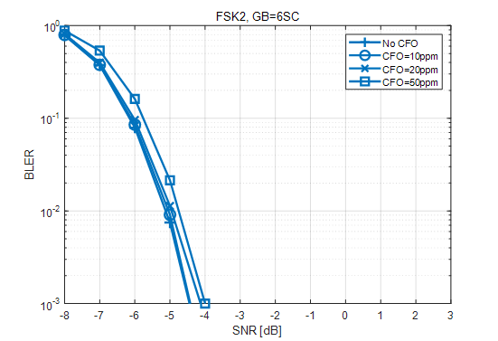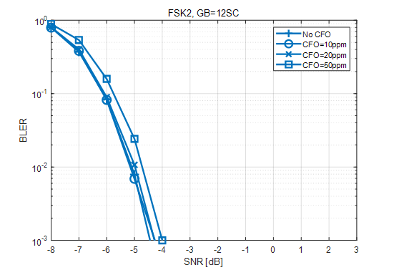

e) ASCS guard RB evaluation for FSK-2

Figure 7.1.2.3-3: ASCS guard RB evaluation

Less guard RB is required for ASCS compared to ACS between LP-WUS and NR signals. Considering frequency offset impact, guard RB with the size of one 15kHz SCS RB could provide necessary protection of LP-WUS from interference of adjacent NR sub-carriers.

[7B-7],[7B-9]

For ASCS, it can be observed that 1st order filter performs worst while and even with adding 6 guard RBs, the link performance only slightly improves., This means that guard RB does not considerably help if filter order is so low in WUR implementation. For higher than 2nd and 3rd order, the needed Guard RB is not obvious. In simulated link performance vs # RB for 3rd order filter in Figure 7.1.2.3-4, the SNR improvement for 2 RB is 0.2 dB.

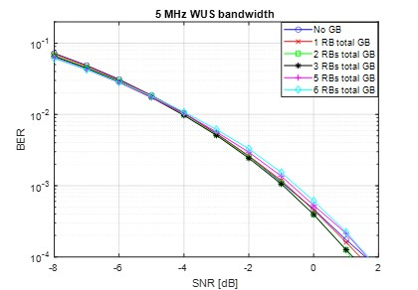

Figure 7.1.2.3-4: Link performance for ASCS selectivity with different filter order

If the filter order is higher than and equal to 2, smaller guard RB (1 to 2 RB) is sufficient between adjacent subcarrier of eMBB signal and a WUS signal. If the filter order is too low, the guard RB does not help to improve the ASCS selectivity.

To investigate the ADC impact on the ASCS, the below simulation with different ADC setting is assumed. The following ADC parameters are used:

ADC number of bit [2, 4, 6,8] and ADC sampling rate [down sampling factor 4, 8, 16, 32]

It can be observed that generally there is SNR degradation when sampling rate down-sampling factor is increased from 4 to 32 for the same number of ADC bits and the same BPF order. Such SNR degradation is most prominent for ADC 2 bit case where 1.8 dB SNR degradation is observed in 7.1.2.3-5. Higher ADC bits can reduce the SNR degradation. For example, for ADC bits of 4, 6 and 8, the SNR degradation is around 1 dB. With Higher BPF order (>=6), SNR degradation can be further reduced to around 0.5 dB.

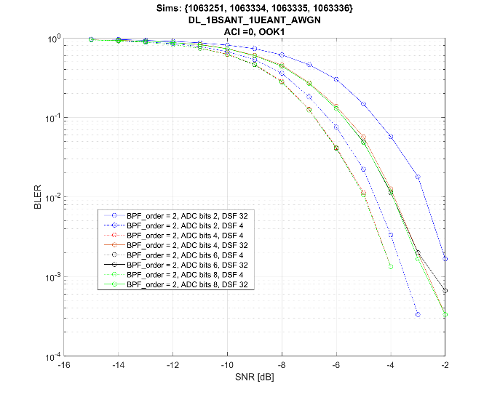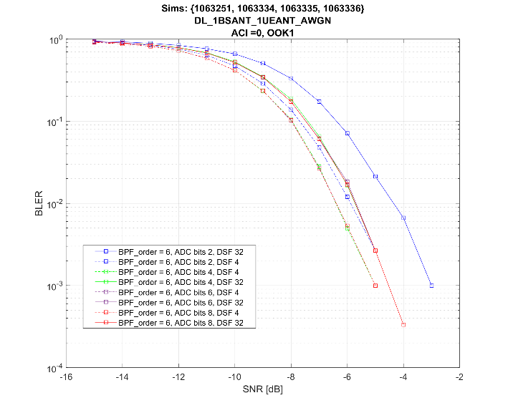

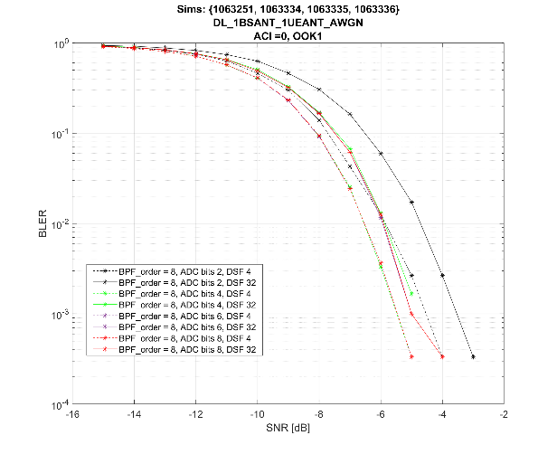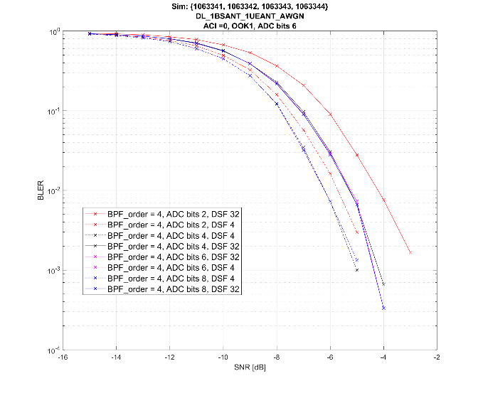

Figure 7.1.2.3-5: Link performance for ASCS selectivity for filter order 4 and 6 when ADC impairment is enabled.

[7B-10]

Link-level simulations to evaluate the required guard RBs for ASCS were performed based on the assumptions as listed in Table 7.1.2.3-7. Simulations were done for OOK1 and OOK4 modulation. Simulations were repeated for different filter order, guard RBs, and residual frequency error. SNR required to achieve 1% BLER are reported in the following tables.

Table 7.1.2.3-7: LP-WUS link-level simulation parameters.

|  |  |  |
| --- | --- | --- |
| Attributes | Assumptions | |
| Carrier Frequency | 2.6 GHz | |
| Case name | OOK-1 waveform | OOK-4 waveform |
| Channel structure | data: 6 bits CRC: 8 bits | data: 20bits CRC: 8 bits |
| Chip rate | M=1 | M=2 |
| WUS duration | 28 symbols | |
| Waveform | OOK -1/OOK-4 | |
| Coding | 1/2 rate Manchester coding | |
| Time error | 0 | |
| residual Frequency error | 0/10/20/50/200 ppm | |
| SCS | 30kHz | |
| gNB Channel BW | 20MHz (50 RB) | |
| WUS BW | 12RB ~ 4.32MHz | |
| Position within channel | Center | |
| Guardband of NR channel, both wanted cell and interfer cell (ACS) | 27RE~810kHz for wanted cell1 20MHz (5MHz WUS at edge), and 510kHz for interference cell2 5MHz. | |
| Guard RB | Outer GB:2/1RB on each side of LP-WUS bandwidth (2 RB for ACS)  Inner GB: 4RE between segments | |
| Filter | 3th/5th Order lowpass Butterworth with 4.32MHz bandwidth | |
| ASCS | PDSCH mapped on RBs not used for LP-WUS and Guard RB;  EPRE of PDSCH /EPRE of LP-WUS  = 0 dB  Same PSD with WUS signal | |
| ADC bit width | No ADC. | |
| Phase noise | none | |
| Power boosting | 0dB for OOK-1/4 | |
| Channel Model | TDL-C 300 | |
| Performance metric | BLER 1% | |

Table 7.1.2.3-8: SNR required for 1% BLER with 3rd order filter. Modulation used is OOK1.

|  |  |  |  |  |  |  |
| --- | --- | --- | --- | --- | --- | --- |
| Guard RBs | CFO | | | | | |
|  | ± 0 ppm | ± 10 ppm | ± 20 ppm | ± 50 ppm | ± 100 ppm | ± 200 ppm |
| 1 | 2.31 | 2.3 | 2.36 | 2.34 | 2.5 | 3.09 |
| 2 | 2.31 | 2.28 | 2.38 | 2.34 | 2.5 | 3 |

Table 7.1.2.3-9: SNR required for 1% BLER with 4th order filter. Modulation used is OOK1.

|  |  |  |  |  |  |  |
| --- | --- | --- | --- | --- | --- | --- |
| Guard RBs | CFO | | | | | |
|  | ± 0 ppm | ± 10 ppm | ± 20 ppm | ± 50 ppm | ± 100 ppm | ± 200 ppm |
| 1 | 2.28 | 2.28 | 2.34 | 2.31 | 2.5 | 3.09 |
| 2 | 2.28 | 2.27 | 2.34 | 2.33 | 2.48 | 2.97 |

Table 7.1.2.3-10: SNR required for 1% BLER with 5th order filter. Modulation used is OOK1.

|  |  |  |  |  |  |  |
| --- | --- | --- | --- | --- | --- | --- |
| Guard RBs | CFO | | | | | |
|  | ± 0 ppm | ± 10 ppm | ± 20 ppm | ± 50 ppm | ± 100 ppm | ± 200 ppm |
| 1 | 2.25 | 2.25 | 2.3 | 2.31 | 2.47 | 3.09 |
| 2 | 2.28 | 2.31 | 2.3 | 2.31 | 2.47 | 2.95 |

Table 7.1.2.3-11: SNR required for 1% BLER with 3rd order filter. Modulation used is OOK4.

|  |  |  |  |  |  |  |
| --- | --- | --- | --- | --- | --- | --- |
| Guard RBs | CFO | | | | | |
|  | ± 0 ppm | ± 10 ppm | ± 20 ppm | ± 50 ppm | ± 100 ppm | ± 200 ppm |
| 1 | 4.23 | 4.22 | 4.25 | 4.3 | 4.53 | 5.47 |
| 2 | 4.25 | 4.22 | 4.25 | 4.3 | 4.53 | 5.02 |

Table 7.1.2.3-12: SNR required for 1% BLER with 4th order filter. Modulation used is OOK4.

|  |  |  |  |  |  |  |
| --- | --- | --- | --- | --- | --- | --- |
| Guard RBs | CFO | | | | | |
|  | ± 0 ppm | ± 10 ppm | ± 20 ppm | ± 50 ppm | ± 100 ppm | ± 200 ppm |
| 1 | 4.19 | 4.19 | 4.22 | 4.25 | 4.5 | 5.44 |
| 2 | 4.2 | 4.19 | 4.22 | 4.25 | 4.5 | 5 |

Table 7.1.2.3-13: SNR required for 1% BLER with 5th order filter. Modulation used is OOK4.

|  |  |  |  |  |  |  |
| --- | --- | --- | --- | --- | --- | --- |
| Guard RBs | CFO | | | | | |
|  | ± 0 ppm | ± 10 ppm | ± 20 ppm | ± 50 ppm | ± 100 ppm | ± 200 ppm |
| 1 | 4.19 | 4.17 | 4.22 | 4.25 | 4.53 | 5.47 |
| 2 | 4.19 | 4.19 | 4.2 | 4.25 | 4.53 | 5 |

Based on the above presented data, following observations can be made: One PRB worth of guard RB with 30 kHz SCS is enough, provided the CFO is under ±100 ppm. However, in case of ±200 ppm of residual frequency error, there is a minor improvement in the required SNR by an additional guard RB. Given the low chip rate, filter order doesn't seem to impact performance, as in, given a modulation scheme, number of guard RBs and residual frequency error, increasing the filter order does not provide significant reduction in the required SNR.

Therefore, in for 30kHz SCS one PRB worth of guard RB can be used.

#### 7.1.2.4 Phase noise

At WUR receiver, reciprocal mixing occurs when a high-power level adjacent interferer signal that is present at antenna mixes with the oscillator noise sideband (phase noise). The reciprocal mixing generates cochannel interference to the WUR receiver passband as illustrated in Figure 7.1.2.4-1.



Figure 7.1.2.4-1: Reciprocal mixing for ACI case

#### 7.1.2.5 gNodeB RF impacts

The power boosting of 3 dB or 6 dB of a WUS signal relative to the average power of a configured NR carrier can improve the WUS signal coverage. It is beneficial to enable the 3dB or 6 dB power boosting at the existing network. Therefore, RAN4 assumes to reuse the legacy RF specification as a starting point. Some company observed that 3 dB or 6 dB power boosting for a 24 RB WUS signal may not be feasible for some of deployed gNB when average power is kept the same before and after power boosting. It is feasible to configure different PSD carriers in a multiple carrier configuration where WUS signal can be placed in a higher PSD carrier among all configured carriers. The amount of boosting is up to manufacturer declaration following the legacy manufacturer declaration.

BS manufacturer could declare if power boosting for WUS signal is supported and the boosting level in the range of [0] to [6] dB is considered. Final power boosting level and the condition of power boosting will be decided based on further analysis in WI phase.

#### 7.1.2.6 Multi-band capability

RF envelop detection architecture is more appropriate for single-band operation. IF envelop detection and BB envelop detection are more appropriate for multi-bands operation. Multi-band here still means that only one band at a time is being received. Multi-band capability for other architectures is FFS.

#### 7.1.2.7 Noise Figure

RAN4 noticed that the assumed NF in RAN1 simulation may be different with RAN4. RAN4 will derive RF requirement based on NF which is feasible from coverage and implementation perspective. RAN4 will focus on sensitivity evaluation instead of specific NF value in the normative work.

Generally, noise figure and power consumption are competing specifications, it is very challenging to achieve both low noise figure and low power consumption at the same time, and power consumption typically increases when sensitivity is improved. There is a delicate balance between lower power consumption, e.g., higher noise figure, and system performance.

#### 7.1.2.8 Band operation for LP-WUS

RAN4 has discussed the band operation for LP-WUS according to the scenarios listed below with the understanding that the associated RF aspects could be analysed in the work item phase, depending on the scope of the related normative work.

1) The band for the low-power radio (LR) and main radio (MR) can be the same, e.g., WUS is located within the NR band used for LP-WUR. In this scenario the WUS and NR DL could be multiplexed according to TDM/FDM modes.

2) The band for LR and MR can be different, e.g., WUS is located within an NR band for LP-WUR, and another NR band is used for the MR.

Additionally, RAN4 has concluded the following aspects from RF perspective, which are provided for information:

- WUS located in an SDO band in TS 36.101 is proposed by some companies, and RAN4 recognizes that there exist dependencies on other WGs that have not been considered in this study.

Note: Some companies have expressed a concern that SDO bands may not be IMT bands.

## 7.2 LP-WUS design and L1 procedure

- When evaluating and/or comparing link performance of MC-ASK, MC-FSK, and CP-OFDMA waveforms of LP-WUS at least

- raw information bit-size

- Alt 1:

- average EPRE within the [time]/frequency resources used for LP-WUS (including any guard bands)

- time/frequency resources used for LP-WUS (including any guard bands)

- Alt 2:

- average EPRE within the [time]/frequency resources used for LP-WUS (including any guard bands)

- FFS: false alarm probability/rate

- FFS: misdetection probability/rate

are kept [comparable or fixed].

- Study at least

- impact of timing error

- impact of frequency error

- impact of phase noise and I/Q imbalance, if applicable

- impact of ADC resolution and sampling rate

- impact of interference

- impact of delay spread

- impact of doppler spread

- Companies to report

- how they modelled SINR

- SNR is calculated as average EPRE divided by power of noise [and interference].

- whether and how power pooling across and within MR OFDMA symbols is used.

- FFS: PAPR applicable to LP-WUS

- time/frequency resources (including any guard bands) for the scheme

- false alarm probability/rate and misdetection probability/rate

- receiver architecture type and its relative power consumption

- When comparing waveforms of LP-WUS, consider the impact to gNB for each of the waveform generation schemes. Consider whether there is impact to PAPR and a need for additional hardware for WUS.

### 7.2.1 Signal design

#### 7.2.1.1 Waveform

- Study generation and link performance of multi-carrier (MC)-ASK (including OOK) waveform

- study techniques to generate waveform by modulating sub-carriers of CP-OFDM symbol, consider up to M bits transmitted per OFDM symbol, where M is FFS.

- Note that above does not preclude DFT-S-OFDMA

- Study generation and link performance of multi-carrier (MC)-FSK waveforms

- study techniques to generate waveform by modulating sub-carriers of CP-OFDM symbol symbol, consider up to M bits transmitted per OFDM symbol, where M is FFS.

- Study link performance of OFDMA-based signals/channels considering at least the existing signal/channel structure (e.g. CSI-RS, SSS)

- Other signal/channel structures are not precluded

For MC-ASK or MC-FSK waveform generation, SCS of a CP-OFDM symbol used for LP-WUS generation can be the same as SCS used for other NR transmissions in CP-OFDM symbol overlapping in time with, study whether SCS can be different, also study

- FDM/TDM multiplexing with other NR transmissions

- link performance

- impact to legacy UEs

- impact on gNB

For waveform generation the following observations are made

- Flat spectrum in frequency domain provides robustness against frequency selective fading compared to concentrated energy in frequency domain.

- for OOK-4, sequence before DFT/LS with variation in phase via such as ZC, M-sequence or QAM sequence can achieve more flattened spectrum.

- Sequences(s) used in LP-WUS symbol generation with different pulse shape or spectral shape may have different performance.

- Knowledge of sequence(s) used in LP-WUS waveform generation may improve performance for at least a receiver with I/Q branches

Further discuss the following potential observations for waveform generation:

- When DFT is employed in OOK-4 (M>=2), -1/1 alternation in time or frequency shift in frequency domain may be needed to match CP-OFDM generation.

- Pre-storing of the generated frequency domain samples at gNB may reduce complexity of waveform generation at gNB with memory requirement depending on number of possible combination. This may be up to gNB implementation.

- Quantization of generated waveform in frequency domain to existing constellation (e.g. 64QAM) has low impact on performance and reduces complexity. This may be up to gNB implementation.

- Repetition of a sequence(s) used in LP-WUS generation in frequency can be used to improve diversity for MC-OOK and robustness against frequency offsets for MC-FSK.

##### 7.2.1.1.1 MC-ASK waveform

For MC-ASK waveform generation, where K is size of iFFT of CP-OFDMA, N is number of SCs used by LP-WUS including potential guard-bands, study further

- Option OOK-1: Single-bit in 1 OFDM symbol, SCs of LP-WUS are

- OOK=1 means all SCs are modulated

- OOK=0 means all SCs are zero power (from base-band point of view)



- Option OOK-2: Parallel M-bit OOK in frequency domain,

- N SCs of LP-WUS is further separated into M segments (M=2 in Figure) possibly with guard-bands in-between and/or around

- OOK=1 means all SCs in segment are modulated

- OOK=0 means all SCs in segment are zero power (from base-band point of view)

- OOK-2 can be received using the agreed receiver architectures for OOK with parallel envelope detection.



- Option OOK-3: Multi-tone single-bit OOK

- N SCs of LP-WUS is separated into L segments (L=2 on Figure) without guard-bands in-between segment, but possibly around

- OOK=1 means 1 sub-carrier (known by UE) of each segment is modulated, rest of SC is zero power (from base-band point of view)

- OOK=0 means all SCs in all segments are zero power (from base-band point of view)

- receiver architecture refers to clause 7.1.1-F



- Option OOK-4: Transform M-bit OOK in time domain

- N SCs of OOK-1 are generated by a transformation (DFT/Least square)

- N' samples are generated from M-bits

- signal modification may or may NOT be used

- truncation or other additional modification may or may NOT be used, if not used, N is the same as N'

- N' can be the same as K



- FFS modulated SCs are e.g. QAM symbols, sequences or other signals

- Companies to report their assumptions

- potential guard-band SCs are zero power (from base-band point of view)

- optionally, 2 additional segments, one always modulated and one always zero power (from baseband point of view) can be transmitted

- Other options are not precluded (e.g. OOK-1 with multiple bits in one OFDM symbol)

Study further methods to modulate input signal of the DFT/Least-Square block for OOK-4, and methods to modulate input signal of N SCs for other MC-ASK/FSK schemes

- study methods with respect to

- improving frequency diversity by flattening the spectrum, frequency repetition and frequency hopping

- impact to dynamic range of RE power in frequency domain

- FFS: impact to PAPR of generated time domain modulated MC-ASK/FSK symbol

- improving robustness to timing error necessary spectrum adjustment for compatibility with CP-OFDM generation

##### 7.2.1.1.2 FSK waveform

For M-bit MC-FSK generation study further the following options

- Option FSK-1: N SCs of LP-WUS are separated to M pairs of segments with potential guard-bands in-between and around.

- segment comprises one sub-carrier or multiple contiguous SCs

- in a pair of segments one segment is modulated, other segment is zero power (from base-band point of view)

- Option FSK-2: N SCs of LP-WUS are separated to 2^M segments with potential guard-bands in-between and around.

- segment comprises one sub-carrier or multiple contiguous SCs

- one segment from 2^M segments is modulated, other segments of SCs are zero power (from baseband point of view)

- M >0

- N >1

- Study how to generate segment in time domain, e.g. OOK-1 or OOK-4

- Other options are not precluded.

In FSK2-envelope-IF waveform generation, the N SCs of LP-WUS can be used to generate 2^M segments at the envelope of the LP-WUR's received signal in baseband where each segment comprises one or more tones.

##### 7.2.1.1.3 OFDM waveform

#### 7.2.1.2 Bandwidth and location

For the purpose of study, the BW of one LP-WUS is not greater than X (FFS X is 5 or 20) MHz for FR1, study further

- whether BW of LP-WUS is configurable (implicitly or explicitly)

- size of guard band [FFS: within or outside of BW X], if any

- whether there is different X for Idle, Connected, Inactive modes

FFS: Whether FR2 is included in the scope of LP-WUS SI

- From RAN1 perspective, LP-WUS and signals/channels used by MR can be within the same FR1 band.

- At least LP-WUS and signals/channels by MR can be on the same carrier in the band

- Study further

- Whether LP-WUS and signals/channels used by MR can be different carriers in the band

- Details on the LP-WUS location within a carrier

- Band can be different than band of signals/channels used by MR

- LP-WUS association with BWP

- LP-WUS can be configurable within guard-band of a band (like NB-IoT)

- Study RRC connected mode LP-WUS BW, whether same as IDLE/Inactive mode or different

At least for IDLE/Inactive mode, at least one BW-size <=5MHz is recommended to be supported for FR1

- Other BW sizes are not precluded

- if additional BW-size(s) are recommended to be supported, BW-size can be up to 20MHz

- LP-WUS bandwidth size (including guard-bands) is assumed to be an integer number of PRBs

From RAN1 perspective, for multiplexing with other NR signals and channels, it is beneficial if LP-WUS can be flexibly configured within a carrier.

#### 7.2.1.3 LP-WUS content

- For IDLE/INACTIVE mode study at least following candidates for content of LP-WUS

- information on which user(s) is/are targeted by the LP-WUS

- e.g. UE-group, -subgroup or -ID

- FFS: cell information

- FFS: SI change and ETWS/CMAS information, tracking area information, and RAN area information

- For CONNECTED mode, study at least following candidates for content of LP-WUS

- information on which user(s) is/are targeted by the LP-WUS

- e.g UE-group, -subgroup or -ID

- indication to wake-up to PDCCH monitoring.

- Other information candidates are not precluded

- Study pros and cons of including above information to LP-WUS.

- Note: the information may be explicitly or implicitly indicated.

- Study further following alternatives to carry the LP-WUS information using:

- Alt 1: by sequence(s) detection/selection

- FFS sequence type

- Alt 2: by encoded bits

- FFS: what type of encoding scheme

- FFS: with or without other bits (e.g. CRC/FCS)

- Other alternatives are not precluded

- Study whether LP-WUS information needs to be preceded by known one or more sequence(s).

### 7.2.2 L1 procedures

#### 7.2.2.1 RRM measurements

Study potential measurement metric used for RRM measurements performed by LP-WUR.

- examples of measurement metric are signal quality, signal power, detection rate of LP-WUS/synch signal

- companies to report assumption of signal used for measurements

For at least RRM serving cell measurement performed by LP-WUR based on reference signal(s), RAN1 identified at least the following metrics for further study and evaluation (including feasibility, complexity, power consumption, etc)

- LP-RSSI or Energy detection: linear average of total received power over a RSSI resource.

- FFS RSSI resource.

- LP-RSRP: linear average of received power of resource of reference signal(s) or signal(s) parts.

- FFS resource of reference signal(s) or signal(s) parts

- LP-SINR = LP-RSRP/(power of interference and noise)

- FFS how to define "power of interference and noise"

- LP-RSRQ= [N x] LP-RSRP/LP-RSSI, where N is the factor of resource size difference for evaluation LP-RSRP and LP-RSSI.

- Accounting AGC accuracy, ADC of at least 4 bits is required.

Note: Reference signal for performing measurements can be e.g. SSB (PSS/SSS/PBCH DMRS), LP-WUS-waveform sequence, LP-SS

Note: The definition of metrics could be further refined based on future study

**RRC IDLE/INACTIVE mode**

For a UE support LP-WUR in IDLE/INACTIVE mode,

- Study how to reduce UE power consumption due to existing RRM measurement requirements at least for mobility support,

- study feasibility of RRM measurements performed by LP-WUR, at least for serving/camping cell, based on signals detected by LP-WUR

- FFS: measurement metric

- FFS: whether and how to identify cell/ tracking area

- FFS: need for neighbouring cells

- FFS: need for relaxation of existing RRM measurement requirements (for UE)

- For Idle/Inactive mode, study offloading of RRM measurements of serving cell to LP-WUR under certain conditions, if any, and relaxation of serving/neighboring cell RRM measurements in MR considering

- Periodic reference signal(s) is/are used for LR measurements.

- FFS: reference signal(s) to measure, e.g. PSS/SSS/PBCH DMRS, LP-WUS waveform sequence, LP-SS

- FFS: periodicity, content

- MR performs measurements

- Alt2: with relaxed periodicity if RRM measurement in MR is relaxed.

- FFS: Condition for relaxation if any

- Can apply for both neighboring and serving cell

- Alt3: only when reference signal(s) based measurements by LP-WUR satisfy certain condition(s), e.g. are below threshold.

- FFS threshold.

- Above MR measurement under certain conditions can apply for both neighboring and serving cell

- Potentially with relaxation methods for MR neighboring cell measurement

- Other alternatives are not precluded

- FFS: Feasibility of RRM measurements of neighbour cells by LP-WUR

The followings are observed,

- At least for LP-WUR that cannot receive existing PSS/SSS, periodic LP-SS signal is beneficial for the following functionality.

- RRM measurements by LP-WUR, if supported

- at least coarse time synchronization of LP-WUR.

- at least coarse frequency synchronization of LP-WUR.

- Additional periodic LP-SS system overhead depends on LP-SS periodicity, system BW, # of beams, and resource required to fulfil the target functionality, etc. Periodic signal if used for coarse synchronization may reduce overhead of signal preceding LP-WUS, if any. LP-SS can be designed to be common among UE groups (cell-specific) and such further reduce system overhead.

- For LP-WUR that can receive existing PSS/SSS potentially assisted by PBCH DMRS/TRS for synchronization, existing PSS/SSS potentially assisted by PBCH DMRS/TRS may be used for above functionality.

- Periodic LP-SS coverage should be equal to or better than that of LP-WUS.

- For fine time and frequency synchronization, a signal (e.g. preamble) preceding or part of LP-WUS may be used.

**RRC CONNECTED mode**

Additional descriptions for RRM RRC CONNECTED mode can be found in 7.2.2.6.

#### 7.2.2.2 Synchronization of LP-WUR

Study synchronisation signal used by LP-WUR, if needed, based on

- Option 1: aperiodic signal transmitted as part of LP-WUS

- FFS: Whether the signal can additionally be transmitted separately from LP-WUS

- Option 2: periodic signal transmitted separately from LP-WUS

- Option 3: Option1 + Option2

Additional description of synchronization of LP-WUR can be found in 7.2.2.1.

#### 7.2.2.3 LP-WUS monitoring

Study further pros and cons of the following monitoring behaviours of LP-WUR

- Option1: Duty cycle, corresponds to LP-WUR switches between ON/OFF states

- Option2: Continuous monitoring, corresponds to LP-WUR is ON all the time

#### 7.2.2.4 Activation/Deactivation procedures of LP-WUS

- Study RRC connected mode LP-WUS activation/deactivation procedures.

- For Idle/Inactive mode, following options for activation and deactivation of LP-WUS monitoring by LP-WUR for a UE can be considered for study

- Alt 1a:

- gNB transmits legacy paging indication and LP-WUS

- UE activation and/or deactivation of LP-WUS WUS monitoring is up to UE implementation.

- This behavior may apply based on channel condition, e.g. when coverage is sufficient/insufficient.

- Alt 1b:

- gNB transmits legacy paging indication and LP-WUS

- UE activation and/or deactivation of LP-WUS monitoring is based on preconfigured criteria

- This behavior may apply based on channel condition, e.g. when coverage is sufficient/insufficient.

- Alt 2:

- activation and/or deactivation of LP-WUS monitoring in a cell is based on signalling.

- Paging misdetection performance shall not be impacted.

- In RRC CONNECTED mode, LP-WUS monitoring can be activated/deactivated by at least one or more of

- by gNB RRC signaling, with or without UE assistance.

- by gNB L1/L2 LP-WUS activation/deactivation signaling, with or without UE assistance.

- based on pre-configured condition(s), such as timer.

- LP-WUS monitoring by UE is known to gNB, study whether it could be transparent to gNB.

- other options are not precluded.

#### 7.2.2.5 Coverage

- Study techniques/mechanisms to enhance coverage performance of LP-WUS

- Study potential gains available as well as drawback(s) of the technique(s)/mechanisms(s), e.g. system overhead, increased complexity network energy consumption etc…

- Study potential issues and corresponding solutions for the case when LP-WUS coverage is insufficient

- At least study fallback mechanisms where the Main Radio switches to legacy operation in case the channel condition of LP-WUS is not sufficient, e.g. below threshold.

- Study the following techniques/mechanisms to enhance coverage performance of LP-WUS

- low complex channel coding

- FEC

- spreading code in time domain

- time domain repetition

- with combining before or after ED

- time-domain interleaving

- Note: Also Manchester coding can be considered as channel code

- non-contiguous transmission in the frequency domain

- frequency domain repetition

- frequency-hopping

- power-boosting

- transmit diversity

- study whether any above techniques could be transparent to UE.

#### 7.2.2.6 Additional L1 procedures for RRC CONNECTED mode

- Study RRC connected mode LP-WUS functionality/purpose/procedures

- In RRC connected, study the relationship between LP-WUS and legacy UE power saving techniques.

- In RRC CONNECTED mode, study benefit of LP-WUS over existing Rel-15, R16, and R17 power saving techniques for following functionalities:

- LP-WUS with similar functionality as R16 DCP.

- LP-WUS activates/resumes PDCCH monitoring when LP-WUS is received.

- interaction with legacy power saving techniques, if any

- other functionalities are not precluded

- for evaluation

- companies to report

- assumption on MR sleep state when LP-WUR is monitoring LP-WUS

- deep sleep,

- light sleep,

- micro sleep

- how to activate/deactivate LP-WUS monitoring and deactivate/activate PDCCH monitoring

- LP-WUS waveform

- For RRC connected mode, the following is assumed for LP-WUS study in RAN1

- RLM/BFD/CSI are performed by UE Main Radio (MR)

- RRM measurements are performed by UE Main Radio (MR)

- Ultra-deep sleep state is not allowed for MR.

- Study additional support of RRM measurement by LP-WUR for RRC connected mode

#### 7.2.2.7 Additional L1 procedures for RRC IDLE/INACTIVE modes

#### 7.2.2.8 Others

## 7.3 Higher-layer aspects

### 7.3.1 RRC\_IDLE/INACTIVE mode

#### 7.3.1.1 RRC\_IDLE/INACTIVE mode procedures

In RRC\_IDLE and RRC\_INACTIVE states, UEs shall perform RRC\_IDLE/INACTIVE mode procedures defined in TS 38.304 and TS 38.331, which specify how UEs shall monitor paging, keep system information up to date, receive ETWS/CMAS information, and perform RRM measurements and corresponding cell selection/re-selection to ensure that UE is camping on the best cell. These procedures may need to be modified to accommodate operation using LP-WUS/WUR.

Though the network may use different signals to page UE for the case that UE monitors LP-WUS and the case that UE doesn't monitor LP-WUS, the network doesn't need to be aware of whether the UE is monitoring LP-WUS or not in RRC\_IDLE/RRC\_INACTIVE. Otherwise, it requires the UE to switch on MR or wake up MR to inform the network whether the UE is monitoring LP-WUS or not, which leads to further signalling overhead, Uu resource consumption and also UE power consumption accordingly.

With LP-WUS/WUR, the Main Receiver (MR) of a UE could enter ultra-deep sleep state, which denotes a state when the MR may sleep or turn off. Such ultra-deep sleep state could be entered when predefined condition (e.g. quality of LP-SS and/or SSB is better than the threshold) is fulfilled. An operation like the one for Mobile Initiated Communication Only (MICO), where both monitoring of the downlink and RRM measurements are stopped until there is a subsequent uplink transmission, is however not feasible for LP-WUS/WUR. Thhe point with LP-WUS/WUR is to reduce UE power consumption while maintaining some downlink monitoring functionality, and this is not possible if either the UE stops monitoring in downlink or if the UE does not detect that it has moved into a new cell/area and therefore apply the incorrect configuration for downlink monitoring. According to TS 38.300, the functionality to be supported over Uu interface in RRC\_IDLE and RRC\_INACTIVE includes PLMN selection, SI reception, cell re-selection mobility, and paging, etc. Therefore, it is feasible to introduce LP-WUS/WUR as a power saving feature for RRC\_IDLE and RRC\_INACTIVE, while ultra-deep sleep state as a power saving state for RRC\_IDLE and RRC\_INACTIVE.

#### 7.3.1.2 LP-WUS monitoring and wake up procedure

Paging reception in RRC\_IDLE and RRC\_INACTIVE is supported both with discontinuous reception (DRX), and from Rel-17 and Rel-18, respectively, with extended DRX (eDRX). LP-WUS/WUR could also be supported with or without duty-cycled operation, i.e., as 'continuous' or as 'duty-cycled'. Since the LP-WUS/WUR feature is introduced to lower the UE energy consumption, it is for these two options feasible to introduce support for the LP-WUR option which can introduce the greatest UE energy consumption reduction compared to baseline as discussed above in section 6. If the gain is similar, the magnitude of implementation complexity, specification impact, and latency impact should be the determining factors for which LP-WUR option to support.

Currently, paging monitoring in RRC\_IDLE/INACTIVE mode is based on the configured I-DRX, as well as PEI is also designed as 'duty-cycled' associated with legacy PO. The specification impact for 'continuous' and 'duty-cycled' depends on the detailed design. While, a potential benefit of 'continuous' is shorter downlink latency. That is, since the UE monitors the downlink continuously the downlink latency could potentially be shorter.

Due to the transition time to start up the main receiver however, LP-WUR operation may always have worse latency performance than legacy, i.e., comparing to legacy continuous monitoring or DRX. 'Continuous' could still provide shorter downlink latency compared to 'duty-cycled', comparing at the same UE energy consumption reduction gain. This however depends on the UE procedure triggered by LP-WUS and the LP-WUS payload content and size.

On one hand, after waking up by LP-WUS, the legacy paging monitoring procedure could be triggered for the main receiver. That is, if the UE detects LP-WUS it would start up its main receiver to monitor legacy paging, i.e., the PDCCH scheduling of the paging message on PDSCH, and at first after finding its own *PagingRecord* in the paging message the UE could determine that it is being paged (similar to Rel-15 WUS for NB-IoT/LTE-M or Rel-17 PEI). In this case, the downlink latency will be determined by the periodicity of the legacy paging occasions (POs).

- In some case, 'continuous' mode may not have latency benefit compared to 'duty-cycled'. That is, even if LP-WUS is immediately received using 'continuous' mode the UE might anyway need to wait for the subsequent PO (i.e., maybe a same PO as if 'duty-cycled' is used).

- In some other case, the beneficial part comes from the margin that LP-WUS could be received earlier in case 'continuous' than 'duty-cycled', which would wake up the main receiver earlier and an earlier PO will be monitored by main receiver after waking up by LP-WUS.

- On the other hand, after waken up by LP-WUS, the main receiver could also monitor legacy PEI defined in Rel-17, if it is configured by network and it is supported by UE. Especially for the case that LP-WUS doesn't have full coverage compared to legacy signalling, e.g. SSB, main receiver needs to wake up to perform legacy operation out of LP-WUS coverage. In this case, network could still configure PEI for the use of fallback mechanism to save UE power consumption for paging monitoring. It means, the network would configure and transmit both LP-WUS and PEI for the UE, especially when the network is not aware of UE's entry/exit of LP-WUS monitoring. From UE perspective, LP-WUS may be used together with PEI if both LP-WUS and PEI are configured, to achieve more power saving gain.

The corresponding pros/cons of the above UE wake up procedures are listed as below:

Table 7.3.1.2-1: Pros and Cons of different alternatives for wake-up procedures

|  |  |  |
| --- | --- | --- |
|  | Alt1.1: LP-WUS+ Paging | Alt 1.2: LP-WUS+PEI+paging |
| Access latency | LP-WUS reception+ paging reception+ random access procedure | LP-WUS reception + PEI reception + paging reception +random access procedure |
| False Alarm | Can be reduced by use of UE subgrouping for LP-WUS. | Unclear if and how it can be further reduced if UE subgrouping mechanism is used in LP-WUS and PEI together. |
| Complexity of LP-WUS Design | Low | It is higher if UE subgrouping mechanism is used in LP-WUS and PEI together |
| Integration with legacy | Smooth as LP-WUS replaces PEI | Unclear what PEI functionality adds on top of LP-WUS |

After waking up from LP-WUS, in case UE needs to monitor PO, the time offset between LP-WUS and the PO should be long enough to include the transition time to start up the main receiver to be ready for PDCCH monitoring, which depends on the design of LP-WUR and the detailed procedure after waking up. After waking up from LP-WUS, some PO(s) needs to be monitored. Whether there is association between LP-WUS and PO, and how to define the association if yes, depends on the detailed procedure. For reference, in legacy, Rel-17 PEI supports mapping of up to 8 POs (configured the parameter po-*NumPerPEI)*, and Rel-15 WUS and Rel-16 GWUS for NB-IoT/LTE-M supports mapping of up to 4 POs, but only when the UE is configured with eDRX.

Furthermore, after waking up from LP-WUS, either all UEs could be triggered to wake up to monitor paging in associated PO(s), or just a subset of the UEs sharing the PO, so called LP-WUS UE subgrouping. The latter can be used to reduce the negative impact from false paging, i.e., unnecessary energy consumption in the UE caused by paging intended for another UE. In the latter case, LP-WUS UE subgrouping information corresponding to 2 bits or more, would be indicated by LP-WUS. How to indicate the subgrouping information, e.g. included in the LP-WUS payload or from the use of multiple LP-WUS signals corresponding to different subgroups, etc., depends on the design of LP-WUS. For reference, both Rel-17 PEI and Rel-16 GWUS for NB-IoT/LTE-M support up 8 subgroups per PO (configured by the parameters *subgroupsNumPerPO* and *GWUS-NumGroups*, respectively). The number of subgroups depends on the decision on payload of LP-WUS

Both these features rely on I-DRX and UEs already being distributed over the different POs in the cell, and the UE subgrouping therefore refers to further subgrouping of the UEs already divided into the same PO. This would be the same for 'duty-cycled' operation. For 'continuous' operation, UE should monitor the downlink continuously. false paging could apply to all UEs in the cell since all UEs are monitoring the downlink continuously. False paging would therefore be much more severe for 'continuous' and a larger number of LP-WUS/WUR UE subgroups would be required to achieve the same false paging rate.

A summary of the impact from carrying a UE subgroup indication in the LP-WUS is given below.

Table 7.3.1.2-2: Impact from the inclusion of UE subgroup information in the LP-WUS payload.

|  |  |
| --- | --- |
|  | UE subgroup indication in LP-WUS: |
| Procedure triggered by LP-WUS reception: | Legacy monitoring of paging in PO or PEI |
| gNB transmission upon paging: | LP-WUS and legacy paging (PDCCH+PDSCH). |
| False paging: | False paging among all UEs in the cell using 'Continuous', and among all UEs sharing a PO using 'duty-cycled'.  False paging is reduced by use of UE subgrouping and an increasing number of UE subgroups. |
| Latency impact: | DL latency determined by I-DRX cycle length and PRACH periodicity. |

In Rel-17 PEI, two subgrouping methods were introduced, which includes: CN assigned and UE\_ID based subgrouping. For CN assigned subgrouping, UE's subgroup is assigned by CN taking into account the UE's characters, such as mobility pattern, paging probabilities, etc. While for UE\_ID based subgrouping, UE's subgroup is formed based on UE\_ID and the subgroup number in RAN. UE supporting CN assigned subgrouping in RRC\_IDLE or RRC\_INACTIVE state can be assigned a subgroup ID by AMF through NAS signalling. The UE belonging to the assigned subgroup ID monitors its associated PEI which indicates the paged subgroup(s). Paging with UE\_ID based subgrouping is used in the cell which supports UE\_ID based subgrouping. It is up to network configuration to determine which subgrouping should be used.

Similar as PEI, the subgrouping methods for LP-WUS could include the CN assigned, and UE\_ID based subgrouping. Details, e.g. which one/both should be supported, how to support/provide the configuration, etc., could be further determined during WI phase.

#### 7.3.1.3 LP-WUS coverage and trigger condition

According to evaluation in section 8.2, LP-WUS link performance is considerably worse than legacy physical channels (e.g., PDCCH or PUSCH), and there could be partial LP-WUS coverage in the cell. Another possible scenario is LP-WUS could also have same coverage as legacy cell, while the details depend on the signalling and LP-WUR design. For the partial coverage case, UE may need to keep track of whether it moves in and out of LP-WUS coverage in the cell, this to be able to fall back to monitoring paging using the main receiver when the coverage of LP-WUS is not sufficient (see network awareness in 7.3.1.1 above). The UE could determine this based on the measured RSRP, e.g., compared to an RSRP threshold in system information.

For the partial coverage case, UE's MR could stay in ultra-deep sleep power state only when UE is in the coverage of LP-WUS. When UE moves out of the coverage of LP-WUS, the network cannot wake up UE's MR via LP-WUS. Hence, UE should start up its MR when it moves out of the coverage of LP-WUS to avoid missing the paging message. In this way, one of the exit conditions for using LP-WUS or ultra-deep sleep power state should be that the UE is out of LP-WUS coverage. A quality threshold of target Reference Signal can be pre-configured to UE to define the exit condition for using LP-WUS. With this threshold, UE can stop using LP-WUS and exit the ultra-deep sleep power state when the quality of target Reference Signal is lower than the threshold.

During ultra-deep sleep or when using LP-WUS, UE's MR may not perform measurement as per legacy procedures and requirements. Thus, in order to be applicable for all cases, the pre-configured exit condition should be based on the measurement of target Reference Signal by LR and / or MR.

Similarly, the measurements and trigger conditions would need to be defined for using LP-WUS. One way is to define a quality threshold for the target Reference Signal measurement to determine the coverage. One entry condition for using LP-WUS could be configured to UE based on this quality threshold. From network perspective, the threshold could be set based on the coverage of LP-WUS. With this threshold, LP-WUS could be used, and UE's MR could enter ultra-deep-sleep power state when the quality of target Reference Signal is better than the threshold.

Before the entry condition is fulfilled, UE should perform legacy measurement on serving cell based on legacy SSB, e.g. for cell (re)selection purpose. Hence, it is straightforward to use the legacy SSB as the target Reference Signal for pre-configured entry condition. That is, when the quality of the serving cell's SSB measured by MR is better than a pre-configured threshold, UE considers the entry condition is fulfilled, then, LP-WUS could be used and MR could enter ultra-deep-sleep power state for power saving. Alternatively, LP-SS could be introduced for LR measurement, the pre-condition could be also defined based on the measurement on LP-SS via LR. In this way, the target Reference Signal could be the LP-SS sent by the serving cell, i.e. when the quality of the LP-SS measured by LR is better than a pre-configured threshold, UE considers the entry condition for using LP-WUS is fulfilled. The solution requires the UE to perform measurement on LP-SS via LR before using LP-WUS. In this way, the UE needs to turn on its LR before entering ultra-deep-sleep power state, which may lead to extra power consumption, but it is not an issue as the power consumption of LR is very low.

From the network perspective, if a unique UE identifier (e.g., 48-bit 5G-S-TMSI or 24/40-bit I-RNTI) is not carried in the LP-WUS payload, a gNB may need to transmit both LP-WUS and the associated legacy PDCCH and PDSCH for the paging message. In this case, the gNB would in principle not need to consider whether the UE is within LP-WUS coverage in the cell or not, but in case it is not there would be some unnecessary control signalling overhead from the transmission of LP-WUS. If instead a unique UE identifier is carried in the LP-WUS payload, the gNB could either transmit LP-WUS or legacy paging depending on if the UE is within LP-WUS coverage or not. However, without any signalling from the UE upon LP-WUS coverage change, or from being in the cell or not, this would have to be done blindly and would be left to the gNB implementation (similar to paging the UE in two different cells, i.e., up to trial and error). With partial coverage, the most severe error case would be if the UE from inaccurate measurements incorrectly concludes that it is in LP-WUS coverage when it is not, and therefore becomes unreachable in the downlink (the UE only monitors using LP-WUR but is outside LP-WUS coverage).

#### 7.3.1.4 Configuration

Regarding the LP-WUS configuration, both UE and gNB must have a common understanding of when LP-WUS should be applied to avoid that UEs become unreachable in the downlink, as mentioned above in 7.2.3.1.3. Both UE and gNB could apply LP-WUS if LP-WUS has been configured in the cell in SI. This would further determine the conditions for entering and leaving LP-WUS monitoring operation as being tied to the monitoring of paging in a cell: A UE enables LP-WUS monitoring if it is configured with LP-WUS and camp on a cell in RRC\_IDLE or RRC\_INACTIVE state in which LP-WUS is configured, for example when re-selecting a cell in which LP-WUS is configured or being released from RRC\_CONNECTED in a cell in which LP-WUS is configured.

#### 7.3.1.5 System information update and PWS

Reception of system information (SI) broadcast and ETWS/CMAS are RRC\_IDLE mode procedures which must be supported for UE with LP-WUS/WUR. When the UE initiates the acquisition of SI, for example when SI has become outdated or upon cell change, the UE anyway needs to start up the main receiver for the reception of the SI message(s). However, this is not the case for a gNB notification of SI update and it must be possible to notify also UEs with LP-WUR about an upcoming SI change in the cell. For reference, in Rel-16 GWUS for NB-IoT/LTE-M this is done by a subgroup common to all UEs (configured by the parameter *commonSequence*), whereas for Rel-17 PEI the gNB must transmit PEI to all subgroups separately and upon the reception of PEI UEs continue to, as in legacy operation, monitor for the *systemInfoModification* and *systemInfoModification-eDRX* in the Short Messages transmitted on PDCCH using P-RNTI. When UE is using LP-WUS, UE could wake up by LP-WUS firstly and then receive the notification of SI change based on the *systemInfoModification* and *systemInfoModification-eDRX* in the Short Messages transmitted on PDCCH using P-RNTI as legacy.

ETWS/CMAS is regulatory requirement for UEs supporting ETWS/CMAS. Therefore, even for UE in ultra-deep sleep, the ETWS/CMAS messages should be ensured to be reachable if the UE is capable of ETWS/CMAS. As in legacy, the gNB would upon ETWS/CMAS information need to wake up UE by LP-WUS from ultra-deep sleep. Similar to the notification of SI change, when UE is using LP-WUS, UE could wake up by LP-WUS and receive the notification of ETWS/CMAS notification based on *etwsAndCmasIndication* in the Short Messages.

#### 7.3.1.6 Mobility and RRM

To ensure a UE in RRC\_IDLE or RRC\_INACTIVE is camping on the best cell it needs to perform mobility measurements as specified in TS 38.304. RRM measurement for mobility includes serving cell measurements and neighbour cell measurements, which can be intra-frequency or inter-frequency (including inter-RAT) measurements. In general, the neighbour cell measurements however only need to be performed by the UE if the serving cell is not strong enough, i.e., when the intra-frequency cell re-selection criterion (Srxlev> SIntraSearchP and Squal > SIntraSearchQ) or the inter-frequency cell re-selection criterion (Srxlev > SnonIntraSearchP and Squal > SnonIntraSearchQ) is not fulfilled. For the majority of UEs, and in a well deployed network without coverage holes, it is therefore the serving cell measurements that need to be performed the most frequently, and therefore they will also have the biggest impact on UE energy consumption.

For a UE operating with LP-WUR, infrequently starting up the main receiver (MR) for neighbour cell measurements is not expected to have any significant impact on UE energy consumption. However, using the MR for serving cell measurements has a significant impact on UE energy consumption and reduce the LP-WUS/WUR gain according to the observations from the study evaluation results. This since according to Clause 4.2.2.2 in TS 38.133, serving cell measurements must be performed every or every second I-DRX cycle in FR1 (and somewhat more relaxed in FR2). Starting the main receiver for RRM measurements every I-DRX cycle removes a large part of the UE energy consumption reductions from LP-WUS/WUR.

In order to achieve the UE power saving gain by LP-WUS/WUR, the RRM measurement on serving cell and neighbouring cell via MR is relaxed or may be stopped when UE is using LP-WUS or MR is in ultra-deep sleep. In Rel-16/17 PowSav and RedCap WI, RRM measurement relaxation on neighbouring cell was introduced. But here, further relaxation or even no measurement by MR could be considered while serving cell measurements are offloaded to LR. The relaxation on RRM measurement may impact the performance of mobility performance in RRC\_IDLE or RRC\_INACTIVE. In order to avoid or minimize such impact, the RRM measurement on LP-WUR could be considered. Thus, the above RRM measurement relaxation on serving cell and neighbouring cell should be premised on the feasibility or support of RRM measurement on LR.

### 7.3.2 RRC\_CONNECTED mode

#### 7.3.2.1 RRC\_CONNECTED mode procedures

For legacy UE in RRC\_CONNECTED state, it should keep MR monitoring PDCCH in C-DRX active time, if C-DRX is configured, also when there is nothing scheduled for the UE. As a result, the power consumption caused by unnecessary PDCCH monitoring is unavoidable. The gain for legacy UE power saving features in RRC\_CONNECTED, such as Short C-DRX, Long C-DRX, Rel-16 PDCCH-based WUS, or Rel-17 PDCCH monitor adaptation, comes from reducing the PDCCH monitoring time.

Both Rel-16 DCP and Rel-17 PDCCH monitor adaptation are both PDCCH based signalling. For a UE equipped with LR, the MR can be in a sleep state while the LR remains active to monitor Low-Power Wake-Up Signal (LP-WUS), and when LP-WUS is received by LR, it will trigger the MR to wake up to monitor PDCCH. As LR would adopt a minimalistic design, the power consumption of LR is expected to be significantly lower than legacy PDCCH based signaling using the main receiver (MR) in some cases. In this way, LP-WUS in RRC\_CONNECTED can potentially further reduce the UE energy consumption by being able the monitor the downlink with a LR such that the MR used for PDCCH monitoring can be kept in a sleep state. The LP-WUS/WUR solution should target power saving gain compared to the existing Rel-15/16/17 UE power saving mechanisms, e.g., according to the evaluation results above, {6%~15%} additional UE power saving gain with no capacity loss in both low load and high load cases for DL only XR traffic compared to the existing Rel-15/16/17 power saving solutions.

Compared with UE in RRC\_IDLE/INACTIVE state, UE in RRC\_CONNECTED state is more sensitive to the latency. Therefore, the RAN2 study on LP-WUS procedures in RRC\_ CONNECTED should target to reduce power consumption while guarantee the latency performance.

The MR sleep states considered for LP-WUS/WUR evaluation in RRC\_CONNECTED are the same as for baseline: deep sleep state with a 20 ms transition time, light sleep state with a 6 ms transition time, or micro sleep without any transition time, as described TR 38.840. Ultra-deep sleep state is not considered for LP-WUS/WUR in RRC\_CONNECTED state as a 400 ms transition time is too long to allow the MR to be ready for PDCCH monitoring from the ultra-deep sleep state considering the traffic requirements for NR. Therefore, the power saving gain for LP-WUS/WUR would be determined by the time duration in which the MR can be kept in a sleep state, and significantly lower power consumed by LP-WUS/LP-WUR compared to the PDCCH monitoring by MR. Regarding latency, the transition time for the MR to start up upon LP-WUS detection by LP-WUR would in principle not be worse comparing to the existing power saving mechanism since the MR could be in micro, light, or deep sleep state as legacy, but is not allowed to be in ultra-deep sleep state when LR is monitoring LP-WUS, as described above.

When using LP-WUS, other conditions could also trigger MR to wake up for PDCCH monitor, e.g. UL transmission by MR, which would be similar to using baseline solutions, e.g. C-DRX, with the same MR sleep state.

#### 7.3.2.2 LP-WUS monitoring

Similar as in RRC\_IDLE/INACTIVE, there are two mechanisms to monitor LP-WUS for LP-WUS in RRC\_CONNECTED, i.e. 'continuous' and 'duty-cycled' mode. For 'continuous' mode, LP-WUS is monitored continuously in time, while for 'duty-cycled' mode, LP-WUS is monitored based on a defined duty cycle, which is similar as DRX mechanism. 'Continuous' mode could be expected to have lower latency than 'duty-cycled' mode, but both solutions will have the same lower latency bound from the MR transition time as described above, and in the same way as for legacy C-DRX the duty cycle length for 'duty-cycled' mode would be defined or configured based on the downlink latency requirement. Therefore, any performance comparison of these two LP-WUS monitoring mechanisms, or any down selection between them, should be considered based on the downlink latency requirement. The corresponding pros/cons for these two mechanisms are summarized in the below table.

Table 7.3.2.2-1: Pros and Cons of 'duty-cycled' and 'continuous' mode for LP-WUS in RRC\_CONNECTED mode

|  |  |  |
| --- | --- | --- |
|  | 'Duty-cycled' mode for LP-WUS | 'Continuous' mode for LP-WUS |
| Pros | More UE power saving gain than continuous mode LP-WUS. | Potentially shorter DL latency than 'Duty-cycled' mode.  LP-WUR does not need to keep track of slot or radio frame numbering (i.e., DRX timing). |
| Cons | LP-WUR must keep track of slot and/or radio frame numbering (i.e., DRX timing).  Potentially longer DL latency. | Higher power consumption than duty-cycled LP-WUS. |

Two examples for UE operations for 'duty-cycled' mode and 'continuous' mode are shown in the below two Figures.

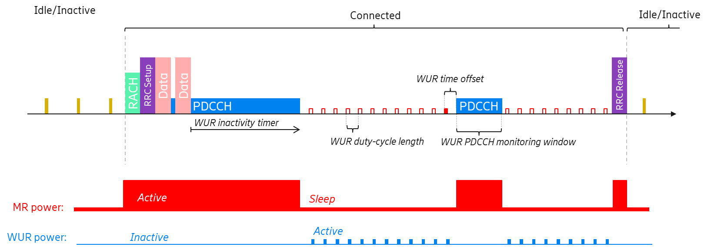

Figure 7.3.2.2-1: Example for 'Duty-cycled WUR' operation

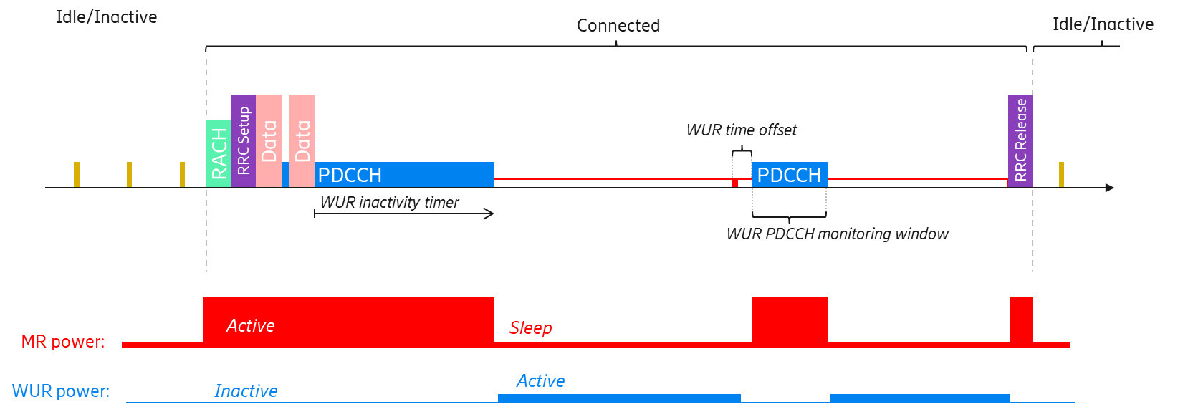

Figure 7.3.2.2-2: Example for 'Continuous WUR' operation

#### 7.3.2.3 LP-WUS use options

As described above, in order to save UE power consumption for PDCCH monitoring and guarantee the latency, the basic design is: when MR is in a sleep state, LR will remain active to monitor LP-WUS. When LP-WUS is received by LR, it will trigger the MR to wake up to monitor PDCCH.

The use of LP-WUS in RRC\_CONNECTED could be considered to replace the legacy methods, e.g. Short C-DRX, Long C-DRX, Rel-16 PDCCH-based WUS (DCP), Rel-17 PDCCH skipping, Rel-17 SSSG switching, etc. or be an enhancement thereof when configured, an example is Rel-16 PDCCH-based WUS is an enhancement on top of Long C-DRX. The detailed design for the use of LP-WUS could be in different directions as below, which is summarized in Table X.

Table 7.3.2.3-1: LP-WUS operation methods in RRC\_CONNECTED

|  |  |  |  |
| --- | --- | --- | --- |
| LP-WUS application | Details | Start PDCCH monitoring condition | Stop PDCCH monitoring condition |
| Direction 1: LP-WUS monitoring occasion is determined based on timer(s) related C-DRX | Option 1: similar to Rel-16 DCP, i.e. the LP-WUS monitoring occasion is located before *drx-onDurationTimer*. | If LP-WUS addressed to UE or UE's subgroup is detected and the legacy *drx-onDurationTimer* is started | It could follow legacy, i.e. at expiration of a C-DRX timer, e.g. C-DRX *drx-OnDurationTimer* or when the UE receives Rel-17 PDCCH skipping indication (if supported and configured). |
| Option 2: the LP-WUS monitoring occasion is located at any time outside DRX active time to indicate UE to enter into active time | If LP-WUS addressed to UE or UE's subgroup is detected |
| Direction 2: LP-WUS monitoring occasion is not determined based on timer(s) related C-DRX | Option 4: the LP-WUS monitoring occasion is located at any time regardless of whether DRX is configured or not. |
| Direction 3: LP-WUS is transparent to current MAC operation | The LP-WUS monitoring occasion should be determined based on physical layer design/restriction.  This direction may not have any impact on MAC. | N/A | N/A |

Note: The above directions/solutions are NOT Mutually Exclusive absolutely, e.g. some overlap may exist between direction 3 and direction 2, or between option 2 and option 4, based on the detailed design for each direction/option. The detailed design would be further determined in WI, if included.

In direction 1 above, LP-WUS is used in conjunction with C-DRX. LP-WUS could be configured outside the DRX active time with either of the following two options.

- Same function as Rel-16 DCP to indicate whether to start the next *drx-onDurationTimer* (i.e. option 1 above)

- To indicate UE to enters into active time for PDCCH monitoring (i.e. option 2 above)

Some examples for different options in direction 1 are shown as illustrated in the below figures.

For option 1: LP-WUS is used similar as Rel-16 DCP, an example is shown as below (note that a longer time offset may likely have to be applied to cover the MR transition time compared to DCP):



Figure 7.3.2.3-1: Example for option 1

For option 2: LP-WUS could be used at any time outside C-DRX active time to indicate UE to enter into active time, different examples for both 'duty-cycled' and 'continuous' mode are shown as below:



Figure 7.3.2.3-2: Example for option 2 with 'duty-cycled' LP-WUS



Figure 7.3.2.3-3: Example for option 2 with 'continuous' LP-WUS

In direction 2 above, LP-WUS is used in conjunction with C-DRX as the direction 1 or without C-DRX. In the latter case, the LP-WUS is used to indicate UE to activate/resume PDCCH monitoring. Some other solutions used to indicate UE to stop the PDCCH monitoring should be used in conjunction with LP-WUS, e.g. Rel-17 PDCCH monitoring adaptation.

For option 4: LP-WUS could be used at any time regardless of whether C-DRX is configured or not, different examples for both 'duty-cycled' and 'continuous' mode are shown as below:



Figure 7.3.2.3-4: Example for option 4 with 'duty-cycled' LP-WUS



Figure 7.3.2.3-5: Example for option 4 with 'continuous' LP-WUS

In direction 3, the detailed design should be determined based on physical layer design/restriction.

The corresponding pros/cons for the above options on LP-WUS using in RRC\_CONNECTED are summarized in the below table.

Table 7.3.2.3-2: Pros and Cons of LP-WUS using options in RRC\_CONNECTED

|  |  |  |
| --- | --- | --- |
| LP-WUS options | Pros | Cons |
| Option 1: LP-WUS is used similar as Rel-16 DCP | More Power Saving gain is expected compared to legacy DCP due to the difference on power consumption between LP-WUS monitor and PDCCH monitor;  Less specification impact and complexity from reuse of DCP functionality compared to other solutions, e.g. option 2 option 3. | It would result in having redundant mechanism for the same purpose.  Artificially limiting WUR duty-cycle to the C-DRX cycle length (can easily be avoided using separate configuration parameters). |
| Option 2: LP-WUS could be used at any time outside C-DRX active time to indicate UE to enter into active time | Power saving gain is excepted compared to current C-DRX mechanism.  LP-WUS configuration is more flexible than option 1 and option 3, e.g. since WUR duty-cycle is not locked to C-DRX cycle;  If a shorter WUR duty-cycle is compared to a longer C-DRX cycle, or continuous mode is used, DL data transmission latency could be reduced compared to C-DRX mechanism and option 1 by not limiting the DL data transmission to a C-DRX onDuration. | More complexity: how to coexist with current C-DRX mechanism;  More specification impacts: new PDCCH monitoring mechanism needs to be captured, e.g. separate WUR duty-cycle (different from C-DRX cycle), and WUR-specific on-duration timer for PDCCH monitoring must be introduced. |
| [Option 3: LP-WUS could be used after the beginning of *drx-onDurationTimer*] | Power Saving gain is expected by reducing unnecessary PDCCH monitoring for XR traffic than legacy C-DRX if there is one-stream XR traffic with a non-changing fps which can be matched by the DRX cycle. | More specification impacts considering it may change the current PDCCH monitoring behaviour  Given the ramp-up time from micro/deep sleep, it may be useable in the limited cases, e.g., long *drx-onDurationTimer*. |
| Option 4: LP-WUS could be used at any time regardless of whether C-DRX is configured or not | Power Saving gain is expected compared to current C-DRX mechanism and DCP since LP-WUS monitoring consumes less power than PDCCH monitoring;  LP-WUS configuration is more flexible than other options above;  DL data transmission latency could be reduced compared to current C-DRX mechanism. | More complexity: we need to discuss how to stop the PDCCH monitoring and how to configure the LP-WUS; |

#### 7.3.2.4 Configuration

A UE is expected to be configured with LP-WUS/WUR in RRC\_CONNECTED mode, e.g. upon RRC connection establishment, i.e., either during RRC Connection Setup or RRC Connection Resumption. Therefore, UE specific LP-WUS/WUR configuration is possible in RRC\_CONNECTED mode.

The time gap between the LP-WUS monitoring occasion and the PDCCH monitoring occasion for MR must be designed or configured long enough to cover the transition time of the MR to be ready for PDCCH monitoring. Another alternative is similar to Rel-15 WUS for NB-IoT/LTE-M, different transition time gaps, if introduced, could be defined as UE capability. Then, gNB could, based on this capability, know which time gap to configure for the UE (which if, several sleep states are supported, lets the UE to determine the MR sleep state to apply).

For partial LP-SS/LP-WUS coverage in the cell, LP-WUS should only be configured/used for a UE within LP-SS/LP-WUS coverage:

- In one solution, the coverage determination is similar as in RRC\_IDLE/INACTIVE, which is based on the measurement of LR and/or MR, and the corresponding threshold determined/configured by network. Furthermore, when UE moves out of LP-WUS coverage, LP-WUS cannot be used at the UE, as it is unreachable by the gNB for LP-WUS. It should be either released or de-activated by the network. Otherwise, some conditions would have to be introduced to ensure the UE could autonomously fall back to legacy operation without LP-WUS.

- In another solution, monitoring LP-WUS can be explicitly activated and de-activated by the network, e.g., entry/exit condition(s) of using LP-WUS may not be needed.

Meanwhile, for full LP-SS/LP-WUS coverage in the cell, no special configuration would be required. That is, LP-WUS could be configured/activated for a UE in the cell, and not used when it is released/de-activated in the cell.

According to above analysis, LP-WUS in RRC\_CONNECTED with partial LP-WUS coverage is expected to have more standardization impacts than the scenario with full LP-WUS coverage.

#### 7.3.2.5 LP-WUS coexistence with DCP

On one hand, LP-WUS could be configured together with Rel-16 DCP for a specific UE. However, the UE may only use one of them at any time, e.g. depend on the network configuration or link quality, etc. It should be noted that this operation is more useful for the partial LP-SS/LP-WUS coverage as described in 7.3.2.4. For example, for partial LP-SS/LP-WUS coverage, when the UE is in LP-SS/LP-WUS coverage, UE could monitor LP-WUS autonomously or UE could monitor LP-WUS if the gNB activate the LP-WUS monitoring. When UE moves out of LP-SS/LP-WUS coverage, the measurement quality of LP-SS via LR is not good enough, UE could consider to use Rel-16 DCP as in legacy in this case.

On the other hand, the LP-WUS could be used in conjunction with Rel-16 DCP. That is, the UE firstly monitor LP-WUS and, in case the MR is waked up by the LP-WUS, then, the UE will continue to monitor DCP.

## 7.4 RAN4 RRM study

This clause captures the outcome of RAN4 review on RRM aspects for LP-WUR during SI phase.

RAN4 confirms that the evaluation methodology by RAN1 in TR38.869 for serving cell RSRP/RSRQ measurement offloading to LP-WUR for IDLE/INACTIVE mode is reasonable for SI phase.

- The evaluation methodology refers to the consideration of SNR side conditions, number of measurement samples and measurement accuracy.

- In addition, in RAN4, RF impairment margin is considered.

RAN4 understands that the determination of SNR target for serving cell RSRP/RSRQ measurement offloading to LP-WUR should consider at least the NF difference between LP-WUR and MR and the applicable coverage conditions of LP-WUR.

# 8 Evaluation results

## 8.1 Power and latency evaluation

### 8.1.1 RRC IDLE/INACTIVE mode

The following '**Effective per UE paging arrival rate (i.e., Reff)**' is defined as (without taking FAR into account)

- Per UE paging probability RE if LP-WUS is per UE paging

- Per group paging probability RG = 1 – (1 – RE)N, if LP-WUS is per group paging (N is the number of UEs in the group)

The following names are used,

- Effective per UE paging arrival rate

- the period for complete an on-and-off cycle for LP-WUS duty-cycled monitoring,

- the active time for monitoring LP-WUS every cycle for LP-WUS duty-cycled monitoring

- LP-WUR duty cycle ratio = **D/T**

**-** LP-WUR on state power

**-** LP-WUR off state power

#### 8.1.1.1 Duty cycled LP-WUS

In this clause, duty cycled LP-WUS is studied and compared to I-DRX cases. In addition, the following is assumed,

- no RRM measurement performed by MR or LR, or RRM measurement offloaded to LR or MR RRM relaxed at least 8 times of I-DRX cycle

- MR in ultra-deep sleep if no traffic is arrival

- MR ramp-up time, transition energy = 400ms, 15000unit,

- I-DRX cycle = 1.28s

- FAR <=1% (0%, 0.001%, 0.1%, 1%)

##### 8.1.1.1.1 Collection of the results

8.1.1.1.1.1 LR (PWURON, R, FAR) = (<10unit, <=1%, <=1%)

I-DRX cycle = 1.28s, LP-WUR on state power <10unit, LP-WUR duty cycle ratio <=1%, FAR <=1% (0%, 0.001%, 0.1%, 1%)

Figure 8.1.1.1-1

Note1: The results combine different LP-WUR(ON, OFF) power values. And detailed simulated combinations can be seen in Table 8.1.1.3-1

Note2: [8A-12] assumes MR ramp-up time, transition energy is 100ms, 2000unit(not aligned with agreed assumption)

Note3: WUS monitoring duration is assumed as follows:

- [8A-16](2ms)/ [8A-11](2ms)/ [8A-17](1ms)/ [8A-9] (1ms)/ [8A-3] (1/1.5/2.5ms)/ [8A-12] (1.26ms)/ [8A-8] (1.28ms)/ [8A-7] (0.25) assume very short WUS monitoring duration.

- [8A-11](12.8ms)/ [8A-10](8ms)/ [8A-1] (10ms)/ [8A-5] (10ms)/ [8A-15] (6/9/10/12ms)/ [8A-8] (12.8ms)/ [8A-3] (6/10/13ms)/ [8A-4] (13ms)/ [8A-13] (10ms) assume long WUS monitoring duration.

Note4: FAR is assumed as follows:

- FAR = 0 is simulated by [8A-3], [8A-11], [8A-8], [8A-5]

- FAR = 0.001% is simulated by [8A-12, [8A-15]]

- FAR = 0.1% is simulated by [8A-3], [8A-4], [8A-17], [8A-11], [8A-13], [8A-16], [8A-8]

- FAR = 1% is simulated by [8A-3], [8A-4], [8A-17], [8A-11], [8A-13], [8A-1], [8A-10], [8A-16], [8A-8], [8A-7]

Note5: All the possible values for LP-WUR ON power < 10 are mixed together, further split is shown in clause 8.1.1.3

8.1.1.1.1.2 LR (PWURON, R, FAR) = (<10unit, (1%,5%], <=1%)

I-DRX cycle = 1.28s, LP-WUR on state power <10unit, 1%< LP-WUR duty cycle ratio <=5%, FAR <=1% (0.001%, 0.1%, 1%)

Figure 8.1.1.1-2

Note1: The results combine different LP-WUR(ON, OFF) power values. And detailed simulated combinations can be seen in Table 8.1.1.3-1

Note2: FAR is assumed as follows:

- FAR = 0.001% is simulated by [8A-15]

- FAR = 0.1% is simulated by [8A-3]

- FAR = 1% is simulated by [8A-7]

Note3: All the possible values for LP-WUR ON power < 10 are mixed together, further split is shown in clause 8.1.1.3

Note 4: Results with duty cycle ratio 5~30% are provided by [8A-3], [8A-5], [8A-8], [8A-11], and included in the spread sheet for power evaluation

8.1.1.1.1.3 LR (PWURON, R, FAR) = (>=10unit, <=1%, <=1%)

I-DRX cycle = 1.28s, LP-WUR on state power >=10unit, LP-WUR duty cycle ratio <=1%, FAR <=1% (0%, 0.001%, 0.1%, 1%)

Figure 8.1.1.1-3

Note1: The results combines different LP-WUR(ON, OFF) power values. And detailed simulated combinations can be seen in Table 8.1.1.3-1

Note2: WUS monitoring duration is assumed as follows:

- [8A-7](0.25ms)/ [8A-16] (2ms)/ [8A-8] (1.28/2.56ms)/ [8A-3] (1/1.5/2.5ms)/ [8A-11] (2ms)/ [8A-9] (1ms)/ [8A-10] (2ms) assume very short WUS monitoring duration.

- [8A-15](6/9/10/12ms)/ [8A-8](6.4/12.8ms)/ [8A-3] (6/10ms)/ [8A-11] (12.8ms)/ [8A-1] (10ms)/ [8A-13] (10ms) assume long WUS monitoring duration.

Note3: FAR is assumed as follows:

- FAR = 0 is simulated by [8A-3], [8A-11], [8A-8]

- FAR = 0.001% is simulated by [8A-15]

- FAR = 0.1% is simulated by [8A-3], [8A-9], [8A-11], [8A-13], [8A-16], [8A-8]

- FAR = 1% is simulated by [8A-3], [8A-11], [8A-13], [8A-1], [8A-10], [8A-16], [8A-8], [8A-7]

Note4: all the possible values for LP-WUR ON power > 10 are mixed together, further split is shown in clause 8.1.1.3

8.1.1.1.1.3 Latency

I-DRX cycle = 1.28s, LP-WUR duty cycle ratio <=1%, effective per UE paging arrival rate <=8%

Figure 8.1.1.1-4: Legacy PO

Note: [8A-5] assumes UE-specific indication and therefore latency is the time interval between data arrival at the gNB until the UE finish sync/re-sync for MR, while other companies assume latency is the time interval between data arrival at the gNB until the first PO that UE can monitor for paging message.

Figure 8.1.1.1-5: Dynamic PO

Note: [8A-13] assumes LP-WUS duty cycle is 1280ms.

Note: [8A-8] assumes the effective monitoring periodicity for LP-WUS is 128ms.

Note: [8A-11] assumes LP-WUS duty cycle is 200ms

##### 8.1.1.1.2 Observations

For duty-cycled LP-WUS monitoring, the following observations are made with the assumption that

- no RRM measurement performed by MR or LR, or RRM measurement offloaded to LR or MR RRM relaxed at least 8 times of I-DRX cycle

- MR in ultra-deep sleep if no traffic is arrival

- MR ramp-up time, transition energy = 400ms, 15000unit,

- I-DRX cycle = 1.28s

- FAR <=1% (0%, 0.001%, 0.1%, 1%)

- effective per UE paging arrival rate <=8%

1) For WUR ON power < 10unit (i.e., 0.01/0.05/0.1/0.5/1/2/4 unit) with no more than duty cycle ratio 1%

- Effective per UE paging arrival rate<=1%

- Results in [8A-1], [8A-3], [8A-4], [8A-5], [8A-7], [8A-8], [8A-9], [8A-10], [8A-11], [8A-12], [8A-13], [8A-15], [8A-16], [8A-17] show that compared with i-DRX with or without PEI, LP-WUS provides mean power saving gain (average: 77%, range: 30%~97%)

- 1%<Effective per UE paging arrival rate <=8%

- Results in [8A-1], [8A-3], [8A-5], [8A-8], [8A-10] show that compared with i-DRX with or without PEI, LP-WUS provides mean power saving gain (average: 69%, range: 53%~83%)

2) For WUR ON power < 10unit (i.e., 0.01/0.05/0.1/0.5/1/2/4 unit) with duty cycle ratio between 1% and 5%

- Effective per UE paging arrival rate<=1%

- Results in [8A-3], [8A-7], [8A-15] show that compared with i-DRX with or without PEI, LP-WUS provides mean power saving gain (average: 92%, range 87%~98%)

- 1%<Effective per UE paging arrival rate <=8%

- Results in [8A-3] show that compared with i-DRX with or without PEI, LP-WUS provides mean power saving gain (81%).

3) For WUR ON power>=10unit (i.e., 10/20/30 unit) with no more than duty cycle ratio 1%

- Effective per UE paging arrival rate <=1%

- Results in [8A-1], [8A-3], [8A-7], [8A-8], [8A-9], [8A-10], [8A-11], [8A-13], [8A-15], [8A-16] show that compared with i-DRX with or without PEI, LP-WUS provides mean power saving gain (average: 62%, range: -13%~95%)

- 1%<Effective per UE paging arrival rate <=8%

- Results in [8A-1], [8A-3], [8A-8], [8A-10], [8A-15] show that compared with i-DRX with or without PEI, LP-WUS provides mean power saving gain (average: 63%, range: 42%~81%)

4) For latency

- Legacy PO

- Results in [8A-1], [8A-4], [8A-5], [8A-7], [8A-8], [8A-11], [8A-15], [8A-17] show that compared with i-DRX with or without PEI mean paging latency (0.638~0.768) second, LP-WUS will result in mean paging latency (1.022~1.264) second, which increases mean paging latency (52%~98%)

- Results in [8A-3], [8A-10], [8A-13], [8A-16] show that compared with i-DRX with or without PEI paging latency, LP-WUS will result in mean paging latency (1.053~1.909) second without baseline i-DRX latency.

- Dynamic PO

- Results in [8A-8], [8A-11] show that compared with i-DRX with or without PEI mean paging latency (0.638~0.687) second, LP-WUS will result in mean paging latency (0.568~0.599) second, which decreases mean paging latency (6%~17%)

- Results in [8A-13] show that compared with i-DRX with or without PEI paging latency, LP-WUS will result in mean paging latency (1.08) second without baseline i-DRX latency.

#### 8.1.1.2 Continuous monitoring results and results with duty cycle ratio = 50% LP-WUS

In this clause, continuous monitoring of LP-WUS and LP-WUS monitoring with duty cycle ratio of 50% are studied and the following is assumed,

- Continuous monitoring results and results with duty cycle ratio = 50% LP-WUS comparing with I-DRX is as baseline

- FAR target is determined across a reference time duration T of multiple LP-WUS attempts/trials.

- no RRM measurement performed by MR or LR, or RRM measurement offloaded to LR or MR RRM relaxed at least 8 times of I-DRX cycle

- MR in ultra-deep sleep if no traffic is arrival

- MR ramp-up time, transition energy = 400ms, 15000unit

- I-DRX cycle = 1.28s

- FAR<=1% (0%, 0.001%, 0.1%, 1%)

Table 8.1.1.2-1: FAR assumptions of different sources

|  |  |
| --- | --- |
| Sources | (FAR\_target, N, T) |
| [8A-2] | Not considered as FAR=0 |
| [8A-3] | (0.1%, 1, 5ms) |
| [8A-4] | N=1280, T=1.28s |
| [8A-5] | N=1500, T=1.28s |
| [8A-7] | (1%, 1, 1.28s) |
| [8A-8] | (0%, 1, 1.28s) / (1%, 1, 1.28s) |
| [8A-9] | (0.1%, 1280, 1.28s) |
| [8A-11] | (0.1%, 1, 1.28s) / (1%, 1, 1.28s) |
| [8A-13] | (0.1%, N=1~64, 1.28s) / (1%, N=1~64, 1.28s) |
| [8A-14] | (0, 1280, 1.28s) |
| [8A-15] | (0.001%, 1, 1ms) |
| [8A-16] | (0.1%, 1280, 1.28s) / (1%, 1280, 1.28s) |

##### 8.1.1.2.1 Collection of the results

8.1.1.2.1.1 LR (PWURON, FAR) = (<= 1unit, <=1%)

I-DRX cycle = 1.28s, T = I-DRX cycle, LP-WUR on state power <=1unit, FAR<=1% (0%, 0.001%, 0.1%, 1%)

Figure 8.1.1.2-1

Note1: The results tagged with [8A-2](1) are for LP-WUS UEs, and the results tagged with [8A-2](2) are for the system UEs which contain both LP-WUS UEs and legacy UEs who are unable to apply LP-WUS monitoring

Note2: For (FAR, N, T), [8A-3] assumes (T= 5ms, N=1), [8A-15] assumes (T=1ms, N=1), while other companies assume T = I-DRX cycle period, N value in (FAR, N, T) is summarized in table 8.1.1.2-1.

Note3: FAR is assumed as follows:

- FAR = 0 is simulated by [8A-2], [8A-5], [8A-11], [8A-8], [8A-14]

- FAR = 0.001% is simulated by [8A-15]

- FAR = 0.1% is simulated by [8A-3], [8A-4], [8A-5], [8A-17], [8A-9], [8A-11], [8A-13], [8A-16]

- FAR = 1% is simulated by [8A-4], [8A-5], [8A-17], [8A-11], [8A-13], [8A-7], [8A-16], [8A-8]

8.1.1.2.1.2 LR (PWURON, FAR) = ( > 1unit, <=1%)

I-DRX cycle = 1.28s, T = I-DRX, LP-WUR on state power >1unit, FAR<=1% (0% , 0.1%, 1%)

Figure 8.1.1.2-2

Note1: FAR is assumed as follows:

- FAR = 0 is simulated by [8A-5, [8A-11], [8A-8], [8A-14]]

- FAR = 0.1% is simulated by [8A-4], [8A-17], [8A-9], [8A-11], [8A-16]

- FAR = 1% is simulated by [8A-4], [8A-17], [8A-11], [8A-16], [8A-8]

Note2: For (FAR, N, T), [8A-3] assumes (T= 5ms, N=1), [8A-15] assumes (T=1ms, N=1), while other companies assume T = I-DRX cycle period, N value in (FAR, N, T) is summarized in table 8.1.1.2-1.

8.1.1.2.1.3 Latency

I-DRX cycle = 1.28s, T = I-DRX cycle, effective per UE paging arrival rate <=8%

Figure 8.1.1.2-3: Legacy PO

Note: [8A-5] assumes UE-specific indication and therefore latency is the time interval between data arrival at the gNB until the UE finish sync/re-sync for MR, while other companies assume latency is the time interval between data arrival at the gNB until the first PO that UE can monitor for paging message.

Figure 8.1.1.2-4: Dynamic PO

##### 8.1.1.2.2 Observations

For continuous and duty cycle ratio = 50% based LP-WUS monitoring, the following observations are made with the assumption that

- I-DRX cycle = 1.28s

- T = I-DRX cycle

- MR ramp-up time, transition energy = 400ms, 15000unit

- no RRM measurement performed by MR or LR, or RRM measurement offloaded to LR or MR RRM relaxed at least 8 times of I-DRX cycle

- MR in ultra-deep sleep.

- FAR<=1% (0%, 0.001%, 0.1%, 1%)

- effective per UE paging arrival rate <=8%

1) For WUR ON power <=1unit

- Effective per UE paging arrival rate <=1%

- Results in [8A-2], [8A-4], [8A-5], [8A-7], [8A-8], [8A-9], [8A-11], [8A-13], [8A-14], [8A-15], [8A-16], [8A-17] show that compared with i-DRX with or without PEI, LP-WUS provides mean power saving gain (average: 61.5%, range: 21%~97%, which assumes FAR reference timeT= 1280ms.

- Results in [8A-3] show that compared with i-DRX with or without PEI, LP-WUS provides mean power saving gain (-12%) which assumes FAR reference timeT= 5ms.

- 1%<Effective per UE paging arrival rate <=8%

- Results in [8A-8], [8A-15] show that compared with i-DRX with or without PEI, LP-WUS provides mean power saving gain (average:58%, range: 45%~72%)

2) For WUR ON power >1unit

- Effective per UE paging arrival rate <=1%

- Results in [8A-4], [8A-5], [8A-8], [8A-9], [8A-11], [8A-14], [8A-16], [8A-17] show that compared with i-DRX with or without PEI, LP-WUS provides mean power saving gain (average: -248.5%, range: -674%~-61%)

- 1%<Effective per UE paging arrival rate <=8%

- Results in [8A-8] show that compared with i-DRX with or without PEI, LP-WUS provides mean power saving gain (-778%).

3) For latency (LP-WUS Continuous monitoring results and results with duty cycle ratio=50%)

- Legacy PO

- Results in [8A-4], [8A-7], [8A-8], [8A-11], [8A-14],[8A-15], [8A-17 show that compared with i-DRX with or without PEI mean paging latency (0.637~0.768) second, LP-WUS will result in mean paging latency (0.902~1.189) second, which increases mean paging latency (34%~91%)

- Results in [8A-5] show that compared with i-DRX with or without PEI mean paging latency (0.67) second, LP-WUS will result in mean paging latency (0.571) second, which decreases mean paging latency (15%) by one company. This company assumes UE-specific indication and therefore latency is the time interval between data arrival at the gNB until the UE finishes sync/re-sync for MR.

- Results in [8A-3], [8A-13], [8A-16] show that compared with i-DRX with or without PEI paging latency, LP-WUS will result in mean paging latency (1.053~1.382) second without baseline i-DRX latency.

- Dynamic PO

- Results in [8A-5], [8A-11] show that compared with i-DRX with or without PEI mean paging latency (0.637~0.67) second, LP-WUS will result in mean paging latency (0.42~0.5) second, which decreases mean paging latency (22%~37%)

- Results in [8A-13] show that compared with i-DRX with or without PEI paging latency, LP-WUS will result in mean paging latency (0.45) second without baseline i-DRX latency.

#### 8.1.1.3 Various LP-WUR relative power for duty-cycled monitoring

In this clause, various relative (ON, OFF) power of LP-WUR is compared and I-DRX is as baseline. In addition, the following is assumed,

- no RRM measurement performed by MR or LR, or RRM measurement offloaded to LR or MR RRM relaxed at least 8 times of I-DRX cycle

- MR in ultra-deep sleep if no traffic is arrival

- MR ramp-up time, transition energy = 400ms, 15000unit

- I-DRX cycle = 1.28s

The table summarizes the simulated combinations of LP-WUR ON and OFF power. In each combination 'X' in 'y(X)' stands for the number of simulated cases.

Table 8.1.1.3-1: Simulated combinations for LP-WUR (ON, OFF) power values

|  |  |  |  |  |  |  |  |  |  |  |  |  |  |  |  |  |  |  |  |  |  |  |  |  |  |  |  |  |  |  |  |  |  |  |  |  |  |  |
| --- | --- | --- | --- | --- | --- | --- | --- | --- | --- | --- | --- | --- | --- | --- | --- | --- | --- | --- | --- | --- | --- | --- | --- | --- | --- | --- | --- | --- | --- | --- | --- | --- | --- | --- | --- | --- | --- | --- |
| **ON Power value** | **0.01** | | | **0.05** | | | **0.1** | | | **0.2** | | | **0.5** | | | **1** | | | | **2** | | | **4** | | | | | **10** | | | | | **20** | | | **30** | | |
| **OFF Power value** | **0.001** | **0.02** | **0.1** | **0.001** | **0.02** | **0.1** | **0.001** | **0.02** | **0.1** | **0.001** | **0.02** | **0.1** | **0.001** | **0.02** | **0.1** | **0.001** | **0.01** | **0.02** | **0.1** | **0.001** | **0.02** | **0.1** | **0.001** | **0.01** | **0.02** | **0.05** | **0.1** | **0.001** | **0.01** | **0.02** | **0.05** | **0.1** | **0.001** | **0.02** | **0.1** | **0.001** | **0.02** | **0.1** |
| **[8A-1]** |  |  |  |  |  |  | Y |  |  |  |  |  |  |  |  | Y |  |  |  |  |  |  | Y |  | Y |  | Y | Y |  |  |  |  |  |  |  |  |  |  |
| **[8A-3]** |  |  |  |  |  |  |  |  |  |  |  |  | Y |  |  |  |  |  |  |  |  |  | Y | Y |  | Y |  | Y | Y |  | Y |  |  |  |  |  |  |  |
| **[8A-4]** | Y |  |  | Y |  |  | Y |  |  |  |  |  | Y |  |  | Y |  |  |  | Y |  |  | Y |  |  |  |  |  |  |  |  |  |  |  |  |  |  |  |
| **[8A-5]** |  |  |  |  |  |  | Y |  |  |  |  |  |  |  |  | Y |  |  |  |  |  |  | Y |  |  |  |  |  |  |  |  |  |  |  |  |  |  |  |
| **[8A-17]** | Y |  |  |  |  |  | Y |  |  |  |  |  | Y |  |  | Y |  |  |  |  |  |  | Y |  |  |  |  |  |  |  |  |  |  |  |  |  |  |  |
| **[8A-7]** |  |  |  |  |  |  |  | Y |  |  |  |  |  |  |  |  |  |  |  |  |  |  |  |  | Y |  |  |  |  | Y |  |  |  |  |  |  |  |  |
| **[8A-15]** |  |  |  |  |  |  |  |  |  |  |  |  |  |  |  |  |  |  |  |  |  |  | Y |  |  |  |  |  | Y |  |  |  |  |  |  |  |  |  |
| **[8A-9]** | Y | Y | Y | Y | Y | Y | Y | Y | Y | Y | Y | Y | Y | Y | Y | Y |  | Y | Y | Y | Y | Y | Y |  | Y |  | Y | Y |  | Y |  | Y | Y | Y | Y | Y | Y | Y |
| **[8A-16]** |  |  |  |  |  |  |  |  |  |  |  |  | Y | Y | Y | Y |  | Y | Y |  |  |  | Y |  | Y |  | Y | Y |  | Y |  | Y | Y | Y | Y | Y | Y | Y |
| **[8A-8]** | Y |  |  | Y |  |  | Y |  |  |  |  |  | Y | Y |  | Y |  |  |  | Y |  |  | Y |  |  |  |  |  |  |  |  |  | Y |  |  |  |  | Y |
| **[8A-12]** |  |  |  |  |  |  | Y |  |  |  |  |  |  |  |  |  |  |  |  |  |  |  |  |  |  |  |  |  |  |  |  |  |  |  |  |  |  |  |
| **[8A-10]** | Y |  |  |  |  |  |  |  |  |  |  |  | Y |  |  |  | Y | Y |  |  |  |  |  | Y | Y |  |  |  |  |  |  | Y |  |  |  |  |  | Y |
| **[8A-11]** | Y |  |  |  |  |  | Y |  |  |  |  |  |  |  |  | Y |  |  |  |  |  |  |  |  |  |  |  | Y |  | Y |  | Y |  | Y | Y |  |  |  |
| **[8A-13]** | Y |  |  |  |  |  |  |  |  |  |  |  | Y |  |  | Y |  |  |  |  |  |  |  |  |  |  |  |  |  | Y |  | Y |  |  |  |  | Y | Y |

##### 8.1.1.3.1 Collection of the results

8.1.1.3.1.1 LR (FAR, Reff, R) = (<=0.1%, <=0.1%, <=1%)

I-DRX cycle = 1.28s, Effective per UE paging arrival rate <=0.1% , LP-WUR duty cycle ratio <=1%, FAR<=0.1% (0%, 0.001%, 0.1%)

Figure 8.1.1.3-1

Note1: [8A-12] assumes MR ramp-up time, transition energy is 100ms, 2000unit(not aligned with agreed assumption)

Note2: WUS monitoring duration is assumed as follows:

- [8A-7](0.25ms)/ [8A-16](2ms) /[8A-11](2ms)/ [8A-3] (1/1.5/2.5ms)/ [8A-17] (1ms)/ [8A-12] (1.26ms) assume very short WUS monitoring duration.

- [8A-3](6/10/13ms)/ [8A-11] (12.8ms)/ [8A-13] (10ms)/ [8A-4] (13/38ms) assume long WUS monitoring duration.

Note3: FAR is assumed as follows:

- FAR = 0 is simulated by [8A-3], [8A-11]

- FAR = 0.001% is simulated by [8A-12][8A-15]

- FAR = 0.1% is simulated by [8A-3], [8A-4], [8A-17], [8A-11], [8A-13], [8A-16]

8.1.1.3.1.2 LR (FAR, Reff, R) = (<=1%, (0.1%,1%], <=1%)

I-DRX cycle = 1.28s, 0.1%< Effective per UE paging arrival rate <=1% , LP-WUR duty cycle ratio <=1%, FAR<=1% (0%, 0.001%, 0.1%, 1%)

Figure 8.1.1.3-2

Note1: [8A-12] assumes MR ramp-up time, transition energy is 100ms, 2000unit(not aligned with agreed assumption)

Note2: WUS monitoring duration is assumed as follows:

- [8A-7](0.25ms)/ [8A-3] (1/1.5/2.5ms)/ [8A-16] (2ms)/ [8A-10] (2ms) /[8A-11] (2ms)/ [8A-17] (1ms)/ [8A-8] (1.28ms)/ [8A-9] (1ms) assume very short WUS monitoring duration.

- [8A-8](12.8ms)/ [8A-3](6/10/13ms)/ [8A-11] (12.8ms)/ [8A-1](10ms)/ [8A-13](10ms)/ [8A-10] (8ms)/ [8A-4] (13/38ms)/ [8A-5] (10ms) assume long WUS monitoring duration.

Note3: FAR is assumed as follows:

- FAR = 0 is simulated by [8A-3], [8A-5], [8A-11], [8A-8]

- FAR = 0.001% is simulated by [8A-12], [8A-15]

- FAR = 0.1% is simulated by [8A-3], [8A-4], [8A-17], [8A-9], [8A-11], [8A-13], [8A-16], [8A-8]

- FAR = 1% is simulated by [8A-3], [8A-4], [8A-17], [8A-11], [8A-13], [8A-10], [8A-1], [8A-7], [8A-16], [8A-8]

8.1.1.3.1.3 LR (FAR, Reff, R) = (<=0.1%, <=0.1%, (1%,10%])

I-DRX cycle = 1.28s, Effective per UE paging arrival rate <=0.1% , 1%<LP-WUR duty cycle ratio <=10%, FAR<=0.1% (0%, 0.001%, 0.1%)

Figure 8.1.1.3-3

Note: FAR is assumed as follow:

- FAR = 0 is simulated by [8A-11]

- FAR = 0.001% is simulated by [8A-15]

- FAR = 0.1% is simulated by [8A-3], [8A-11]

8.1.1.3.1.4 LR (FAR, Reff, R) = (<=1%, (0.1%,1%], (1%,10%] )

I-DRX cycle = 1.28s, 0.1%< Effective per UE paging arrival rate <=1%, 1%<LP-WUR duty cycle ratio <=10%, FAR <=1% (0%, 0.001%, 0.1%, 1%)

Figure 8.1.1.3-4

Note: FAR is assumed as follows:

- FAR = 0 is simulated by [8A-11], [8A-8]

- FAR = 0.001% is simulated by [8A-15]

- FAR = 0.1% is simulated by [8A-3], [8A-11]

- FAR = 1% is simulated by [8A-11], [8A-7]

##### 8.1.1.3.2 Observations

For various relative power of LP-WUR, the following observations are made with the assumption that

- I-DRX cycle = 1.28s

- MR ramp-up time, transition energy = 400ms, 15000unit

- no RRM measurement performed by MR or LR, or RRM measurement offloaded to LR or MR RRM relaxed at least 8 times of I-DRX cycle

- MR in ultra-deep sleep.

Observations:

1) For (FAR, Effective per UE paging arrival rate, duty cycle ratio) = (<=0.1%, <=0.1%, <=1%)

- WUR ON power <=1unit

- Results in [8A-3], [8A-4], [8A-11], [8A-12], [8A-13], [8A-16], [8A-17] show that compared with i-DRX with or without PEI, LP-WUS provides UE mean power saving gain 57%~99% (average 80%), corresponding to 1%~43% (average 20%) of UE power consumption in legacy I-DRX operation

- 2unit<= WUR ON power <=4unit

- Results in [8A-3], [8A-4], [8A-15], [8A-16], [8A-17] show that compared with i-DRX with or without PEI, LP-WUS provides UE mean power saving gain 55%~97% (average 83%), corresponding to 3%~45% (average 17%) of UE power consumption in legacy I-DRX operation.

- 5unit<= WUR ON power <=10unit

- Results in [8A-3], [8A-11], [8A-13], [8A-16] show that compared with i-DRX with or without PEI, LP-WUS provides UE mean power saving gain 29%~95% (average 66%), corresponding to 5%~71% (average 34%) of UE power consumption in legacy I-DRX operation.

- 20unit<= WUR ON power <=30unit

- Results in [8A-11], [8A-13], [8A-16] show that compared with i-DRX with or without PEI, LP-WUS provides UE mean power saving gain -79%~86% (average 16%), corresponding to 14%~179% (average 84%) of UE power consumption in legacy I-DRX operation.

2) For (FAR, Effective per UE paging arrival rate, duty cycle ratio) = (<=1%, (0.1%,1%], <=1%)

- WUR ON power <=1unit

- Results in [8A-1], [8A-3], [8A-4], [8A-5], [8A-8], [8A-9], [8A-10], [8A-11], [8A-12], [8A-13], [8A-16], [8A-17] show that compared with i-DRX with or without PEI, LP-WUS provides UE mean power saving gain 31%~91% (average 74%), corresponding to 9%~69% (average 26%) of UE power consumption in legacy I-DRX operation.

- 2unit<= WUR ON power <=4unit

- Results in [8A-1], [8A-3], [8A-4], [8A-5], [8A-7], [8A-8], [8A-9], [8A-10], [8A-15], [8A-17] show that compared with i-DRX with or without PEI, LP-WUS provides UE mean power saving gain 30%~94% (average 72%), corresponding to 6%~70% (average 28%) of UE power consumption in legacy I-DRX operation.

- 5unit<= WUR ON power <=10unit

- Results in [8A-1], [8A-3], [8A-7], [8A-9], [8A-10], [8A-11], [8A-13], [8A-15], [8A-16] show that compared with i-DRX with or without PEI, LP-WUS provides UE mean power saving gain 40%~92% (average 69%), corresponding to 8%~60% (average 31%) of UE power consumption in legacy I-DRX operation.

- 20unit<= WUR ON power <=30unit

- Results in [8A-8], [8A-9], [8A-10], [8A-11], [8A-13], [8A-16] show that compared with i-DRX with or without PEI, LP-WUS provides UE mean power saving gain -58%~63% (average 25%), corresponding to 37%~158% (average 75%) of UE power consumption in legacy I-DRX operation.

3) For (FAR, Effective per UE paging arrival rate, duty cycle ratio) = (<=0.1%, <=0.1%, (1%,10%])

- WUR ON power <=1unit

- Results in [8A-3], [8A-11] show that compared with i-DRX with or without PEI, LP-WUS provides UE mean power saving gain 84%~97% (average 90%), corresponding to 3%~16% (average 10%) of UE power consumption in legacy I-DRX operation.

- 2unit<= WUR ON power <=4unit

- Results in [8A-15] show that compared with i-DRX with or without PEI, LP-WUS provides UE mean power saving gain 85%, corresponding to 15% of UE power consumption in legacy I-DRX operation.

- 5unit<= WUR ON power <=10unit

- Results in [8A-11] show that compared with i-DRX with or without PEI, LP-WUS provides UE mean power saving gain 24%, corresponding to 76% of UE power consumption in legacy I-DRX operation.

- 20unit<= WUR ON power <=30unit

- Results in [8A-11] show that compared with i-DRX with or without PEI, LP-WUS provides UE mean power saving gain -34%, , corresponding to 134% of UE power consumption in legacy I-DRX operation

4) For (FAR, Effective per UE paging arrival rate, duty cycle ratio) = (<=1%, (0.1%,1%], (1%,10%])

- WUR ON power <=1unit

- Results in [8A-3], [8A-7], [8A-8], [8A-11] show that compared with i-DRX with or without PEI, LP-WUS provides UE mean power saving gain 68%~94% (average 84%), corresponding to 6%~32% (average 16%) of UE power consumption in legacy I-DRX operation.

- 2unit<= WUR ON power <=4unit

- Results in [8A-8], [8A-15] show that compared with i-DRX with or without PEI, LP-WUS provides UE mean power saving gain 81%~87%(average 84%), corresponding to 13%~19% (average 16%) of UE power consumption in legacy I-DRX operation.

- 5unit<= WUR ON power <=10unit

- Results in [8A-11], [8A-15] show that compared with i-DRX with or without PEI, LP-WUS provides UE mean power saving gain 1%~82%(average 41%), corresponding to 18%~99% (average 59%) of UE power consumption in legacy I-DRX operation.

- 20unit<= WUR ON power <=30unit

- Results in [8A-8], [8A-11] show that compared with i-DRX with or without PEI, LP-WUS provides UE mean power saving gain -63%~31%(average -16%), corresponding to 69%~163% (average 116%) of UE power consumption in legacy I-DRX operation.

#### 8.1.1.4 Compared with eDRX

In this clause, Duty cycled LP-WUS is compared to eDRX and eDRX is as baseline.

For eDRX, the effective paging rate is defined per Y\_REF, where Y\_REF =1.28s.

##### 8.1.1.4.1 Collection of the results

8.1.1.4.1.1 LP-WUS monitoring within PTW and legacy PO determination

- LP-WUR duty cycle ratio <=1%,

- no RRM measurement performed by MR or LR, or RRM measurement offloaded to LR or MR RRM relaxed at least 8 times of I-DRX cycle

- MR in ultra-deep sleep

Figure 8.1.1.4-1

Figure 8.1.1.4-2

Note: [8A-3] assumes eDRX cycle is 51.2/593.92s.

8.1.1.4.1.2 LP-WUS monitoring not restricted in PTW and dynamic PO determination

- LP-WUR duty cycle ratio <=1%,

- no RRM measurement performed by MR or LR, or RRM measurement offloaded to LR or MR RRM relaxed at least 8 times of I-DRX cycle

- MR in ultra-deep sleep

Figure 8.1.1.4-3

Figure 8.1.1.4-4

##### 8.1.1.4.2 Observations

For duty-cycled LP-WUS, comparing with eDRX, the following observations are made with the assumption that

- LP-WUR duty cycle ratio <=1%

- no RRM measurement performed by MR or LR, or RRM measurement offloaded to LR or MR RRM relaxed at least 8 times of I-DRX cycle

- MR in ultra-deep sleep.

Observations:

1) LP-WUS monitoring within PTW and legacy PO determination

- Effective per UE paging arrival rate <=1%

- Results in [8A-3], [8A-4], [8A-8], [8A-12], [8A-16] show that compared with eDRX, LP-WUS provide mean power saving gain (average: 67.5%, range: 28%~92%)

- Results in [8A-4], [8A-8] show that compared with eDRX mean paging latency (16.697~25.92) second, LP-WUS will result in mean paging latency (19.863~31.24) second, which increases mean paging latency (19%~21%)

- Results in [8A-3], [8A-16] show that compared with eDRX, LP-WUS will result in mean paging latency (42.679~161.73) second without baseline eDRX latency.

- 1%<Effective per UE paging arrival rate <=8%

- Results in [8A-8] show that compared with eDRX, LP-WUS provides mean power saving gain (75%).

- Results in [8A-8] show that compared with eDRX mean paging latency (16.927) second, LP-WUS will result in mean paging latency (16.953) second, which increases mean paging latency (0.2%)

2) LP-WUS monitoring is not restricted in PTW and dynamic PO determination

- Effective per UE paging arrival rate <=1%

- Results in [8A-7], [8A-8], [8A-11] show that compared with eDRX, LP-WUS provides mean power saving gain (average: 22%, range: 9%~58%)

- Results in [8A-7], [8A-8], [8A-11] show that compared with eDRX mean paging latency (16.927~28.192) second, LP-WUS will result in mean paging latency (0.566~1.035) second, which decreases mean paging latency (96%~98%) if LP-WUS monitoring and the corresponding paging monitoring after MR wake-up is performed not restricted within existing PTW of eDRX.

- 1%<Effective per UE paging arrival rate <=8%

- Results in [8A-8] show that compared with eDRX, LP-WUS provides mean power saving gain (-15%).

- Results in [8A-8] show that compared with eDRX mean paging latency (16.927) second, LP-WUS will result in mean paging latency (0.566) second, which decreases mean paging latency (97%).

#### 8.1.1.5 RRM for LP-WUR duty-cycled monitoring

In this clause, measurement performed by MR only and MR RRM relaxed X times and RRM offload to LR are studied for duty-cycled LP-WUS monitoring. In addition, the following is assumed,

- I-DRX cycle = 1.28s

- MR in ultra-deep sleep

- Effective per UE paging arrival rate <=1%

- LP-WUR duty cycle ratio <=1%

- MR ramp-up time, transition energy = 400ms, 15000unit

- FAR<=1% (0%, 0.001%, 0.1%, 1%)

##### 8.1.1.5.1 Collection of the results

8.1.1.5.1.1 LR (FAR, Reff, R) = (<=1%, <=1%, <=1%)

I-DRX cycle = 1.28s, Effective per UE paging arrival rate <=1% , LP-WUR duty cycle ratio <=1%, baseline: I-DRX, FAR<=1% (0%, 0.001%, 0.1%, 1%)

Figure 8.1.1.5-1

Note1: [8A-15] assumes that the MR is in deep sleep when there is no any MR RRM relaxation, while other companies assume MR ultra-deep sleep

Note2: [8A-12] assumes MR ramp-up time, transition energy is 100ms, 2000unit(not aligned with agreed assumption)

Note3: FAR is assumed as follows:

- FAR = 0 is simulated by [8A-3], [8A-11], [8A-8], [8A-5]

- FAR = 0.001% is simulated by [8A-12], [8A-15]

- FAR = 0.1% is simulated by [8A-3], [8A-4], [8A-17], [8A-11], [8A-13], [8A-16], [8A-8]

- FAR = 1% is simulated by [8A-3], [8A-17], [8A-1], [8A-10], [8A-16], [8A-8], [8A-7], [8A-4]

Note 4: Different LR measurement periodicity are used by companies

##### 8.1.1.5.2 Observations

For RRM with duty-cycled LP-WUS monitoring, the following observations are made with the assumption that

- I-DRX cycle = 1.28s

- MR in ultra-deep sleep

- Effective per UE paging arrival rate <=1%

- LP-WUR duty cycle ratio <=1%

- MR ramp-up time, transition energy = 400ms, 15000unit

- FAR<=1% (0%, 0.001%, 0.1%, 1%)

Observations:

1) For (Effective per UE paging arrival rate, LP-WUR on state power, FAR) = (<=1%, <=1unit, <=1%), compared with i-DRX, LP-WUS operation with

- No MR RRM relaxed

- Results in [8A-3], [8A-8], [8A-11], [8A-12], [8A-16] show that compared with i-DRX with or without PEI, LP-WUS provide mean power saving gain (average: -211%, range: -624%~-5%), assuming MR enters ultra-deep sleep

- Results in [8A-15] show that compared with i-DRX with or without PEI, LP-WUS provides power saving gain 21%, assuming MR enters deep sleep

- MR relaxed < 8 times

- Results in [8A-1], [8A-3], [8A-8], [8A-9], [8A-15], [8A-16] show that compared with i-DRX with or without PEI, LP-WUS provide mean power saving gain (average: 4%, range: -18%~50%)

- 8 times<= MR relaxed <=16 times

- Results in [8A-1], [8A-3], [8A-4], [8A-8], [8A-9], [8A-11], [8A-12], [8A-13], [8A-15] show that compared with i-DRX with or without PEI, LP-WUS provide mean power saving gain (average: 40%, range: -18%~60%)

- MR relaxed > 16 times

- Results in [8A-1], [8A-3], [8A-4], [8A-8], [8A-11], [8A-13], [8A-15], [8A-16], [8A-17] show that compared with i-DRX with or without PEI, LP-WUS provide mean power saving gain (average: 60%, range: 22%~90%)

- MR offload RRM to LR

- Results in [8A-3], [8A-4], [8A-5], [8A-7], [8A-8], [8A-10], [8A-11], [8A-15], [8A-16], [8A-17] show that compared with i-DRX with or without PEI, LP-WUS provide mean power saving gain (average: 83%, range: 76%~94%)

#### 8.1.1.6 RRM for LP-WUR continuously monitoring

In this clause, measurement performed by MR only and MR RRM relaxed X times and RRM offload to LR are studied for continuous LP-WUS monitoring. In addition, the following is assumed,

- I-DRX cycle = 1.28s

- MR in ultra-deep sleep

- LP-WUR on state power <= 1unit

- Effective per UE paging arrival rate <=1%

- MR ramp-up time, transition energy = 400ms, 15000unit

- FAR<=1% (0%, 0.001%, 0.1%, 1%)

##### 8.1.1.6.1 Collection of the results

8.1.1.6.1.1 LR (Reff, PWURON, FAR) = (<=1unit, <=1%, <=1%)

I-DRX cycle = 1.28s, Effective per UE paging arrival rate <=1% , LP-WUR on state power <=1unit, baseline: I-DRX, FAR<=1% (0%, 0.001%, 0.1%, 1%)

Figure 8.1.1.6-1

Note1: [8A-15] assumes that the MR is in deep sleep when there is no any MR RRM relaxation while other companies assume ultra-deep sleep.

Note2: FAR is assumed as follow:

- FAR = 0 is simulated by [8A-11], [8A-8], [8A-5], [8A-14]

- FAR = 0.001% is simulated by [8A-15]

- FAR = 0.1% is simulated by [8A-4], [8A-17], [8A-11], [8A-13], [8A-16], [8A-9], [8A-5]

- FAR = 1% is simulated by [8A-4], [8A-17], [8A-11], [8A-16], [8A-8], [8A-7], [8A-5]

Note3: For (FAR, N, T), [8A-3] assums (T= 5ms, N=1), [8A-15] assumes (T=1ms, N=1), while other companies assume T = I-DRX cycle period, N value in (FAR, N, T) is summarized in table 8.1.1.2-1.

##### 8.1.1.6.2 Observations

For RRM with continuous LP-WUS monitoring, the following observations are made with the assumption that

- I-DRX cycle = 1.28s

- MR in ultra-deep sleep

- LP-WUR on state power <= 1unit

- Effective per UE paging arrival rate <=1%

- MR ramp-up time, transition energy = 400ms, 15000unit

- FAR<=1% (0%, 0.001%, 0.1%, 1%)

Observations

1) For (Effective per UE paging arrival rate, ON power, FAR) = (<=1%, <=1unit, <=1%), compared with i-DRX, LP-WUS operation with

- No MR RRM relaxed

- Results in [8A-11], [8A-16], show that compared with i-DRX with or without PEI, LP-WUS provides mean power saving gain (average: -325.5%, range: -644%~-7%) assuming MR enters ultra-deep sleep

- Results in [8A-15] show that compared with i-DRX with or without PEI, LP-WUS provides power saving gain 20%, assuming MR enters deep sleep

- MR relaxed < 8 times

- Results in [8A-8], [8A-15], [8A-16] show that compared with i-DRX with or without PEI, LP-WUS provides mean power saving gain (average: 22%, range: 7%~49%)

- 8 times<= MR relaxed <=16 times

- Results in [8A-4], [8A-5], [8A-9], [8A-11], [8A-13], [8A-15] show that compared with i-DRX with or without PEI, LP-WUS provide mean power saving gain (average: 32%, range: 2%~61%)

- MR relaxed > 16 times

- Results in [8A-4], [8A-5], [8A-8], [8A-11], [8A-13], [8A-15], [8A-16], [8A-17] show that compared with i-DRX with or without PEI, LP-WUS provide mean power saving gain (average: 57%, range: 37%~80%)

- MR offload RRM to LR

- Results in [8A-4], [8A-5], [8A-7], [8A-8], [8A-11], [8A-14], [8A-15], [8A-16], [8A-17] show that compared with i-DRX with or without PEI, LP-WUS provide mean power saving gain (average: 74%, range: 52%~87%)

#### 8.1.1.7 Impact by various MR sync/re-sync assumptions

##### 8.1.1.7.1 Collection of the results

8.1.1.7.1.1 LR (Reff, R, PWURON, FAR) = (<=1%, <=1%,<= 4unit, <=1%)

- I-DRX cycle = 1.28s,

- FAR <= 1%, (0%, 0.1%, 1%)

- Effective per UE paging arrival rate <=1% ,

- duty cycle ratio<= 1%,

- no RRM measurement performed by MR or LR, or RRM measurement offloaded to LR or MR RRM relaxed at least 8 times of I-DRX cycle

- baseline: I-DRX

Figure 8.1.1.7-1

Note: For [8A-4] results, different SNR assumptions for the baseline scheme contribute to the difference in power saving gain between (sync/re-sync energy <= 1000) and (1000< sync/re-sync energy <= 3000).

Note: FAR is assumed as follow:

- FAR = 0 is simulated by [8A-11], [8A-8], [8A-5]

- FAR = 0.1% is simulated by [8A-4], [8A-17], [8A-11], [8A-16], [8A-9], [8A-8]

- FAR = 1% is simulated by [8A-4], [8A-17], [8A-11], [8A-10], [8A-16], [8A-8], [8A-7]

8.1.1.7.1.2 LR (Reff, R, PWURON, FAR) = (<=1%, <=1%, >= 10unit, <=1%)

- DRX cycle = 1.28s,

- FAR <= 1%, (0%, 0.1%, 1%)

- Effective per UE paging arrival rate <=1% ,

- duty cycle ratio<= 1%,

- no RRM measurement performed by MR or LR, or RRM measurement offloaded to LR or MR RRM relaxed at least 8 times of I-DRX cycle

- baseline: I-DRX

Figure 8.1.1.7-2

Note: FAR is assumed as follow:

- FAR = 0 is simulated by [8A-8], [8A-11]

- FAR = 0.1% is simulated by [8A-11], [8A-16], [8A-9], [8A-8]

- FAR = 1% is simulated by [8A-11], [8A-16], [8A-8], [8A-7], [8A-10]

##### 8.1.1.7.2 Observations

For various MR sync/re-sync evaluation, the following observations are made with the assumption that

- I-DRX cycle = 1.28s

- LP-WUR duty cycle ratio <=1%

- Effective per UE paging arrival rate <=1%

- no RRM measurement performed by MR or LR, or RRM measurement offloaded to LR or MR RRM relaxed at least 8 times of I-DRX cycle

- MR in ultra-deep sleep.

- FAR<=1% (0%, 0.1%, 1%)

Observations:

1) For (Effective per UE paging arrival rate, duty cycle ratio, ON power, FAR) = (<=1%, <=1%,<=4unit, <=1%)

- 1000unit<MR sync/re-sync energy consumption <=3000unit

- Results in [8A-4], [8A-5], [8A-7], [8A-8] show that compared with i-DRX with or without PEI, LP-WUS provides mean power saving gain (66%~87%)

- MR sync/re-sync energy consumption > 3000unit

- Results in [8A-4], [8A-9], [8A-10], [8A-11], [8A-17] show that compared with i-DRX with or without PEI, LP-WUS provides mean power saving gain (41%~83%)

2) For (Effective per UE paging arrival rate, duty cycle ratio, ON power, FAR) = (<=1%, <=1%,>=10unit, <=1%)

- 1000unit<MR sync/re-sync energy consumption <=3000unit

- Results in [8A-7], [8A-8] show that compared with i-DRX with or without PEI, LP-WUS provides mean power saving gain (46%~79%)

- MR sync/re-sync energy consumption > 3000unit

- Results in [8A-9], [8A-10], [8A-11] show that compared with i-DRX with or without PEI, LP-WUS provides mean power saving gain (41%~70%)

#### 8.1.1.8 Impact by various MR ramp-up time/transition energy assumptions and sleep state

##### 8.1.1.8.1 Collection of the results

8.1.1.8.1.1 LR (Reff, R, PWURON, FAR) = (<=1%, <=1%,<=4unit, <=1%)

- DRX cycle = 1.28s,

- Effective per UE paging arrival rate <=1% ,

- duty cycle ratio<=1%,

- no RRM measurement performed by MR or LR, or RRM measurement offloaded to LR or MR RRM relaxed at least 8 times of I-DRX cycle

- baseline: I-DRX

- FAR<=1% (0%, 0.001%, 0.1%, 1%)

Figure 8.1.1.8-1

Note1: 450 is associated with MR deep sleep and 15000/40000 is associated with MR ultra-deep sleep

Note2: FAR is assumed as follows:

- FAR = 0 is simulated by [8A-3], [8A-11,] [8A-5], [8A-8]

- FAR = 0.001% is simulated by [8A-15]

- FAR = 0.1% is simulated by [8A-3], [8A-17], [8A-11], [8A-16], [8A-9], [8A-13], [8A-8]

- FAR = 1% is simulated by [8A-3], [8A-17], [8A-11], [8A-16], [8A-13], [8A-8], [8A-10], [8A-1], [8A-7]

8.1.1.8.1.2 LR (Reff, R, PWURON, FAR) = (<=1%, <=1%,>=10unit, <=1%)

- DRX cycle = 1.28s,

- Effective per UE paging arrival rate <=1%

- duty cycle ratio<=1%

- no RRM measurement performed by MR(including measurement offloaded to LR) or MR RRM relaxed at least 8 times of I-DRX cycle,

- baseline: I-DRX

- FAR<=1% (0%, 0.001%, 0.1%, 1%)

Figure 8.1.1.8-2

Note1: 450 is associated with MR deep sleep and 15000/40000 is associated with MR ultra-deep sleep

Note2: FAR is assumed as follows:

- FAR = 0 is simulated by [8A-3], [8A-11], [8A-8]

- FAR = 0.001% is simulated by [8A-15]

- FAR = 0.1% is simulated by [8A-3], [8A-9], [8A-11], [8A-16], [8A-13], [8A-8]

- FAR = 1% is simulated by [8A-3], [8A-11], [8A-16], [8A-13], [8A-8], [8A-10], [8A-1], [8A-7]

##### 8.1.1.8.2 Observations

For various MR ramp-up time/transition energy evaluation, the following observations are made with the assumption that

- I-DRX cycle = 1.28s

- Effective per UE paging arrival rate <=1%

- FAR<=1% (0%, 0.001%, 0.1%, 1%)

- LP-WUR duty cycle ratio<=1%

- no RRM measurement performed by MR or LR, or RRM measurement offloaded to LR or MR RRM relaxed at least 8 times of I-DRX cycle

- MR in ultra-deep sleep when MR transition energy is 15000/40000unit

- MR in deep sleep when MR transition energy is 450unit.

Observations:

1) For (Effective per UE paging arrival rate, duty cycle ratio, ON power, FAR) = (<=1%, <=1%,<=4unit, <=1%)

- (Baseline for MR ultra-deep sleep) MR ramp-up time, energy consumption = 400ms, 15000unit

- Results in [8A-1], [8A-3], [8A-4], [8A-5], [8A-7], [8A-8], [8A-9], [8A-10], [8A-11], [8A-13], [8A-15], [8A-16], [8A-17] show that compared with i-DRX with or without PEI, LP-WUS provide mean power saving gain (average: 76%, range: 43%~92%)

- (Optional for MR ultra-deep sleep) MR ramp-up time, energy consumption = 800ms, 40000unit

- Results in [8A-1], [8A-13], [8A-17] show that compared with i-DRX with or without PEI, LP-WUS provides mean power saving gain (average: 44%, range: 14%~82%)

- (MR deep sleep) MR ramp-up time, energy consumption = 10~20ms, 450unit

- Results in [8A-1], [8A-3], [8A-7], [8A-10], [8A-11] show that compared with i-DRX with or without PEI, LP-WUS provides mean power saving gain (average: 49%, range: 34%~64%)

2) For (Effective per UE paging arrival rate, duty cycle ratio, ON power, FAR) = (<=1%, <=1%,>=10unit, <=1%)

- (Baseline for MR ultra-deep sleep) MR ramp-up time, energy consumption = 400ms, 15000unit

- Results in [8A-1], [8A-3], [8A-7], [8A-8], [8A-9], [8A-10], [8A-11], [8A-13], [8A-15], [8A-16] show that compared with i-DRX with or without PEI, LP-WUS provide mean power saving gain (average: 60%, range: -11%~93%)

- (Optional for MR ultra-deep sleep) MR ramp-up time, energy consumption = 800ms, 40000unit

- Results in [8A-1], [8A-13] show that compared with i-DRX with or without PEI, LP-WUS provides mean power saving gain (average: 49%, range: 25%~73%)

- (MR deep sleep) MR ramp-up time, energy consumption = 10~20ms, 450unit

- Results in [8A-1], [8A-7], [8A-10], [8A-11] show that compared with i-DRX with or without PEI, LP-WUS provides mean power saving gain (average: 35%, range: 29%~51%)

### 8.1.2 RRC CONNECTED mode

#### 8.1.2.1 XR traffic model

In this clause, the usage of LP-WUS for XR traffic is studied.

The following schemes are compared, and the description of the schemes are as follows,

- Always on

- i.e., no DRX, UE is always available for gNB scheduling

- C-DRX

- Including long and short DRX

- R17 PDCCH Scheme

- i.e., R17 PDCCH skipping and/or R17 SSSG switching, with or without C-DRX configuration

- R18 enhanced C-DRX

- i.e., aligning C-DRX cycle with non-integer traffic periodicity

- LP-WUS

- LP-WUS triggers the resumption of MR PDCCH monitoring from micro/light sleep e.g., via starting a PDCCH monitoring timer.

Note: MR based RRM measurements were not explicitly modelled for power saving evaluation.

##### 8.1.2.1.1 Collection of the results

8.1.2.1.1.1 DL only traffic

Figure 8.1.2.1-1

Note: The values shown in the figure are averaged gain.

Note: For XR, all companies assume 60FPS DL only traffic. [8A-11], [8A-13] and [8A-7] assume the data rate of DL traffic is 30Mbps, [8A-14] assumes the data rate of DL traffic is 45Mbps.

Note: For the case of R17 PDCCH as the baseline, [8A-13] evaluation included C-DRX, while [8A-14], [8A-7]results did not include C-DRX configuration

Figure 8.1.2.1-2

Figure 8.1.2.1-3

Note: The results with the setting that number of deployed UE per cell exceeds the upper bound of system capacity are excluded.

Note: High load and low load are reported by companies, or the low load is for the case that number of UE per cell is no more than half of the capacity upper bound and high load is for the others.

Note: The values shown in the figure are averaged gain.

8.1.2.1.1.2 DL + UL traffics

Figure 8.1.2.1-4

Note: [8A-11] provides both the results for single DL flow or two DL flows (DL video flow: 60FPS, 30Mbps and 10ms PDB; DL audio flow: 10ms periodicity, 0.756Mbps and 30ms PDB) and single UL flow (UL pose flow: 16.67ms periodicity and 10ms PDB).

Note: [8A-3] provide the results for DL two flows (DL video flow: 60FPS and 10ms PDB; DL audio flow: 10ms periodicity and 30ms PDB) and single UL flow (UL pose flow:4ms periodicity and 10ms PDB).

Note: The values shown in the figure are averaged gain.

Figure 8.1.2.1-5

Figure 8.1.2.1-6

Note: The results with the setting that number of deployed UE exceed the upper bound of system capacity are excluded.

Note: High load and low load are reported by companies, or the low load is for the case that Number of UE per cell is no more than half of the capacity upper bound and high load is for the others.

Note: The values shown in the figure are averaged gain.

##### 8.1.2.1.2 Observations

Note: The average value, the min and max value in the range is calculated across all companies' results

For **DL only** XR traffic in **low load**, compared with legacy schemes,

- For power saving gain, LP-WUS can provide

- Results in [8A-3], [8A-11], [8A-14] show that power saving gain (average: 11.2%, range:2%~23%), assuming MR enters **micro** sleep during LP-WUS monitoring.

- Results in [8A-11] show that power saving gain (average: 20%, range:14%~26%), assuming MR enters **light** sleep during LP-WUS monitoring.

- the legacy schemes evaluated by companies included R17 PDCCH skipping, SSSG switching, R18 enhanced DRX, R15 short CDRX.

- For satisfied UE rate, LP-WUS can provide

- Results in [8A-3], [8A-11], [8A-14] show that the relative impact of satisfied UE rate (average: +0.3%, range: -1%~+2%), assuming MR enters **micro** sleep during LP-WUS monitoring.

- Results in [8A-11] show that the relative impact of satisfied UE rate -1%, assuming MR enters **light** sleep during LP-WUS monitoring.

- the legacy schemes evaluated by companies included R17 PDCCH skipping, SSSG switching, R18 enhanced DRX, R15 short CDRX.

For **DL only** XR traffic in **high load**, compared with legacy schemes,

- For power saving gain, LP-WUS can provide

- Results in [8A-3] [8A-11] [8A-13] [8A-7] show that power saving gain (average: 11.6%, range: 2%~19%), assuming MR enters **micro** sleep during LP-WUS monitoring.

- Results in [8A-11] show that power saving gain (average: 18%, range: 12%~24%), assuming MR enters **light** sleep during LP-WUS monitoring.

- the legacy schemes evaluated by companies included R17 PDCCH skipping, SSSG switching, R18 enhanced DRX, R15 short CDRX.

- For satisfied UE rate, LP-WUS can provide

- Results in [8A-3] [8A-11] [8A-13] [8A-7] show that the relative impact of satisfied UE rate (average: +0.96%, range: -3.8%~+5%), assuming MR enters **micro** sleep during LP-WUS monitoring.

- Results in [8A-11] show that the relative impact of satisfied UE rate (average: -15.2%, range: -15.9%~-14.4%), assuming MR enters **light** sleep during LP-WUS monitoring.

- the legacy schemes evaluated by companies included R17 PDCCH skipping, SSSG switching, R18 enhanced DRX, R15 short CDRX.

For **DL + UL** XR traffics in **low load**, compared with legacy schemes,

- For power saving gain, LP-WUS can provide

- Results in [8A-3] [8A-11] show that power saving gain (average: 6.5%, range: 0%~12%), assuming MR enters **micro** sleep during LP-WUS monitoring;

- Results in [8A-11] show that power saving gain (average: 19%, range: 18%~20%), assuming MR enters **light** sleep during LP-WUS monitoring;

- the legacy schemes evaluated by companies included R17 PDCCH skipping, SSSG switching, R18 enhanced DRX, R15 short CDRX.

- For satisfied UE rate, LP-WUS can provide

- Results in [8A-3] [8A-11] show that the relative impact of satisfied UE rate (average: +0.25%, range: 0%~+1%), assuming MR enters **micro** sleep during LP-WUS monitoring;

- Results in [8A-11] show that the relative impact of satisfied UE rate (average: -3.5%, range: -6%~-1%), assuming MR enters **light** sleep during LP-WUS monitoring;

- the legacy schemes evaluated by companies included R17 PDCCH skipping, SSSG switching, R18 enhanced DRX, R15 short CDRX.

For **DL + UL** XR traffics in **high load**, compared with legacy schemes,

- For power saving gain, LP-WUS can provide

- Results in [8A-3] [8A-11] show that power saving gain (average: 5.5%, range: 0%~10%), assuming MR enters **micro** sleep during LP-WUS monitoring;

- Results in [8A-11] show that power saving gain (average: 16.5%, range: 16%~17%), assuming MR enters **light** sleep during LP-WUS monitoring;

- the legacy schemes evaluated by companies included R17 PDCCH skipping, SSSG switching, R18 enhanced DRX, R15 short CDRX.

- For satisfied UE rate, LP-WUS can provide

- Results in [8A-3] [8A-11] show that the relative impact of satisfied UE rate (average: -0.5%, range: -3%~+2%), assuming MR enters **micro** sleep during LP-WUS monitoring;

- Results in [8A-11] show that the relative impact of satisfied UE rate (average: -15.5%, range: -16%~-15%), assuming MR enters **light** sleep during LP-WUS monitoring;

- the legacy schemes evaluated by companies included R17 PDCCH skipping, SSSG switching, R18 enhanced DRX, R15 short CDRX.

#### 8.1.2.2 FTP 3 and IM traffic model

In this clause, the usage of LP-WUS for FTP3 and IM traffic is studied.

For the evaluated FTP3 traffic, packet size: 0.5Mbyte and average inter-arrival time: 200ms are assumed by companies, unless otherwise noted.

For the evaluated IM traffic, packet size: 0.1 Mbyte and average inter-arrival time: 2seconds are assumed by companies, unless otherwise noted.

The following schemes are compared, and the description of the schemes are as follows,

- Always on

- i.e., no DRX , UE is always available for gNB scheduling

- C-DRX

- DCP

- R16 wake-up signal for RRC CONNECTED UE

- R17 PDCCH Scheme

- i.e., R17 PDCCH skipping and/or R17 SSSG switching

- LP-WUS scheme 1

- LP-WUS to trigger the resumption of MR PDCCH monitoring from micro/light/deep sleep.

- Note: LP-WUS scheme1 does not require C-DRX configuration.

- LP-WUS scheme 2

- LP-WUS to replace DCP, i.e. LP-WUS to trigger the start of the *drx\_onDurationTimer*.

- LP-WUS to replace DCP outside DRX active time, and LP-WUS to trigger the resumption of MR PDCCH monitoring during DRX active time (including *drx\_onDurationTimer* and *drx-inactivityTimer).* (evaluated by [8A-1])

- Note: LP-WUS scheme 2 can only be used with C-DRX configuration.

Note: MR based RRM measurements were not explicitly modelled for power saving evaluation.

##### 8.1.2.2.1 Collection of the results

8.1.2.2.1.1 LP-WUS Scheme 1

Figure 8.1.2.2-1a: (deep sleep)

Figure 8.1.2.2-1b: (light sleep)

Figure 8.1.2.2-1c: (micro sleep)

Note: [8A-7] assume duty cycled LP-WUS monitoring with 40 or 80ms duty cycle. And the others assume continuous LP-WUS monitoring.

Note: [8A-14] assumes the packet size of FTP3 traffic is 0.1Mbyte.

Note: The values shown in the figure are average gain.

Figure 8.1.2.2-2

Note: [8A-7] assume duty cycled LP-WUS monitoring with 40 or 80ms duty cycle. And the others assume continuous LP-WUS monitoring.

Note: The values shown in the figure are average gain

Figure 8.1.2.2-3a: (deep sleep)

Figure 8.1.2.2-3b: (light sleep)

Figure 8.1.2.2-3c: (micro sleep)

8.1.2.2.1.2 LP-WUS Scheme 2

For LP-WUS used as to replace DCP, the power saving and UPT impact are summarized in figure 8.1.2.2-4 and 8.1.2.2.5, respectively.

Figure 8.1.2.2-4

Figure 8.1.2.2-5

Note:

- [8A-2] , [8A-8] , [8A-11] assume LP-WUS is used to replace DCP and LP-WUR ON power value no more than 1 unit,

- [8A-15] assumes LP-WUS is used to replace DCP and LP-WUR ON power value is 0.1/4/10units.

- 200ms/400ms/800ms/1.6s/5s/10s average interval times for FTP3 traffic are evaluated by [8A-2].

- The assumed ramp up time of MR from deep/light sleep is 10ms/3ms

In [8A-1]'s evaluation, in addition to DCP replacement, LP-WUS is also used to trigger the resumption of MR PDCCH during DRX active time(including drx\_onDurationTimer and drx-inactivityTimer) and LP-WUR ON power value is 1/4/10 unit. The results are shown in Figures 8.1.2.2-6 and 8.1.2.2-7.

Figure 8.1.2.2-6

Figure 8.1.2.2-7

Note: [8A-1] assumes the ramp up time of MR from deep/light sleep is 20ms/6ms

##### 8.1.2.2.2 Observations

Note: the average value, the min and max value in the range is calculated across all companies' results

**For the usage of LP-WUS is to trigger the resumption of PDCCH monitoring (i.e., LP-WUS scheme1),**

- For FTP3 traffic, when WUR ON power setting is **NO more than 4units,**

- LP-WUS compared with **CDRX or CDRX+DCP** provide

- Results in [8A-11] [8A-7] [8A-13] [8A-14] show that power saving gain 24%~86% (average: 61.3%) when MR is allowed to enter in **deep-sleep** state during LP-WUS monitoring

- Results in [8A-11] [8A-13] [8A-14] show that power saving gain -3%~41% (average: 23.75%) when MR is allowed to enter in **light-sleep** state during LP-WUS monitoring

- Results in [8A-11] [8A-14] show that power saving gain -74%~-25% (average: -36%) when MR is allowed to enter in **micro-sleep** state during LP-WUS monitoring

- LP-WUS compared with **R17 PDCCH + CDRX+ DCP** provide

- Results in [8A-5] [8A-13] show that power saving gain 44%~62% (average: 53%) when MR is allowed to enter in **deep-sleep** state during LP-WUS monitoring

- Results in [8A-5] [8A-13] show that power saving gain -11%~18% (average: 3.5%) when MR is allowed to enter in **light-sleep** state during LP-WUS monitoring

- Results in [8A-5] shows that power saving gain -26% when MR is allowed to enter in **micro-sleep** state during LP-WUS monitoring

- LP-WUS compared with **alwayson** provide

- Results in [8A-11] shows that power saving gain 40%~53% (average: 46.5%) when MR is allowed to enter in **micro-sleep** state during LP-WUS monitoring

- For FTP3 traffic, when WUR ON power setting is equal to **10 units,**

- LP-WUS compared with **CDRX or CDRX+ DCP** provide

- Results in [8A-7] [8A-11] [8A-13] show that power saving gain 24%~58% (average: 40.25) when MR is allowed to enter in **deep-sleep** state during LP-WUS monitoring

- Results in [8A-11] [8A-13] show that power saving gain -33%~12% (average: -10.5%) when MR is allowed to enter in **light-sleep** state during LP-WUS monitoring

- Results in [8A-11] shows that power saving gain -114% when MR is allowed to enter in **micro-sleep** state during LP-WUS monitoring

- LP-WUS compared with **R17 PDCCH + CDRX+ DCP** provide

- Results in [8A-13] shows that power saving gain 33% when MR is allowed to enter in **deep-sleep** state during LP-WUS monitoring

- Results in [8A-13] shows that power saving gain-40% when MR is allowed to enter in **light-sleep** state during LP-WUS monitoring

- For IM traffic, when WUR ON power setting is **NO more than 4units,**

- LP-WUS compared with **CDRX or CDRX+DCP** provide

- Results in [8A-7] shows that power saving gain 69% when MR is allowed to enter in **deep-sleep** state during LP-WUS monitoring

- LP-WUS compared with **R17 PDCCH + CDRX+ DCP** provide

- Results in [8A-5] shows that power saving gain 79% when MR is allowed to enter in **deep-sleep** state during LP-WUS monitoring

- Results in [8A-5] shows that power saving gain -150% when MR is allowed to enter in **light-sleep** state during LP-WUS monitoring

- Results in [8A-5] shows that power saving gain -425% when MR is allowed to enter in **micro-sleep** state during LP-WUS monitoring

- For IM traffic, when WUR ON power setting is **equal to 10 units,**

- LP-WUS compared with **CDRX+ DCP** provide

- Results in [8A-7] shows that power saving gain 56% when MR is allowed to enter in **deep-sleep** state during LP-WUS monitoring

- For FTP3 traffic,

- LP-WUS compared with **CDRX or CDRX+DCP** provide

- Results in [8A-11] [8A-7] [8A-13] show that UPT gain -26%~194% (average: 10.75%) when MR is allowed to enter in **deep-sleep** state during LP-WUS monitoring

- Results in [8A-11] [8A-13] show that UPT gain 36%~87% (average: 62.7%) when MR is allowed to enter in **light-sleep** state during LP-WUS monitoring

- Results in [8A-11] shows that UPT gain 124%~180% (average: 152%) when MR is allowed to enter in **micro-sleep** state during LP-WUS monitoring

- LP-WUS compared with **R17 PDCCH + CDRX+ DCP** provide

- Results in [8A-5] [8A-13] show that UPT gain -9%~1% (average: -4%) when MR is allowed to enter in **deep-sleep** state during LP-WUS monitoring

- Results in [8A-5] [8A-13] show that UPT gain 59%~86% (average: 72.5%) when MR is allowed to enter in **light-sleep** state during LP-WUS monitoring

- Results in [8A-5] shows that UPT gain 128% when MR is allowed to enter in **micro-sleep** state during LP-WUS monitoring

- LP-WUS compared with **always-on** provides

- Results in [8A-11] shows that the same UPT performance as always-on when MR is allowed to enter in **micro-sleep** state during LP-WUS monitoring

- For IM traffic,

- LP-WUS compared with **CDRX+ DCP** provide

- Results in [8A-7] show that UPT gain 44%~774% (average: 184%) when MR is allowed to enter in **deep-sleep** state during LP-WUS monitoring

- LP-WUS compared with **R17 PDCCH + CDRX+ DCP** provide

- Results in [8A-5] show that UPT gain 94% when MR is allowed to enter in **deep-sleep** state during LP-WUS monitoring

- Results in [8A-5] show that UPT gain 453% when MR is allowed to enter in **light-sleep** state during LP-WUS monitoring

- Results in [8A-5] show that UPT gain 2260% when MR is allowed to enter in **micro-sleep** state during LP-WUS monitoring

**For the usage of LP-WUS to replace DCP (i.e., LP-WUS scheme2) for FTP3 traffic,**

- The scheme of LP-WUS for DCP replacement compared with **CDRX+DCP** provide (LP-WUR ON power no more than 1 unit)

- Results in [8A-2] [8A-8] [8A-11] [8A-15] show that power saving gain (1%~88%, average: 16.75%) when CDRX cycle length is 160ms;

- Results in [8A-11] [8A-15] show that power saving gain (18%~47%, average: 27%) when CDRX cycle length is 40ms;

- Results in [8A-2] [8A-8] show that power saving gain (9%~78%, average: 25%) when CDRX cycle length is 320ms;

- Results in [8A-2] show that power saving gain (10%~63%, average: 34%) when CDRX cycle length is 640ms;

- The scheme of LP-WUS to replace DCP outside DRX active time and to trigger the resumption of MR PDCCH monitoring during DRX active time *(including drx\_onDurationTimer and drx-inactivityTimer)* compared with **R17 PDCCH+CDRX+DCP** provide

- Results in [8A-1] show that power saving gain (8%, 29%, 50%) for the case MR enters (micro sleep, light sleep, deep sleep) during LP-WUS monitoring, respectively;

- The scheme of LP-WUS for DCP replacement compared with **CDRX+DCP** provide

- Results in [8A-2] [8A-11] [8A-15] show that UPT gain (-6%~0%, average: -1.7%) when CDRX cycle length is 160ms;

- Results in [8A-11] [8A-15] show that UPT gain (-22%~0%, average: -5.5%) when CDRX cycle length is 40ms;

- Results in [8A-2] show that the same UPT performance when CDRX cycle length is 320ms;

- Results in [8A-2] show that the same UPT performance when CDRX cycle length is 640ms;

- The scheme of LP-WUS to replace DCP outside DRX active time and to trigger the resumption of MR PDCCH monitoring during DRX active time *(including drx\_onDurationTimer and drx-inactivityTimer)* compared with **R17 PDCCH+CDRX+DCP** provide

- Results in [8A-1] show that UPT gain (34%, -15%, -35%) for the case MR enters (micro sleep, light sleep, deep sleep) during LP-WUS monitoring, respectively;

## 8.2 Coverage

### 8.2.1 Comparison between LP-WUS and NR reference channel

#### 8.2.1.1 Summary of the performance gap between LP-WUS and NR reference channel

The results are summarized in clause 8.2.2 and clause 8.2.3. A subset of the results are selected to draw observations for comparison between coverage of LP-WUS and reference NR channel. The selection and comparison are performed based on following criterion.

- The relative difference for MIL gap between LP-WUS and NR channel is calculated per each company.

- If companies only report MIL of NR reference channel or only MIL of LP-WUS, no performance gap can be derived from input from this company.

- If company only input Msg3 results, and PDCCH results is not provided, only performance gap between LP-WUS and MSG3 can be derived from this company.

- To find whether LP-WUS can achieve similar to or better then MIL of reference NR channels per each companies' results and then observe the amount of resources required per bit in LP-WUS required for LP-WUS, the following is considered,

- MIL margin of LP-WUS is defined as Y= (MIL of LP-WUS – MIL of NR channel), and when Y>= *-1dB*, the LP-WUS sample is considered to have similar to or better than reference NR channels.

- If there are multiple samples fulfil above condition from one company, only the sample with minimum resource per bit is kept to draw conclusion.

- The resource required per bit is provided in terms of X MHz\*Symbol/bit. For example, if X= 8.64 and WUS BW is 4.32MHz, it means 2 OFDM symbols are required for LP-WUS to achieve MIL similar to or better than that of NR channel.

- If no samples can fulfil the above condition (i.e. Y<-1dB), observation is drawn based on the range of X and Y value across companies.

- If multiple results were provided by one company, the result with minimum abs(Y) value is selected

The summary of the observation is provided in the following **Table 8.2 -1**. In each case, only the samples fulfil above condition are collected, where company A: [X (MHz\*Symbol/bit), Y (dB)] means company A results show LP-WUS configuration with X MHz\*Symbol/bit can achieve MIL similar to or better than MIL of reference channel, and the MIL of LP-WUS – MIL of ref channel is Y dB.

Table 8.2.1-1: Summary of the performance gap between LP-WUS and NR reference channel

|  |  |  |  |  |  |  |  |  |
| --- | --- | --- | --- | --- | --- | --- | --- | --- |
| Company: [X (MHz\*Symbol/bit), Y (dB)] | | | OOK | | FSK | | OFDM | |
|  | | | Results | Observation | Results | Observation | Results | Observation |
| **Urban** | **Normal UE** | AL16,4Rx | - | [8.2.2.1](file:///C:\Users\shenxiaodong\Documents\项目\组织文档\PJ项目-Project\PJ.LP-WUS\AZP接收机\3GPP\RAN1%23114\TPs\draft%20TP%20for%20clean%20up\v030\TR38.869v030afterR1%23114\section8.2(Coverage)_V013(change%20mark%20R1-2308389).docx#_OOK,_Urban,_normal) | - | [8.2.2.5](file:///C:\Users\shenxiaodong\Documents\项目\组织文档\PJ项目-Project\PJ.LP-WUS\AZP接收机\3GPP\RAN1%23114\TPs\draft%20TP%20for%20clean%20up\v030\TR38.869v030afterR1%23114\section8.2(Coverage)_V013(change%20mark%20R1-2308389).docx#_FSK,_Urban,_Normal_2) | - | [8.2.2.9](file:///C:\Users\shenxiaodong\Documents\项目\组织文档\PJ项目-Project\PJ.LP-WUS\AZP接收机\3GPP\RAN1%23114\TPs\draft%20TP%20for%20clean%20up\v030\TR38.869v030afterR1%23114\section8.2(Coverage)_V013(change%20mark%20R1-2308389).docx#_OFDM,_Urban,_Normal_1) |
|  |  | AL8,4Rx | [8A-13]: [46.08, -0.4] | [8.2.2.1](file:///C:\Users\shenxiaodong\Documents\项目\组织文档\PJ项目-Project\PJ.LP-WUS\AZP接收机\3GPP\RAN1%23114\TPs\draft%20TP%20for%20clean%20up\v030\TR38.869v030afterR1%23114\section8.2(Coverage)_V013(change%20mark%20R1-2308389).docx#_[Observation_8.2-1])  - X = 46.08, Y = -0.4, reported by 1 source. | - |  | [8A-13]: [34.56, 2.59]  [8A-8]: [0.31, 2.08] | [8.2.2.9](file:///C:\Users\shenxiaodong\Documents\项目\组织文档\PJ项目-Project\PJ.LP-WUS\AZP接收机\3GPP\RAN1%23114\TPs\draft%20TP%20for%20clean%20up\v030\TR38.869v030afterR1%23114\section8.2(Coverage)_V013(change%20mark%20R1-2308389).docx#_OFDM,_Urban,_Normal_1)  - X = 34.56, Y = 2.59, reported by 1 source.  - X = 0.31, Y = 2.08, reported by 1 source. |
|  |  | AL16,2Rx | - |  | - |  | [8A-3]: [2.16, -0.71] [8A-8]: [0.31, 2.18] | [8.2.2.9](file:///C:\Users\shenxiaodong\Documents\项目\组织文档\PJ项目-Project\PJ.LP-WUS\AZP接收机\3GPP\RAN1%23114\TPs\draft%20TP%20for%20clean%20up\v030\TR38.869v030afterR1%23114\section8.2(Coverage)_V013(change%20mark%20R1-2308389).docx#_OFDM,_Urban,_Normal_1)  - X = 2.16, Y = -0.71, reported by 1 source.  - X = 0.31, Y = 2.18, reported by 1 source. |
|  |  | AL8,2Rx | [8A-3]: [604.8, 0.91] [8A-11]: [28.8, -0.53] | [8.2.2.1](file:///C:\Users\shenxiaodong\Documents\项目\组织文档\PJ项目-Project\PJ.LP-WUS\AZP接收机\3GPP\RAN1%23114\TPs\draft%20TP%20for%20clean%20up\v030\TR38.869v030afterR1%23114\section8.2(Coverage)_V013(change%20mark%20R1-2308389).docx#_OOK,_Urban,_normal)  - X = 28.8, Y = -0.53, reported by 1 source.  - X = 604.8, Y = 0.91, reported by 1 source. | - | [8.2.2.5](file:///C:\Users\shenxiaodong\Documents\项目\组织文档\PJ项目-Project\PJ.LP-WUS\AZP接收机\3GPP\RAN1%23114\TPs\draft%20TP%20for%20clean%20up\v030\TR38.869v030afterR1%23114\section8.2(Coverage)_V013(change%20mark%20R1-2308389).docx#_FSK,_Urban,_Normal_2) | [8A-3]:[2.16, 1.79] [8A-8]: [0.31, 5.38] [8A-11]: [18, 0.02] | [8.2.2.9](file:///C:\Users\shenxiaodong\Documents\项目\组织文档\PJ项目-Project\PJ.LP-WUS\AZP接收机\3GPP\RAN1%23114\TPs\draft%20TP%20for%20clean%20up\v030\TR38.869v030afterR1%23114\section8.2(Coverage)_V013(change%20mark%20R1-2308389).docx#_OFDM,_Urban,_Normal_1)  - X = 0.31~2.16, Y = 1.79~5.38, reported by 1 source.  - X = 18, Y = 0.02, reported by 1 source. |
|  |  | Msg3 | [8A-3]: [241.92, -0.96] (Msg3 with 4dB HARQ gain)  [8A-5]: [8.64, -0.93] [8A-7]: [17.28, 0.06] [8A-8]: [3.24, 3.23] [8A-11]: [1.8, 2.2] [8A-13]: [2.88, 0.78]  [8A-2]: [8.64, 1.79]  [8A-6]: [8.64, 11.97]  [8A-11](2): [4.32, -0.99] (assumes BS array gain correction for LP-WUS 4dB more than Msg3)  [8A-11]: [0.9, 0.68] (ρ=3dB)  [8A-14]: [3.24, 1.24] (ρ=3dB)  [8A-2]: [4.32, -0.61] (ρ=3dB) | [8.2.2.3](file:///C:\Users\shenxiaodong\Documents\项目\组织文档\PJ项目-Project\PJ.LP-WUS\AZP接收机\3GPP\RAN1%23114\TPs\draft%20TP%20for%20clean%20up\v030\TR38.869v030afterR1%23114\section8.2(Coverage)_V013(change%20mark%20R1-2308389).docx#_OOK,_Urban,_Normal_1)  - X = 1.8~8.64, Y = -0.93~11.97, reported by 6 source, no power boosting for LP-WUS;  - X = 17.28, Y = 0.06, reported by 1 sources, assumes antenna element gain of LP-WUR is 3dB worse than MR.  - X = 241.92, Y = -0.96, reported by 1 sources, assuming 4dB HARQ gain from 2 retransmissions for Msg3 PUSCH and no power boost for LP-WUS.  - X=0.9~4.32, Y=-0.61~1.24, reported by 3 sources, assuming 3dB power boosting for LP-WUS. | [8A-2]: [4.32, -0.31]  [8A-5]: [4.32, -0.42] [8A-7]: [25.92, -0.34] | [8.2.2.7](file:///C:\Users\shenxiaodong\Documents\项目\组织文档\PJ项目-Project\PJ.LP-WUS\AZP接收机\3GPP\RAN1%23114\TPs\draft%20TP%20for%20clean%20up\v030\TR38.869v030afterR1%23114\section8.2(Coverage)_V013(change%20mark%20R1-2308389).docx#_FSK,_Urban,_Normal_1)  - X=4.32, Y=-0.31, reported by 1 source.  - X= 4.32, Y=-0.42 reported by 1 source.  - X= 25.92, Y=-0.34, reported by one source, assumes antenna element gain of LP-WUR is 3dB worse than MR. | [8A-3]: [2.16, 2.82] (Msg3 with 4dB HARQ gain) [8A-5]: [1.8, 0.06] [8A-7]: [1.08,-0.24] [8A-8]: [0.31, 18.03] [8A-11]: [3.6, 4.84] [8A-13]: [4.32, 5.82]  [8A-11](2): [3.6, 0.84] (assumes BS array gain correction for LP-WUS 4dB more than Msg3) | [8.2.2.11](file:///C:\Users\shenxiaodong\Documents\项目\组织文档\PJ项目-Project\PJ.LP-WUS\AZP接收机\3GPP\RAN1%23114\TPs\draft%20TP%20for%20clean%20up\v030\TR38.869v030afterR1%23114\section8.2(Coverage)_V013(change%20mark%20R1-2308389).docx#_OFDM,_Urban,_Normal_2)  - X= 0.31~4.32, Y=0.06~16.01 reported by 4 sources.  - X= 1.08, Y=-0.24, reported by one source, assumes antenna element gain of LP-WUR is 3dB worse than MR.  - X=2.16, Y=2.82, reported by 1 source, assuming 4dB HARQ gain from 2 retransmissions for Msg3 PUSCH. |
|  | **Redcap UE** | AL16,2Rx | - |  | - |  | - |  |
|  |  | AL8, 2Rx | - |  | - |  | - |  |
|  |  | AL16,1Rx | [8A-3]:[302.4, -0.79] [8A-16]: [23.04, 0.47]  [8A-2]: [4.32, -0.38] | [8.2.2.2](file:///C:\Users\shenxiaodong\Documents\项目\组织文档\PJ项目-Project\PJ.LP-WUS\AZP接收机\3GPP\RAN1%23114\TPs\draft%20TP%20for%20clean%20up\v030\TR38.869v030afterR1%23114\section8.2(Coverage)_V013(change%20mark%20R1-2308389).docx#_OOK,_Urban,_Redcap_1)  - X=4.32, Y=-0.31, reported by 1 source.  - X = 23.04, Y = 0.47, reported by 1 source.  - X = 302.4, Y = -0.79, reported by 1 source. | [8A-2]: [4.32, 2.92] | [8.2.2.6](file:///C:\Users\shenxiaodong\Documents\项目\组织文档\PJ项目-Project\PJ.LP-WUS\AZP接收机\3GPP\RAN1%23114\TPs\draft%20TP%20for%20clean%20up\v030\TR38.869v030afterR1%23114\section8.2(Coverage)_V013(change%20mark%20R1-2308389).docx#_FSK,_Urban,_Redcap_2)  - X=4.32, Y=2.92, reported by 1 source. | [8A-3]: [2.16,2.92] [8A-11]: [7.2, -0.48]  [8A-8]: [0.43, 1.2] | [8.2.2.10](file:///C:\Users\shenxiaodong\Documents\项目\组织文档\PJ项目-Project\PJ.LP-WUS\AZP接收机\3GPP\RAN1%23114\TPs\draft%20TP%20for%20clean%20up\v030\TR38.869v030afterR1%23114\section8.2(Coverage)_V013(change%20mark%20R1-2308389).docx#_OFDM,_Urban,_Redcap)  X=0.43~2.16, Y=1.2~2.92, reported by 2 sources  X=7.2, Y=-0.48, reported by 1 source. |
|  |  | AL8, 1Rx | [8A-3]:[ 120.96, -0.89]  [8A-7]: [60.48, -0.92]  [8A-8]:[12.96, -0.02] [8A-11]: [7.2, -0.7] [8A-13]:[ 5.76, 0.12]  [8A-2]: [4.32, 1.32] | [8.2.2.2](file:///C:\Users\shenxiaodong\Documents\项目\组织文档\PJ项目-Project\PJ.LP-WUS\AZP接收机\3GPP\RAN1%23114\TPs\draft%20TP%20for%20clean%20up\v030\TR38.869v030afterR1%23114\section8.2(Coverage)_V013(change%20mark%20R1-2308389).docx#_OOK,_Urban,_Redcap_1)  - X=4.32~12.96, Y=-0.02~1.32, reported by 4 sources.  - X=60.48~120.96, Y=-0.89~-0.92, reported by 2 sources. | [8A-2]: [4.32, -0.12] [8A-7]:[51.84, 0.18] | [8.2.2.6](file:///C:\Users\shenxiaodong\Documents\项目\组织文档\PJ项目-Project\PJ.LP-WUS\AZP接收机\3GPP\RAN1%23114\TPs\draft%20TP%20for%20clean%20up\v030\TR38.869v030afterR1%23114\section8.2(Coverage)_V013(change%20mark%20R1-2308389).docx#_FSK,_Urban,_Redcap_2)  - X=4.32, Y=-0.12, reported by 1 source.  - X= 51.84, Y=0.18, reported by 1 source. | [8A-3]: [2.16, 4.99]  [8A-7]: [2.16, 0.48]  [8A-8]: [0.31, 9.28]  [8A-11]: [3.6, -0.33]  [8A-13]: [4.32, 0.97] | [8.2.2.10](file:///C:\Users\shenxiaodong\Documents\项目\组织文档\PJ项目-Project\PJ.LP-WUS\AZP接收机\3GPP\RAN1%23114\TPs\draft%20TP%20for%20clean%20up\v030\TR38.869v030afterR1%23114\section8.2(Coverage)_V013(change%20mark%20R1-2308389).docx#_OFDM,_Urban,_Redcap)  - X= 0.31~4.32, Y=-0.33~9.28, reported by 5 sources. |
|  |  | Msg3 | [8A-3]: [241.92, -0.96] (Msg3 with 4dB HARQ gain) [8A-7]: [17.28, 0.06] [8A-16]: [2.88, 0.16]  [8A-8]: [3.24, 1.72] [8A-11]: [1.8, 2.2] [8A-13]: [2.88, 0.78]  [8A-2]: [8.64, 1.79]  [8A-5]: [8.64, -0.93]  [8A-11](2):[2.52, 2.24] (assumes BS array gain correction for LP-WUS 4dB more than Msg3)  [8A-2]: [4.32, -0.61] (ρ=3dB)  [8A-11]: [0.9, 0.68] (ρ=3dB) [8A-14]: [3.24, 1.24] (ρ=3dB)  [8A-11](2):[1.68, 2.24] (ρ=3dB) (assumes BS array gain correction for LP-WUS 4dB more than Msg3) | [8.2.2.4](file:///C:\\Users\\shenxiaodong\\Documents\\项目\\组织文档\\PJ项目-Project\\PJ.LP-WUS\\AZP接收机\\3GPP\\RAN1%23114\\TPs\\draft%20TP%20for%20clean%20up\\v030\\TR38.869v030afterR1%23114\\section8.2(Coverage)_V013(change%20mark%20R1-2308389).docx" \l "_OOK,_Urban,_Redcap)  - X=1.8~8.64, Y=-0.93~2.2, reported by 6 sources, no power boosting for LP-WUS.  - X=17.28, Y=0.06, reported by 1 sources, no power boosting for LP-WUS, assumes antenna element gain of LP-WUR is 3dB worse than MR.  - X=241.92, Y=-0.96, reported by 1 source, assuming 4dB HARQ gain from 2 retransmissions for Msg3 PUSCH.  - X=0.9~4.32, Y=-0.61~1.24, reported by 3 sources, assuming 3dB power boosting for LP-WUS. | [8A-2]: [4.32, -0.31]  [8A-7]: [25.92, 0.04]  [8A-5]: [4.32, -0.43] | [8.2.2.8](file:///C:\Users\shenxiaodong\Documents\项目\组织文档\PJ项目-Project\PJ.LP-WUS\AZP接收机\3GPP\RAN1%23114\TPs\draft%20TP%20for%20clean%20up\v030\TR38.869v030afterR1%23114\section8.2(Coverage)_V013(change%20mark%20R1-2308389).docx#_FSK,_Urban,_Redcap_1)  - X=4.32, Y=-0.43~-0.31, reported by 2 sources.  - X=25.92, Y=0.04, reported by 1 source, assumes antenna element gain of LP-WUR is 3dB worse than MR. | [8A-3]: [2.16, 2.82] (Msg3 with 4dB HARQ gain) [8A-7]: [1.08, -0.24]  [8A-8]: [0.31, 18.03] [8A-11]: [3.6, 6.84] [8A-13]: [4.32, 5.82]  [8A-5]: [1.8, 0.06]  [8A-11](2): [3.6, 2.84] (assumes BS array gain correction for LP-WUS 4dB more than Msg3) | [8.2.2.12](file:///C:\Users\shenxiaodong\Documents\项目\组织文档\PJ项目-Project\PJ.LP-WUS\AZP接收机\3GPP\RAN1%23114\TPs\draft%20TP%20for%20clean%20up\v030\TR38.869v030afterR1%23114\section8.2(Coverage)_V013(change%20mark%20R1-2308389).docx#_OFDM,_Urban,_Redcap_1)  - X= 0.31~4.32, Y=~18.03, reported by 4 sources.  - X= 1.08, Y=-0.24, reported by 1 source, assumes antenna element gain of LP-WUR is 3dB worse than MR.  - X=2.16, Y=2.82, reported by 1 source, assuming 4dB HARQ gain from 2 retransmissions for Msg3 PUSCH. |
| **Rural** | **Normal UE** | AL16,4Rx | - |  | - |  | - |  |
|  |  | AL8,4Rx | - |  | - |  | - |  |
|  |  | AL16,2Rx | [8A-11]: [69.12, -0.96] | [8.2.3.1](file:///C:\Users\shenxiaodong\Documents\项目\组织文档\PJ项目-Project\PJ.LP-WUS\AZP接收机\3GPP\RAN1%23114\TPs\draft%20TP%20for%20clean%20up\v030\TR38.869v030afterR1%23114\section8.2(Coverage)_V013(change%20mark%20R1-2308389).docx#_OOK,_Rural,_normal)  - X =69.12, Y =-0.96, reported by 1 source. | - |  | - | [8.2.3.9](file:///C:\Users\shenxiaodong\Documents\项目\组织文档\PJ项目-Project\PJ.LP-WUS\AZP接收机\3GPP\RAN1%23114\TPs\draft%20TP%20for%20clean%20up\v030\TR38.869v030afterR1%23114\section8.2(Coverage)_V013(change%20mark%20R1-2308389).docx#_OFDM,_Rural,_normal_2) |
|  |  | AL8,2Rx | [8A-11]: [28.8, 0.09]  [8A-13]: [46.08, -0.25] | [8.2.3.1](file:///C:\Users\shenxiaodong\Documents\项目\组织文档\PJ项目-Project\PJ.LP-WUS\AZP接收机\3GPP\RAN1%23114\TPs\draft%20TP%20for%20clean%20up\v030\TR38.869v030afterR1%23114\section8.2(Coverage)_V013(change%20mark%20R1-2308389).docx#_OOK,_Rural,_normal)  - X =28.8 ~ 46.08, Y =-0.25 ~ 0.09, reported by 2 sources. | - |  | [8A-11]: [7.2, -0.29]  [8A-13]: [34.56, -0.18] | [8.2.3.9](file:///C:\Users\shenxiaodong\Documents\项目\组织文档\PJ项目-Project\PJ.LP-WUS\AZP接收机\3GPP\RAN1%23114\TPs\draft%20TP%20for%20clean%20up\v030\TR38.869v030afterR1%23114\section8.2(Coverage)_V013(change%20mark%20R1-2308389).docx#_OFDM,_Rural,_normal_2)  - X =34.56, Y =-0.18, reported by 1 source.  - X =7.2, Y =-0.29, reported by 1 source. |
|  |  | Msg3 | [8A-11]: [1.8, 1.07]  [8A-13]: [2.88, 4.71]  [8A-6]: [4.32, 11.57]  [8A-5]: [8.64, -0.37]  [8A-3]: [120.96, 1.56] (Msg3 with 4dB HARQ gain)  [8A-11]: [0.9, -0.49] (ρ=3dB)  [8A-14]: [3.02, -0.04] (ρ=3dB) | [8.2.3.3](file:///C:\Users\shenxiaodong\Documents\项目\组织文档\PJ项目-Project\PJ.LP-WUS\AZP接收机\3GPP\RAN1%23114\TPs\draft%20TP%20for%20clean%20up\v030\TR38.869v030afterR1%23114\section8.2(Coverage)_V013(change%20mark%20R1-2308389).docx#_OOK,_Rural,_Normal_1)  - X =1.8 ~ 8.64, Y =-0.37 ~ 11.57, reported by 4 sources, no power boosting for LP-WUS.  - X =0.9 ~ 3.02, Y=-0.49~-0.04, reported by 2 sources, 3dB power boosting for LP-WUS.  - X= 120.96, Y= 1.56, reported by 1 source, assuming 4dB HARQ gain from 2 retransmissions for Msg3 PUSCH. | [8A-5]: [4.32, 0.13] | [8.2.3.7](file:///C:\Users\shenxiaodong\Documents\项目\组织文档\PJ项目-Project\PJ.LP-WUS\AZP接收机\3GPP\RAN1%23114\TPs\draft%20TP%20for%20clean%20up\v030\TR38.869v030afterR1%23114\section8.2(Coverage)_V013(change%20mark%20R1-2308389).docx#_FSK,_Rural,_Normal)  - X =4.32, Y=0.13, reported by 1 source | [8A-11]: [3.6, 3.8]  [8A-13]: [2.16, 4.36]  [8A-5]: [1.8, 0.62] | [8.2.3.11](file:///C:\Users\shenxiaodong\Documents\项目\组织文档\PJ项目-Project\PJ.LP-WUS\AZP接收机\3GPP\RAN1%23114\TPs\draft%20TP%20for%20clean%20up\v030\TR38.869v030afterR1%23114\section8.2(Coverage)_V013(change%20mark%20R1-2308389).docx#_OFDM,_Rural,_Normal_1)  - X =1.8 ~ 3.6, Y =0.62 to 4.36, reported by 3 sources. |
|  | **Redcap UE** | AL16,2Rx | - |  | - |  | - |  |
|  |  | AL8, 2Rx | - |  | - |  | - |  |
|  |  | AL16,1Rx | [8A-16]: [46.08, 1.92] | [8.2.3.2](file:///C:\Users\shenxiaodong\Documents\项目\组织文档\PJ项目-Project\PJ.LP-WUS\AZP接收机\3GPP\RAN1%23114\TPs\draft%20TP%20for%20clean%20up\v030\TR38.869v030afterR1%23114\section8.2(Coverage)_V013(change%20mark%20R1-2308389).docx#_OOK,_Rural,_Redcap)  - X =46.08, Y =1.92, reported by 1 source | - |  | [8A-11]: [7.2, -0.28] | [8.2.3.10](file:///C:\Users\shenxiaodong\Documents\项目\组织文档\PJ项目-Project\PJ.LP-WUS\AZP接收机\3GPP\RAN1%23114\TPs\draft%20TP%20for%20clean%20up\v030\TR38.869v030afterR1%23114\section8.2(Coverage)_V013(change%20mark%20R1-2308389).docx#_OFDM,_Rural,_Redcap)  - X =7.2, Y =-0.28, reported by 1 source. |
|  |  | AL8, 1Rx | [8A-11]: [3.78, -0.32]  [8A-13]: [11.52, -0.62] | [8.2.3.2](file:///C:\Users\shenxiaodong\Documents\项目\组织文档\PJ项目-Project\PJ.LP-WUS\AZP接收机\3GPP\RAN1%23114\TPs\draft%20TP%20for%20clean%20up\v030\TR38.869v030afterR1%23114\section8.2(Coverage)_V013(change%20mark%20R1-2308389).docx#_OOK,_Rural,_Redcap)  - X =3.78 ~ 11.52, Y =-0.62 ~ -0.32, reported by 2 source. | - |  | [8A-11]: [3.6, -0.21]  [8A-13]: [17.28, 3.7] | [8.2.3.10](file:///C:\Users\shenxiaodong\Documents\项目\组织文档\PJ项目-Project\PJ.LP-WUS\AZP接收机\3GPP\RAN1%23114\TPs\draft%20TP%20for%20clean%20up\v030\TR38.869v030afterR1%23114\section8.2(Coverage)_V013(change%20mark%20R1-2308389).docx#_OFDM,_Rural,_Redcap)  - X =3.6 ~ 17.28, Y =-0.21 ~ 3.7, reported by 2 source. |
|  |  | Msg3 | [8A-16]: [0.18, 0.65]  [8A-11]: [1.8, 1.07]  [8A-13]: [2.88, 4.71]  [8A-5]: [8.64, -0.37]  [8A-3]: [120.96, 1.56] (Msg3 with 4dB HARQ gain)  [8A-11]:[0.9, -0.49] (ρ=3dB)  [8A-14]: [3.02, -0.04] (ρ=3dB) | [8.2.3.4](file:///C:\Users\shenxiaodong\Documents\项目\组织文档\PJ项目-Project\PJ.LP-WUS\AZP接收机\3GPP\RAN1%23114\TPs\draft%20TP%20for%20clean%20up\v030\TR38.869v030afterR1%23114\section8.2(Coverage)_V013(change%20mark%20R1-2308389).docx#_OOK,_Rural,_Redcap_1)  - X =0.18 ~ 8.64, Y =-0.37 ~ 4.71, reported by 4 sources, no power boosting for LP-WUS.  - X=0.9~3.02, Y= -0.49~-0.04, 3dB power boosting for LP-WUS reported by 2 sources.  - X= 120.96, Y= 1.56, reported by 1 source, assuming 4dB HARQ gain from 2 retransmissions for Msg3 PUSCH. | [8A-5]: [4.32, 0.13] | [8.2.3.8](file:///C:\Users\shenxiaodong\Documents\项目\组织文档\PJ项目-Project\PJ.LP-WUS\AZP接收机\3GPP\RAN1%23114\TPs\draft%20TP%20for%20clean%20up\v030\TR38.869v030afterR1%23114\section8.2(Coverage)_V013(change%20mark%20R1-2308389).docx#_FSK,_Rural,_Redcap)  - X =4.32, Y=0.13, reported by 1 source | [8A-11]: [3.6, 3.8]  [8A-13]: [2.16, 4.36]  [8A-5]: [1.8, 0.62] | [8.2.3.12](file:///C:\Users\shenxiaodong\Documents\项目\组织文档\PJ项目-Project\PJ.LP-WUS\AZP接收机\3GPP\RAN1%23114\TPs\draft%20TP%20for%20clean%20up\v030\TR38.869v030afterR1%23114\section8.2(Coverage)_V013(change%20mark%20R1-2308389).docx#_OFDM,_Rural,_Redcap_1)  - X =1.8 ~ 3.6, Y =0.62 to 4.36, reported by 3 sources. |

#### 8.2.1.2 NR Coverage for comparison

The NR coverage for comparison are provided in the following tables

Table 8.2.1-2: NR Coverage, Urban, Normal UE

|  |  |  |  |  |  |  |  |  |  |  |
| --- | --- | --- | --- | --- | --- | --- | --- | --- | --- | --- |
|  | Source | Scenarios | AL16, 4Rx | AL8, 4Rx | AL16, 2Rx | AL8, 2Rx | AL16, 1RX | AL8, 1RX | PUSCH eMBB | PUSCH Msg3 |
| Normal UE | [8A-11] | Urban 2.6GHz |  |  | 154.94 | 152.33 |  |  | 138.28 | [8A-11]:141.85  [8A-11](2):145.85 |
| [8A-15] | Urban 2.6GHz | 166.27 | 164.28 | 162.86 | 160.74 |  |  | 137.62 | 147.20 |
| [8A-14] | Urban 4GHz |  |  | 162.65 | 159.84 |  |  | 130.69 | 146.77 |
| [8A-5] | Urban 2.6GHz |  |  |  |  |  |  |  | 149.61 |
| [8A-9] | Urban 2.6GHz |  |  |  | 163.54 |  |  | 135.88 |  |
| [8A-2] | Urban 2.6GHz | 158.80 |  |  |  |  |  |  | 147.83 |
| [8A-3] | Urban 2.6GHz | 159.96 | 157.26 | 156.76 | 154.26 |  |  |  | 153.23 |
| [8A-8] | Urban 4GHz | 168.30 | 162.21 | 162.11 | 158.91 |  |  |  | 146.26 |
| [8A-6] | Urban 2.6Ghz |  |  | 165.55 |  |  |  |  | 135.46 |
| [8A-13] | Urban 2.6GHz |  | 162.54 |  |  |  |  |  | 151.53 |
| [8A-7] | Urban 2.6GHz | 160.81 | 158.31 |  |  |  |  | 142.51 | 148.73 |
| Note: "[8A-11](2)" assumes UL 4dB correction factor better than DL, "[8A-11]" assumes UL and DL same correction factor in coverage evaluation template. For the figures in clause 8.2.2 and 8.2.3, the meanings of '[8A-11]' and '[8A-11] 2' refer to this. | | | | | | | | | | |

Table 8.2.1-3: NR Coverage, Urban, Redcap UE

|  |  |  |  |  |  |  |  |  |  |  |
| --- | --- | --- | --- | --- | --- | --- | --- | --- | --- | --- |
|  | Company Name | Scenarios | AL16, 4Rx | AL8, 4Rx | AL16, 2Rx | AL8, 2Rx | AL16, 1RX | AL8, 1RX | PUSCH  eMBB | PUSCH Msg3 |
| Redcap UE | [8A-11] | Urban 2.6GHz |  |  |  |  | 148.72 | 146.02 | 134.96 | [8A-11]:138.85  [8A-11](2): 142.85 |
| [8A-15] | Urban 2.6GHz |  |  | 159.86 | 157.74 | 156.61 | 153.17 | 134.62 | 144.20 |
| [8A-16] | Urban 2.6GHz |  |  |  |  | 152.96 |  |  | 147.27 |
| [8A-17] | Urban 2.6GHz |  |  |  |  | 157.81 |  |  |  |
| [8A-2] | Urban 2.6GHz |  |  |  |  | 144.60 | 142.90 |  | 147.83 |
| [8A-3] | Urban 2.6GHz |  |  |  |  | 153.76 | 151.06 |  | 153.23 |
| [8A-14] | Urban 4GHz |  |  |  |  | 156.40 | 153.11 | 127.69 | 143.77 |
| [8A-13] | Urban 2.6GHz |  |  |  |  |  | 153.38 |  | 148.53 |
| [8A-7] | Urban 2.6GHz |  |  |  |  | 154.61 | 152.11 | 142.51 | 148.73 |
| [8A-8] | Urban 4GHz |  |  |  |  | 155.35 | 152.01 |  | 143.26 |
| [8A-5] | Urban 2.6GHz |  |  |  |  |  |  |  | 146.61 |
| Note: "[8A-11](2)" assumes UL 4dB correction factor better than DL, "[8A-11]" assumes UL and DL same correction factor in coverage evaluation template. For the figures in clause 8.2.2 and 8.2.3, the meanings of '[8A-11]' and '[8A-11] 2' refer to this. | | | | | | | | | | |

Table 8.2.1-4: NR Coverage, Rural, Normal UE

|  |  |  |  |  |  |  |  |  |  |  |
| --- | --- | --- | --- | --- | --- | --- | --- | --- | --- | --- |
|  | Company Name | Scenarios | AL16, 4Rx | AL8, 4Rx | AL16, 2Rx | AL8, 2Rx | AL16, 1RX | AL8, 1RX | PUSCH  eMBB | PUSCH Msg3 |
| Normal UE | [8A-11] | Rural 700MHz |  |  | 154.99 | 152.32 |  |  | 143.97 | 143.60 |
| [8A-15] | Rural 700MHz |  |  | 154.73 | 152.75 |  |  | 138.97 | 140.20 |
| [8A-14] | Rural 700MHz |  |  | 157.36 | 154.24 |  |  | 134.78 | 140.76 |
| [8A-6] | Rural 700Mhz |  |  |  |  | 154.35 |  |  | 133.27 |
| [8A-13] | Rural 700MHz |  |  |  | 150.00 |  |  |  | 135.23 |
| [8A-5] | Rural 700MHz |  |  |  |  |  |  |  | 145.3 |
| [8A-3] | Rural 700MHz |  |  | 156.63 |  |  |  |  | 148.97 |

Table 8.2.1-5: NR Coverage, Rural, Redcap UE

|  |  |  |  |  |  |  |  |  |  |  |
| --- | --- | --- | --- | --- | --- | --- | --- | --- | --- | --- |
|  | Company Name | Scenarios | AL16, 4Rx | AL8, 4Rx | AL16, 2Rx | AL8, 2Rx | AL16, 1RX | AL8, 1RX | PUSCH  eMBB | PUSCH Msg3 |
| Redcap UE | [8A-11] | Rural 700MHz |  |  |  |  | 149.31 | 146.61 | 140.97 | 140.60 |
| [8A-15] | Rural 700MHz |  |  | 151.73 | 149.75 | 149.45 | 145.48 | 135.97 | 136.09 |
| [8A-16] | Rural 700MHz |  |  |  |  | 153.72 |  |  | 138.99 |
| [8A-14] | Rural 700MHz |  |  |  |  | 150.59 | 146.80 | 131.78 | 137.76 |
| [8A-13] | Rural 700MHz |  |  |  |  |  | 143.46 |  | 132.23 |
| [8A-5] | Rural 700MHz |  |  |  |  |  |  |  | 142.3 |
| [8A-3] | Rural 700MHz |  |  |  |  | 152.83 |  |  | 148.97 |

It can be observed that for a given NR channel, there is a MIL difference among companies. One of the reasons contributes to this difference could be the different assumptions for antenna gain corrections for gNB Tx and Rx. Another reason could be different HARQ assumption for MSG3. Another reason could be different link performance between different companies. The assumed antenna gain correction values used by companies for link budget evaluation is summarized as in Table 8.2.1-6

Table 8.2.1-6: Antenna gain correction value (dB) in the link budget evaluation

|  |  |  |  |  |  |  |  |  |
| --- | --- | --- | --- | --- | --- | --- | --- | --- |
|  | Urban | | | | Rural | | | |
| Company | PDCCH | WUS | Msg3 | PUSCH | PDCCH | WUS | Msg3 | PUSCH |
| [8A-3] | 6 | 6 | 4 | NA | 4 | 4 | 4 | NA |
| [8A-11] | 2.65+8 | 2.65+8 | [8A-11]: 2.65+8  [8A-11](2): 2.65+4 | 0 | 2.65 | 2.65 | 2.65 | 0 |
| [8A-5] | NA | 10.06 | 4.04 | NA | NA | 10.06 | 4.04 | NA |
| [8A-15] | 5.77 | NA | 5.77 | 5.77 | 5.68 | NA | 5.68 | 5.68 |
| [8A-9] | 1.5 | 1.5 | NA | 0 | NA | NA | NA | NA |
| [8A-14] | 5.77 | 3 | 5.77 | 5.77 | 3 | 3 | 0 | NA |
| [8A-16] | 8.05 | 8 | 3 | NA | 0 | 0 | 0 | NA |
| [8A-7] | 8 | 8 | 4.04 | NA | NA | NA | NA | NA |
| [8A-2] | 8 | 8 | 8 | NA | NA | NA | NA | NA |
| [8A-13] | 2.95 | 2.95 | 2.95 | NA | 7.55 | 7.55 | 7.55 | NA |
| [8A-6] | 5.77 | 2.65+8 | 0 | NA | 5.68 | 2.65 | 0 | NA |
| [8A-8] | 5.77 | 5.77 | 5.77 | NA | NA | NA | NA | NA |

### 8.2.2 Results for urban

In the evaluation, FAR of <=0.1% and <=1% was be used by companies.

The LP-WUR noise figure assumed for coverage evaluation is

- For OOK based LP-WUS, 12~20dB

- For FSK based LP-WUS, 12~20dB

- For OFDM based LP-WUS, 9~15dB

#### 

#### 8.2.2.1 OOK, Urban, normal UE, PDCCH

Table 8.2.2.1-1: Gap with PDCCH AL16, 4RX, Urban, MR is normal UE

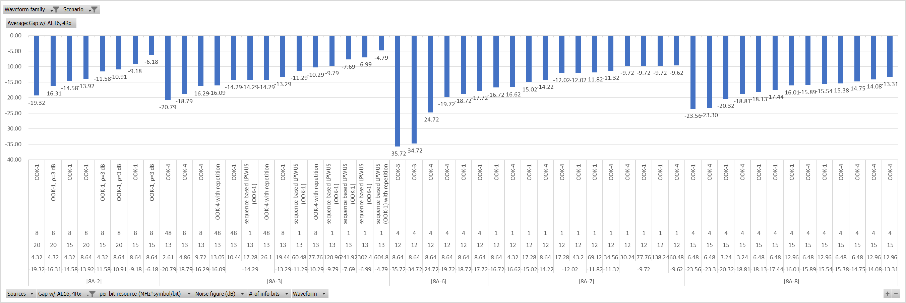

**Observation:**

For normal UE and urban scenario, comparing MIL of OOK based LP-WUS to legacy PDCCH AL16, 4Rx for paging

- [8A-2], [8A-3], [8A-6], [8A-7] and [8A-8] show that with the LP-WUS resource of X=8.64~604.8 MHz\*Symbol/bit , the MIL margin Y is -17.72~-4.79 dB

Table 8.2.2.1-2: Gap with PDCCH AL8, 4RX, Urban, MR is normal UE

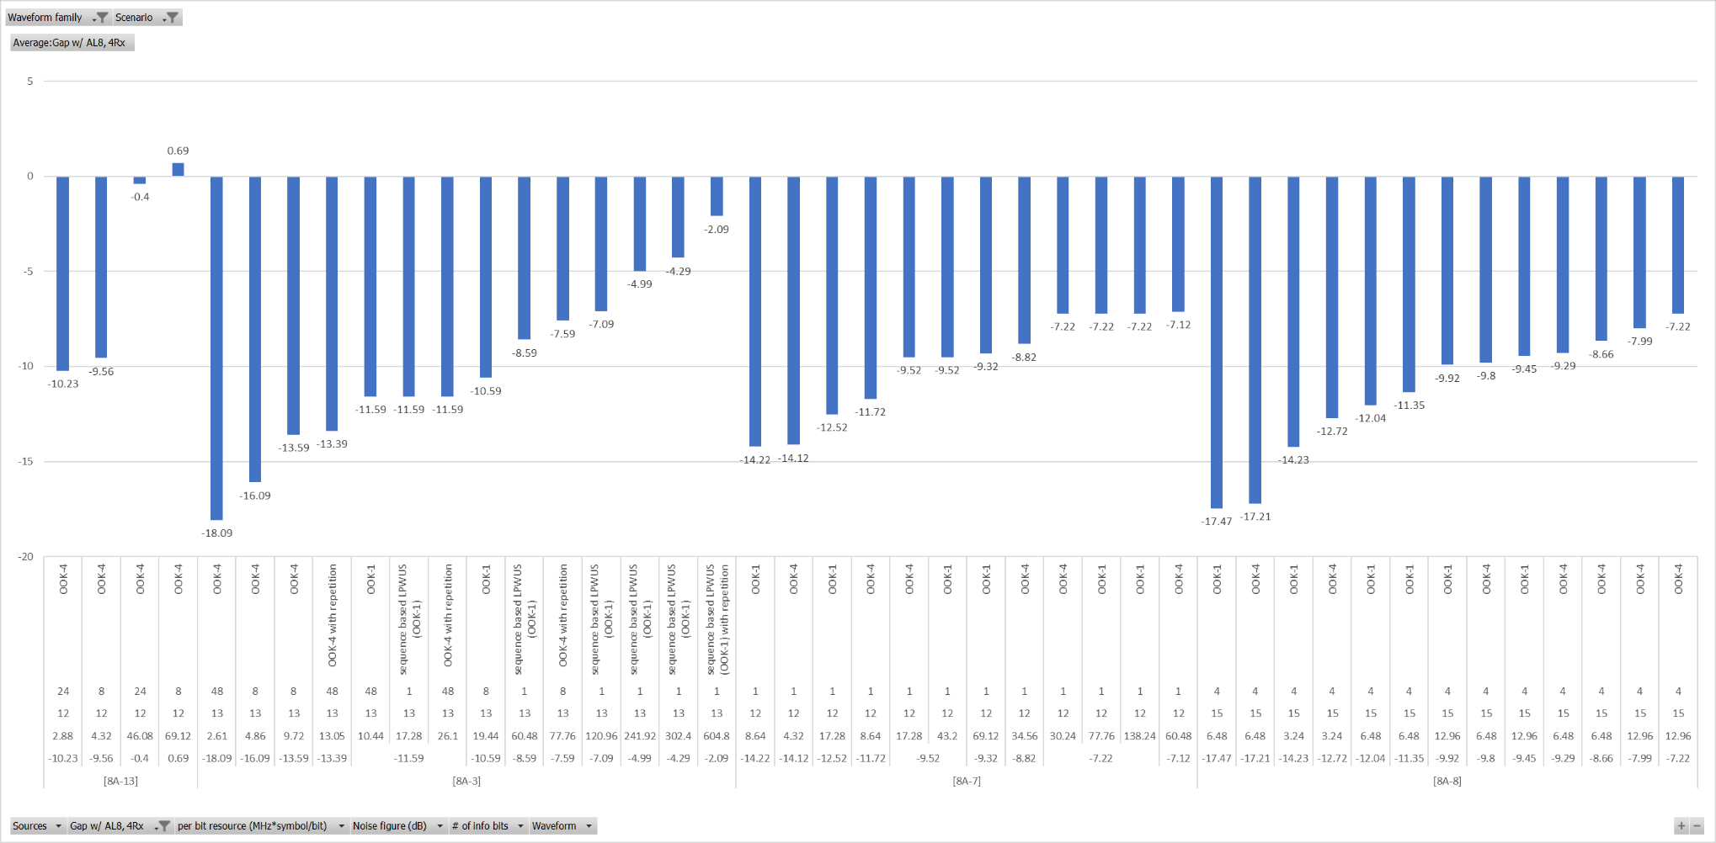

**Observation:**

For normal UE and Urban scenario, comparing MIL of OOK based LP-WUS to legacy PDCCH AL8, 4Rx for paging

- [8A-13] shows it is feasible to achieve comparable MIL (i.e.MIL margin Y>=-1dB) with LP-WUS of X = 46.08 MHz\*Symbol/bit, MIL margin Y = -0.4dB

- [8A-3], [8A-7] and [8A-8] show that with the LP-WUS resource of X=12.96~604.8 MHz\*Symbol/bit , the MIL margin Y is -7.22~-2.09 dB

Table 8.2.2.1-3: Gap with PDCCH AL8, 2RX, Urban, MR is normal UE

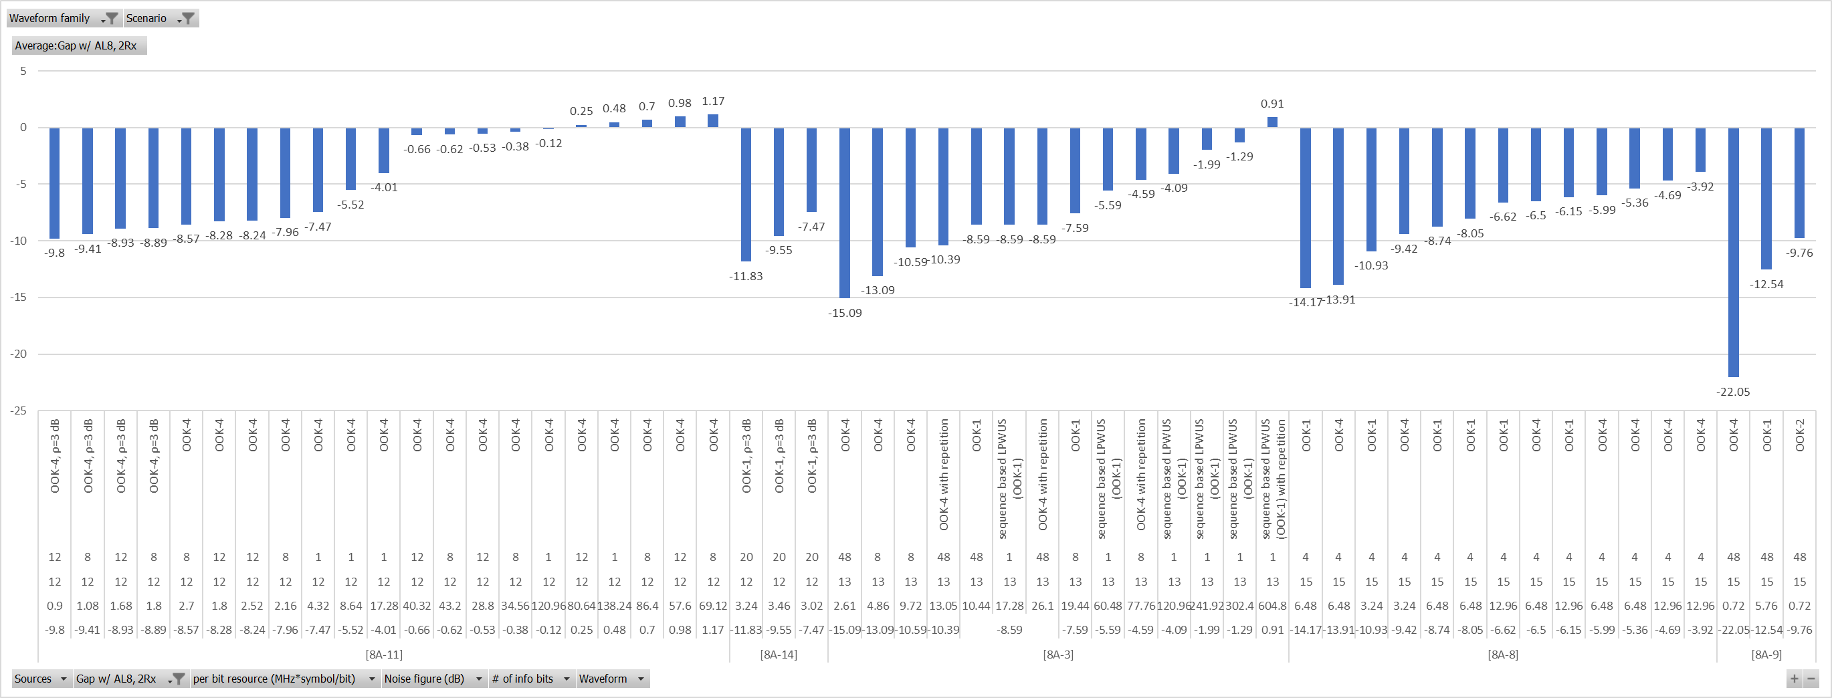

**Observation:**

For normal UE and Urban scenario, comparing MIL of OOK based LP-WUS to legacy PDCCH AL8, 2Rx for paging

- [8A-3] and [8A-11] show it is feasible to achieve comparable MIL (i.e.MIL margin Y>=-1dB)

- [8A-11] shows the resource of LP-WUS X = 28.8 MHz\*Symbol/bit, MIL margin Y=-0.53dB

- [8A-3] shows the resource of LP-WUS X = 604.8 MHz\*Symbol/bit, MIL margin Y=0.91dB

- [8A-8], [8A-9] and [8A-14] show that with the LP-WUS resource of X=0.72~12.96 MHz\*Symbol/bit , the MIL margin Y is -9.76~-3.92 dB

#### 8.2.2.2 OOK, Urban, Redcap UE, PDCCH

Table 8.2.2.2-1: Gap with PDCCH AL16, 1RX

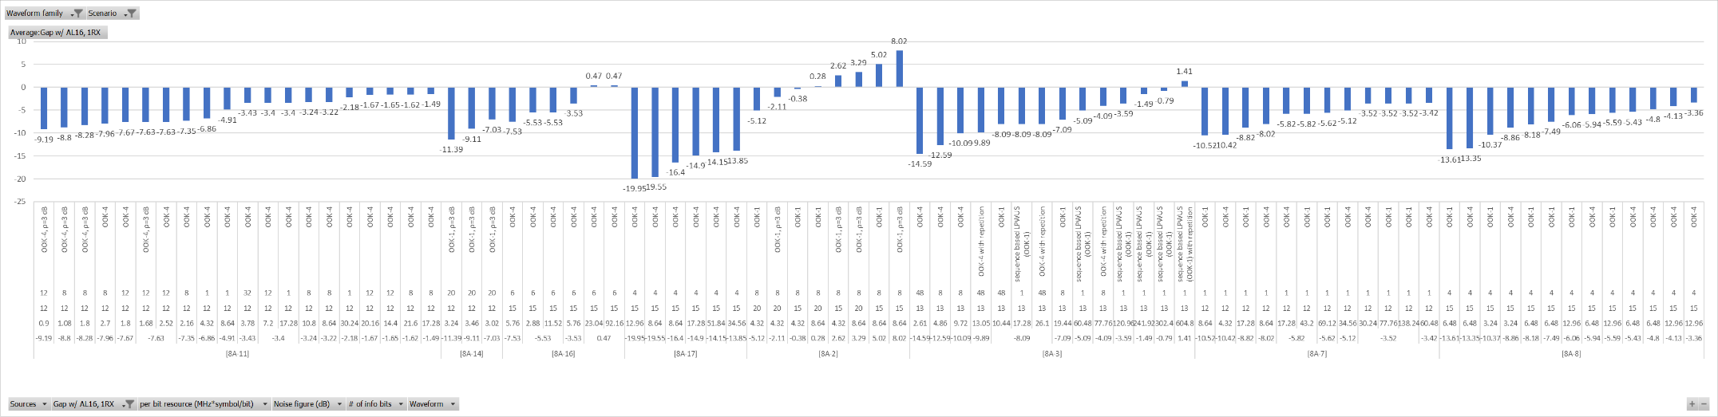

**Observation:**

For RedCap UE and Urban scenario, comparing MIL of OOK based LP-WUS to legacy PDCCH AL16, 1Rx for paging

- [8A-2], [8A-3] and [8A-16] show it is feasible to achieve comparable MIL (i.e.MIL margin Y>=-1dB)

- [8A-2] shows the resource of LP-WUS X = 4.32 MHz\*Symbol/bit, MIL margin Y=-0.38dB

- [8A-16] show the resource of LP-WUS X = 23.04 MHz\*Symbol/bit, MIL margin Y=0.47dB

- [8A-3] show the resource of LP-WUS X = 302.4 MHz\*Symbol/bit, MIL margin Y=-0.79dB

- [8A-7], [8A-8], [8A-11], [8A-14] and [8A-17] show that with the LP-WUS resource of X=3.02~60.48 MHz\*Symbol/bit , the MIL margin Y is -13.85~-1.49 dB

Table 8.2.2.2-2: Gap with PDCCH AL8, 1RX

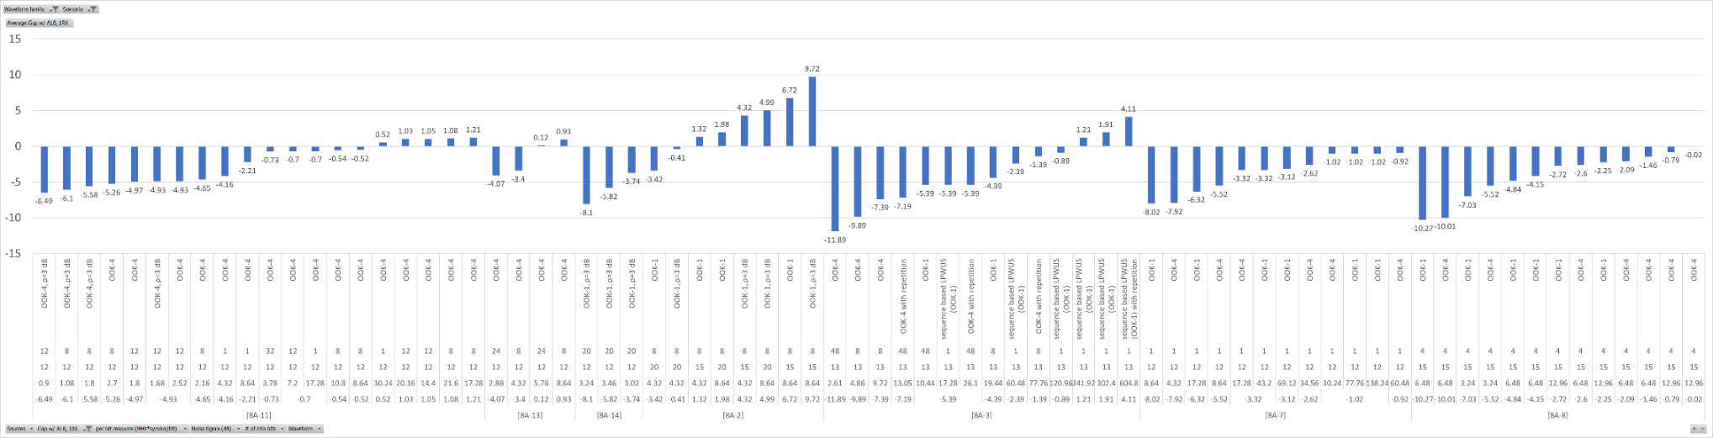

**Observation:**

For RedCap UE and Urban scenario, comparing MIL of OOK based LP-WUS to legacy PDCCH AL8, 1Rx for paging

- [8A-2], [8A-3], [8A-7], [8A-8], [8A-11] and [8A-13] show it is feasible to achieve comparable MIL (i.e.MIL margin Y>=-1dB)

- [8A-2], [8A-11], [8A-13] and [8A-8] show the resource of LP-WUS X = 4.32~12.96 MHz\*Symbol/bit, MIL margin Y=-0.02~1.32 dB

- [8A-3] and [8A-7] show the resource of LP-WUS X = 60.48~120.96 MHz\*Symbol/bit, MIL margin Y=-0.89~-0.92dB

- [8A-14] show that with the LP-WUS resource of X=3.02 MHz\*Symbol/bit , the MIL margin Y is -3.74 dB

#### 8.2.2.3 OOK, Urban, Normal UE, Msg.3

Table 8.2.2.3: OOK, Urban, Normal UE, Msg.3

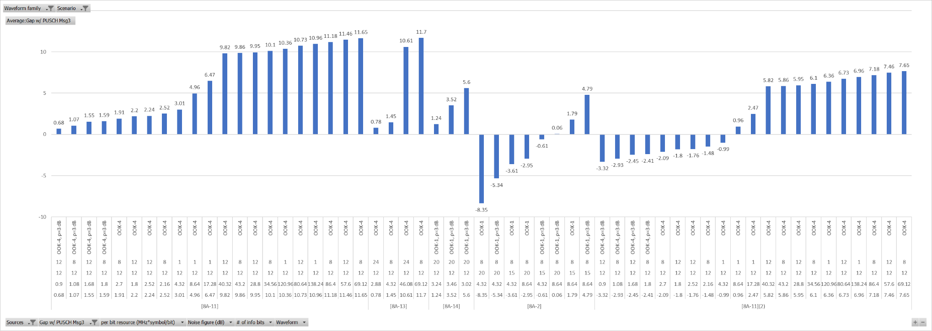

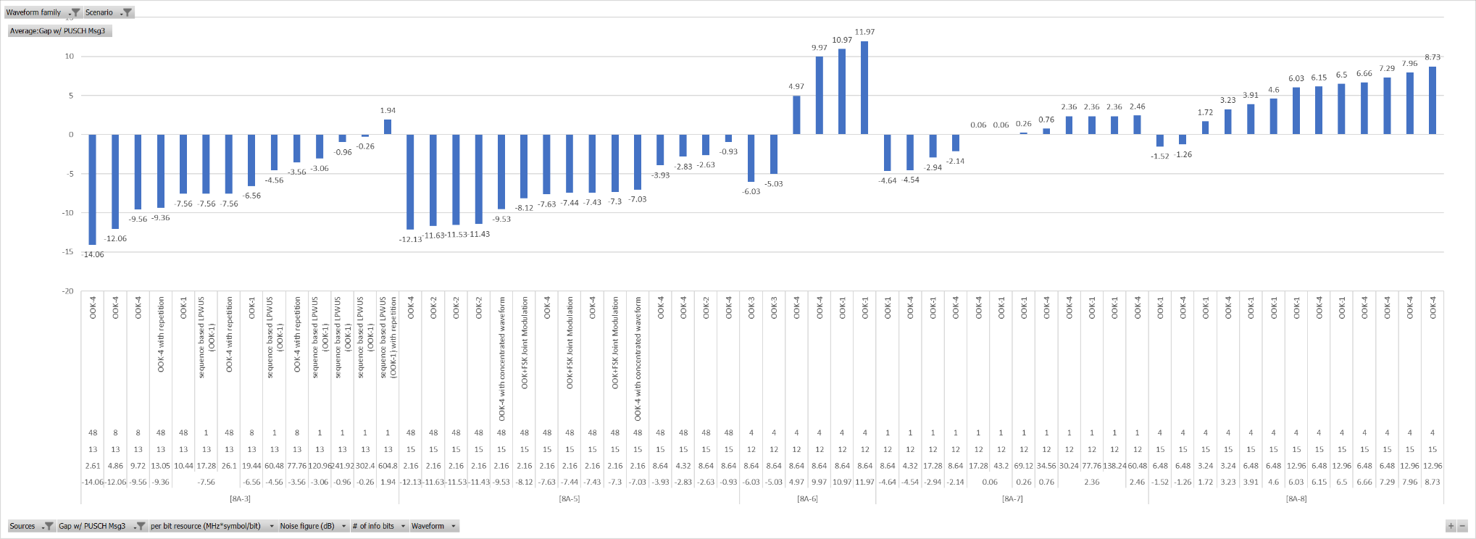

**Observation:**

For Normal UE in Urban, [8A-2], [8A-3], [8A-5], [8A-6], [8A-7], [8A-8], [8A-11], [8A-13] and [8A-14], show OOK based LP-WUS is feasible to achieve comparable MIL (i.e.MIL margin Y>=-1dB) than PUSCH for Msg.3

- [8A-2], [8A-5], [8A-6], [8A-8], [8A-11] and [8A-13] show that, with LP-WUS resource X = 1.8~8.64 MHz\*Symbol/bit, MIL margin Y = -0.93~11.97dB, assuming no power boosting for LP-WUS;

- [8A-7] show that, with LP-WUS resource X=17.28 MHz\*Symbol/bit, MIL margin Y=0.06dB, assuming antenna element gain of LP-WUR is 3dB worse than MR.

- [8A-3] show that, with LP-WUS resource X=241.92 MHz\*Symbol/bit, MIL margin Y=-0.96dB, assuming 4dB HARQ gain from 2 retransmissions for Msg3 PUSCH and no power boost for LP-WUS

- [8A-2], [8A-11] and [8A-14], show that, with LP-WUS resource X=0.9~4.32 MHz\*Symbol/bit, MIL margin Y=-0.61dB~1.24dB, assuming 3dB power boosting for LP-WUS

#### 8.2.2.4 OOK, Urban, Redcap UE, Msg.3

Table 8.2.2.4: OOK, Urban, Redcap UE, Msg.3

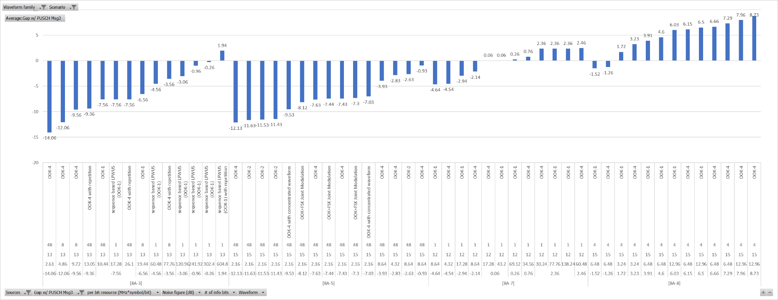

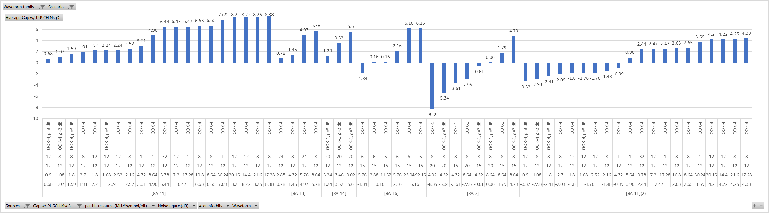

**Observation:**

For Redcap UE in Urban, [8A-2], [8A-3], [8A-5], [8A-7], [8A-8], [8A-11], [8A-13] , [8A-14] and [8A-16] show OOK based LP-WUS is feasible to achieve comparable MIL (i.e.MIL margin Y>=-1dB) than PUSCH for Msg.3

- [8A-2], [8A-5], [8A-8], [8A-11], [8A-13] and [8A-16] show that, with LP-WUS resource X=1.8~8.64 MHz\*Symbol/bit, MIL margin Y =-0.93dB~2.2dB, assuming no power boosting for LP-WUS

- [8A-7] show that with LP-WUS resource X=17.28 MHz\*Symbol/bit, MIL margin Y=0.06dB, assuming no power boosting for LP-WUS, assumes antenna element gain of LP-WUR is 3dB worse than MR.

- [8A-3] show that with LP-WUS resource X=241.92 MHz\*Symbol/bit, MIL margin Y=-0.96dB, assuming no power boosting for LP-WUS and 4dB HARQ gain from 2 retransmissions for Msg3 PUSCH.

- [8A-2], [8A-11] and [8A-14] show that with LP-WUS resource X=0.9~4.32 MHz\*Symbol/bit, MIL margin Y=-0.61dB~1.24dB, assuming 3dB power boosting for LP-WUS.

#### 8.2.2.5 FSK, Urban, Normal UE, PDCCH

Table 8.2.2.5-1: Gap with PDCCH AL16, 4RX

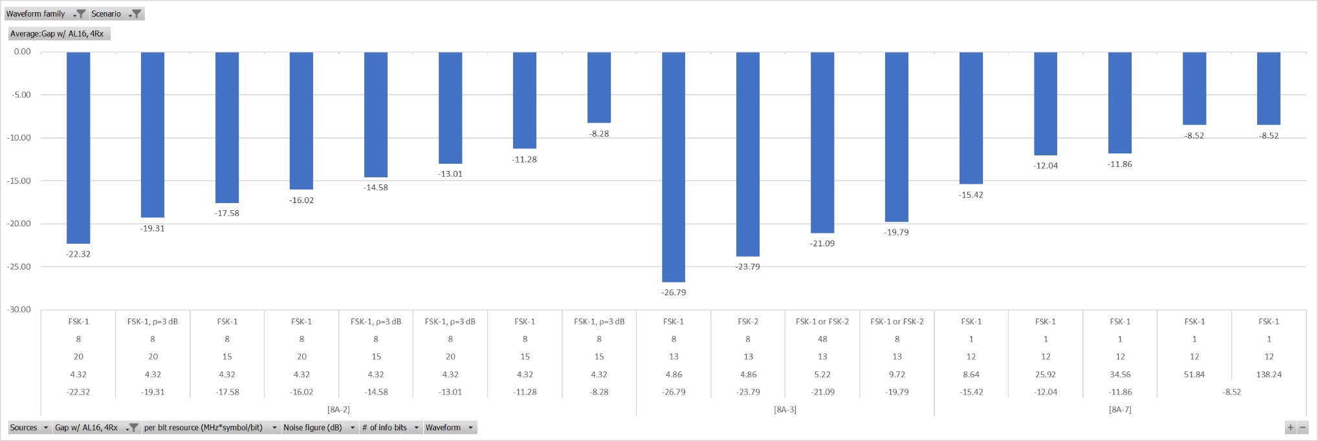

**Observation:**

For normal UE and Urban scenario, comparing MIL of FSK based LP-WUS to legacy PDCCH AL16, 4Rx for paging

- [8A-2], [8A-3] and [8A-7] show that with the LP-WUS resource of X=4.32~51.84 MHz\*Symbol/bit , the MIL margin Y is -19.79~-5.52 dB

Table 8.2.2.5-2: Gap with PDCCH AL8, 4RX

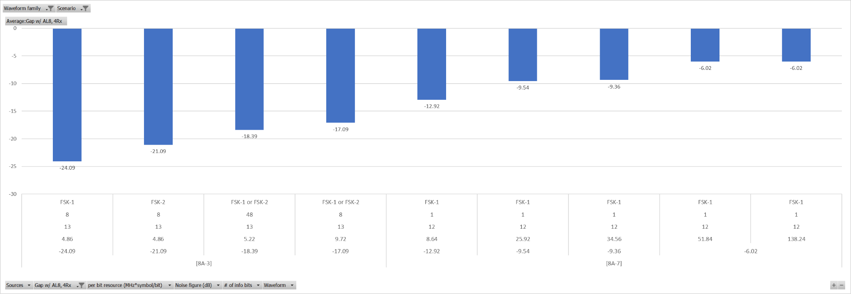

**Observation:**

For normal UE and Urban scenario, comparing MIL of FSK based LP-WUS to legacy PDCCH AL8, 4Rx for paging

- [8A-3] and [8A-7] show that with the LP-WUS resource of X=9.72~51.84 MHz\*Symbol/bit , the MIL margin Y is -17.09~-6.02 dB

Table 8.2.2.5-3: Gap with PDCCH AL8, 2RX

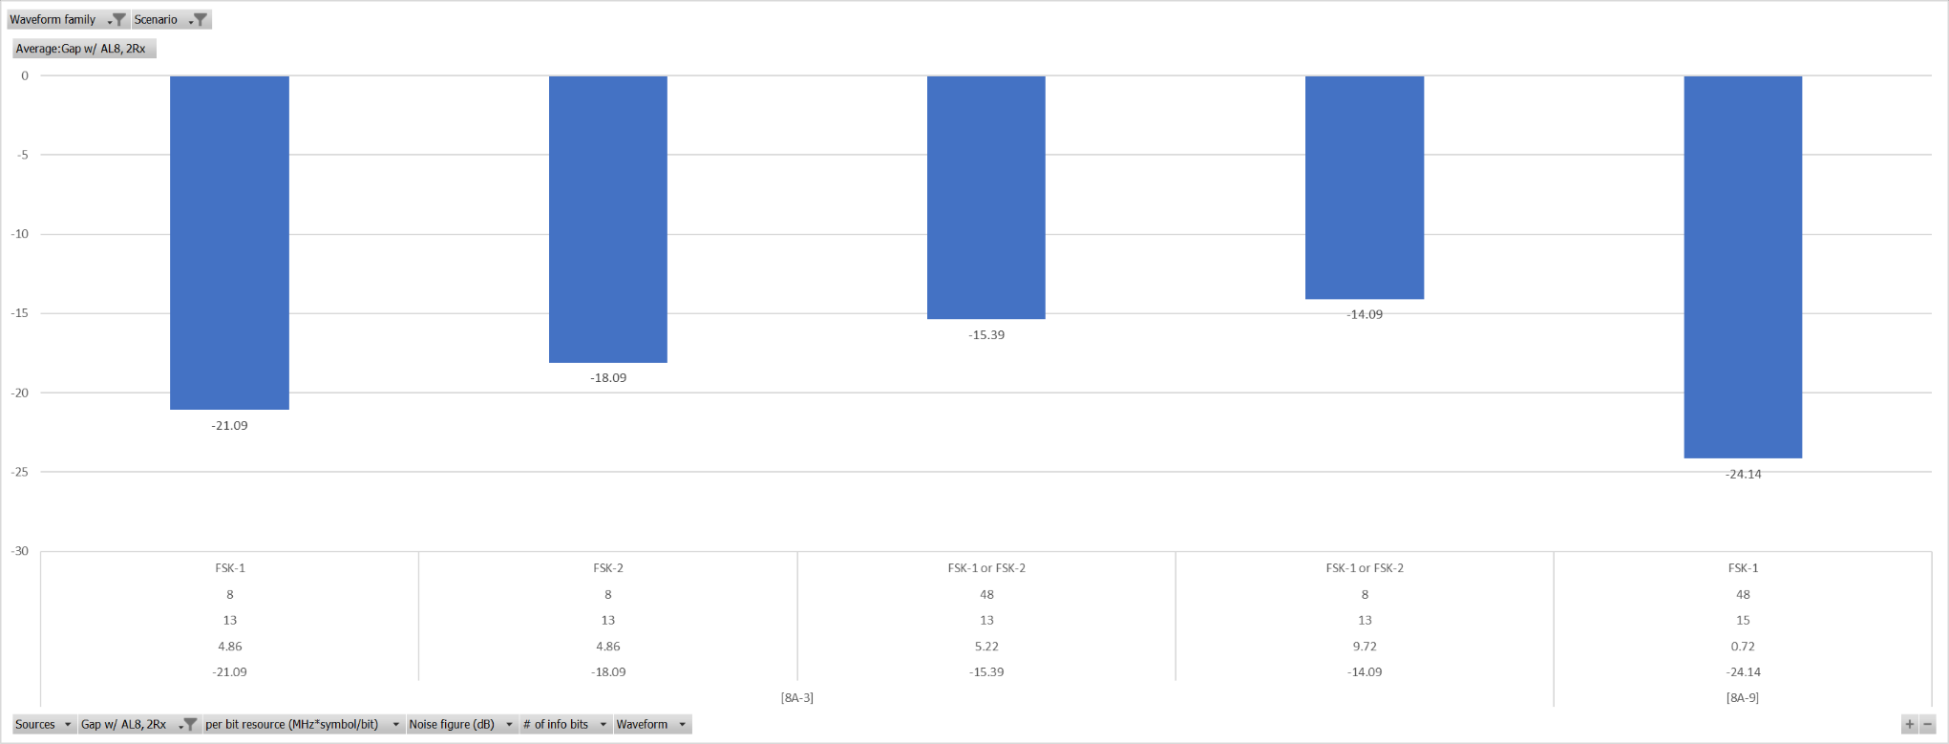

**Observation:**

For normal UE and Urban scenario, comparing MIL of FSK based LP-WUS to legacy PDCCH AL8, 2Rx for paging

- [8A-3] and [8A-9] show that with the LP-WUS resource of X=0.72~9.72 MHz\*Symbol/bit , the MIL margin Y is -24.14~-14.09 dB

#### 8.2.2.6 FSK, Urban, Redcap UE, PDCCH

Table 8.2.2.6-1: Gap with PDCCH AL16, 1RX

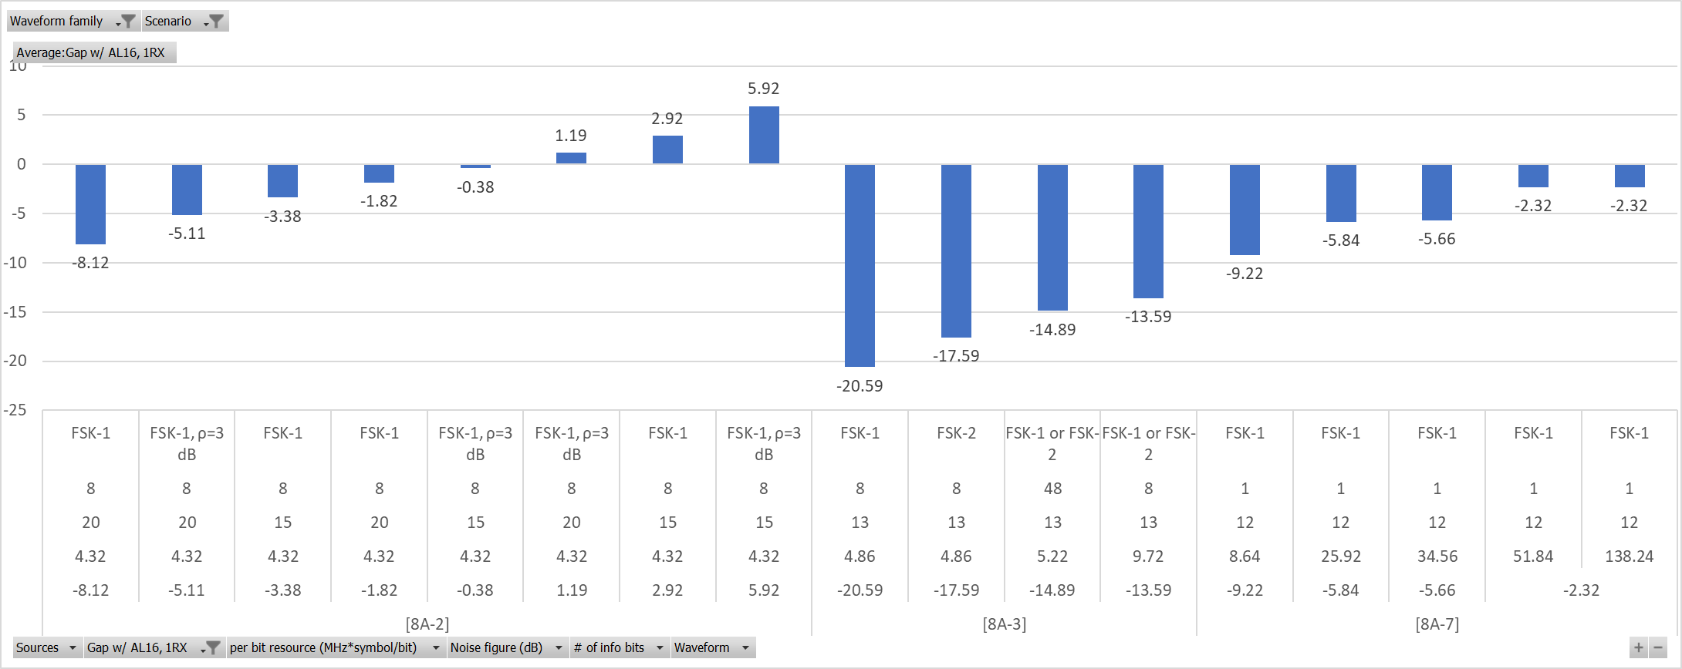

**Observation:**

For RedCap UE and Urban scenario, comparing MIL of FSK based LP-WUS to legacy PDCCH AL16, 1Rx for paging

- [8A-2] show it is feasible to achieve comparable MIL (i.e.MIL margin Y>=-1dB) with LP-WUS resource X=4.32 MHz\*Symbol/bit, MIL margin Y=2.92dB

- [8A-3] and [8A-7] show that with the LP-WUS resource of X=9.72~51.84 MHz\*Symbol/bit , the MIL margin Y is -13.59~-2.32 dB

Table 8.2.2.6-2: Gap with PDCCH AL8, 1RX

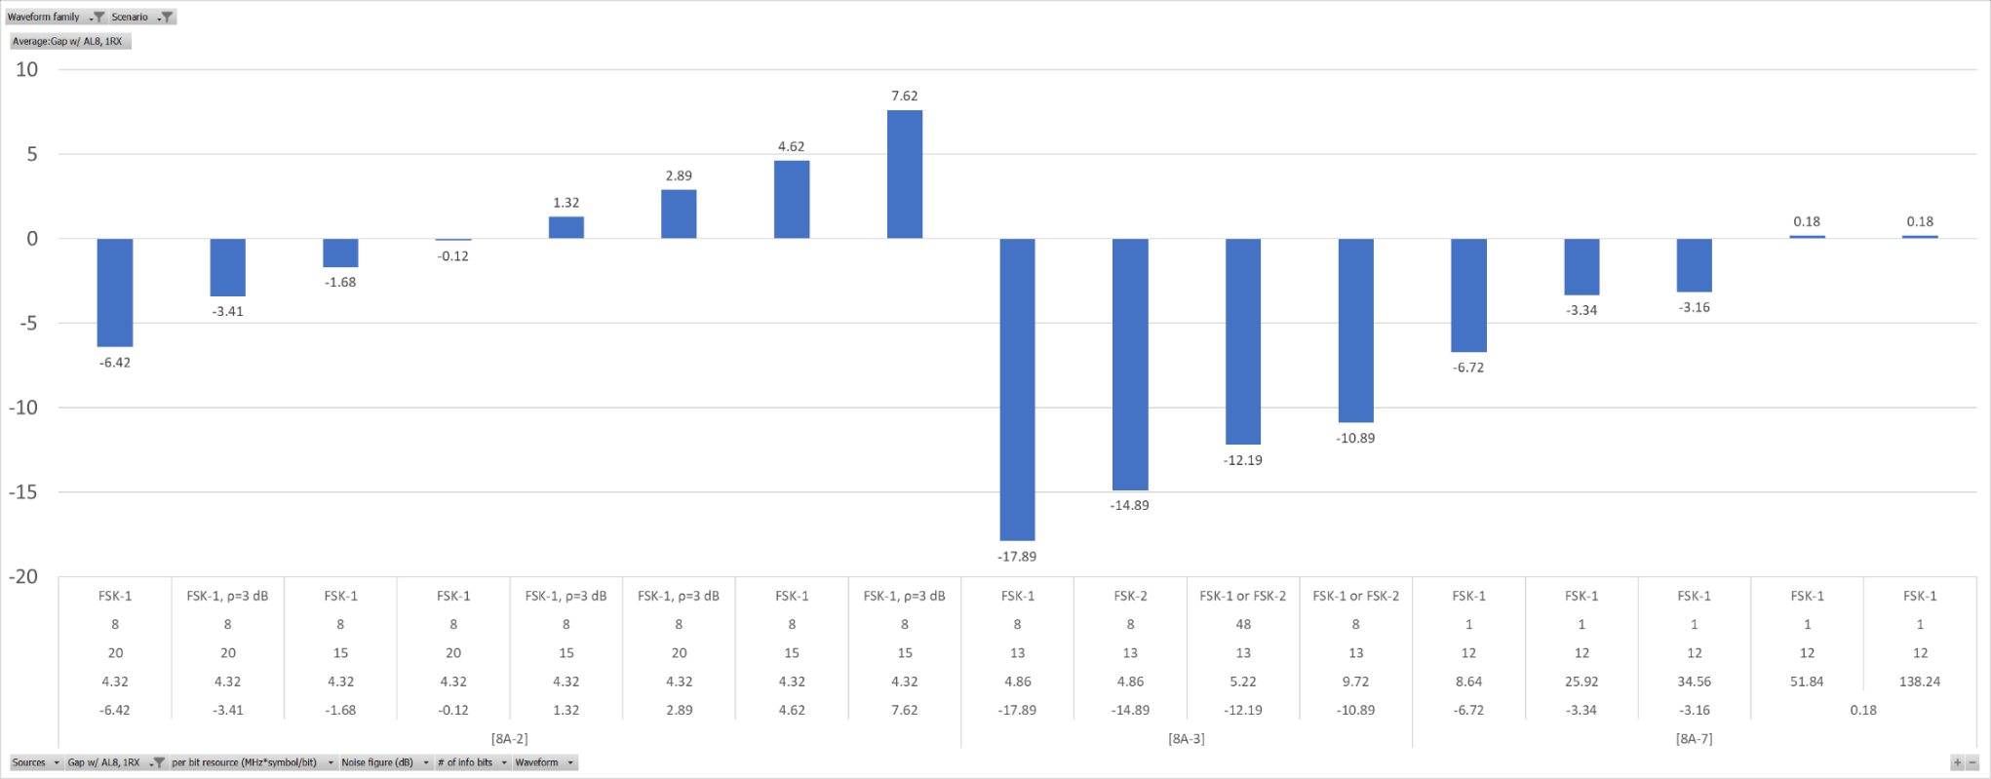

**Observation:**

For RedCap UE and Urban scenario, comparing MIL of FSK based LP-WUS to legacy PDCCH AL8, 1Rx for paging

- [8A-2] and [8A-7] show it is feasible to achieve comparable MIL (i.e.MIL margin Y>=-1dB) when

- [8A-2] with LP-WUS resource X=4.32 MHz\*Symbol/bit, MIL margin Y=-0.12dB

- [8A-7] with LP-WUS resource X=51.84 MHz\*Symbol/bit, MIL margin Y=0.18dB

- [8A-3] show that with the LP-WUS resource of X=9.72 MHz\*Symbol/bit , the MIL margin Y is -10.89 dB

#### 8.2.2.7 FSK, Urban, Normal UE, Msg.3

Table 8.2.2.7: Gap with Msg.3

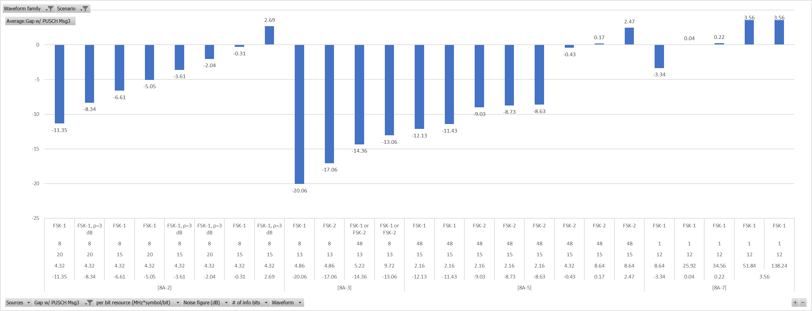

**Observation:**

For normal UE and Urban scenario, comparing MIL of FSK based LP-WUS to legacy PUSCH for Msg.3,

- [8A-2], [8A-5] and [8A-7] show it is feasible to achieve comparable MIL (i.e.MIL margin Y>=-1dB)

- [8A-2] with LP-WUS resource X=4.32 MHz\*Symbol/bit, MIL margin Y=-0.31dB

- [8A-5] with LP-WUS resource X=4.32 MHz\*Symbol/bit, MIL margin Y=-0.43dB

- [8A-7] with LP-WUS resource X=25.92 MHz\*Symbol/bit, MIL margin Y=-0.34dB, assuming antenna element gain of LP-WUR is 3dB worse than MR.

- [8A-3] show that with the LP-WUS resource of X=9.72 MHz\*Symbol/bit , the MIL margin Y is -13.06 dB

#### 8.2.2.8 FSK, Urban, Redcap UE, Msg.3

Table 8.2.2.8: FSK, Urban, Redcap UE, Msg.3



**Observation:**

For RedCap UE and Urban scenario, comparing MIL of FSK based LP-WUS to legacy PUSCH for Msg.3,

- [8A-2], [8A-5] and [8A-7] show it is feasible to achieve comparable MIL (i.e.MIL margin Y>=-1dB)

- [8A-5] and [8A-2] with LP-WUS resource X=4.32 MHz\*Symbol/bit, MIL margin Y=-0.43dB~-0.31dB

- [8A-7] with LP-WUS resource X=25.92 MHz\*Symbol/bit, MIL margin Y=-0.01dB, assuming antenna element gain of LP-WUR is 3dB worse than MR

- [8A-3] show that with the LP-WUS resource of X=9.72 MHz\*Symbol/bit , the MIL margin Y is -13.06 dB

#### 8.2.2.9 OFDM, Urban, Normal UE, PDCCH

Table 8.2.2.9-1: Gap with PDCCH AL16, 4RX

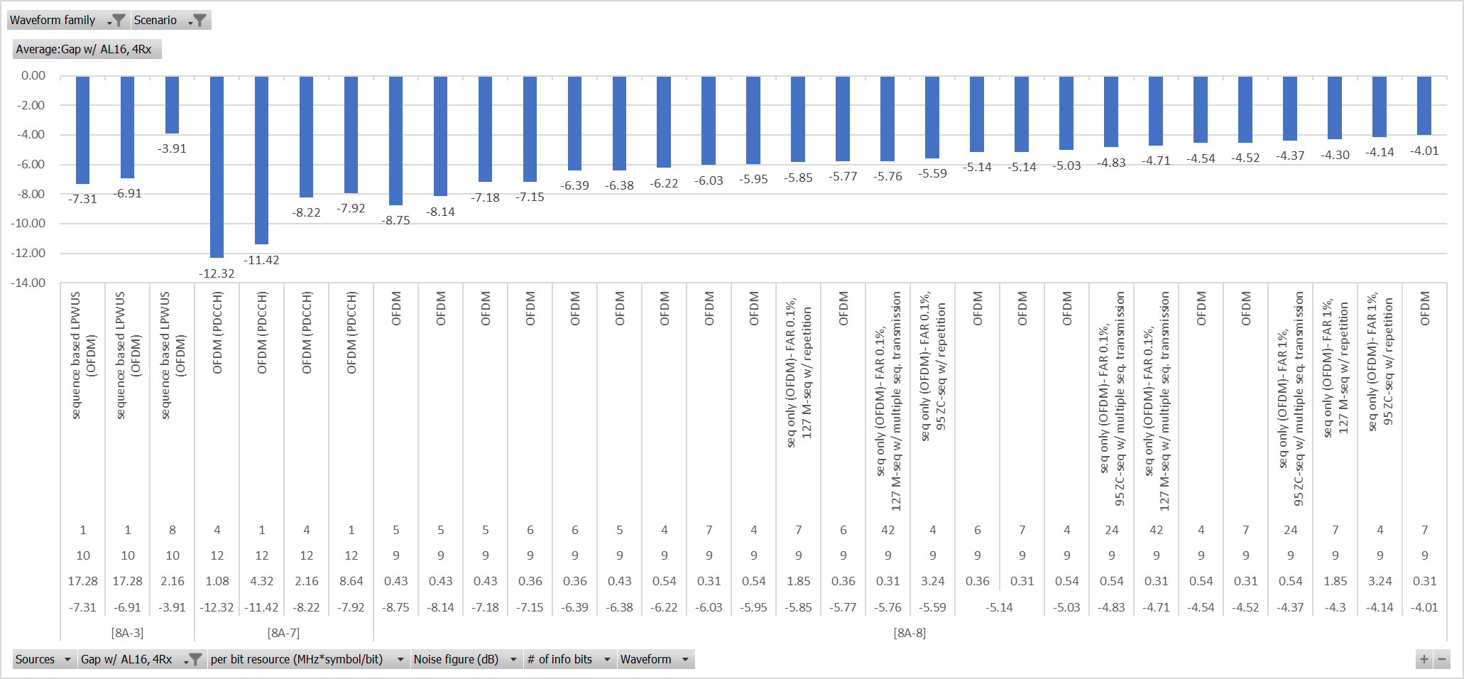

**Observation:**

For normal UE and urban scenario, comparing MIL of OFDM based LP-WUS to legacy PDCCH AL16, 4Rx for paging

- [8A-3], [8A-7] and [8A-8] show that with the LP-WUS resource of X=0.31~8.64 MHz\*Symbol/bit , the MIL margin Y is -7.92~-3.91 dB

Table 8.2.2.9-2: Gap with PDCCH AL16, 2RX

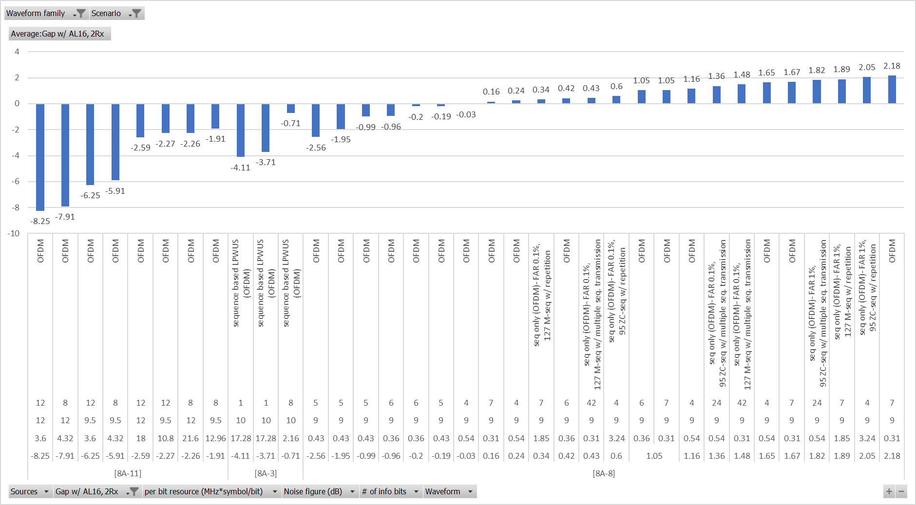

**Observation:**

For normal UE and Urban scenario, comparing MIL of OFDM based LP-WUS to legacy PDCCH AL16, 2Rx for paging,

- [8A-3] and [8A-8] show it is feasible to achieve comparable MIL (i.e.MIL margin Y>=-1dB)

- [8A-3] with LP-WUS resource X=2.16 MHz\*Symbol/bit, MIL margin Y=-0.71dB

- [8A-8] with LP-WUS resource X=0.31 MHz\*Symbol/bit, MIL margin Y=2.18dB

- [8A-11] shows that with the LP-WUS resource of X=12.96 MHz\*Symbol/bit, the MIL margin Y is -1.91 dB

Table 8.2.2.9-3: Gap with PDCCH AL8, 4RX

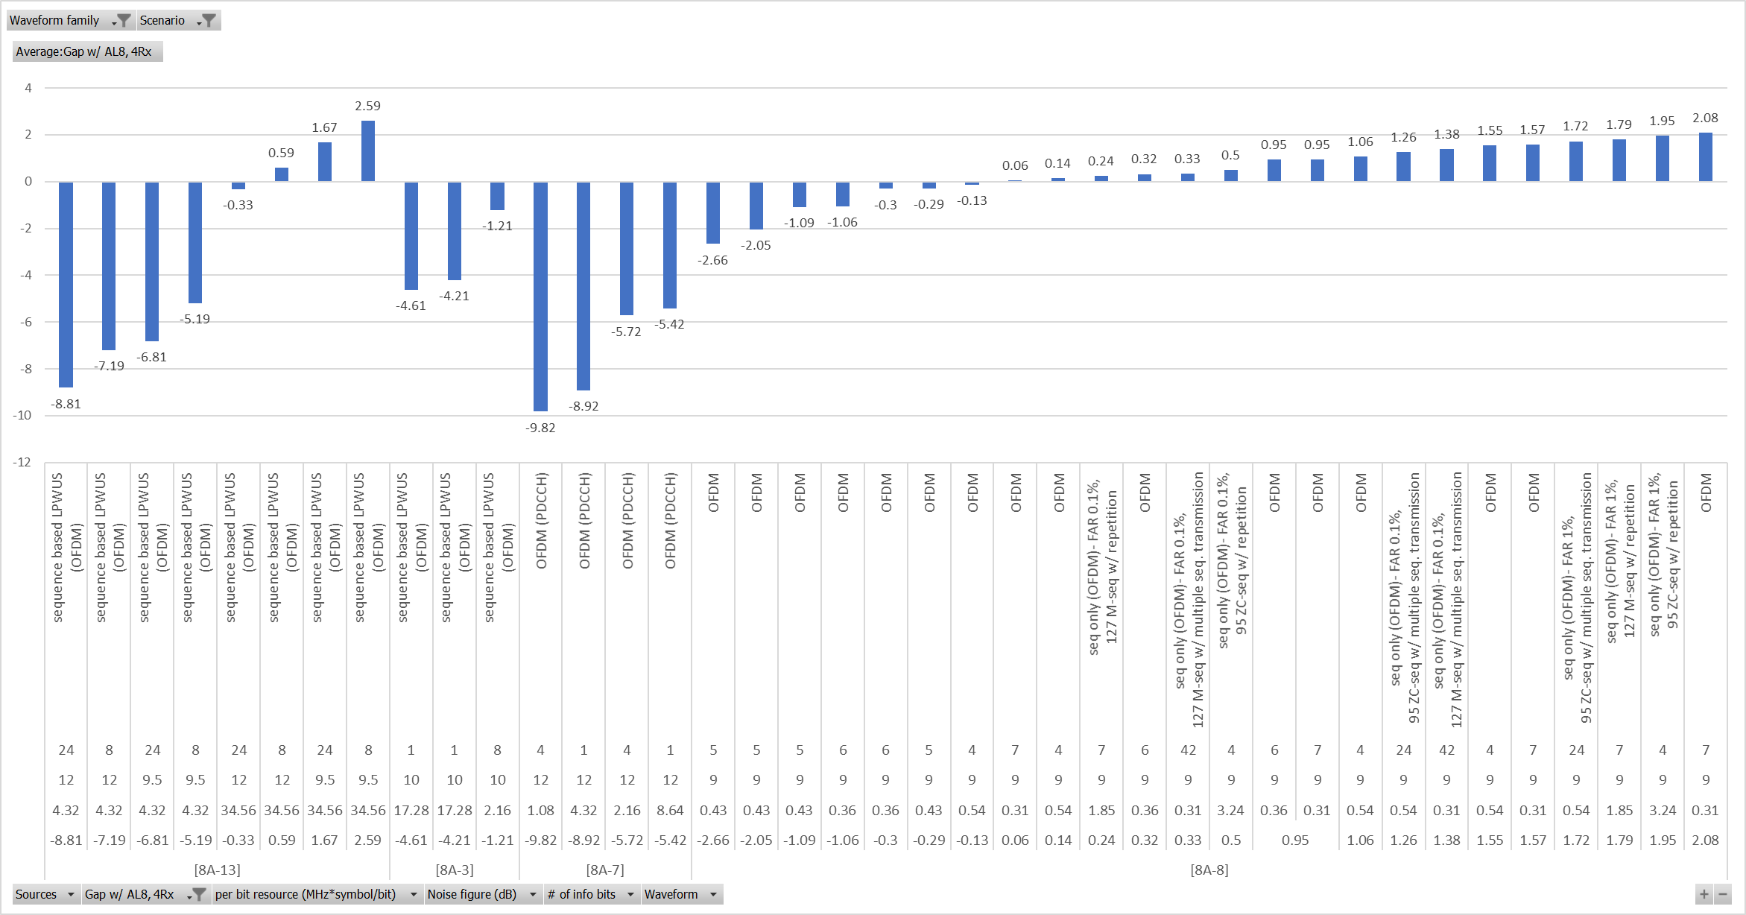

**Observation:**

For normal UE and Urban scenario, comparing MIL of OFDM based LP-WUS to legacy PDCCH AL8, 4Rx for paging,

- [8A-8] and [8A-13] show it is feasible to achieve comparable MIL (i.e.MIL margin Y>=-1dB)

- [8A-13] with LP-WUS resource X=34.56 MHz\*Symbol/bit, MIL margin Y=2.59 dB

- [8A-8] with LP-WUS resource X=0.31 MHz\*Symbol/bit, MIL margin Y=2.08 dB

- [8A-3] and [8A-7] show that with the LP-WUS resource of X=2.16~8.64 MHz\*Symbol/bit, the MIL margin Y is -5.42~-1.21 dB

Table 8.2.2.9-4: Gap with PDCCH AL8, 2RX

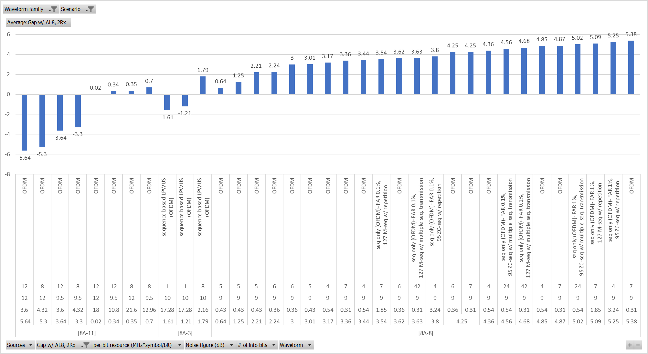

**Observation:**

For Normal UE in Urban, [8A-3], [8A-8] and [8A-11], show OFDM based LP-WUS is feasible to achieve comparable MIL (i.e. MIL margin Y>=-1dB) than PDCCH AL8 2Rx for paging,

- [8A-3] and [8A-8] show that with LP-WUS resource X=0.31~2.16 MHz\*Symbol/bit, MIL margin Y=1.79~5.38 dB

- [8A-11] shows that with LP-WUS resource X=18 MHz\*Symbol/bit, MIL margin Y=0.02dB

#### 8.2.2.10 OFDM, Urban, Redcap UE, PDCCH

Table 8.2.2.10-1: Gap with PDCCH AL16, 1RX

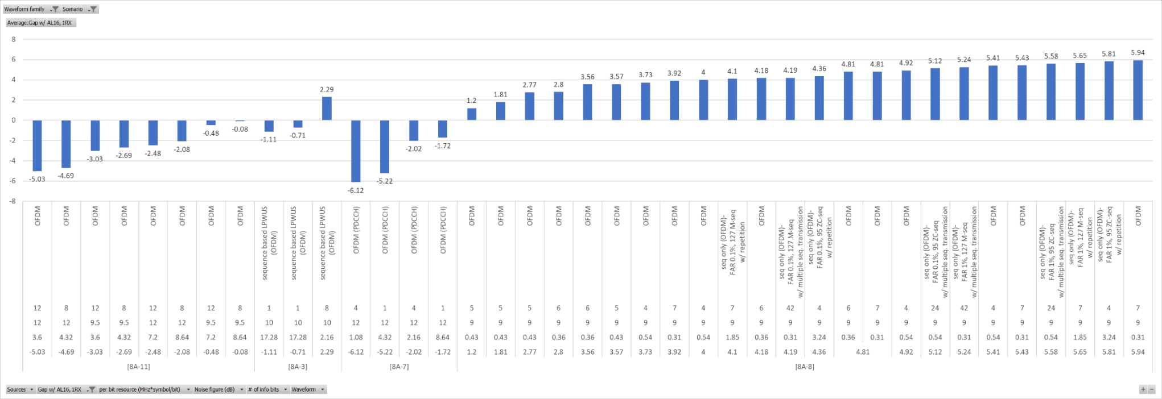

**Observation:**

For Redcap UE and Urban scenario, comparing MIL of OFDM based LP-WUS to legacy PDCCH AL16, 1Rx for paging

- [8A-3], [8A-11] and [8A-8] show that it is feasible to achieve comparable MIL (i.e. MIL margin >=-1dB)

- [8A-3] and [8A-8] with LP-WUS resource X=0.43~2.16 MHz\*Symbol/bit, MIL margin Y=1.2~2.92dB

- [8A-11] with LP-WUS resource X=7.2 MHz\*Symbol/bit, MIL margin Y=-0.48dB

- [8A-7] shows that with the LP-WUS resource of X=8.64 MHz\*Symbol/bit, the MIL margin Y is -1.72 dB

Table 8.2.2.10-2: Gap with PDCCH AL8, 1RX

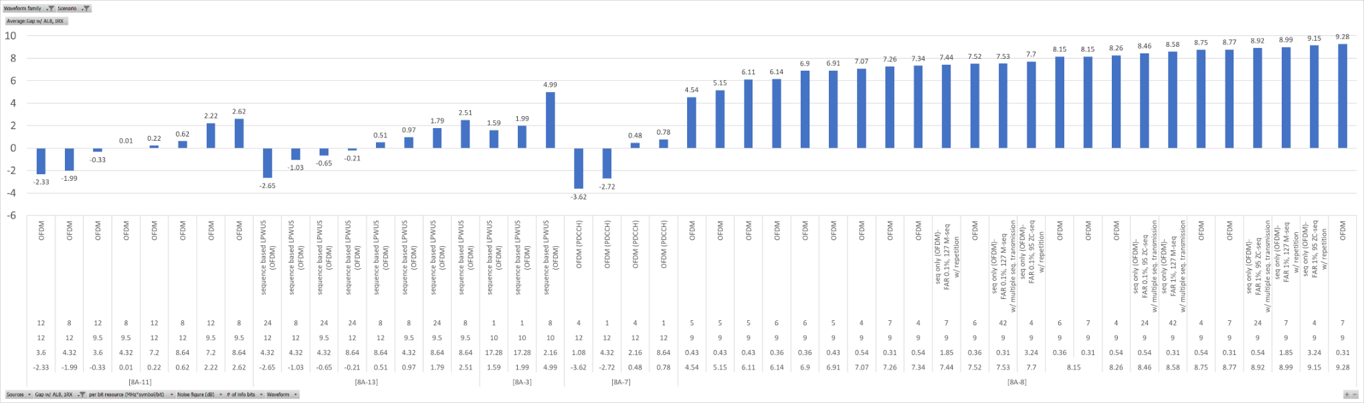

**Observation:**

For Redcap UE and Urban scenario, [8A-3], [8A-7], [8A-8], [8A-11] and [8A-13], show OFDM based LP-WUS is feasible to achieve comparable MIL (i.e. MIL margin >=-1dB) than PDCCH AL8 1Rx for paging,

- [8A-3], [8A-7], [8A-8], [8A-11] and [8A-13] show that with LP-WUS resource X= 0.31~4.32 MHz\*Symbol/bit, MIL margin Y=-0.33dB~9.28dB

#### 8.2.2.11 OFDM, Urban, Normal UE, Msg.3

Table 8.2.2.11: Gap with PUSCH Msg.3

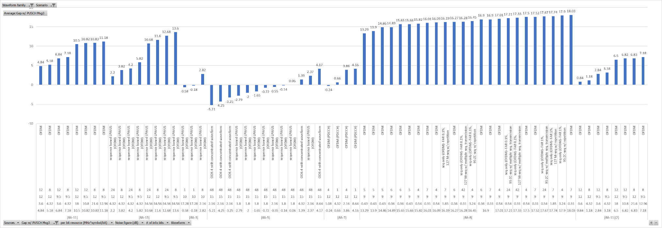

**Observation:**

For Normal UE and Urban scenario, [8A-3], [8A-5], [8A-7], [8A-8], [8A-11] and [8A-13], show OFDM based LP-WUS is feasible to achieve comparable MIL (i.e. MIL margin >=-1dB) than PUSCH for Msg.3

- [8A-5], [8A-8], [8A-11] and [8A-13] show that with LP-WUS resource X= 0.31~4.32 MHz\*Symbol/bit, MIL margin Y=0.06dB~18.03dB

- [8A-7] shows X= 1.08 MHz\*Symbol/bit, MIL margin Y=-0.24dB, assuming antenna element gain of LP-WUR is 3dB worse than MR.

- [8A-3] shows that with LP-WUS resource X= 2.16 MHz\*Symbol/bit, MIL margin Y=2.82dB, assuming 4dB HARQ gain from 2 retransmissions for Msg3 PUSCH

#### 8.2.2.12 OFDM, Urban, Redcap UE, Msg.3

Table 8.2.2.12: OFDM, Urban, Redcap UE, Msg.3

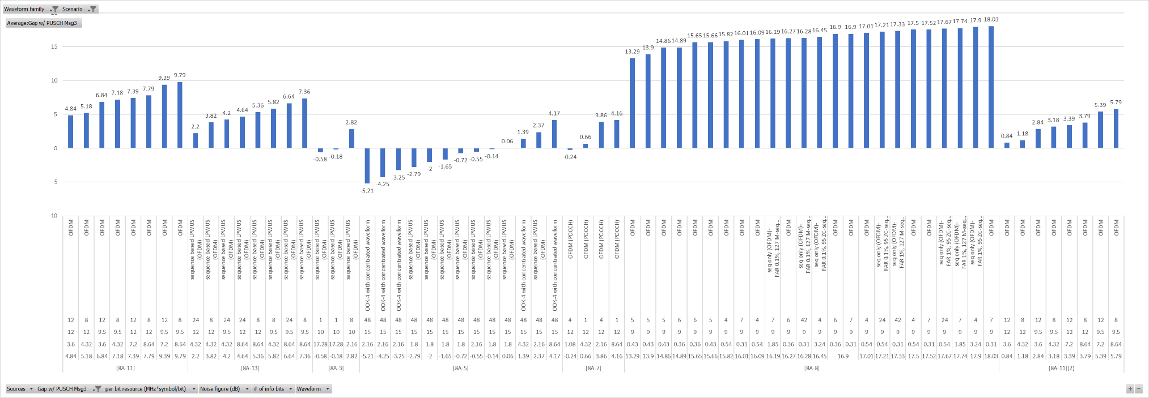

**Observation:**

For RedCap UE and Urban scenario, [8A-3], [8A-5], [8A-7], [8A-8], [8A-11] and [8A-13] show OFDM based LP-WUS is feasible to achieve comparable MIL (i.e. MIL margin >=-1dB) than PUSCH for Msg.3

- [8A-5], [8A-8], [8A-11] and [8A-13] show that with LP-WUS resource X= 0.31~4.32 MHz\*Symbol/bit, MIL margin Y=0.06dB~18.03dB

- [8A-7] shows that with LP-WUS resource X= 1.08 MHz\*Symbol/bit, MIL margin Y=-0.24dB, assuming antenna element gain of LP-WUR is 3dB worse than MR

- [8A-3] shows that with LP-WUS resource X= 2.16 MHz\*Symbol/bit, MIL margin Y=2.82dB, assuming 4dB HARQ gain from 2 retransmissions for Msg3 PUSCH

### 8.2.3 Results for rural

In the evaluation, FAR of 0.1% and 1% are used by companies.

The LP-WUR noise figure assumed for coverage evaluation is

- For OOK based LP-WUS, 12~15dB

- For OFDM based LP-WUS, 9.5~12dB

#### 8.2.3.1 OOK, Rural, normal UE, PDCCH

**Gap with AL16, 2Rx**

Table 8.2.3.1-1: Gap with AL16, 2Rx, OOK, Rural, normal UE, PDCCH

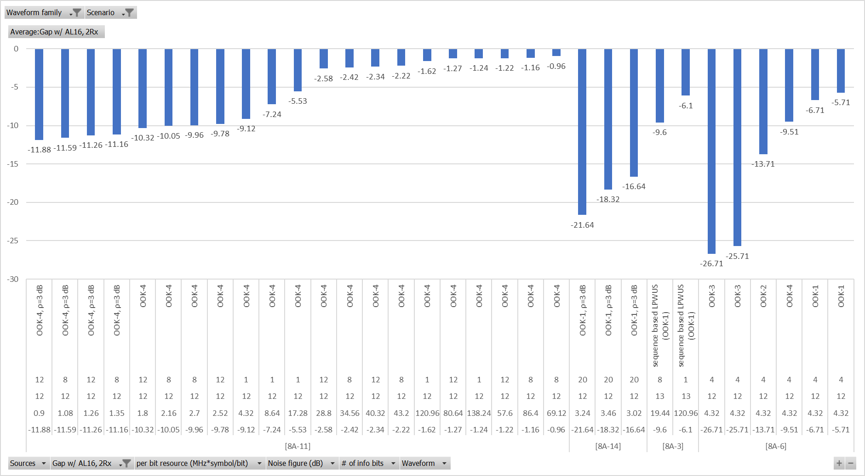

**Observation:**

For normal UE and Rural scenario, comparing MIL of OOK based LP-WUS to legacy PDCCH AL16, 2Rx for paging

- [8A-11] shows that it is feasible to achieve comparable MIL (i.e. MIL margin >=-1dB) when LP-WUS resource X=69.12 MHz\*Symbol/bit, MIL margin Y=-0.96dB

- [8A-3], [8A-6] and [8A-14] show that with the LP-WUS resource of X = 3.02 ~ 120.96 MHz\*Symbol/bit, the MIL margin Y is -16.64~-5.71 dB

**Gap with AL8, 2Rx**

Table 8.2.3.1-2: Gap with AL8, 2Rx, OOK, Rural, normal UE, PDCCH

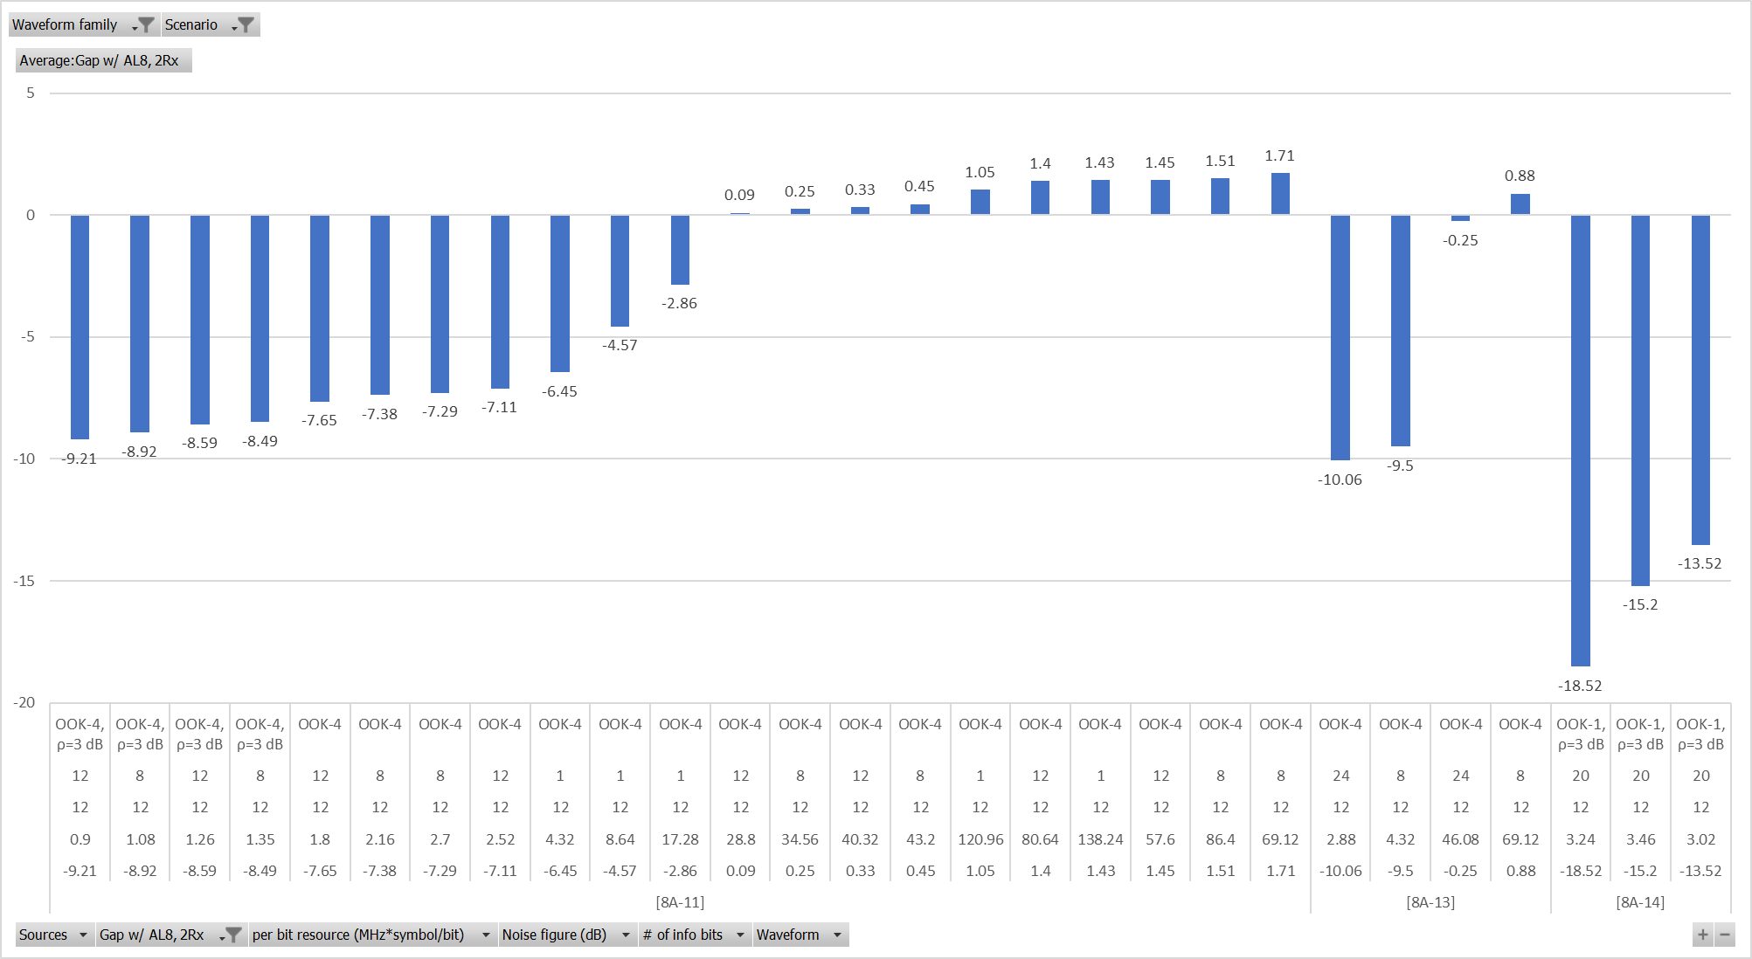

**Observation:**

For normal UE and Rural scenario, comparing MIL of OOK based LP-WUS to legacy PDCCH AL8, 2Rx for paging

- [8A-11] and [8A-13] show that it is feasible to achieve comparable MIL (i.e. MIL margin >=-1dB) when LP-WUS resource X=28.8~46.08 MHz\*Symbol/bit, MIL margin Y=-0.25~0.09dB

- [8A-14] shows that with the LP-WUS resource of X=3.02 MHz\*Symbol/bit, the MIL margin Y is -13.52 dB

#### 8.2.3.2 OOK, Rural, Redcap UE, PDCCH

**Gap with AL16, 1Rx**

Table 8.2.3.2-1: Gap with AL16, 1Rx, OOK, Rural, normal UE, PDCCH

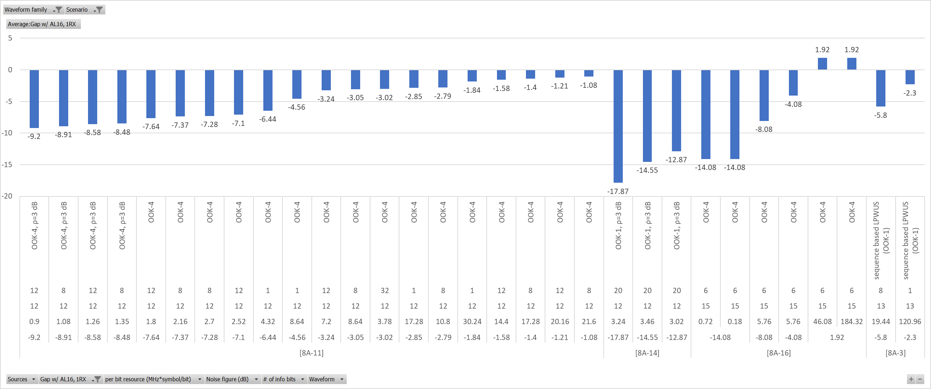

**Observation:**

For RedCap UE and Rural scenario, comparing MIL of OOK based LP-WUS to legacy PDCCH AL16, 1Rx for paging

- [8A-16] shows that it is feasible to achieve comparable MIL (i.e. MIL margin >=-1dB) when LP-WUS resource X=46.08 MHz\*Symbol/bit, MIL margin Y=1.92dB

- [8A-3], [8A-11] and [8A-14] show that with the LP-WUS resource of X=3.02~120.96 MHz\*Symbol/bit, the MIL margin Y is -12.87~-1.08 dB

**Gap with AL8, 1Rx**

Table 8.2.3.2-2: Gap with AL8, 1Rx, OOK, Rural, normal UE, PDCCH

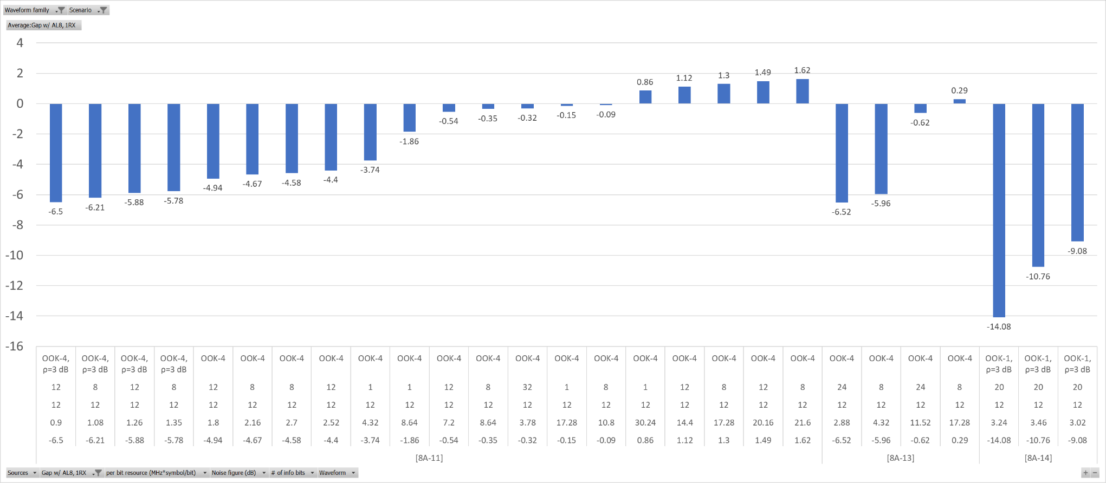

**Observation:**

For RedCap UE and Rural scenario, comparing MIL of OOK based LP-WUS to legacy PDCCH AL8, 1Rx for paging

- [8A-11] and [8A-13] show that it is feasible to achieve comparable MIL (i.e. MIL margin >=-1dB) when LP-WUS resource X=3.78~11.52 MHz\*Symbol/bit, MIL margin Y=-0.62dB~-0.32dB

- [8A-14] shows that with the LP-WUS resource of X=3.02 MHz\*Symbol/bit, the MIL margin Y is -9.08 dB

#### 8.2.3.3 OOK, Rural, Normal UE, Msg.3

Table 8.2.3.3: OOK, Rural, Normal UE, Msg.3

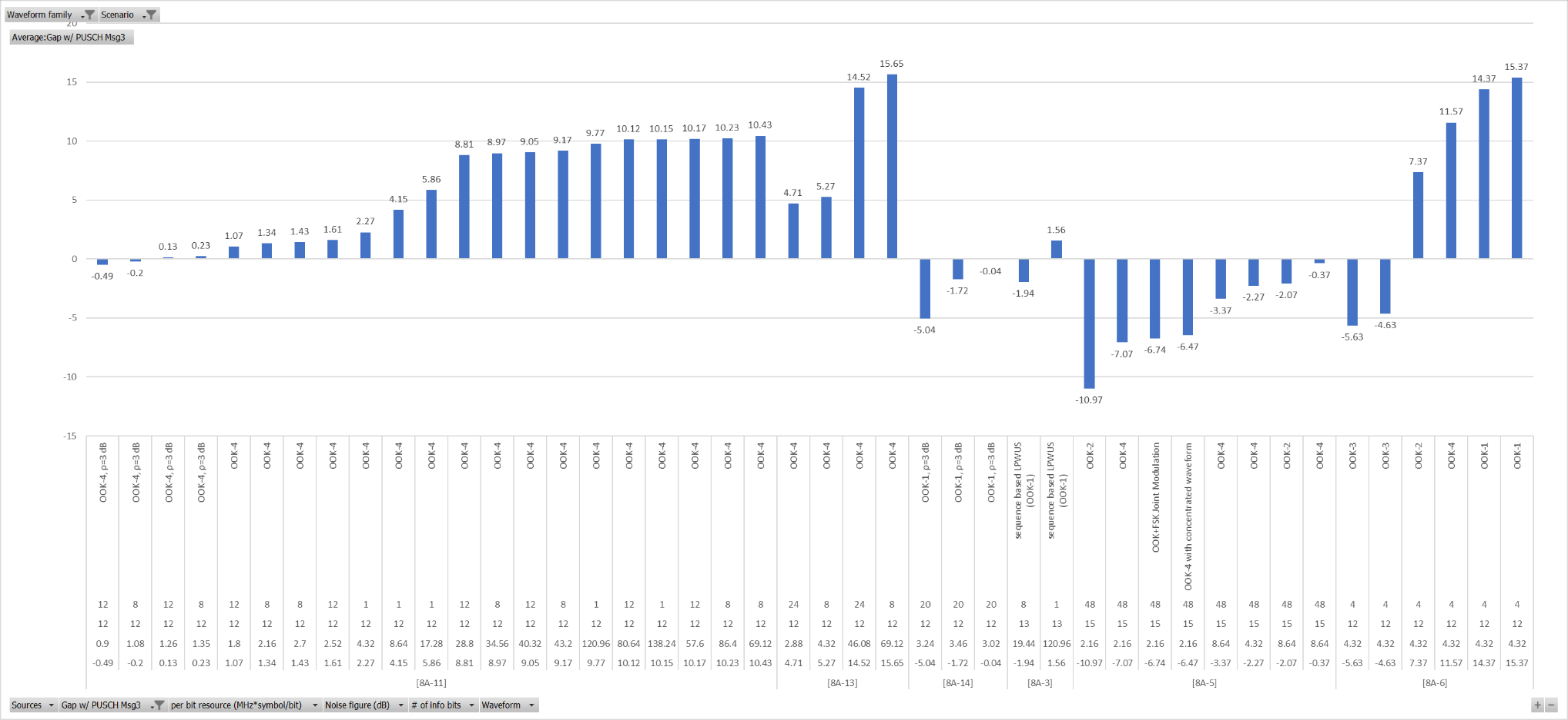

**Observation:**

For Normal UE in Rural, based on the results, [8A-3], [8A-5], [8A-6], [8A-11], [8A-13] and [8A-14] show OOK based LP-WUS is feasible to achieve comparable MIL (i.e. MIL margin Y>=-1dB) than MSG3 PUSCH,

- [8A-5], [8A-6], [8A-11] and [8A-13] show that with LP-WUS resource X=1.8~8.64 MHz\*Symbol/bit, MIL margin Y=-0.37B~11.57dB

- [8A-11] and [8A-14] show that with LP-WUS resource X=0.9~3.02 MHz\*Symbol/bit, MIL margin Y=-0.49dB~-0.04dB, assuming 3dB power boosting for LP-WUS.

- [8A-3] shows that with LP-WUS resource X=120.96 MHz\*Symbol/bit, MIL margin Y=1.56dB, assuming 4dB HARQ gain from 2 retransmissions for Msg3 PUSCH.

#### 8.2.3.4 OOK, Rural, Redcap UE, Msg.3

Table 8.2.3.4: OOK, Rural, Redcap UE, Msg.3

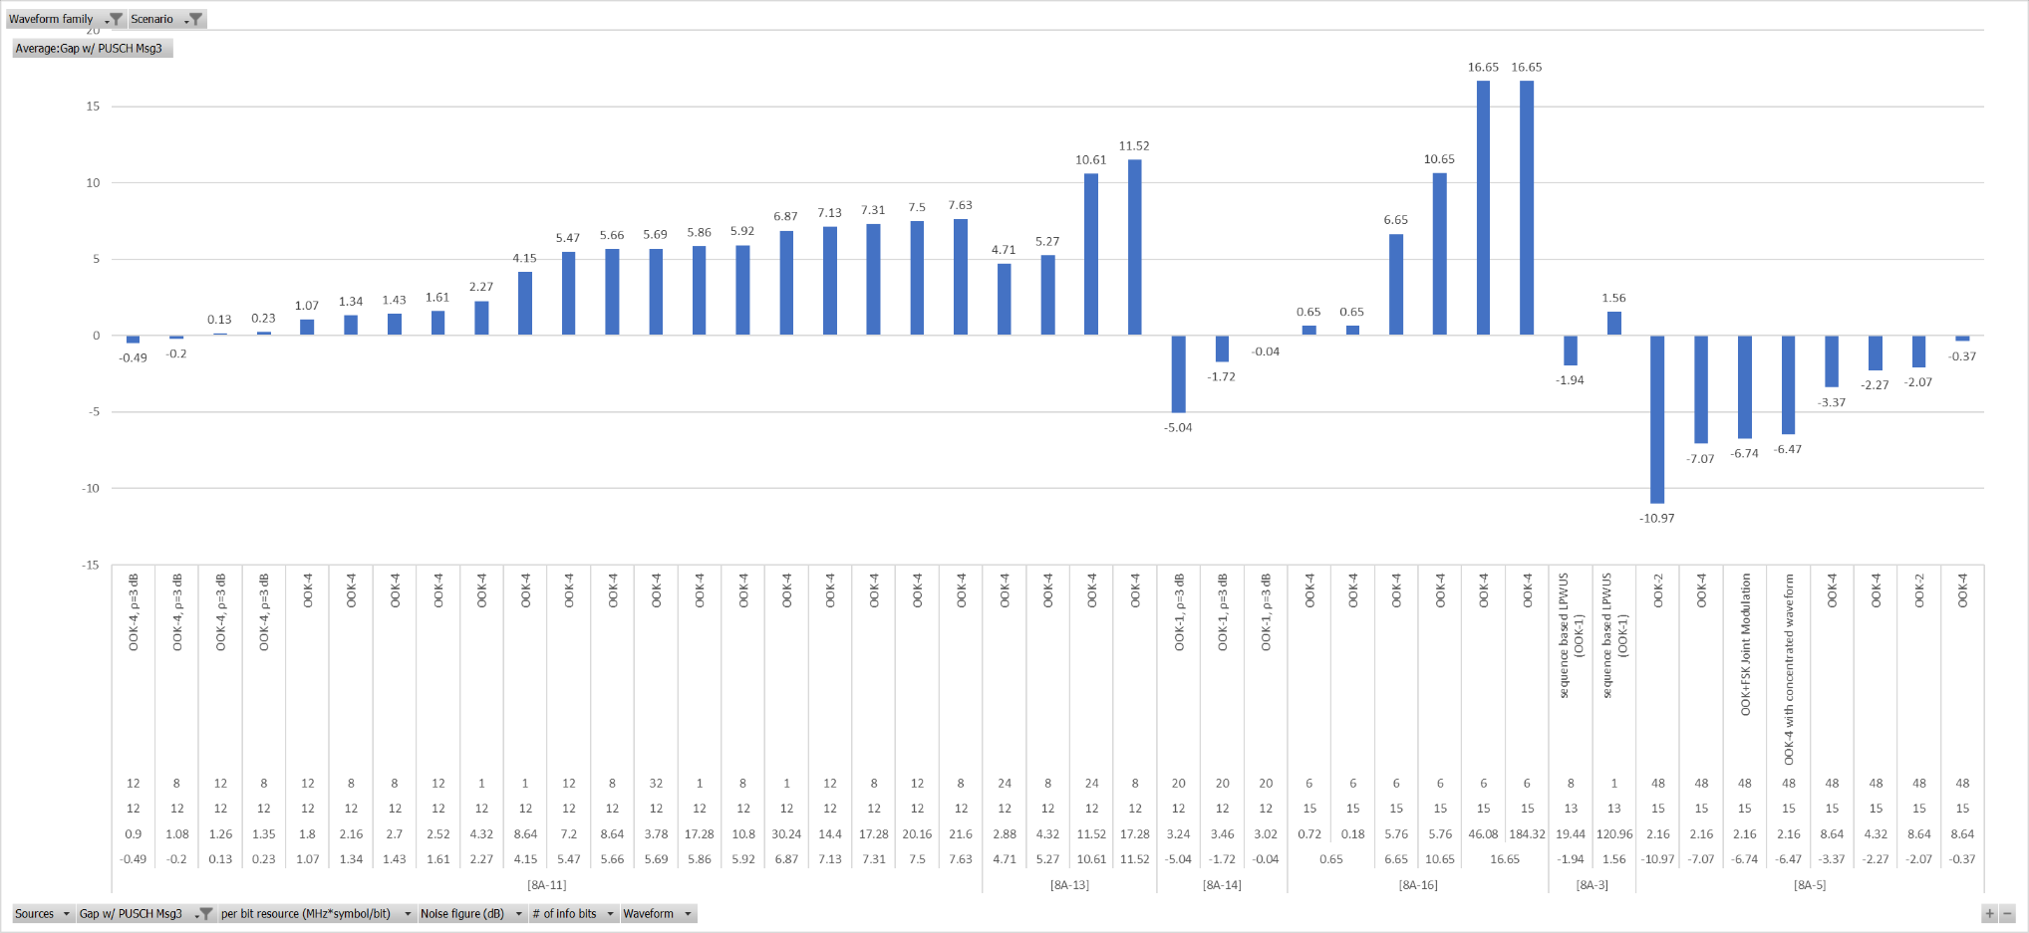

**Observation:**

For RedCap UE in Rural, based on the results, [8A-3], [8A-5], [8A-16], [8A-11], [8A-13] and [8A-14] show OOK based LP-WUS is feasible to achieve comparable MIL (i.e. MIL margin Y>=-1dB) than MSG3 PUSCH,

- [8A-5], [8A-11], [8A-13] and [8A-16] show that with LP-WUS resource X = 0.18 ~ 8.64 MHz\*Symbol/bit, MIL margin Y=-0.37dB~4.71dB, assuming no power boosting for LP-WUS

- [8A-11] and [8A-14] show that with LP-WUS resource X=0.9~3.02 MHz\*Symbol/bit, MIL margin Y=-0.49dB~-0.04dB, assuming 3dB power boosting for LP-WUS

- [8A-3] shows that with LP-WUS resource X=120.96 MHz\*Symbol/bit, MIL margin Y=1.56dB, assuming 4dB HARQ gain from 2 retransmissions for Msg3 PUSCH.

#### 8.2.3.5 FSK, Rural, normal UE, PDCCH

No input

#### 8.2.3.6 FSK, Rural, Redcap UE, PDCCH

No input

#### 8.2.3.7 FSK, Rural, Normal UE, Msg.3

Table 8.2.3.7: FSK, Rural, Normal UE, Msg.3

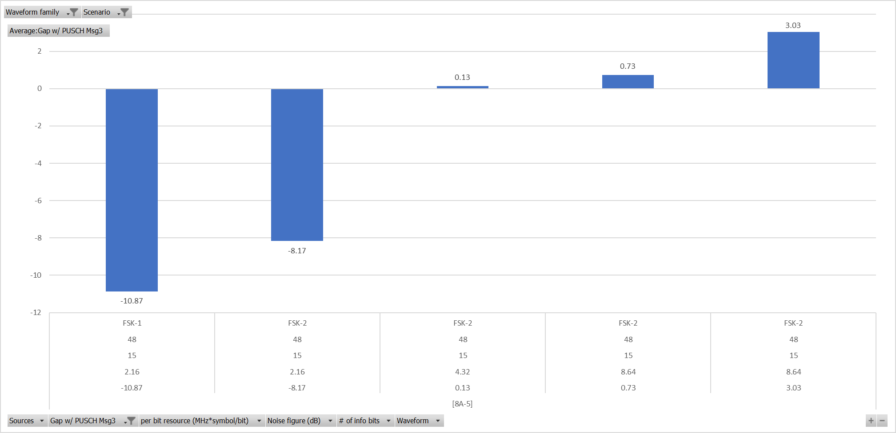

Observation:

For normal UE and Rural scenario, [8A-5] shows FSK based LP-WUS is feasible to achieve comparable MIL (i.e. MIL margin Y>=-1dB) than MSG3 PUSCH when

- LP-WUS resource X=4.32MHz\*Symbol/bit, MIL margin Y=0.13dB

#### 8.2.3.8 FSK, Rural, Redcap UE, Msg.3

Table 8.2.3.8: FSK, Rural, Redcap UE, Msg.3



**Observation:**

For RedCap UE and Rural scenario, [8A-5] shows FSK based LP-WUS is feasible to achieve comparable MIL (i.e. MIL margin Y>=-1dB) than MSG3 PUSCH when

- LP-WUS resource X=4.32MHz\*Symbol/bit, MIL margin Y=0.13dB

#### 8.2.3.9 OFDM, Rural, normal UE, PDCCH

**Gap with PDCCH AL16, 2Rx**

Table 8.2.3.9-1 Gap with PDCCH AL16, 2Rx

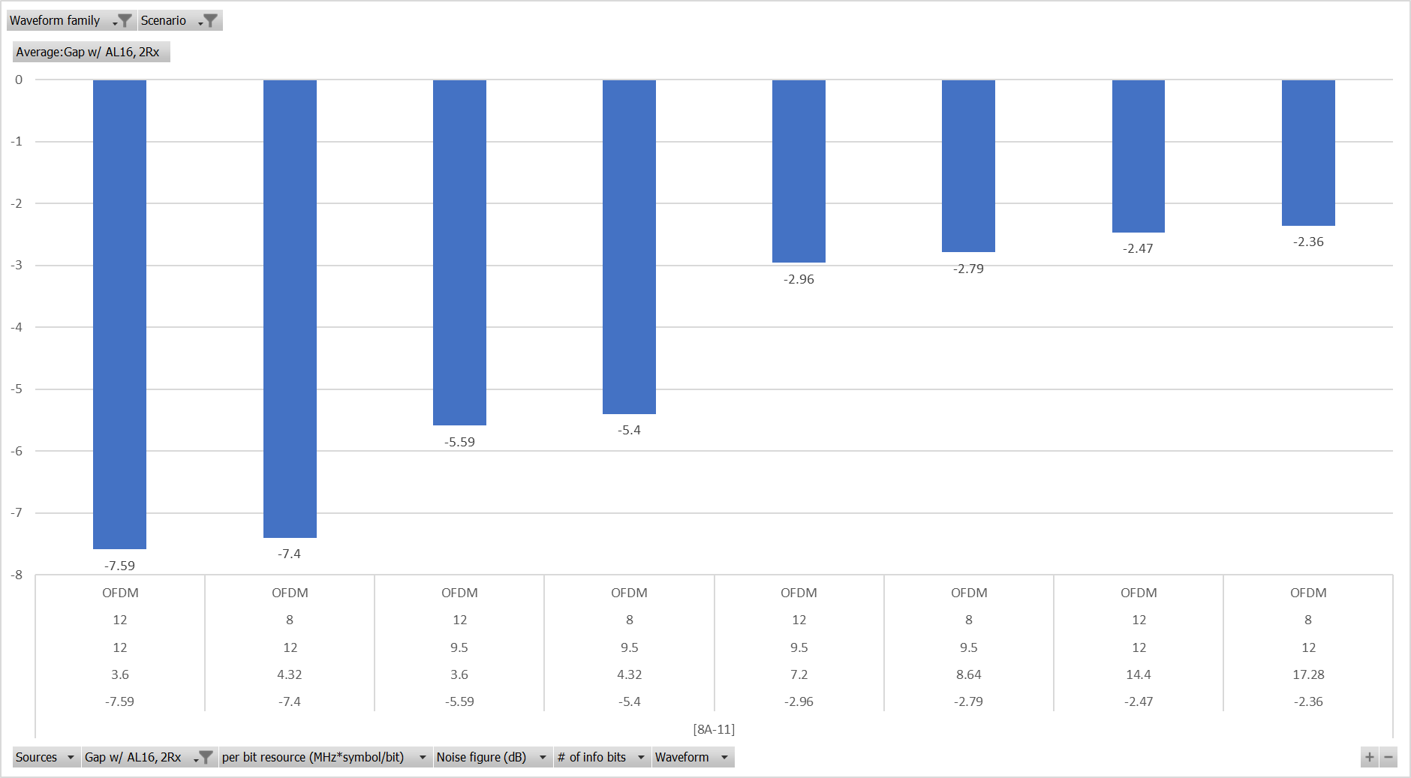

**Observation:**

- For normal UE and Rural scenario, comparing MIL of OFDM based LP-WUS to legacy PDCCH AL16, 2Rx

- [8A-11] show that with the LP-WUS resource of X=17.28 MHz\*Symbol/bit, the MIL margin Y is -2.36 dB.

**Gap with PDCCH AL8 2Rx**

Table 8.2.3.9-2: Gap with PDCCH AL8, 2Rx

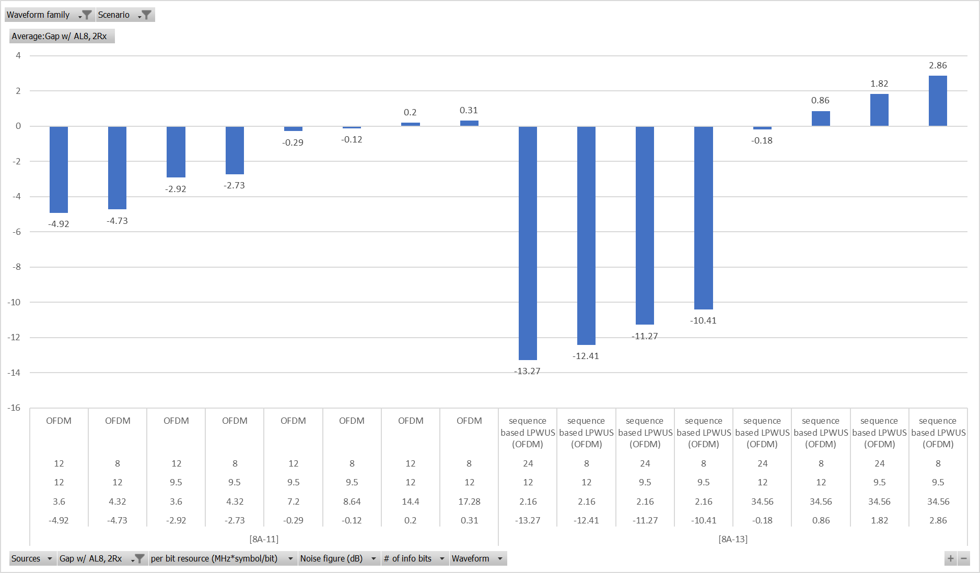

**Observation:**

For normal UE and Rural scenario, [8A-11] and [8A-13] show OFDM based LP-WUS is feasible to achieve comparable MIL (i.e. MIL margin Y>=-1dB) than MSG3 PUSCH

- [8A-13] shows that with LP-WUS resource X=34.56 MHz\*Symbol/bit, MIL margin Y=-0.18dB

- [8A-11] shows that with LP-WUS resource X=7.2MHz\*Symbol/bit, MIL margin Y=-0.29dB

#### 8.2.3.10 OFDM, Rural, Redcap UE, PDCCH

**Gap with PDCCH AL16 1Rx**

Table 8.2.3.10-1: Gap with PDCCH AL16 1Rx

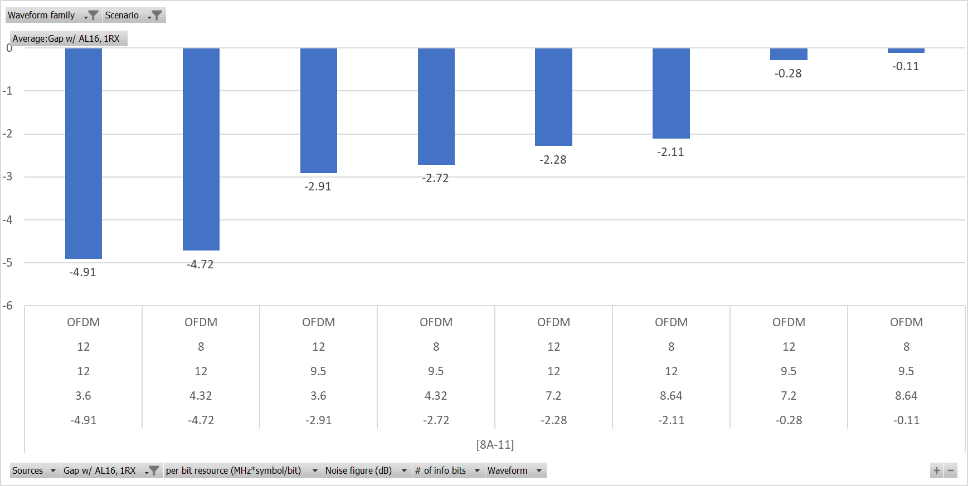

**Observation:**

For Redcap UE in Rural, [8A-11] shows OFDM based LP-WUS is feasible to achieve comparable MIL (i.e. MIL margin Y>=-1dB) than PDCCH AL16 1Rx for paging when

- LP-WUS resource X=7.2 MHz\*Symbol/bit, MIL margin Y=-0.28dB

**Gap with PDCCH AL8 1Rx**

Table 8.2.3.10-2: Gap with PDCCH AL8 1Rx

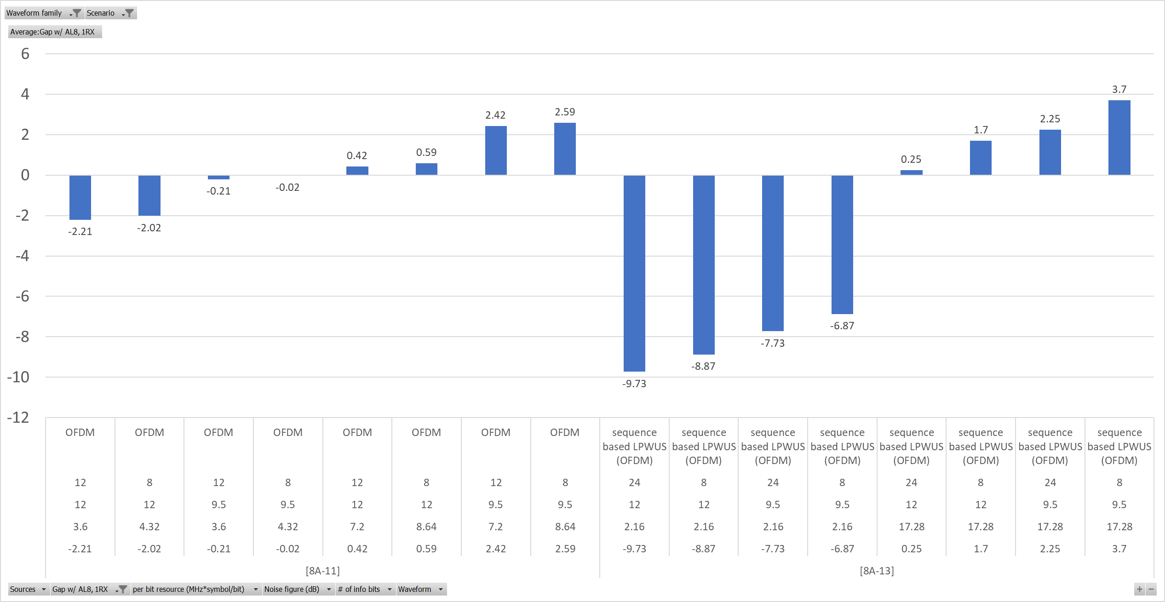

**Observation:**

For Redcap UE in Rural, [8A-11] and [8A-13] show OFDM based LP-WUS is feasible to achieve comparable MIL (i.e. MIL margin Y>=-1dB) than PDCCH AL8 1Rx for paging when

- LP-WUS resource X=3.6~17.28 MHz\*Symbol/bit, MIL margin Y=-0.21dB~3.7dB

#### 8.2.3.11 OFDM, Rural, Normal UE, Msg.3

Table 8.2.3.11: OFDM, Rural, Normal UE, Msg.3

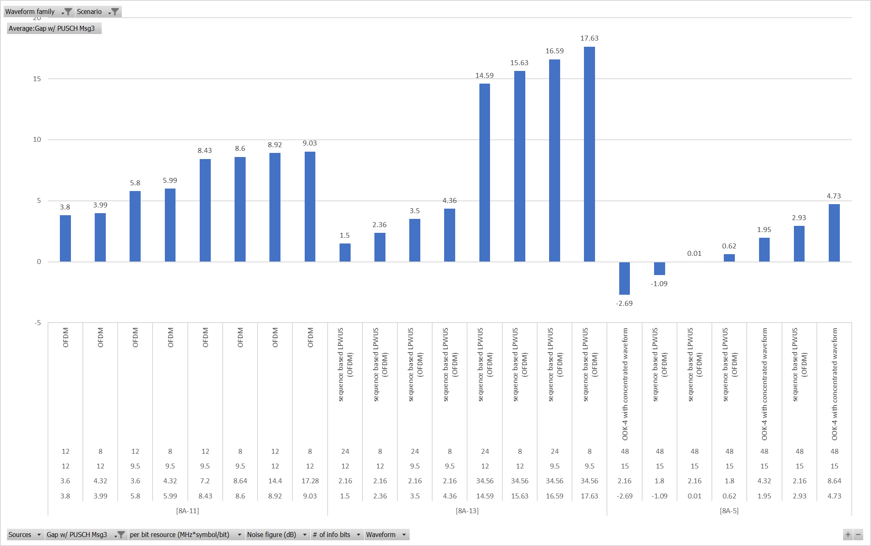

**Observation:**

For normal UE in Rural, [8A-5], [8A-11] and [8A-13] show OFDM based LP-WUS is feasible to achieve comparable MIL (i.e. MIL margin Y>=-1dB) than PUSCH for MSG.3 when

- LP-WUS resource X=1.8~3.6 MHz\*Symbol/bit, MIL margin Y=0.62dB~4.36dB

#### 8.2.3.12 OFDM, Rural, Redcap UE, Msg.3

Table 8.2.3.12: OFDM, Rural, Redcap UE, Msg.3

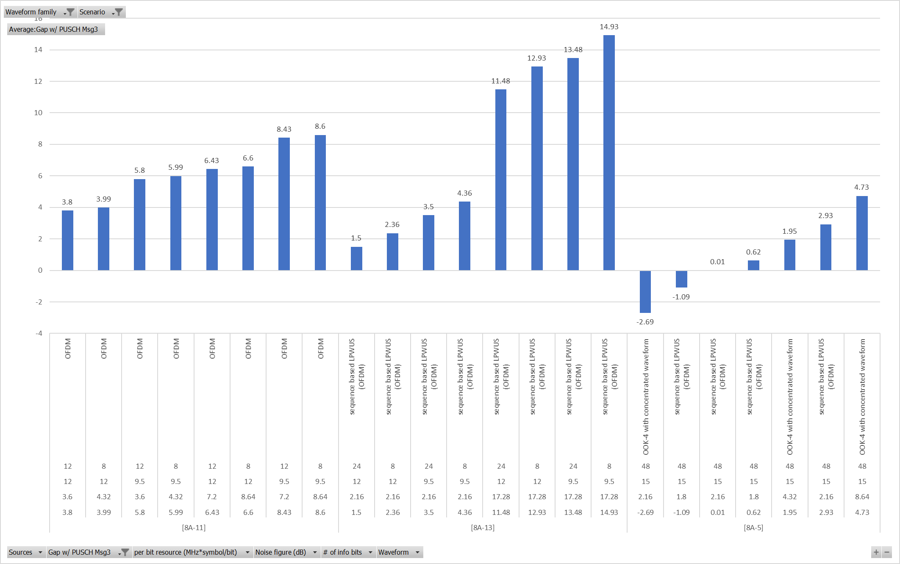

**Observation:**

For RedCap UE in Rural, [8A-5], [8A-11] and [8A-13] show OFDM based LP-WUS is feasible to achieve comparable MIL (i.e. MIL margin Y>=-1dB) than PUSCH for MSG.3 when

- LP-WUS resource X=1.8~3.6 MHz\*Symbol/bit, MIL margin Y=0.62dB~4.36dB

## 8.3 LLS results observations

In this clause and sub-clauses it is assumed that "tolerate" means that SNR degradation <= 2dB compared to error free case. Clause is based on contributed results in [8B-29].

### 8.3.1 Timing error

#### 8.3.1.1 Results for timing error (without sliding window)

The results are generated so that script finds a pair of results from a single source that differ only in timing error column. The SNR degradation is extracted, and the smallest degradation shown by a source is taken as representative value for the source.

For the following Waveforms:

- OOK-1 30kHz SCS

- OOK-1 60kHz SCS

- OOK-1 120kHz SCS

- OOK-2 M=2

- OOK-2 M=4

- OOK-3

- OOK-4 M=2

- OOK-4 M=4

- OOK-4 M>4

- FSK M=1

- FSK-1 M=2

- FSK-2 M=2

- OFDMA

With the following assumption

- ADC bit-width is 4 or more bits.

- Frequency error is 0 ppm.

- Other parameters are not restricted.

Results are captured in Table 8.3-1.

Table 8.3-1: Timing error without sliding window.

|  |  |  |  |  |  |  |  |  |
| --- | --- | --- | --- | --- | --- | --- | --- | --- |
| Te  [us] | OOK-1  30kHz SCS | | OOK-1  60kHz SCS | | OOK-1  120kHz SCS | | OOK-3 | |
| SNR deg [dB] | <2dB  sources | >=2dB  sources | <2dB  sources | >=2dB  sources | <2dB  sources | >=2dB  sources | <2dB  sources | >=2dB  sources |
| 1 | [8B-7][8B-11]  [8B-17][8B-2]  [8B-24][8B-27] |  | [8B-2][8B-17]  [8B-7][8B-28] |  | [8B-17][8B-2]  [8B-28] |  |  |  |
| 2 | [8B-7][8B-11]  [8B-17][8B-2]  [8B-24][8B-27] |  | [8B-7][8B-1][8B-21]  [8B-17][8B-2][8B-28] |  | [8B-28] | [8B-1][8B-17]  [8B-2][8B-21] | [8B-15] |  |
| 3 | [8B-17] |  | [8B-17] |  |  | [8B-17] | [8B-15] |  |
| 4 | [8B-7][8B-1]  [8B-11][8B-17]  [8B-2][8B-24][8B-27] |  | [8B-1][8B-17][8B-7] | [8B-21][8B-2]  [8B-28] |  | [8B-17][8B-2]  [8B-28][8B-21] | [8B-15] |  |
| 5 | [8B-3] |  |  |  |  |  |  |  |
| 10 |  | [8B-3] |  |  |  |  |  |  |
| 15 |  | [8B-3] |  |  |  |  |  |  |
| 20 |  | [8B-3] |  |  |  |  |  |  |
| Sampling  rate range [MHz] | 0,96-  15,36 | | 1,12-  7,68 | | 1,12-  7,68 | | 30,72-  30,72 | |
| Inner GB BW  range, if applicable [kHz] | 0-  180 | | N/A | | N/A | | N/A | |
| Total Source | [8B-7][8B-1][8B-11][8B-17]  [8B-2][8B-3][8B-24][8B-27] | | [8B-7][8B-1][8B-21]  [8B-17][8B-2][8B-28] | | [8B-1][8B-21][8B-17]  [8B-2][8B-28] | | [8B-15] | |

|  |  |  |  |  |  |  |  |  |  |  |
| --- | --- | --- | --- | --- | --- | --- | --- | --- | --- | --- |
| Te  [us] | OOK-2  M=2 | | OOK-2  M=4 | | OOK-4  M=2 | | OOK-4  M=4 | | OOK-4  M>4 | |
| SNR deg [dB] | <2dB  sources | >=2dB  sources | <2dB  sources | >=2dB  sources | <2dB  sources | >=2dB  sources | <2dB  sources | >=2dB  sources | <2dB  sources | >=2dB  sources |
| 1 | [8B-8][8B-7]  [8B-11][8B-17]  [8B-2][8B-24] |  | [8B-8][8B-7]  [8B-1][8B-11]  [8B-17][8B-2]  [8B-24] |  | [8B-7][8B-11]  [8B-17][8B-2]  [8B-24][8B-27] |  | [8B-7][8B-1]  [8B-17][8B-2]  [8B-3][8B-24] | [8B-11] | [8B-3] | [8B-1] |
| 2 | [8B-8][8B-7]  [8B-11][8B-17]  [8B-2][8B-24] |  | [8B-8][8B-1]  [8B-11][8B-17]  [8B-2][8B-24] | [8B-7] | [8B-7][8B-1]  [8B-21][8B-17]  [8B-2][8B-24]  [8B-27] | [8B-11] | [8B-13][8B-3]  [8B-7] | [8B-1][8B-11]  [8B-21][8B-17]  [8B-2][8B-24] |  | [8B-3] |
| 3 | [8B-17] |  | [8B-17] |  | [8B-17] |  | [8B-3] | [8B-17] |  | [8B-3] |
| 4 | [8B-8][8B-17]  [8B-2][8B-24] | [8B-11]  [8B-7] | [8B-8][8B-17]  [8B-2] | [8B-11][8B-7]  [8B-24] | [8B-7][8B-27] | [8B-11][8B-21]  [8B-17][8B-2]  [8B-24] | [8B-7] | [8B-11][8B-21]  [8B-17][8B-2]  [8B-3][8B-24] |  | [8B-3] |
| 5 |  |  |  |  | [8B-3] |  |  | [8B-3] |  | [8B-3] |
| 10 |  |  |  |  |  | [8B-3] |  | [8B-3] |  | [8B-3] |
| 15 |  |  |  |  |  | [8B-3] |  | [8B-3] |  | [8B-3] |
| 20 |  |  |  |  |  | [8B-3] |  | [8B-3] |  | [8B-3] |
| Sampling  rate range [MHz] | 0,96-  15,36 | | 0,96-  15,36 | | 1,92-  15,36 | | 1,92-  15,36 | | 3,4-  7,68 | |
| Inner GB BW  range, if applicable [kHz] | 120-  480 | | 120-  480 | | N/A | | N/A | | N/A | |
| Total Sources | [8B-7][8B-11]  [8B-17][8B-2][8B-24] | | [8B-7][8B-1][8B-11]  [8B-17][8B-2][8B-24] | | [8B-7][8B-1][8B-11][8B-21]  [8B-17][8B-2][8B-3]  [8B-24][8B-27] | | [8B-7][8B-1][8B-11][8B-21]  [8B-17][8B-13][8B-2]  [8B-3][8B-24] | | [8B-1][8B-3] | |

|  |  |  |  |  |  |  |  |  |
| --- | --- | --- | --- | --- | --- | --- | --- | --- |
| Te  [us] | FSK M=1 | | FSK-1  M=2 | | FSK-2  M=2 | | OFDMA | |
| SNR deg [dB] | <2dB  sources | >=2dB  sources | <2dB  sources | >=2dB  sources | <2dB  sources | >=2dB  sources | <2dB  sources | >=2dB  sources |
| 1 | [8B-7]  [8B-17][8B-24]  [8B-27] |  | ~~[8B-8]~~[8B-17]  [8B-7][8B-24] |  | [8B-7]  [8B-11] [8B-1]  [8B-17][8B-2]  [8B-24] |  | [8B-28] | 0 |
| 2 | [8B-17]  [8B-7][8B-27] | [8B-24] | [8B-17] | [8B-7][8B-24] | [8B-17][8B-2]  [8B-11] [8B-1] | [8B-7]  [8B-24] | [8B-28] | 0 |
| 3 | [8B-17] |  | [8B-17] |  | [8B-1] [8B-17] |  |  |  |
| 4 | [8B-17][8B-27] | [8B-7][8B-24] | [8B-17] | [8B-7][8B-24] | [8B-1][8B-17]  [8B-2] | [8B-11]  [8B-7][8B-24] | [8B-28] | 0 |
| 10 | 0 |  | 0 |  | 0 |  |  |  |
| Sampling  rate range [MHz] | 0,96-  8,64 | | 0,96-  8,64 | | 0,96-  15,36 | | 3,84-  7,68 | |
| Inner GB BW  range, if applicable [kHz] | 0-  480 | | 180-  480 | | 0-  480 | | N/A | |
| Total Sources | [8B-7][8B-17]  [8B-24][8B-27] | | [8B-17][8B-7][8B-24] | | [8B-7][8B-1][8B-11]  [8B-17][8B-2][8B-24] | | [8B-28] | |

Table 8.3-2: Tolerance to timing error by waveform

|  |  |  |
| --- | --- | --- |
| Waveform | Tolerance up to timing error [us] | Note |
| OOK-1 30kHz SCS | 5 |  |
| OOK-1 60kHz SCS | 3 |  |
| OOK-1 120kHz SCS | 1 |  |
| OOK-3 | 4 | single source |
| OOK-2 M=2 | 4 |  |
| OOK-2 M=4 | 3 |  |
| OOK-4 M=2 | 3 |  |
| OOK-4 M=4 | 1 | [8B-2] shows that performance degrade more than 2dB for 1us, with assumption of TDL-C 1000ns, but degrades <2dB for 1us with assumption of TDL-C 300ns. The 300ns delay spread was baseline. |
| OOK-4 M>4 | 1 |  |
| FSK M=1 | 2 |  |
| FSK-1 M=2 | 1 |  |
| FSK-2 M=2 | 2/3 | [8B-1] [8B-17] sources showed tolerance up to 3us. |
| OFDMA | 4 | [8B-28] shows that OFDMA can be tolerant up to 4us. |

#### 8.3.1.1A Observation for timing error (without sliding window):

There are the following observations for timing error from Table 8.3-2:

- OOK/FSK waveform with longer time segment and with a single or multiple frequency segments is comparable (0 us) or more robust (up to 4us) to timing error than waveform with shorter time segment.

- [8B-28] shows that without sliding window, OFDMA tolerates up to 4us timing error, when SCS <=30kHz, and receiver did not perform FFT.

#### 8.3.1.2 Results for timing error (with sliding window)

For the following waveforms:

- OOK-1 30kHz SCS

- OOK-1 60kHz SCS

- OOK-1 120kHz SCS

- OOK-2 M=2

- OOK-2 M=4

- OOK-3

- OOK-4 M=2

- OOK-4 M=4

- OOK-4 M>4

- FSK M=1

- FSK-1 M=2

- FSK-2 M=2

- OFDMA

With the following assumption

- ADC bit-width is 4 or more bits.

- Frequency error is 0 ppm.

- Other parameters are not restricted.

Results are presented in Table 8.3-3:

Table 8.3-3: Timing error with time sliding window

|  |  |  |  |  |  |  |
| --- | --- | --- | --- | --- | --- | --- |
| Te  [us] | OOK-1  30kHz SCS | | OOK-2  M=2 | | OOK-2  M=4 | |
| SNR deg [dB] | <2dB  sources | >=2dB  sources | <2dB  sources | >=2dB  sources | <2dB  sources | >=2dB  sources |
| 1 | [8B-8] |  | [8B-8] |  | [8B-8] |  |
| 2 | [8B-8] |  | [8B-8] |  | [8B-8] |  |
| 4 | [8B-8] |  | [8B-8] |  | [8B-8] |  |
| 10 | [8B-8] |  | [8B-8] |  | [8B-8] |  |
| Sampling  rate range [MHz] | 0,96-  7,68 | | 0,96-  7,68 | | 0,96-  7,68 | |
| Inner GB BW  range, if applicable [kHz] | N/A | | 180-  180 | | 180-  180 | |
| Total Source | [8B-8] | | [8B-8] | | [8B-8] | |

|  |  |  |  |  |  |  |
| --- | --- | --- | --- | --- | --- | --- |
| Te  [us] | FSK M=1 | | FSK-1  M=2 | | FSK-2  M=2 | |
| SNR deg [dB] | <2dB  sources | >=2dB  sources | <2dB  sources | >=2dB  sources | <2dB  sources | >=2dB  sources |
| 1 | [8B-8] |  | [8B-8] |  | [8B-8] |  |
| 2 | [8B-8] |  |  | [8B-8] |  | [8B-8] |
| 3 |  |  |  |  |  |  |
| 4 |  | [8B-8] |  | [8B-8] |  | [8B-8] |
| 10 |  | [8B-8] |  | [8B-8] |  | [8B-8] |
| Sampling  rate range [MHz] | 0,96-  7,68 | | 0,96-  7,68 | | 0,96-  7,68 | |
| Inner GB BW  range, if applicable [kHz] | 180-  180 | | 180-  180 | | 180-  180 | |
| Total Sources | [8B-8] | | [8B-8] | | [8B-8] | |

|  |  |  |
| --- | --- | --- |
| Te  [us] | OFDMA | |
| SNR deg [dB] | <2dB  sources | >=2dB  sources |
| 1 | [8B-2][8B-21] [8B-15] |  |
| 2 | [8B-25][8B-17][8B-13][8B-15] | [8B-21] |
| 3 |  | [8B-15] |
| 4 | [8B-25][8B-21] |  |
| 10 |  |  |
| Sampling  rate range [MHz] | 3,84  30,72 | |
| Inner GB BW  range, if applicable [kHz] | N/A | |
| Total Sources | [8B-15][8B-21][8B-17][8B-2]  [8B-13][8B-25] | |

#### 8.3.1.2A Observation for timing error (with sliding window):

There are the following observations for timing error in Table 8.3-3:

- For OFDMA, tolerance to timing error varies with sliding window size assumed by a receiver and was shown to tolerate timing error up to 4us if proper sliding window size is assumed by a receiver.

### 8.3.2 Frequency error

#### 8.3.2.1 Results for frequency error

Theresults are generated so that script finds a pair of results from a single source that differ only in frequency error column. The SNR degradation is extracted, and the smallest degradation shown by company is taken as representative value for the source.

For the following waveforms:

- OOK-1 30kHz SCS

- OOK-1 60kHz SCS

- OOK-1 120kHz SCS

- OOK-2 M=2

- OOK-2 M=4

- OOK-3

- OOK-4 M=2

- OOK-4 M=4

- OOK-4 M>4

- FSK M=1

- FSK-1 M=2

- FSK-2 M=2

- OFDMA

With the following assumptions:

- ADC bit-width is 4 or more bits.

- Timing error is 0 micro sec.

- Other parameters are not restricted.

Results are presented in Table 8.3-4:

Table 8.3-4: Frequency error robustness for different waveforms

|  |  |  |  |  |  |  |  |  |  |  |  |
| --- | --- | --- | --- | --- | --- | --- | --- | --- | --- | --- | --- |
| Fe  [kHz] | OOK-1  30kHz SCS | | Fe  [kHz] | OOK-1  60kHz SCS | | Fe  [kHz] | OOK-1  120kHz SCS | | Fe  [kHz] | OOK-2  M=2 | |
|  | <2dB  sources | >=2dB  sources |  | <2dB  sources | >=2dB  sources |  | <2dB  sources | >=2dB  sources |  | <2dB  sources | >=2dB  sources |
| 2 | [8B-17] |  | 2 | [8B-17] |  | 2 | [8B-17] |  | 2 | [8B-17] |  |
| 2,6 | [8B-8] |  | 4 | [8B-17] |  | 4 | [8B-17] |  | 2,6 | [8B-8] |  |
| 4 | [8B-17] |  | 10 | [8B-17] |  | 10 | [8B-17] |  | 4 | [8B-17] |  |
| 5,2 | [8B-8] |  | 13 | [8B-2][8B-7] |  | 20 | [8B-17] |  | 5,2 | [8B-8] |  |
| 10 | [8B-17] |  | 20 | [8B-17] |  | 26 | [8B-2] |  | 13 | [8B-8][8B-2]  [8B-7] |  |
| 13 | [8B-8][8B-27]  [8B-2]  [8B-7] |  | 26 | [8B-2] |  | 40 | [8B-21] |  | 20 | [8B-17] |  |
| 20 | [8B-17] |  | 40 | [8B-21] |  | 100 | [8B-17] |  | 26 | [8B-8][8B-2] |  |
| 26 | [8B-8][8B-27]  [8B-2] |  | 100 | [8B-17] |  | 200 | [8B-17] |  | 40 | [8B-24] |  |
| 40 | [8B-24] |  | 200 | [8B-7] |  | 260 | [8B-1] |  | 52 | [8B-7] |  |
| 100 | [8B-17] |  | 260 | [8B-17] |  | 300 | [8B-17] |  | 100 | [8B-17] |  |
| 130 | [8B-22][8B-8]  [8B-11][8B-3]  [8B-7][8B-27] |  | 300 | [8B-7][8B-1] |  | 400 | [8B-21][8B-17] |  | 130 | [8B-8][8B-25]  [8B-7][8B-11] |  |
| 200 | [8B-24][8B-17] |  | 400 | [8B-17] |  |  |  |  | 200 | [8B-24][8B-17] |  |
| 260 | [8B-1][8B-8]  [8B-11][8B-3]  [8B-7] |  |  |  |  |  |  |  | 260 | [8B-8][8B-11]  [8B-7] |  |
| 300 | [8B-17] |  |  |  |  |  |  |  | 300 | [8B-17] |  |
| 390 | [8B-3] |  |  |  |  |  |  |  | 400 |  | [8B-24] |
| 400 | [8B-24][8B-17] |  |  |  |  |  |  |  | 520 |  | [8B-25][8B-11] |
| 520 | [8B-11][8B-3]  [8B-22][8B-7] |  |  |  |  |  |  |  | 600 |  | [8B-24] |
| 600 | [8B-24] |  |  |  |  |  |  |  | 800 |  | [8B-24] |
| 800 | [8B-24] |  |  |  |  |  |  |  |  |  |  |
|  |  |  |  |  |  |  |  |  |  |  |  |
| Sampling  rate range [MHz] | 0,96-  15,36 | |  | 1,12-  4,32 | |  | 1,12-  4,32 | |  | 0,96-  15,36 | |
| Inner GB BW  range, if applicable [kHz] | N/A | |  | N/A | |  | N/A | |  | 120-  480 | |
| # of sources  with/wo time domain  sliding window | [8B-8]/  [8B-24][8B-17]  [8B-22][8B-1] [8B-2][8B-11]  [8B-3][8B-7][8B-27] | |  | [-]/  [8B-17][8B-21]  [8B-1][8B-2][8B-7] | |  | [-]  [8B-21][8B-17][8B-2][8B-1] | |  | [8B-8]/ [8B-24][8B-17][8B-25]  [8B-2][8B-11][8B-7] | |
| # of sources with/wo  frequency adjustment | [-]/  [8B-8][8B-24][8B-17]  [8B-22][8B-1] [8B-2][8B-11]  [8B-3][8B-7][8B-27] | |  | [-]/  [8B-17][8B-21]  [8B-1][8B-2][8B-7] | |  | [-] [8B-21][8B-17][8B-2][8B-1] | |  | [-]/ [8B-24][8B-17][8B-25]  [8B-8][8B-2][8B-11][8B-7] | |

|  |  |  |  |  |  |  |  |  |  |  |  |
| --- | --- | --- | --- | --- | --- | --- | --- | --- | --- | --- | --- |
| Fe  [kHz] | OOK-2  M=4 | | Fe  [kHz] | OOK=4  M=2 | | Fe  [kHz] | OOK=4  M=4 | | Fe  [kHz] | OOK=4  M>4 | |
|  | <2dB  sources | >=2dB  sources |  | <2dB  sources | >=2dB  sources |  | <2dB  sources | >=2dB  sources |  | <2dB  sources | >=2dB  sources |
| 2 | [8B-17] |  | 2 | [8B-17] |  | 2 | [8B-17] |  | 130 | [8B-3] |  |
| 2,6 | [8B-8] |  | 4 | [8B-17] |  | 4 | [8B-17] |  | 260 | [8B-3][8B-1] |  |
| 4 | [8B-17] |  | 10 | [8B-17] |  | 7 | [8B-13] |  | 390 | [8B-3] |  |
| 5,2 | [8B-8] |  | 13 | [8B-27][8B-2]  [8B-7] |  | 10 | [8B-17] |  |  |  |  |
| 13 | [8B-8][8B-2]  [8B-7] |  | 20 | [8B-17] |  | 13 | [8B-2] |  |  |  |  |
| 20 | [8B-17] |  | 26 | [8B-27][8B-2] |  | 20 | [8B-17] |  |  |  |  |
| 26 | [8B-8][8B-2]  [8B-1] |  | 32 | [8B-24] |  | 26 | [8B-13][8B-2] |  |  |  |  |
| 40 | [8B-24] |  | 40 | [8B-21][8B-24] |  | 40 | [8B-21][8B-24]  [8B-13] |  |  |  |  |
| 52 | [8B-7] |  | 100 | [8B-17] |  | 52 | [8B-2] |  |  |  |  |
| 100 | [8B-17] |  | 130 | [8B-25][8B-3]  [8B-11][8B-7]  [8B-27] |  | 100 | [8B-17] |  |  |  |  |
| 130 | [8B-8][8B-11]  [8B-22] | [8B-7] | 200 | [8B-24][8B-17] |  | 130 | [8B-25][8B-22]  [8B-3][8B-2]  [8B-11] |  |  |  |  |
| 200 | [8B-24][8B-17] |  | 260 | [8B-11][8B-3]  [8B-7][8B-1] |  | 200 | [8B-24][8B-17] |  |  |  |  |
| 260 |  | [8B-8][8B-11][8B-7] | 300 | [8B-24] |  | 260 | [8B-11][8B-3]  [8B-1] |  |  |  |  |
| 300 | [8B-17] |  | 390 | [8B-3] |  | 390 | [8B-3] |  |  |  |  |
| 400 | [8B-24] |  | 400 | [8B-21][8B-24]  [8B-17] |  | 400 | [8B-21][8B-24][8B-17] |  |  |  |  |
| 520 |  | [8B-11][8B-22] | 520 | [8B-11][8B-3][8B-7] |  | 520 | [8B-11][8B-3]  [8B-22] |  |  |  |  |
| 600 | [8B-24] |  | 600 | [8B-24] |  | 600 | [8B-24] |  |  |  |  |
| 800 | [8B-24] |  | 800 | [8B-24] |  | 800 | [8B-24] |  |  |  |  |
|  |  |  | 1200 | [8B-24] |  |  |  |  |  |  |  |
|  |  |  |  |  |  |  |  |  |  |  |  |
|  |  |  |  |  |  |  |  |  |  |  |  |
| Sampling  rate range [MHz] | 0,96-  15,36 | |  | 1,92-  15,36 | |  | 1,92-  15,36 | |  | 3,4-  7,68 | |
| Inner GB BW  range, if applicable [kHz] | 120-  480 | |  | N/A | |  | N/A | |  | N/A | |
| # of sources  with/wo time domain  sliding window | [8B-8]/  [8B-24][8B-17][8B-22]  [8B-1][8B-8][8B-2][8B-11][8B-7] | |  | [-]/ [8B-24][8B-17][8B-25]  [8B-21][8B-1][8B-2][8B-11]  [8B-3][8B-7][8B-27] | |  | [-]/  [8B-24][8B-17][8B-25]  [8B-13][8B-21][8B-22]  [8B-1][8B-2][8B-11][8B-3] | |  | |  | | --- | |  | | [-] /  [8B-3][8B-1] | |  | | |
| # of sources with/wo  frequency adjustment | [-]/  [8B-24][8B-17][8B-22]  [8B-1][8B-8][8B-2]  [8B-11][8B-7] | |  | [-]/ [8B-24][8B-17][8B-25]  [8B-21][8B-1][8B-2]  [8B-11][8B-3][8B-7][8B-27] | |  | [-]/  [8B-24][8B-17][8B-25]  [8B-13][8B-21][8B-22]  [8B-1][8B-2][8B-11][8B-3] | |  | |  | | --- | | [-]/ | | [8B-3][8B-1] | |  | | |

|  |  |  |  |  |  |  |  |  |  |  |  |
| --- | --- | --- | --- | --- | --- | --- | --- | --- | --- | --- | --- |
| Fe  [kHz] | FSK M=1 | | Fe  [kHz] | FSK-1  M=2 | | Fe  [kHz] | FSK-2  M=2 | | Fe  [kHz] | OFDMA | |
|  | <2dB  sources | >=2dB  sources |  | <2dB  sources | >=2dB  sources |  | <2dB  sources | >=2dB  sources |  | <2dB  sources | >=2dB  sources |
| 2,6 | [8B-8][8B-17]  [8B-27] |  | 2,6 | [8B-8] | 0 | 2,6 | [8B-8][8B-17] |  | 1,4 | [8B-13] | 0 |
| 5,2 | [8B-8][8B-17]  [8B-27] |  | 5,2 | [8B-8][8B-17] | 0 | 5,2 | [8B-8][8B-17] |  | 2 | [8B-17] | 0 |
| 13 | [8B-8][8B-27]  [8B-7] |  | 13 | [8B-8][8B-7] | 0 | 13 | [8B-8][8B-2] |  | 2,6 | [8B-27][8B-7] [8B-15] | 0 |
| 26 | [8B-8][8B-17] |  | 26 | [8B-8][8B-17] | 0 | 26 | [8B-8][8B-17]  [8B-2] |  | 3,5 | [8B-13] | 0 |
| 32 | [8B-24] |  | 40 | [8B-24] | 0 | 40 | [8B-24] |  | 5,2 | [8B-13][8B-7] [8B-15] | [8B-27] |
| 40 | [8B-24] |  | 52 | [8B-7] | 0 | 130 | [8B-8][8B-17]  [8B-11][8B-1] |  | 7 | [8B-13] |  |
| 52 | [8B-7] |  | 130 | [8B-8][8B-17] | [8B-7] | 200 | [8B-24] |  | 8 | [8B-21][8B-13] |  |
| 130 | [8B-8][8B-17]  [8B-27][8B-7] |  | 200 |  | [8B-24] | 260 | [8B-8][8B-1] | [8B-17][8B-11] | 13 | [8B-13] | [8B-15][8B-7] |
| 200 | [8B-24] |  | 260 | [8B-8] | [8B-17][8B-7] | 400 | 0 | [8B-24] | 20 | [8B-17] | [8B-13] |
| 260 | [8B-8][8B-17][8B-7] |  | 400 |  | [8B-24] | 520 | 0 | [8B-11] | 26 | [8B-25][8B-2][8B-7] | [8B-13] |
| 300 | [8B-24] |  | 520 |  | [8B-17] | 600 | 0 | [8B-24] | 40 |  | [8B-13] |
| 400 |  | [8B-24] | 600 |  | [8B-24] | 800 | 0 | [8B-24] | 52 | [8B-2] |  |
| 520 |  | [8B-17][8B-25] |  |  |  |  |  | 0 | 100 |  | [8B-17] |
| 600 |  | [8B-24] |  |  |  |  |  |  | 200 |  | [8B-17] |
| 800 |  | [8B-24] |  |  |  |  |  |  | 300 |  | [8B-17] |
| 1200 |  | [8B-24] |  |  |  |  |  |  | 400 |  | [8B-17] |
|  |  |  |  |  |  |  |  |  |  |  |  |
|  |  |  |  |  |  |  |  |  |  |  |  |
|  |  |  |  |  |  |  |  |  |  |  |  |
| Sampling  rate range [MHz] | 0,96-  10 | |  | 0,96-  8,64 | |  | 0,96-  15,36 | |  | 3,84-  50 | |
| Inner GB BW  range, if applicable [kHz] | 0-  480 | |  | 120-  480 | |  | 0-  480 | |  | N/A | |
| # of sources  with/wo time domain  sliding window | [8B-8]/  [8B-24][8B-17][8B-25]  [8B-8][8B-7][8B-27] | |  | [8B-8]/  [8B-24] [8B-17][8B-7] | |  | [8B-8]/ [8B-24][8B-17][8B-1][8B-8][8B-2][8B-11] | |  | [-]/  [8B-17][8B-25][8B-13]  [8B-21][8B-15][8B-2][8B-27] | |
| # of sources with/wo  frequency adjustment | [8B-8]/  [8B-24][8B-17][8B-25]  [8B-8][8B-7][8B-27] | |  | [8B-8]/  [8B-24] [8B-17][8B-7] | |  | [8B-8]/ [8B-24][8B-17][8B-1][8B-8][8B-2][8B-11] | |  | [-]/  [8B-17][8B-25][8B-13]  [8B-21][8B-15][8B-2][8B-27] | |

|  |  |  |
| --- | --- | --- |
| Fe  [kHz] | OOK-3 | |
|  | <2dB  sources | >=2dB  sources |
| 9.984 | [8B-15] |  |
| 13 |  | [8B-15] |
|  |  |  |
| Sampling  rate range [MHz] | 30,72-  30,72 | |
| Inner GB BW  range, if applicable [kHz] | N/A | |
| # of sources  with/wo time domain sliding window | [-]/  [8B-15] | |
| # of sources with/wo  frequency adjustment | [-]/  [8B-15] | |

Frequency error tolerance for the waveform is captured by the following Table 8.3-5.

Table 8.3-5: Frequency tolerance of waveforms

|  |  |  |
| --- | --- | --- |
| Waveform | Tolerance up to frequency error [kHz] | Note |
| OOK-1  30kHz SCS | 800 | max simulated value |
| OOK-1  60kHz SCS | 400 | max simulated value |
| OOK-1  120kHz SCS | 400 | max simulated value |
| OOK-3 | 9.984 | [8B-15] result |
| OOK-2 M=2 | 300 |  |
| OOK-2 M=4 | 200 | 4 segment OOK-2 is less robust than 2 segment OOK-2 |
| OOK-4 M=2 | 1200 | max simulated value |
| OOK-4 M=4 | 800 | max simulated value |
| OOK-4 M>4 | 390 | max simulated value |
| FSK M=1 | 300 | two segments [8B-8]assumes frequency adjustment which may cause frequency error |
| FSK-1 M=2 | 130 | four segments, and 2 are ON at given time [8B-8] assumes frequency adjustment which may cause frequency error |
| FSK-2 M=2 | 200 | four segments, but only 1 is ON  [8B-8] assumes frequency adjustment which may cause frequency error |
| OFDMA | 26 |  |

#### 8.3.2.1A Observation for frequency error

There are the following observations for frequency error Table 8.3-5:

- Single frequency segment OOK (except OOK3) waveform is more robust to frequency error (of 390 kHz) than OOK/FSK waveforms with multiple frequency segments (depending on guard-band size between segments) and both are more robust than OFDMA waveform assuming no frequency compensation/synchronization.

- [8B-1] showed that single frequency segment FSK2-envelop-IF waveform is more robust to frequency error (of 260 kHz) than OOK/FSK waveforms with multiple frequency segments (depending on guard-band size between segments) and both are more robust than OFDMA waveform assuming no frequency compensation/ synchronization.

### 8.3.3 Spectral efficiency

For the following waveforms:

- OOK-1 30kHz SCS

- OOK-1 60kHz SCS

- OOK-1 120kHz SCS

- OOK-2 M=2

- OOK-2 M=4

- OOK-3

- OOK-4 M=2

- OOK-4 M=4

- OOK-4 M>4

- FSK M=1

- FSK-1 M=2

- FSK-2 M=2

- OFDMA

With the following assumptions:

- Timing error = 0us.

- Frequency error = 0ppm.

- Only TDL-C results.

- Other parameters are not restricted.

- table includes results across different receiver types, different power pooling assumption, different sampling rates, different tx antenna configurations, FAR target for the same waveform.

- best result within a company/source is considered for the table.

Table 8.3-6 presents the results:

Table 8.3-*6*: Spectral efficiency for different range and waveforms

|  |  |  |  |  |  |
| --- | --- | --- | --- | --- | --- |
| OOK-1 30kHz | | | | | |
| SNR Range [dB] | SE median [dB] | SE average [b/s/Hz] | SE Min [b/s/Hz] | SE Max [b/s/Hz] | #Sources [-] |
| [-50, -9] | 0,003241 | 0,003241 | 0,003241 | 0,003241 | [8B-11] |
| [-9, -3] | 0,003241 | 0,003241 | 0,003241 | 0,003241 | [8B-11] [8B-17] |
| [-3, 3] | 0,003241 | 0,00321 | 0,00144 | 0,006481 | [8B-25][8B-3][8B-1][8B-2][8B-7][8B-22][8B-28][8B-8][8B-24][8B-27][8B-11] |
| [3, 9] | 0,003241 | 0,004028 | 0,001389 | 0,01037 | [8B-20][8B-17][8B-1][8B-7][8B-8][8B-27][8B-16] |
| [9, 50] | 0,013889 | 0,016152 | 0,008642 | 0,025926 | [8B-1][8B-2][8B-16] |
| OOK-1 60kHz | | | | | |
| SNR Range [dB] | SE 50% percentile [dB] | SE average [b/s/Hz] | SE Min [b/s/Hz] | SE Max [b/s/Hz] | #Sources [-] |
| [-50, -9] | NA |  |  |  |  |
| [-9, -3] | 0,00216 | 0,00216 | 0,00216 | 0,00216 | [8B-21] |
| [-3, 3] | 0,004321 | 0,004295 | 0,000926 | 0,006481 | [8B-21][8B-1][8B-2][8B-7][8B-28][8B-17] |
| [3, 9] | 0,006481 | 0,006327 | 0,003241 | 0,009259 | [8B-3][8B-7][8B-17] |
| [9, 50] | NA |  |  |  | [8B-3][8B-7][8B-17] |
| OOK-1 120kHz | | | | | |
| SNR Range [dB] | SE 50% percentile [dB] | SE average [b/s/Hz] | SE Min [b/s/Hz] | SE Max [b/s/Hz] | #Sources [-] |
| [-50, -9] | NA |  |  |  |  |
| [-9, -3] | NA |  |  |  |  |
| [-3, 3] | 0,007562 | 0,007562 | 0,006481 | 0,008642 | [8B-21][8B-28] |
| [3, 9] | 0,010802 | 0,010802 | 0,008642 | 0,012963 | [8B-21][8B-1][8B-2][8B-17] |
| [9, 50] | 0,012963 | 0,012963 | 0,012963 | 0,012963 | [8B-17] |
| OOK-2 M=2 | | | | | |
| SNR Range [dB] | SE 50% percentile [dB] | SE average [b/s/Hz] | SE Min [b/s/Hz] | SE Max [b/s/Hz] | #Sources [-] |
| [-50, -9] | NA |  |  |  |  |
| [-9, -3] | 0,012963 | 0,012963 | 0,012963 | 0,012963 | [8B-11] |
| [-3, 3] | 0,006481 | 0,007562 | 0,003241 | 0,012963 | [8B-24][8B-2][8B-11] |
| [3, 9] | 0,00463 | 0,004455 | 0,00144 | 0,006481 | [8B-25][8B-2][8B-7][8B-8][8B-17] |
| [9, 50] | 0,006481 | 0,006481 | 0,006481 | 0,006481 | [8B-8] |
| OOK-2 M=4 | | | | | |
| SNR Range [dB] | SE 50% percentile [dB] | SE average [b/s/Hz] | SE Min [b/s/Hz] | SE Max [b/s/Hz] | #Sources [-] |
| [-50, -9] | NA |  |  |  |  |
| [-9, -3] | NA |  |  |  |  |
| [-3, 3] | 0,014583 | 0,014583 | 0,003241 | 0,025926 | [8B-2][8B-11] |
| [3, 9] | 0,012963 | 0,012963 | 0,012963 | 0,012963 | [8B-24][8B-2] |
| [9, 50] | 0,012037 | 0,013014 | 0,006481 | 0,025926 | [8B-1][8B-2][8B-7][8B-22][8B-8][8B-17] |
| OOK-4 M=2 | | | | | |
| SNR Range [dB] | SE 50% percentile [dB] | SE average [b/s/Hz] | SE Min [b/s/Hz] | SE Max [b/s/Hz] | #Sources [-] |
| [-50, -9] | NA |  |  |  |  |
| [-9, -3] | 0,002566 | 0,004639 | 0,000463 | 0,012963 | [8B-21][8B-7][8B-27][8B-11] |
| [-3, 3] | 0,004321 | 0,004515 | 0,00144 | 0,006481 | [8B-21][8B-25][8B-3][8B-1][8B-2][8B-7][8B-24][8B-27][8B-17] |
| [3, 9] | 0,006481 | 0,008025 | 0,006481 | 0,011111 | [8B-3][8B-7][8B-27] |
| [9, 50] | NA |  |  |  | [8B-3][8B-7][8B-27] |
| OOK-4 M=4 | | | | | |
| SNR Range [dB] | SE 50% percentile [dB] | SE average [b/s/Hz] | SE Min [b/s/Hz] | SE Max [b/s/Hz] | #Sources [-] |
| [-50, -9] | NA |  |  |  |  |
| [-9, -3] | 0,004321 | 0,007121 | 0,000463 | 0,025926 | [8B-13][8B-21][8B-3][8B-2][8B-7][8B-11] |
| [-3, 3] | 0,011111 | 0,010328 | 0,000463 | 0,025926 | [8B-13][8B-21][8B-25][8B-3][8B-2][8B-7][8B-28][8B-24][8B-11] |
| [3, 9] | 0,012037 | 0,010976 | 0,006481 | 0,012963 | [8B-13][8B-3][8B-1][8B-2][8B-7][8B-22][8B-28][8B-17] |
| [9, 50] | 0,019444 | 0,019444 | 0,012963 | 0,025926 | [8B-2][8B-22] |
| OOK-4 M>4 | | | | | |
| SNR Range [dB] | SE 50% percentile [dB] | SE average [b/s/Hz] | SE Min [b/s/Hz] | SE Max [b/s/Hz] | #Sources [-] |
| [-50, -9] | NA |  |  |  |  |
| [-9, -3] | 0,009722 | 0,009722 | 0,009722 | 0,009722 | [8B-3] |
| [-3, 3] | 0,015394 | 0,015394 | 0,004861 | 0,025926 | [8B-3][8B-24] |
| [3, 9] | 0,021605 | 0,021605 | 0,017284 | 0,025926 | [8B-3][8B-1] |
| [9, 50] | NA |  |  |  | [8B-3][8B-1] |
| FSK M=1 | | | | | |
| SNR Range [dB] | SE 50% percentile [dB] | SE average [b/s/Hz] | SE Min [b/s/Hz] | SE Max [b/s/Hz] | #Sources [-] |
| [-50, -9] | NA |  |  |  |  |
| [-9, -3] | 0,00054 | 0,00054 | 0,00054 | 0,00054 | [8B-27] |
| [-3, 3] | 0,006481 | 0,005401 | 0,003241 | 0,006481 | [8B-24][8B-27][8B-17] |
| [3, 9] | 0,005556 | 0,005118 | 0,002881 | 0,006481 | [8B-25][8B-8][8B-7][8B-27] |
| [9, 50] | 0,006481 | 0,006481 | 0,006481 | 0,006481 | [8B-8] |
| FSK-1 M=2 | | | | | |
| SNR Range [dB] | SE 50% percentile [dB] | SE average [b/s/Hz] | SE Min [b/s/Hz] | SE Max [b/s/Hz] | #Sources [-] |
| [-50, -9] | NA |  |  |  |  |
| [-9, -3] | NA |  |  |  |  |
| [-3, 3] | NA |  |  |  |  |
| [3, 9] | 0,012963 | 0,012963 | 0,012963 | 0,012963 | [8B-24][8B-17] |
| [9, 50] | 0,012963 | 0,016667 | 0,011111 | 0,025926 | [8B-8][8B-7][8B-2] |
| FSK-2 M=2 | | | | | |
| SNR Range [dB] | SE 50% percentile [dB] | SE average [b/s/Hz] | SE Min [b/s/Hz] | SE Max [b/s/Hz] | #Sources [-] |
| [-50, -9] | NA |  |  |  |  |
| [-9, -3] | 0,008102 | 0,008102 | 0,003241 | 0,012963 | [8B-2][8B-11] |
| [-3, 3] | 0,012963 | 0,012963 | 0,012963 | 0,012963 | [8B-24][8B-2][8B-17] |
| [3, 9] | 0,011111 | 0,010905 | 0,008642 | 0,012963 | [8B-1][8B-7][8B-2] |
| [9, 50] | 0,019444 | 0,019444 | 0,012963 | 0,025926 | [8B-8][8B-2] |
| OFDMA | | | | | |
| SNR Range [dB] | SE 50% percentile [dB] | SE average [b/s/Hz] | SE Min [b/s/Hz] | SE Max [b/s/Hz] | #Sources [-] |
| [-50, -9] | 0,025926 | 0,025926 | 0,025926 | 0,025926 | [8B-21] |
| [-9, -3] | 0,012963 | 0,018426 | 0,001768 | 0,077778 | [8B-13][8B-21][8B-25][8B-2][8B-15][8B-27][8B-17] |
| [-3, 3] | 0,012626 | 0,015788 | 0,003241 | 0,038889 | [8B-13][8B-25][8B-2][8B-7][8B-28][8B-24][8B-27][8B-17] |
| [3, 9] | 0,012472 | 0,020819 | 0,006481 | 0,051852 | [8B-13][8B-7][8B-27][8B-17] |
| [9, 50] | NA |  |  |  | [8B-13][8B-7][8B-27][8B-17] |
| OOK-3 | | | | | |
| SNR Range [dB] | SE 50% percentile [dB] | SE average [b/s/Hz] | SE Min [b/s/Hz] | SE Max [b/s/Hz] | #Sources [-] |
| [-50, -9] |  |  |  |  |  |
| [-9, -3] | 0.004 | 0.004 | 0.004 | 0.004 | [8B-15] |
| [-3, 3] |  |  |  |  |  |
| [3, 9] |  |  |  |  |  |
| [9, 50] |  |  |  |  |  |

Note 1: The spectral efficiency of OFDMA waveform is dependent on the selection of sequences

Note 2: Spectral efficiency: SE = LP-WUS information size [bits]/ LP-WUS length [s] / LP-WUS BW [Hz]

### 8.3.4 RSRP RRM measurement accuracy

#### 8.3.4.1 Results for LP-SS RSRP RRM measurement, TDL-C

Given assumption:

- Resource unit is defined as total resource used for measurement, i.e. resource length [sym] \* # of samples used for averaging.

- X is the SNR target for measurement, Y is the measurement accuracy (delta-RSRP for 90% measurements)

- Results are shown per each value of X in particular Resource unit range.

- Impairments considered are shown in the table.

- TDL-C 300 channel

- X is SNR observed by LP-WUR. Corresponding SNR observed by MR depends on e.g. NF difference between MR and LR

Results are summarised in Table 8.3-7

Table 8.3-*7*: RSRP TDL-C channel RSRP accuracy

|  |  |  |  |  |  |  |  |  |
| --- | --- | --- | --- | --- | --- | --- | --- | --- |
| Resource unit [sym] range  1-10 | | | | | | | | |
| X=-9 Y=-> | 10 | 3 | 10 | 3 | 10 |  |  |  |
| Source | [8B-25] | [8B-25] | [8B-25] | [8B-25] | [8B-25] |  |  |  |
| Impairment | Te:0 Fe:0 | Te:0 Fe:0 | Te:0 Fe:50 | Te:0 Fe:50 | Te:2 Fe:0 |  |  |  |
| # samples | 1 | 2 | 1 | 2 | 2 |  |  |  |
|  |  |  |  |  |  |  |  |  |
| X=-6 Y=-> | 1,01 |  |  |  |  |  |  |  |
| Source | [8B-13] |  |  |  |  |  |  |  |
| Impairment | Te:0 Fe:0 |  |  |  |  |  |  |  |
| # samples | 1 |  |  |  |  |  |  |  |
|  |  |  |  |  |  |  |  |  |
| X=-3 Y=-> | 1,5 | 0,8 | 1,5 | 0,8 | 5 | 2,3 | 2,25 |  |
| Source | [8B-25] | [8B-25] | [8B-25] | [8B-25] | [8B-25] | [8B-25] | [8B-1] |  |
| Impairment | Te:0 Fe:0 | Te:0 Fe:0 | Te:0 Fe:50 | Te:0 Fe:50 | Te:2 Fe:0 | Te:2 Fe:0 | Te:0 Fe:0 |  |
| # samples | 1 | 2 | 1 | 2 | 1 | 2 | 1 |  |
| Resource unit [sym] range  11-20 | | | | | | | | |
| X=-11 Y=-> | 7,4 | 7,51 | 7,58 |  |  |  |  |  |
| Source | [8B-7] | [8B-7] | [8B-7] |  |  |  |  |  |
| Impairment | Te:0 Fe:0 | Te:0 Fe:200 | Te:4 Fe:0 |  |  |  |  |  |
| # samples | 1 | 1 | 1 |  |  |  |  |  |
|  |  |  |  |  |  |  |  |  |
| X=-9 Y=-> | 2 | 2 | 7 | 3,5 | 6,87 | 7,07 | 7,16 | 1,38 |
| Source | [8B-25] | [8B-25] | [8B-25] | [8B-25] | [8B-7] | [8B-7] | [8B-7] | [8B-13] |
| Impairment | Te:0 Fe:0 | Te:0 Fe:50 | Te:2 Fe:0 | Te:0 Fe:0 | Te:0 Fe:0 | Te:0 Fe:200 | Te:4 Fe:0 | Te:0 Fe:0 |
| # samples | 3 | 3 | 3 | 1 | 1 | 1 | 1 | 1 |
|  |  |  |  |  |  |  |  |  |
| X=-6 Y=-> | 5,93 | 6,12 | 6,29 | 0,78 |  |  |  |  |
| Source | [8B-7] | [8B-7] | [8B-7] | [8B-13] |  |  |  |  |
| Impairment | Te:0 Fe:0 | Te:0 Fe:200 | Te:4 Fe:0 | Te:0 Fe:0 |  |  |  |  |
| # samples | 1 | 1 | 1 | 1 |  |  |  |  |
|  |  |  |  |  |  |  |  |  |
| X=-3 Y=-> | 0,5 | 0,5 | 1,8 |  |  |  |  |  |
| Source | [8B-25] | [8B-25] | [8B-25] |  |  |  |  |  |
| Impairment | Te:0 Fe:0 | Te:0 Fe:50 | Te:2 Fe:0 |  |  |  |  |  |
| # samples | 3 | 3 | 3 |  |  |  |  |  |
| Resource unit [sym] range  21-30 | | | | | | | | |
|  |  |  |  |  |  |  |  |  |
| X=-11 Y=-> | 4,82 | 5,39 | 5,44 |  |  |  |  |  |
| Source | [8B-7] | [8B-7] | [8B-7] |  |  |  |  |  |
| Impairment | Te:0 Fe:0 | Te:0 Fe:200 | Te:4 Fe:0 |  |  |  |  |  |
| # samples | 2 | 2 | 2 |  |  |  |  |  |
|  |  |  |  |  |  |  |  |  |
| X=-9 Y=-> | 2,8 | 4,93 | 5,08 | 5,15 |  |  |  |  |
| Source | [8B-25] | [8B-7] | [8B-7] | [8B-7] |  |  |  |  |
| Impairment | Te:0 Fe:0 | Te:0 Fe:0 | Te:0 Fe:200 | Te:4 Fe:0 |  |  |  |  |
| # samples | 1 | 2 | 2 | 2 |  |  |  |  |
|  |  |  |  |  |  |  |  |  |
| X=-6 Y=-> | 4,27 | 4,4 | 4,58 |  |  |  |  |  |
| Source | [8B-7] | [8B-7] | [8B-7] |  |  |  |  |  |
| Impairment | Te:0 Fe:0 | Te:0 Fe:200 | Te:4 Fe:0 |  |  |  |  |  |
| # samples | 2 | 2 | 2 |  |  |  |  |  |
| Resource unit [sym] range  31-50 | | | | | | | | |
|  |  |  |  |  |  |  |  |  |
| X=-11 Y=-> | 4,34 | 4,41 | 4,46 |  |  |  |  |  |
| Source | [8B-7] | [8B-7] | [8B-7] |  |  |  |  |  |
| Impairment | Te:0 Fe:0 | Te:0 Fe:200 | Te:4 Fe:0 |  |  |  |  |  |
| # samples | 3 | 3 | 3 |  |  |  |  |  |
|  |  |  |  |  |  |  |  |  |
| X=-9 Y=-> | 1,8 | 4,05 | 4,15 | 4,23 |  |  |  |  |
| Source | [8B-25] | [8B-7] | [8B-7] | [8B-7] |  |  |  |  |
| Impairment | Te:0 Fe:0 | Te:0 Fe:0 | Te:0 Fe:200 | Te:4 Fe:0 |  |  |  |  |
| # samples | 1 | 3 | 3 | 3 |  |  |  |  |
|  |  |  |  |  |  |  |  |  |
| X=-6 Y=-> | 3,51 | 3,62 | 3,75 |  |  |  |  |  |
| Source | [8B-7] | [8B-7] | [8B-7] |  |  |  |  |  |
| Impairment | Te:0 Fe:0 | Te:0 Fe:200 | Te:4 Fe:0 |  |  |  |  |  |
| # samples | 3 | 3 | 3 |  |  |  |  |  |
| Resource unit [sym] range  51-70 | | | | | | | | |
| X=-11 Y=-> | 3,78 | 3,36 | 3,83 | 3,37 | 3,87 | 3,48 |  |  |
| Source | [8B-7] | [8B-7] | [8B-7] | [8B-7] | [8B-7] | [8B-7] |  |  |
| Impairment | Te:0 Fe:0 | Te:0 Fe:0 | Te:0 Fe:200 | Te:0 Fe:200 | Te:4 Fe:0 | Te:4 Fe:0 |  |  |
| # samples | 4 | 5 | 4 | 5 | 4 | 5 |  |  |
|  |  |  |  |  |  |  |  |  |
| X=-9 Y=-> | 3,53 | 3,13 | 3,6 | 3,18 | 3,65 | 3,28 | 0,57 |  |
| Source | [8B-7] | [8B-7] | [8B-7] | [8B-7] | [8B-7] | [8B-7] | [8B-13] |  |
| Impairment | Te:0 Fe:0 | Te:0 Fe:0 | Te:0 Fe:200 | Te:0 Fe:200 | Te:4 Fe:0 | Te:4 Fe:0 | Te:0 Fe:0 |  |
| # samples | 4 | 5 | 4 | 5 | 4 | 5 | 5 |  |
|  |  |  |  |  |  |  |  |  |
| X=-6 Y=-> | 3,05 | 2,71 | 3,14 | 2,78 | 3,27 | 2,92 | 0,32 |  |
| Source | [8B-7] | [8B-7] | [8B-7] | [8B-7] | [8B-7] | [8B-7] | [8B-13] |  |
| Impairment | Te:0 Fe:0 | Te:0 Fe:0 | Te:0 Fe:200 | Te:0 Fe:200 | Te:4 Fe:0 | Te:4 Fe:0 | Te:0 Fe:0 |  |
| # samples | 4 | 5 | 4 | 5 | 4 | 5 | 5 |  |

#### 8.3.4.1A Observation RSRP LP-SS, TDL-C:

For OOK based LP-SS RSRP measurement accuracy ([8B-1][8B-13],[8B-7],[8B-25])

- at SNR X=-6, to achieve 90 % accuracy of measurement +-Y<=3dB, [8B-13],[8B-7] show 51-70 symbols spread over 4-5 periods of LP-SS are sufficient, [8B-13] shows 11-20 symbols spread over 1 period is sufficient.

- at SNR X=-3, to achieve 90 % accuracy of measurement +-Y<=3dB, less than 10 symbols spread over 1-2 periods is sufficient. [8B-25][8B-1]

- at SNR X=-9, to achieve 90 % accuracy of measurement +-Y<=5dB, [8B-25],[8B-7] show 21-30 symbols spread over 4-5 periods of LP-SS are sufficient, [8B-13] shows that 11-20 symbols within 1 period are sufficient

- at SNR X=-6, to achieve 90 % accuracy of measurement +-Y<=5dB,. [8B-7] shows 21-30 symbols spread over 4-5 periods of LP-SS are sufficient, [8B-13] shows that 11-20 symbols within 1 period are sufficient.

#### 8.3.4.2 Results for LP-SS RSRP RRM measurement, AWGN

Given assumptions:

- Resource unit is defined as total resource used for measurement, i.e., resource length [sym] \* # of samples used for averaging.

- X is the SNR target for measurement, Y is the measurement accuracy (delta-RSRP for 90% measurements)

- Results are shown per each value of X in particular Resource unit range.

- Impairments and Sources are shown as well.

- AWGN channel.

Results are summarised in Table 8.3-8

Table 8.3-8: RSRP AWGN channel RSRP accuracy

|  |  |  |  |  |  |
| --- | --- | --- | --- | --- | --- |
| Resource unit [sym] range  1-10 | | | | | |
|  |  |  |  |  |  |
| X=-9 Y=-> | 3 | 2 |  |  |  |
| Source | [8B-25] | [8B-25] |  |  |  |
| Impairment | Te:0 Fe:0 | Te:0 Fe:0 |  |  |  |
| # samples | 1 | 2 |  |  |  |
|  |  |  |  |  |  |
| X=-6 Y=-> | 0,81 |  |  |  |  |
| Source | [8B-13] |  |  |  |  |
| Impairment | Te:0 Fe:0 |  |  |  |  |
| # samples | 1 |  |  |  |  |
|  |  |  |  |  |  |
| X=-3 Y=-> | 0,75 | 0,55 |  |  |  |
| Source | [8B-25] | [8B-25] |  |  |  |
| Impairment | Te:0 Fe:0 | Te:0 Fe:0 |  |  |  |
| # samples | 1 | 2 |  |  |  |
| Resource unit [sym] range  11-20 | | | | | |
|  |  |  |  |  |  |
| X=-11 Y=-> | 3,89 | 4,25 | 4,32 |  |  |
| Source | [8B-7] | [8B-7] | [8B-7] |  |  |
| Impairment | Te:0 Fe:0 | Te:0 Fe:200 | Te:4 Fe:0 |  |  |
| # samples | 1 | 1 | 1 |  |  |
|  |  |  |  |  |  |
| X=-9 Y=-> | 1,7 | 2,22 | 2,73 | 2,78 | 1,17 |
| Source | [8B-25] | [8B-7] | [8B-7] | [8B-7] | [8B-13] |
| Impairment | Te:0 Fe:0 | Te:0 Fe:0 | Te:0 Fe:200 | Te:4 Fe:0 | Te:0 Fe:0 |
| # samples | 3 | 1 | 1 | 1 | 1 |
|  |  |  |  |  |  |
| X=-6 Y=-> | 1,15 | 1,3 | 1,33 | 0,64 |  |
| Source | [8B-7] | [8B-7] | [8B-7] | [8B-13] |  |
| Impairment | Te:0 Fe:0 | Te:0 Fe:200 | Te:4 Fe:0 | Te:0 Fe:0 |  |
| # samples | 1 | 1 | 1 | 1 |  |
|  |  |  |  |  |  |
| X=-3 Y=-> | 0,5 |  |  |  |  |
| Source | [8B-25] |  |  |  |  |
| Impairment | Te:0 Fe:0 |  |  |  |  |
| # samples | 3 |  |  |  |  |
| Resource unit [sym] range  21-30 | | | | | |
| X=-11 Y=-> | 3,28 | 3,21 | 3,28 |  |  |
| Source | [8B-7] | [8B-7] | [8B-7] |  |  |
| Impairment | Te:0 Fe:0 | Te:0 Fe:200 | Te:4 Fe:0 |  |  |
| # samples | 2 | 2 | 2 |  |  |
|  |  |  |  |  |  |
| Resource Range unit | 30 | 50 |  |  |  |
|  |  |  |  |  |  |
| X=-6 Y=-> | 0,38 |  |  |  |  |
| Source | [8B-13] |  |  |  |  |
| Impairment | Te:0 Fe:0 |  |  |  |  |
| # samples | 5 |  |  |  |  |
| Resource unit [sym] range  51-70 | | | | | |
| X=-9 Y=-> | 0,52 |  |  |  |  |
| Source | [8B-13] |  |  |  |  |
| Impairment | Te:0 Fe:0 |  |  |  |  |
| # samples | 5 |  |  |  |  |
|  |  |  |  |  |  |
| X=-6 Y=-> | 0,3 |  |  |  |  |
| Source | [8B-13] |  |  |  |  |
| Impairment | Te:0 Fe:0 |  |  |  |  |
| # samples | 5 |  |  |  |  |

#### 8.3.4.2A Observation RSRP LP-SS, AWGN:

For OOK based LP-SS RSRP measurement accuracy ( [8B-13],[8B-7][8B-25]),

- at SNR X=-9, to achieve 90 % accuracy of measurement +-Y<=3dB, <=10 OFDMA symbols over 1-3 periods are sufficient.

- at SNR X=-11, to achieve 90 % accuracy of measurement +-Y<=5dB, 11-20 OFDMA symbols over 1-3 periods are sufficient.

#### 8.3.4.3 Results for SSS RSRP RRM measurement, TDL-C

Given assumptions:

- Resource unit is defined as total resource used for measurement, i.e. resource length [sym] \* # of samples used for averaging.

- X is the SNR target for measurement, Y is the measurement accuracy (delta-RSRP for 90% measurements)

- Results are shown per each value of X in particular Resource unit range.

- Impairments and Sources are shown as well.

- Only TDL-C 300 results

Results are summarised in Table 8.3-9.

Table 8.3-9: RSRP SSS TDL-C

|  |  |  |  |  |  |  |
| --- | --- | --- | --- | --- | --- | --- |
| Resource unit [sym]  1 | | | | | | |
|  |  |  |  |  |  |  |
| X=-6 Y=-> | 1,5 | 1,85 | 1,8 |  |  |  |
| Source | [8B-25] | [8B-25] | [8B-25] |  |  |  |
| Impairment | Te:0 Fe:0 | Te:0 Fe:10 | Te:2 Fe:0 |  |  |  |
| # samples | 1 | 1 | 1 |  |  |  |
|  |  |  |  |  |  |  |
| X=-3 Y=-> | 0,95 | 1,25 | 1,3 | 1,6443 | 1,7817 | 2,2314 |
| Source | [8B-25] | [8B-25] | [8B-25] | [8B-27] | [8B-27] | [8B-27] |
| Impairment | Te:0 Fe:0 | Te:0 Fe:10 | Te:2 Fe:0 | Te:0 Fe:0 | Te:0 Fe:1 | Te:0 Fe:2 |
| # samples | 1 | 1 | 1 | 1 | 1 | 1 |
| Resource unit [sym]  2 | | | | | | |
|  |  |  |  |  |  |  |
| X=-6 Y=-> | 1,2 | 1,4 | 1,3 |  |  |  |
| Source | [8B-25] | [8B-25] | [8B-25] |  |  |  |
| Impairment | Te:0 Fe:0 | Te:0 Fe:10 | Te:2 Fe:0 |  |  |  |
| # samples | 2 | 2 | 2 |  |  |  |
|  |  |  |  |  |  |  |
| X=-3 Y=-> | 0,7 | 0,85 | 0,9 | 1,0021 | 1,0608 | 1,5672 |
| Source | [8B-25] | [8B-25] | [8B-25] | [8B-27] | [8B-27] | [8B-27] |
| Impairment | Te:0 Fe:0 | Te:0 Fe:10 | Te:2 Fe:0 | Te:0 Fe:0 | Te:0 Fe:1 | Te:0 Fe:2 |
| # samples | 2 | 2 | 2 | 2 | 2 | 2 |
| Resource unit [sym]  3 | | | | | | |
|  |  |  |  |  |  |  |
| X=-6 Y=-> | 0,9 | 1,1 | 1,1 |  |  |  |
| Source | [8B-25] | [8B-25] | [8B-25] |  |  |  |
| Impairment | Te:0 Fe:0 | Te:0 Fe:10 | Te:2 Fe:0 |  |  |  |
| # samples | 3 | 3 | 3 |  |  |  |
|  |  |  |  |  |  |  |
| X=-3 Y=-> | 0,5 | 0,65 | 0,65 |  |  |  |
| Source | [8B-25] | [8B-25] | [8B-25] |  |  |  |
| Impairment | Te:0 Fe:0 | Te:0 Fe:10 | Te:2 Fe:0 |  |  |  |
| # samples | 3 | 3 | 3 |  |  |  |
| Resource unit [sym]  4 | | | | | | |
|  |  |  |  |  |  |  |
| X=-3 Y=-> | 0,6481 | 0,7332 | 1,2474 |  |  |  |
| Source | [8B-27] | [8B-27] | [8B-27] |  |  |  |
| Impairment | Te:0 Fe:0 | Te:0 Fe:1 | Te:0 Fe:2 |  |  |  |
| # samples | 4 | 4 | 4 |  |  |  |
| Resource unit [sym]  5 | | | | | | |
|  |  |  |  |  |  |  |
| X=-3 Y=-> | 0,6195 | 0,7151 | 1,0843 |  |  |  |
| Source | [8B-27] | [8B-27] | [8B-27] |  |  |  |
| Impairment | Te:0 Fe:0 | Te:0 Fe:1 | Te:0 Fe:2 |  |  |  |
| # samples | 5 | 5 | 5 |  |  |  |

#### 8.3.4.3A Observation for SSS RSRP RRM measurement, TDL-C

For SSS based RSRP RRM measurement accuracy ([8B-27][8B-25])

- at SNR X=-6, to achieve 90 % accuracy of measurement +-Y<=3dB, 1 symbol is sufficient

- at SNR X=-3, to achieve 90 % accuracy of measurement +-Y<=3dB, 1 symbol is sufficient

### 8.3.5 RSRQ RRM measurement accuracy

#### 8.3.5.1 Results LP-SS, AWGN

Given assumptions:

- Resource unit is defined as total resource used for measurement, i.e. resource length [sym] \* # of samples used for averaging.

- X is the SNR target for measurement, Y is the measurement accuracy (delta-RSRQ for 90% measurements)

- Results are shown per each value of X in particular Resource unit range.

- Impairments and Sources are shown as well.

- AWGN channel

The results are summarized in Table 8.3-10.

Table 8.3-10: RSRQ measurement accuracy LP-SS, AWGN

|  |  |  |  |
| --- | --- | --- | --- |
| Resource unit [sym] range  11-20 | | | |
|  |  |  |  |
| X=-11 Y=-> | 3,87 | 4,23 | 4,3 |
| Source | [8B-7] | [8B-7] | [8B-7] |
| Impairment | Te:0 Fe:0 | Te:0 Fe:200 | Te:4 Fe:0 |
| # samples | 1 | 1 | 1 |
|  |  |  |  |
| X=-9 Y=-> | 2,2 | 2,35 | 2,39 |
| Source | [8B-7] | [8B-7] | [8B-7] |
| Impairment | Te:0 Fe:0 | Te:0 Fe:200 | Te:4 Fe:0 |
| # samples | 1 | 1 | 1 |
|  |  |  |  |
| X=-6 Y=-> | 1,13 | 1,19 | 1,21 |
| Source | [8B-7] | [8B-7] | [8B-7] |
| Impairment | Te:0 Fe:0 | Te:0 Fe:200 | Te:4 Fe:0 |
| # samples | 1 | 1 | 1 |
|  |  |  |  |
| Resource Range unit | 20 | 30 |  |
|  |  |  |  |
| X=-11 Y=-> | 2,93 | 3,2 | 3,26 |
| Source | [8B-7] | [8B-7] | [8B-7] |
| Impairment | Te:0 Fe:0 | Te:0 Fe:200 | Te:4 Fe:0 |
| # samples | 2 | 2 | 2 |

#### 8.3.5.1A Observation RSRQ LP-SS, AWGN:

For OOK-based LP-SS. RSRQ measurement accuracy ([8B-7])

- at SNR X=-6, to achieve 90 % accuracy of measurement +-Y<=3dB, 11-20 OFDMA symbols over 1 period are sufficient.

- at SNR X=-6, to achieve 90 % accuracy of measurement +-Y<=5dB, 11-20 OFDMA symbols over 1 period are sufficient.

- at SNR X=-9, to achieve 90 % accuracy of measurement +-Y<=5dB, 11-20 OFDMA symbols over 1 period are sufficient.

#### 8.3.5.2 Results LP-SS, TDL-C

Given assumptions:

- Resource unit is defined as total resource used for measurement, i.e. resource length [sym] \* # of samples used for averaging.

- X is the SNR target for measurement, Y is the measurement accuracy (delta-RSRQ for 90% measurements)

- Results are shown per each value of X in particular Resource unit range.

- Impairments and Sources are shown as well.

- TDL-C channel

The results are summarized in Table 8.3-11.

Table 8.3-11: RSRQ measurement accuracy LP-SS, TDL-C

|  |  |  |  |  |  |  |
| --- | --- | --- | --- | --- | --- | --- |
| Resource unit [sym] range  11-20 | | | | | | |
| X=-11 Y=-> | 7,14 | 7,27 | 7,33 |  |  |  |
| Source | [8B-7] | [8B-7] | [8B-7] |  |  |  |
| Impairment | Te:0 Fe:0 | Te:0 Fe:200 | Te:4 Fe:0 |  |  |  |
| # samples | 1 | 1 | 1 |  |  |  |
|  |  |  |  |  |  |  |
| X=-9 Y=-> | 6,45 | 6,67 | 6,74 |  |  |  |
| Source | [8B-7] | [8B-7] | [8B-7] |  |  |  |
| Impairment | Te:0 Fe:0 | Te:0 Fe:200 | Te:4 Fe:0 |  |  |  |
| # samples | 1 | 1 | 1 |  |  |  |
|  |  |  |  |  |  |  |
| X=-6 Y=-> | 5,13 | 5,35 | 5,51 |  |  |  |
| Source | [8B-7] | [8B-7] | [8B-7] |  |  |  |
| Impairment | Te:0 Fe:0 | Te:0 Fe:200 | Te:4 Fe:0 |  |  |  |
| # samples | 1 | 1 | 1 |  |  |  |
| Resource unit [sym] range  20-30 | | | | | | |
| X=-11 Y=-> | 5,16 | 5,23 | 5,27 |  |  |  |
| Source | [8B-7] | [8B-7] | [8B-7] |  |  |  |
| Impairment | Te:0 Fe:0 | Te:0 Fe:200 | Te:4 Fe:0 |  |  |  |
| # samples | 2 | 2 | 2 |  |  |  |
|  |  |  |  |  |  |  |
| X=-9 Y=-> | 4,65 | 4,81 | 4,88 |  |  |  |
| Source | [8B-7] | [8B-7] | [8B-7] |  |  |  |
| Impairment | Te:0 Fe:0 | Te:0 Fe:200 | Te:4 Fe:0 |  |  |  |
| # samples | 2 | 2 | 2 |  |  |  |
|  |  |  |  |  |  |  |
| X=-6 Y=-> | 3,75 | 3,89 | 4,05 |  |  |  |
| Source | [8B-7] | [8B-7] | [8B-7] |  |  |  |
| Impairment | Te:0 Fe:0 | Te:0 Fe:200 | Te:4 Fe:0 |  |  |  |
| # samples | 2 | 2 | 2 |  |  |  |
| Resource unit [sym] range  30-50 | | | | | | |
| X=-11 Y=-> | 4,21 | 4,29 | 4,33 |  |  |  |
| Source | [8B-7] | [8B-7] | [8B-7] |  |  |  |
| Impairment | Te:0 Fe:0 | Te:0 Fe:200 | Te:4 Fe:0 |  |  |  |
| # samples | 3 | 3 | 3 |  |  |  |
|  |  |  |  |  |  |  |
| X=-9 Y=-> | 3,84 | 3,94 | 4,02 |  |  |  |
| Source | [8B-7] | [8B-7] | [8B-7] |  |  |  |
| Impairment | Te:0 Fe:0 | Te:0 Fe:200 | Te:4 Fe:0 |  |  |  |
| # samples | 3 | 3 | 3 |  |  |  |
|  |  |  |  |  |  |  |
| X=-6 Y=-> | 3,08 | 3,22 | 3,34 |  |  |  |
| Source | [8B-7] | [8B-7] | [8B-7] |  |  |  |
| Impairment | Te:0 Fe:0 | Te:0 Fe:200 | Te:4 Fe:0 |  |  |  |
| # samples | 3 | 3 | 3 |  |  |  |
| Resource unit [sym] range  50-70 | | | | | | |
| X=-11 Y=-> | 3,68 | 3,27 | 3,72 | 3,29 | 3,77 | 3,39 |
| Source | [8B-7] | [8B-7] | [8B-7] | [8B-7] | [8B-7] | [8B-7] |
| Impairment | Te:0 Fe:0 | Te:0 Fe:0 | Te:0 Fe:200 | Te:0 Fe:200 | Te:4 Fe:0 | Te:4 Fe:0 |
| # samples | 4 | 5 | 4 | 5 | 4 | 5 |
|  |  |  |  |  |  |  |
| X=-9 Y=-> | 3,35 | 2,96 | 3,43 | 3,03 | 3,47 | 3,12 |
| Source | [8B-7] | [8B-7] | [8B-7] | [8B-7] | [8B-7] | [8B-7] |
| Impairment | Te:0 Fe:0 | Te:0 Fe:0 | Te:0 Fe:200 | Te:0 Fe:200 | Te:4 Fe:0 | Te:4 Fe:0 |
| # samples | 4 | 5 | 4 | 5 | 4 | 5 |
|  |  |  |  |  |  |  |
| X=-6 Y=-> | 2,69 | 2,38 | 2,81 | 2,48 | 2,94 | 2,62 |
| Source | [8B-7] | [8B-7] | [8B-7] | [8B-7] | [8B-7] | [8B-7] |
| Impairment | Te:0 Fe:0 | Te:0 Fe:0 | Te:0 Fe:200 | Te:0 Fe:200 | Te:4 Fe:0 | Te:4 Fe:0 |
| # samples | 4 | 5 | 4 | 5 | 4 | 5 |

#### 8.3.5.2A Observation RSRQ LP-SS, TDL-C:

For OOK-based LP-SS measurement accuracy ( [8B-7])

- at SNR X=-6, to achieve 90 % accuracy of measurement +-Y<=3dB, 51-70 symbols over 4 periods are sufficient.

- at SNR X=-6, to achieve 90 % accuracy of measurement +-Y<=5dB, 21-30 symbols over 2 periods are sufficient.

- at SNR X=-9, to achieve 90 % accuracy of measurement +-Y<=5dB, 21-30 symbols over 2 periods are sufficient.

## 8.4 Network power consumption

### 8.4.1 Collection of the results

Evaluation of the network power consumption for introducing LP-SS is summarized in Table 8.4.

It is assumed that the LP-SS periodicity is 320ms. And for more results and details, it can be found in Annex 8.4.

Table 8.4: Summary of network power consumption increases for introducing LP-SS

|  |  |  |  |  |  |
| --- | --- | --- | --- | --- | --- |
| Network load | Company | LP-SS periodicity | LP-SS duration/BW | beam | Additional NW power consumption |
| zero | [8A-11] | 320ms | 14symbols per beam, 8 slots in total and 11PRBs | 8 | 1.097%~3.55% |
| [8A-13] | 320ms | 7symbols per beam, 4slots in total and 12 PRBs | 4 | 0.06%~0.50% |
| [8A-5] | 320ms | 28symbols per beam,5Mhz | 4 | 0.122% |
| [8A-3] | 320ms | 14 symbol duration (1 slot) per beam, 5MHz | 8 | 3.9% |
| 320ms | 42 symbol duration per beam, 5MHz | 8 | 11.4% |
| 320ms | 4 symbol duration per beam, 5MHz | 8 | 1.1% |
| low | [8A-11] | 320ms | 14symbols per beam, 8 slots in total and 11PRBs | 8 | 0.912%~2.716% |
| [8A-13] | 320ms | 7symbols per beam, 4slots in total and 12 PRBs | 4 | 0.07%~0.7% |
| Medium | [8A-11] | 320ms | 14symbols per beam, 8 slots in total and 11PRBs | 8 | 0.388%~1.076% |

Note: The definition of network load is given in TR 38.864.

|  |  |
| --- | --- |
| For evaluation purpose,  - A load (L) % of a cell is a percentage of resources used for UE specific PDSCH / PUSCH  - The following load scenarios are considered | |
| Load scenario | Characteristics |
| Idle/empty load | Include cell-specific signals and channels, and L = 0 |
| Low load | Include cell-specific signals and channels, and 0 < L≤15 |
| Light load | Include cell-specific signals and channels, and 15 < L≤ 30 |
| Medium load | Include cell-specific signals and channels, and • 30 < L≤ 50 |
| For CA, the companies report whether the load is defined per CC or across all CCs. | |

### 8.4.2 Observations

When 320ms LP-SS periodicity, 4 or 8 beams and no more than 14 symbols LP-SS duration is assumed,

- For zero load, results in [8A-3] [8A-11] [8A-13] show that additional increased network power consumption rate is (0.06%~3.9%);

- For low load, results in [8A-11] [8A-13] show that additional increased network power consumption rate is (0.07%~2.716%);

- For medium load, results in [8A-11] show that additional increased network power consumption rate is (0.388%~1.076%).

When 320ms LP-SS periodicity, 4 beams and 28 symbols LP-SS duration is assumed,

- For zero load, results in [8A-5] show that additional increased network power consumption rate is 0.122%;

When 320ms LP-SS periodicity, 8 beams and 42 symbols LP-SS duration is assumed,

- For zero load, results in [8A-3] show that additional increased network power consumption rate is 11.4%;

Lower impact to the network power consumption is expected when LP-SS is transmitted FDM with NR SSB/SIB-1.

LP-SS is assumed to be additional signal transmission than the existing NR signal/channels.

## 8.5 System overhead

### 8.5.1 Collection of the results

Evaluation of the LP-WUS and LP-SS overhead are summarized in Table 8.5. And for more results and details, it can be found in Annex 8.5.

#### 8.5.1.1 RRC IDLE/INACTIVE

##### 8.5.1.1.1 LP-WUS

The system overhead of LP-WUS for RRC IDLE/INACTIVE is summarized in Table 8.5.1-1.

Table 8.5.1-1: Summary of System overhead for LP-WUS for RRC IDLE/INACTIVE

|  |  |  |  |  |  |  |  |  |  |  |  |  |
| --- | --- | --- | --- | --- | --- | --- | --- | --- | --- | --- | --- | --- |
| Source | Signal | # of info bits carried by signal | Overhead (%) | T resources per beam | F resources | SCS | number of paged UE per second | Number of LP-WUS transmissions per second | System configuration, e.g., BW and etc. | the target channel | LP-WUS MIL | Notes |
| [8A-11] | LP-WUS | 1 | 0.0150% | 1 symbol | 5.04MHz | 30kHz | 10 | 10 | 100MHz, 8beams | Msg.3 | 144.86 | For IoT, cases,  Assuming 1,000,000 user/km2 connection density [ITU M.2412], with packet arrival every 1 message/2 hours/device [ITU M.2412], assuming 500m ISD with 3 sectors.  The coverage of LP-WUS with 1/4/5 symbols is comparable to or better than Msg 3 coverage. OOK LP-WUS is assumed. |
| [8A-11] | LP-WUS | 1 | 0.0030% | 1 symbol | 5.04MHz | 30kHz | 10 | 3 | 100MHz, 8beams | Msg.3 | 144.86 |
| [8A-11] | LP-WUS | 8 | 0.0600% | 4 symbols | 5.04MHz | 30kHz | 10 | 10 | 100MHz, 8beams | Msg.3 | 144.37 |
| [8A-11] | LP-WUS | 8 | 0.0100% | 4 symbols | 5.04MHz | 30kHz | 10 | 3 | 100MHz, 8beams | Msg.3 | 144.37 |
| [8A-11] | LP-WUS | 8 or 12 | 0.0750% | 5 symbols | 5.04MHz | 30kHz | 10 | 10 | 100MHz, 8beams | Msg.3 | 144.05 |
| [8A-11] | LP-WUS | 8 or 12 | 0.0130% | 5 symbols | 5.04MHz | 30kHz | 10 | 3 | 100MHz, 8beams | Msg.3 | 144.05 |
| [8A-11] | LP-WUS | 1 | 0.0730% | 1 symbol | 5.04MHz | 30kHz | 10 | 10 | 20MHz, 8beams | Msg.3 | 144.86 |
| [8A-11] | LP-WUS | 1 | 0.0180% | 1 symbol | 5.04MHz | 30kHz | 10 | 3 | 20MHz, 8beams | Msg.3 | 144.86 |
| [8A-11] | LP-WUS | 8 | 0.2900% | 4 symbols | 5.04MHz | 30kHz | 10 | 10 | 20MHz, 8beams | Msg.3 | 144.37 |
| [8A-11] | LP-WUS | 8 | 0.0700% | 4 symbols | 5.04MHz | 30kHz | 10 | 3 | 20MHz, 8beams | Msg.3 | 144.37 |
| [8A-11] | LP-WUS | 8 or 12 | 0.3630% | 5 symbols | 5.04MHz | 30kHz | 10 | 10 | 20MHz, 8beams | Msg.3 | 144.05 |
| [8A-11] | LP-WUS | 8 or 12 | 0.0880% | 5 symbols | 5.04MHz | 30kHz | 10 | 3 | 20MHz, 8beams | Msg.3 | 144.05 |
| [8A-11] | LP-WUS | 1 | 0.0550% | 1 symbol | 5.04MHz | 30kHz | 39 | 39 | 100MHz, 8beams | Msg.3 | 144.86 | For eMBB cases,  Assuming very high population density, e.g., sports event with 5,000 users/cell population density, and per UE paging arrival rate = 1% when paging i-DRX cycle is Tpagingcycle = 1.28s  The coverage of LP-WUS with 1/4/5 symbols is comparable to or better than Msg 3 coverage. OOK LP-WUS is assumed. |
| [8A-11] | LP-WUS | 1 | 0.0150% | 1 symbol | 5.04MHz | 30kHz | 39 | 10 | 100MHz, 8beams | Msg.3 | 144.86 |
| [8A-11] | LP-WUS | 8 | 0.2200% | 4 symbols | 5.04MHz | 30kHz | 39 | 39 | 100MHz, 8beams | Msg.3 | 144.37 |
| [8A-11] | LP-WUS | 8 | 0.0600% | 4 symbols | 5.04MHz | 30kHz | 39 | 10 | 100MHz, 8beams | Msg.3 | 144.37 |
| [8A-11] | LP-WUS | 8 or 12 | 0.2750% | 5 symbols | 5.04MHz | 30kHz | 39 | 39 | 100MHz, 8beams | Msg.3 | 144.05 |
| [8A-11] | LP-WUS | 8 or 12 | 0.0750% | 5 symbols | 5.04MHz | 30kHz | 39 | 10 | 100MHz, 8beams | Msg.3 | 144.05 |
| [8A-11] | LP-WUS | 1 | 0.2800% | 1 symbol | 5.04MHz | 30kHz | 39 | 39 | 20MHz, 8beams | Msg.3 | 144.86 |
| [8A-11] | LP-WUS | 1 | 0.0700% | 1 symbol | 5.04MHz | 30kHz | 39 | 10 | 20MHz, 8beams | Msg.3 | 144.86 |
| [8A-11] | LP-WUS | 8 | 1.1200% | 4 symbols | 5.04MHz | 30kHz | 39 | 39 | 20MHz, 8beams | Msg.3 | 144.37 |
| [8A-11] | LP-WUS | 8 | 0.2800% | 4 symbols | 5.04MHz | 30kHz | 39 | 10 | 20MHz, 8beams | Msg.3 | 144.37 |
| [8A-11] | LP-WUS | 8 or 12 | 1.4000% | 5 symbols | 5.04MHz | 30kHz | 39 | 39 | 20MHz, 8beams | Msg.3 | 144.05 |
| [8A-11] | LP-WUS | 8 or 12 | 0.3500% | 5 symbols | 5.04MHz | 30kHz | 39 | 10 | 20MHz, 8beams | Msg.3 | 144.05 |
| [8A-13] | LP-WUS | 8 | <1% | 7 or 14 symbols | 5MHz | 15KHz/30kHz | Paging rate:1%,0.1%,0.01%,0.001%; POs number per PF: 1,2,4; PFs number per cycle: 1,2,4,8,16 |  | 20M, 100M;  Beams:1,4 | Msg.3 | For LP-WUS with 7 symbols, LP-WUS MIL is 152.28;  For LP-WUS with 14 symbols, LP-WUS MIL is 156.94 | Only one case when 20M system bandwidth, 4beams, no grouping, 15KHz, 14OFDM symbols, paging rate 1%, maximum POs per PF, maximum PFs per cycle are configured, the system overhead may reach 1.6%.  OOK LP-WUS is assumed. |
| [8A-5] | LP-WUS+LP-SS | 24 | 0.1230% | 12 symbols (no repetition) | 5MHz | 30KHz | 50 paging per second | 50 | 100M, 1 beam |  | Sequence modulation w/o repetition: 149.06  Sequence on top of OOK with 3dB power boosting: 149.36 | Resource overhead for 56kbps data rate, which corresponds to the following waveforms to match comparable Msg3 MIL:  sequence modulation w/o repetition  Sequence on top of OOK with 3dB power boosting |
| [8A-5] | LP-WUS+LP-SS | 24 | 0.2300% | 24 symbols for 2 repetitions | 5MHz | 30KHz | 50 paging per second | 50 | 100M, 1 beam |  | FSK-2 transmission with 2 repetitions: 149.18  Sequence on top of OOK/FSK with 2 repetitions: 151 | Resource overhead for 28kbps data rate, which corresponds to the following waveforms to match comparable Msg3 MIL:  FSK-2 transmission with 2 repetitions  Sequence on top of OOK/FSK with 2 repetitions |
| [8A-5] | LP-WUS+LP-SS | 24 | 0.4440% | 48 symbols for 4 repetitions | 5MHz | 30KHz | 50 paging per second | 50 | 100M, 1 beam |  | OOK transmission with 4 repetitions: 148.68 | Resource overhead for 14kbps data rate, which corresponds to the following waveforms to match comparable Msg3 MIL:  OOK transmission with 4 repetitions |
| [8A-5] | LP-WUS+LP-SS | 24 | 0.4910% | 12 symbols (no repetition) | 5MHz | 30KHz | 50 paging per second | 50 | 100M, 4 beams |  | Sequence modulation w/o repetition: 149.06  Sequence on top of OOK with 3dB power boosting: 149.36 | Resource overhead for 56kbps data rate, which corresponds to the following waveforms to match comparable Msg3 MIL:  sequence modulation w/o repetition  Sequence on top of OOK with 3dB power boosting |
| [8A-5] | LP-WUS+LP-SS | 24 | 0.9200% | 24 symbols for 2 repetitions | 5MHz | 30KHz | 50 paging per second | 50 | 100M, 4 beams |  | FSK-2 transmission with 2 repetitions: 149.18  Sequence on top of OOK/FSK with 2 repetitions: 151 | Resourceoverhead for 28kbps data rate, which corresponds to the following waveforms to match comparable Msg3 MIL:  FSK-2 transmission with 2 repetitions  Sequence on top of OOK/FSK with 2 repetitions |
| [8A-5] | LP-WUS+LP-SS | 24 | 1.7770% | 48 symbols for 4 repetitions | 5MHz | 30KHz | 50 paging per second | 50 | 100M, 4 beams |  | OOK transmission with 4 repetitions: 148.68 | Resource overhead for 14kbps data rate, which corresponds to the following waveforms to match comparable Msg3 MIL:  OOK transmission with 4 repetitions |
| [8A-16] | LP-WUS | 6 | 0.1692% | 0.6ms | 5MHz | 30KHz | 20 Groups  I-DRX | 11.28 | 20MHz | Msg.3 | 147.44 | I-DRX cycle = 1.28sec |
| [8A-16] | LP-WUS | 6 | 0.1692% | 0.6ms | 5MHz | 30KHz | 20 Groups, I-DRX | 11.28 | 20MHz | Msg3 | 147.44 | I-DRX cycle = 1.28sec |
| [8A-16] | LP-WUS | 6 | 0.8461% | 0.6ms | 5MHz | 30KHz | 100 Groups, I-DRX | 56.43 | 20MHz | Msg3 | 147.44 | I-DRX cycle = 1.28sec |
| [8A-16] | LP-WUS | 6 | 0.8461% | 0.6ms | 5MHz | 30KHz | 100 Groups, I-DRX | 56.43 | 20MHz | Msg3 | 147.44 | I-DRX cycle = 1.28sec |
| [8A-16] | LP-WUS | 6 | 0.0036% | 0.6ms | 5MHz | 30KHz | 20 Groups, eDRX | 0.2413 | 20MHz | Msg3 | 147.44 | eDRX cycle = 82.9sec |
| [8A-16] | LP-WUS | 6 | 0.0036% | 0.6ms | 5MHz | 30KHz | 20 Groups, | 0.2413 | 20MHz | Msg3 | 147.44 | eDRX cycle = 82.9sec |
| [8A-16] | LP-WUS | 6 | 0.0181% | 0.6ms | 5MHz | 30KHz | 100 Groups, eDRX | 1.2063 | 20MHz | Msg3 | 147.44 | eDRX cycle = 82.9sec |
| [8A-16] | LP-WUS | 6 | 0.0181% | 0.6ms | 5MHz | 30KHz | 100 Groups, eDRX | 1.2063 | 20MHz | Msg3 | 147.44 | eDRX cycle = 82.9sec |
| [8A-4] | LP-WUS | 16 | 0.2165% | 24 OFDM symbols | 5MHz | 30KHz | 10 | 10 | 20MHz,1 beam | Msg3 | 154.68 | LP-WUS waveforms: OOK-4 when 24 OFDM symbols are used |
| [8A-4] | LP-WUS | 16 | 0.0541% | 24 OFDM symbols | 5MHz | 30KHz | 10 | 2.5 | 20MHz,1 beam | Msg3 | 154.68 |
| [8A-4] | LP-WUS | 16 | 0.8660% | 24 OFDM symbols | 5MHz | 30KHz | 10 | 10 | 20MHz,4beam | Msg3 | 154.68 |
| [8A-4] | LP-WUS | 16 | 0.2165% | 24 OFDM symbols | 5MHz | 30KHz | 10 | 2.5 | 20MHz,4 beam | Msg3 | 154.68 |
| [8A-4] | LP-WUS | 16 | 1.7321% | 24 OFDM symbols | 5MHz | 30KHz | 10 | 10 | 20MHz,8 beam | Msg3 | 154.68 |
| [8A-4] | LP-WUS | 16 | 0.4330% | 24 OFDM symbols | 5MHz | 30KHz | 10 | 2.5 | 20MHz,8 beam | Msg3 | 154.68 |
| [8A-4] | LP-WUS | 16 | 0.0433% | 24 OFDM symbols | 5MHz | 30KHz | 10 | 10 | 100MHz,1 beam | Msg3 | 154.68 |
| [8A-4] | LP-WUS | 16 | 0.0108% | 24 OFDM symbols | 5MHz | 30KHz | 10 | 2.5 | 100MHz,1 beam | Msg3 | 154.68 |
| [8A-4] | LP-WUS | 16 | 0.1732% | 24 OFDM symbols | 5MHz | 30KHz | 10 | 10 | 100MHz,4beam | Msg3 | 154.68 |
| [8A-4] | LP-WUS | 16 | 0.0433% | 24 OFDM symbols | 5MHz | 30KHz | 10 | 2.5 | 100MHz,4 beam | Msg3 | 154.68 |
| [8A-4] | LP-WUS | 16 | 0.3464% | 24 OFDM symbols | 5MHz | 30KHz | 10 | 10 | 100MHz,8 beam | Msg3 | 154.68 |
| [8A-4] | LP-WUS | 16 | 0.0866% | 24 OFDM symbols | 5MHz | 30KHz | 10 | 2.5 | 100MHz,8 beam | Msg3 | 154.68 |
| [8A-4] | LP-WUS | 16 | 0.0180% | 24 OFDM symbols | 5MHz | 30KHz | 0.8 | 0.8 | 20MHz,1 beam | Msg3 | 154.68 |
| [8A-4] | LP-WUS | 16 | 0.0045% | 24 OFDM symbols | 5MHz | 30KHz | 0.8 | 0.2 | 20MHz,1 beam | Msg3 | 154.68 |
| [8A-4] | LP-WUS | 16 | 0.0722% | 24 OFDM symbols | 5MHz | 30KHz | 0.8 | 0.8 | 20MHz,4beam | Msg3 | 154.68 |
| [8A-4] | LP-WUS | 16 | 0.0180% | 24 OFDM symbols | 5MHz | 30KHz | 0.8 | 0.2 | 20MHz,4 beam | Msg3 | 154.68 |
| [8A-4] | LP-WUS | 16 | 0.1443% | 24 OFDM symbols | 5MHz | 30KHz | 0.8 | 0.8 | 20MHz,8 beam | Msg3 | 154.68 |
| [8A-4] | LP-WUS | 16 | 0.0361% | 24 OFDM symbols | 5MHz | 30KHz | 0.8 | 0.2 | 20MHz,8 beam | Msg3 | 154.68 |
| [8A-4] | LP-WUS | 16 | 0.0036% | 24 OFDM symbols | 5MHz | 30KHz | 0.8 | 0.8 | 100MHz,1 beam | Msg3 | 154.68 |
| [8A-4] | LP-WUS | 16 | 0.0009% | 24 OFDM symbols | 5MHz | 30KHz | 0.8 | 0.2 | 100MHz,1 beam | Msg3 | 154.68 |
| [8A-4] | LP-WUS | 16 | 0.0144% | 24 OFDM symbols | 5MHz | 30KHz | 0.8 | 0.8 | 100MHz,4beam | Msg3 | 154.68 |
| [8A-4] | LP-WUS | 16 | 0.0036% | 24 OFDM symbols | 5MHz | 30KHz | 0.8 | 0.2 | 100MHz,4 beam | Msg3 | 154.68 |
| [8A-4] | LP-WUS | 16 | 0.0289% | 24 OFDM symbols | 5MHz | 30KHz | 0.8 | 0.8 | 100MHz,8 beam | Msg3 | 154.68 |
| [8A-4] | LP-WUS | 16 | 0.0072% | 24 OFDM symbols | 5MHz | 30KHz | 0.8 | 0.2 | 100MHz,8 beam | Msg3 | 154.68 |
| [8A-4] | LP-WUS | 16 | 0.1083% | 12OFDM symbols | 5MHz | 30KHz | 10 | 10 | 20MHz,1 beam | Msg3 | 151.78 | LP-WUS waveform: FSK-2 (M=2) when 12 OFDM symbols are used |
| [8A-4] | LP-WUS | 16 | 0.0271% | 12OFDM symbols | 5MHz | 30KHz | 10 | 2.5 | 20MHz,1 beam | Msg3 | 151.78 |
| [8A-4] | LP-WUS | 16 | 0.4330% | 12OFDM symbols | 5MHz | 30KHz | 10 | 10 | 20MHz,4beam | Msg3 | 151.78 |
| [8A-4] | LP-WUS | 16 | 0.1083% | 12OFDM symbols | 5MHz | 30KHz | 10 | 2.5 | 20MHz,4 beam | Msg3 | 151.78 |
| [8A-4] | LP-WUS | 16 | 0.8660% | 12OFDM symbols | 5MHz | 30KHz | 10 | 10 | 20MHz,8 beam | Msg3 | 151.78 |
| [8A-4] | LP-WUS | 16 | 0.2165% | 12OFDM symbols | 5MHz | 30KHz | 10 | 2.5 | 20MHz,8 beam | Msg3 | 151.78 |
| [8A-4] | LP-WUS | 16 | 0.0217% | 12OFDM symbols | 5MHz | 30KHz | 10 | 10 | 100MHz,1 beam | Msg3 | 151.78 |
| [8A-4] | LP-WUS | 16 | 0.0054% | 12OFDM symbols | 5MHz | 30KHz | 10 | 2.5 | 100MHz,1 beam | Msg3 | 151.78 |
| [8A-4] | LP-WUS | 16 | 0.0866% | 12OFDM symbols | 5MHz | 30KHz | 10 | 10 | 100MHz,4beam | Msg3 | 151.78 |
| [8A-4] | LP-WUS | 16 | 0.0217% | 12OFDM symbols | 5MHz | 30KHz | 10 | 2.5 | 100MHz,4 beam | Msg3 | 151.78 |
| [8A-4] | LP-WUS | 16 | 0.1732% | 12OFDM symbols | 5MHz | 30KHz | 10 | 10 | 100MHz,8 beam | Msg3 | 151.78 |
| [8A-4] | LP-WUS | 16 | 0.0433% | 12OFDM symbols | 5MHz | 30KHz | 10 | 2.5 | 100MHz,8 beam | Msg3 | 151.78 |
| [8A-4] | LP-WUS | 16 | 0.0090% | 12OFDM symbols | 5MHz | 30KHz | 0.8 | 0.8 | 20MHz,1 beam | Msg3 | 151.78 |
| [8A-4] | LP-WUS | 16 | 0.0023% | 12OFDM symbols | 5MHz | 30KHz | 0.8 | 0.2 | 20MHz,1 beam | Msg3 | 151.78 |
| [8A-4] | LP-WUS | 16 | 0.0361% | 12OFDM symbols | 5MHz | 30KHz | 0.8 | 0.8 | 20MHz,4beam | Msg3 | 151.78 |
| [8A-4] | LP-WUS | 16 | 0.0090% | 12OFDM symbols | 5MHz | 30KHz | 0.8 | 0.2 | 20MHz,4 beam | Msg3 | 151.78 |
| [8A-4] | LP-WUS | 16 | 0.0722% | 12OFDM symbols | 5MHz | 30KHz | 0.8 | 0.8 | 20MHz,8 beam | Msg3 | 151.78 |
| [8A-4] | LP-WUS | 16 | 0.0180% | 12OFDM symbols | 5MHz | 30KHz | 0.8 | 0.2 | 20MHz,8 beam | Msg3 | 151.78 |
| [8A-4] | LP-WUS | 16 | 0.0018% | 12OFDM symbols | 5MHz | 30KHz | 0.8 | 0.8 | 100MHz,1 beam | Msg3 | 151.78 |
| [8A-4] | LP-WUS | 16 | 0.0005% | 12OFDM symbols | 5MHz | 30KHz | 0.8 | 0.2 | 100MHz,1 beam | Msg3 | 151.78 |
| [8A-4] | LP-WUS | 16 | 0.0072% | 12OFDM symbols | 5MHz | 30KHz | 0.8 | 0.8 | 100MHz,4beam | Msg3 | 151.78 |
| [8A-4] | LP-WUS | 16 | 0.0018% | 12OFDM symbols | 5MHz | 30KHz | 0.8 | 0.2 | 100MHz,4 beam | Msg3 | 151.78 |
| [8A-4] | LP-WUS | 16 | 0.0144% | 12OFDM symbols | 5MHz | 30KHz | 0.8 | 0.8 | 100MHz,8 beam | Msg3 | 151.78 |
| [8A-4] | LP-WUS | 16 | 0.0036% | 12OFDM symbols | 5MHz | 30KHz | 0.8 | 0.2 | 100MHz,8 beam | Msg3 | 151.78 |
| [8A-3] | OOK WUS+LP-SS | 1 | 0,0427% | 5 slots | 5MHz | 30KHz | 0.25 | 0.25 | 20MHz, 1beam | Msg3 0rtx | 149.23 | Assume 250 idle UEs per cell, R\_E=0.1%, 1UE/subgroup |
| [8A-3] | OOK WUS+LP-SS | 1 | 0,0519% | 8 slots | 5MHz | 30KHz | 0.25 | 0.25 | 20MHz, 1beam | Msg3 2rtx | 153.23 |
| [8A-3] | OOK WUS+LP-SS | 1 | 0,0549% | 9 slots | 5MHz | 30KHz | 0.25 | 0.25 | 20MHz, 1beam | PDCCH 1rx | 153.76 |
| [8A-3] | OOK WUS+LP-SS | 1 | 0,0885% | 20 slots | 5MHz | 30KHz | 0.25 | 0.25 | 20MHz, 1beam | PDCCH 2rx | 156.76 |
| [8A-3] | OOK WUS+LP-SS | 8 | 0,0580% | 10 slots | 5MHz | 30KHz | 0.25 | 0.25 | 20MHz, 1beam | Msg3 0rtx | 149.23 |
| [8A-3] | OOK WUS+LP-SS | 8 | 0,1129% | 28 slots | 5MHz | 30KHz | 0.25 | 0.25 | 20MHz, 1beam | Msg3 2rtx | 153.23 |
| [8A-3] | OOK WUS+LP-SS | 8 | 0,1434% | 38 slots | 5MHz | 30KHz | 0.25 | 0.25 | 20MHz, 1beam | PDCCH 1rx | 153.76 |
| [8A-3] | OOK WUS+LP-SS | 8 | 0,2960% | 88 slots | 5MHz | 30KHz | 0.25 | 0.25 | 20MHz, 1beam | PDCCH 2rx | 156.76 |
| [8A-3] | OOK WUS+LP-SS | 48 | 0,1251% | 32 slots | 5MHz | 30KHz | 0.25 | 0.25 | 20MHz, 1beam | Msg3 0rtx | 149.23 |
| [8A-3] | OOK WUS+LP-SS | 48 | 0,3845% | 117 slots | 5MHz | 30KHz | 0.25 | 0.25 | 20MHz, 1beam | Msg3 2rtx | 153.23 |
| [8A-3] | OOK WUS+LP-SS | 48 | 0,4547% | 140 slots | 5MHz | 30KHz | 0.25 | 0.25 | 20MHz, 1beam | PDCCH 1rx | 153.76 |
| [8A-3] | OOK WUS+LP-SS | 48 | 1,2177% | 390 slots | 5MHz | 30KHz | 0.25 | 0.25 | 20MHz, 1beam | PDCCH 2rx | 156.76 |
| [8A-3] | OOK WUS+LP-SS | 1 | 0,3418% | 5 slots | 5MHz | 30KHz | 0.25 | 0.25 | 20MHz, 8beam | Msg3 0rtx | 149.23 |
| [8A-3] | OOK WUS+LP-SS | 1 | 0,4150% | 8 slots | 5MHz | 30KHz | 0.25 | 0.25 | 20MHz, 8beam | Msg3 2rtx | 153.23 |
| [8A-3] | OOK WUS+LP-SS | 1 | 0,4395% | 9 slots | 5MHz | 30KHz | 0.25 | 0.25 | 20MHz, 8beam | PDCCH 1rx | 153.76 |
| [8A-3] | OOK WUS+LP-SS | 1 | 0,7080% | 20 slots | 5MHz | 30KHz | 0.25 | 0.25 | 20MHz, 8beam | PDCCH 2rx | 156.76 |
| [8A-3] | OOK WUS+LP-SS | 8 | 0,4639% | 10 slots | 5MHz | 30KHz | 0.25 | 0.25 | 20MHz, 8beam | Msg3 0rtx | 149.23 |
| [8A-3] | OOK WUS+LP-SS | 8 | 0,9033% | 28 slots | 5MHz | 30KHz | 0.25 | 0.25 | 20MHz, 8beam | Msg3 2rtx | 153.23 |
| [8A-3] | OOK WUS+LP-SS | 8 | 1,1475% | 38 slots | 5MHz | 30KHz | 0.25 | 0.25 | 20MHz, 8beam | PDCCH 1rx | 153.76 |
| [8A-3] | OOK WUS+LP-SS | 8 | 2,3682% | 88 slots | 5MHz | 30KHz | 0.25 | 0.25 | 20MHz, 8beam | PDCCH 2rx | 156.76 |
| [8A-3] | OOK WUS+LP-SS | 48 | 1,0010% | 32 slots | 5MHz | 30KHz | 0.25 | 0.25 | 20MHz, 8beam | Msg3 0rtx | 149.23 |
| [8A-3] | OOK WUS+LP-SS | 48 | 3,0762% | 117 slots | 5MHz | 30KHz | 0.25 | 0.25 | 20MHz, 8beam | Msg3 2rtx | 153.23 |
| [8A-3] | OFDM WUS | 1 | 0,00066% | 4 symbols | 3.81MHz | 30KHz | 0.25 | 0.25 | 20MHz, 1beam | Msg3 0rtx | 149.23 |
| [8A-3] | OFDM WUS | 1 | 0,00083% | 5 symbols | 3.81MHz | 30KHz | 0.25 | 0.25 | 20MHz, 1beam | Msg3 2rtx | 153.23 |
| [8A-3] | OFDM WUS | 1 | 0,00100% | 6 symbols | 3.81MHz | 30KHz | 0.25 | 0.25 | 20MHz, 1beam | PDCCH 1rx | 153.76 |
| [8A-3] | OFDM WUS | 1 | 0,00183% | 11 symbols | 3.81MHz | 30KHz | 0.25 | 0.25 | 20MHz, 1beam | PDCCH 2rx | 156.76 |
| [8A-3] | OFDM WUS | 8 | 0,00199% | 12 symbols | 3.81MHz | 30KHz | 0.25 | 0.25 | 20MHz, 1beam | Msg3 0rtx | 149.23 |
| [8A-3] | OFDM WUS | 8 | 0,00199% | 12 symbols | 3.81MHz | 30KHz | 0.25 | 0.25 | 20MHz, 1beam | Msg3 2rtx | 153.23 |
| [8A-3] | OFDM WUS | 8 | 0,00199% | 12 symbols | 3.81MHz | 30KHz | 0.25 | 0.25 | 20MHz, 1beam | PDCCH 1rx | 153.76 |
| [8A-3] | OFDM WUS | 8 | 0,00249% | 15 symbols | 3.81MHz | 30KHz | 0.25 | 0.25 | 20MHz, 1beam | PDCCH 2rx | 156.76 |
| [8A-3] | OFDM WUS | 1 | 0,00532% | 4 symbols | 3.81MHz | 30KHz | 0.25 | 0.25 | 20MHz, 8beam | Msg3 0rtx | 149.23 |
| [8A-3] | OFDM WUS | 1 | 0,00664% | 5 symbols | 3.81MHz | 30KHz | 0.25 | 0.25 | 20MHz, 8beam | Msg3 2rtx | 153.23 |
| [8A-3] | OFDM WUS | 1 | 0,00797% | 6 symbols | 3.81MHz | 30KHz | 0.25 | 0.25 | 20MHz, 8beam | PDCCH 1rx | 153.76 |
| [8A-3] | OFDM WUS | 1 | 0,01462% | 11 symbols | 3.81MHz | 30KHz | 0.25 | 0.25 | 20MHz, 8beam | PDCCH 2rx | 156.76 |
| [8A-3] | OFDM WUS | 8 | 0,01595% | 12 symbols | 3.81MHz | 30KHz | 0.25 | 0.25 | 20MHz, 8beam | Msg3 0rtx | 149.23 |
| [8A-3] | OFDM WUS | 8 | 0,01595% | 12 symbols | 3.81MHz | 30KHz | 0.25 | 0.25 | 20MHz, 8beam | Msg3 2rtx | 153.23 |
| [8A-3] | OFDM WUS | 8 | 0,01595% | 12 symbols | 3.81MHz | 30KHz | 0.25 | 0.25 | 20MHz, 8beam | PDCCH 1rx | 153.76 |
| [8A-3] | OFDM WUS | 8 | 0,01993% | 15 symbols | 3.81MHz | 30KHz | 0.25 | 0.25 | 20MHz, 8beam | PDCCH 2rx | 156.76 |
| [8A-3] | OOK WUS+LP-SS | 1 | 0,0427% | 5 slots | 5MHz | 30KHz | 0.25 | 0.25 | 20MHz, 1beam | Msg3 0rtx | 149.23 | Assume 250 idle UEs per cell, R\_E=0.1%, 4UE/subgroup |
| [8A-3] | OOK WUS+LP-SS | 1 | 0,0519% | 8 slots | 5MHz | 30KHz | 0.25 | 0.25 | 20MHz, 1beam | Msg3 2rtx | 153.23 |
| [8A-3] | OOK WUS+LP-SS | 1 | 0,0549% | 9 slots | 5MHz | 30KHz | 0.25 | 0.25 | 20MHz, 1beam | PDCCH 1rx | 153.76 |
| [8A-3] | OOK WUS+LP-SS | 1 | 0,0885% | 20 slots | 5MHz | 30KHz | 0.25 | 0.25 | 20MHz, 1beam | PDCCH 2rx | 156.76 |
| [8A-3] | OOK WUS+LP-SS | 8 | 0,0580% | 10 slots | 5MHz | 30KHz | 0.25 | 0.25 | 20MHz, 1beam | Msg3 0rtx | 149.23 |
| [8A-3] | OOK WUS+LP-SS | 8 | 0,1129% | 28 slots | 5MHz | 30KHz | 0.25 | 0.25 | 20MHz, 1beam | Msg3 2rtx | 153.23 |
| [8A-3] | OOK WUS+LP-SS | 8 | 0,1434% | 38 slots | 5MHz | 30KHz | 0.25 | 0.25 | 20MHz, 1beam | PDCCH 1rx | 153.76 |
| [8A-3] | OOK WUS+LP-SS | 8 | 0,2960% | 88 slots | 5MHz | 30KHz | 0.25 | 0.25 | 20MHz, 1beam | PDCCH 2rx | 156.76 |
| [8A-3] | OOK WUS+LP-SS | 1 | 0,3418% | 5 slots | 5MHz | 30KHz | 0.25 | 0.25 | 20MHz, 8beam | Msg3 0rtx | 149.23 |
| [8A-3] | OOK WUS+LP-SS | 1 | 0,4150% | 8 slots | 5MHz | 30KHz | 0.25 | 0.25 | 20MHz, 8beam | Msg3 2rtx | 153.23 |
| [8A-3] | OOK WUS+LP-SS | 1 | 0,4395% | 9 slots | 5MHz | 30KHz | 0.25 | 0.25 | 20MHz, 8beam | PDCCH 1rx | 153.76 |
| [8A-3] | OOK WUS+LP-SS | 1 | 0,7080% | 20 slots | 5MHz | 30KHz | 0.25 | 0.25 | 20MHz, 8beam | PDCCH 2rx | 156.76 |
| [8A-3] | OOK WUS+LP-SS | 8 | 0,4639% | 10 slots | 5MHz | 30KHz | 0.25 | 0.25 | 20MHz, 8beam | Msg3 0rtx | 149.23 |
| [8A-3] | OOK WUS+LP-SS | 8 | 0,9033% | 28 slots | 5MHz | 30KHz | 0.25 | 0.25 | 20MHz, 8beam | Msg3 2rtx | 153.23 |
| [8A-3] | OOK WUS+LP-SS | 8 | 1,1475% | 38 slots | 5MHz | 30KHz | 0.25 | 0.25 | 20MHz, 8beam | PDCCH 1rx | 153.76 |
| [8A-3] | OOK WUS+LP-SS | 8 | 2,3682% | 88 slots | 5MHz | 30KHz | 0.25 | 0.25 | 20MHz, 8beam | PDCCH 2rx | 156.76 |
| [8A-3] | OFDM WUS | 1 | 0,00066% | 4 symbols | 3.81MHz | 30KHz | 0.25 | 0.25 | 20MHz, 1beam | Msg3 0rtx | 149.23 |
| [8A-3] | OFDM WUS | 1 | 0,00083% | 5 symbols | 3.81MHz | 30KHz | 0.25 | 0.25 | 20MHz, 1beam | Msg3 2rtx | 153.23 |
| [8A-3] | OFDM WUS | 1 | 0,00100% | 6 symbols | 3.81MHz | 30KHz | 0.25 | 0.25 | 20MHz, 1beam | PDCCH 1rx | 153.76 |
| [8A-3] | OFDM WUS | 1 | 0,00183% | 11 symbols | 3.81MHz | 30KHz | 0.25 | 0.25 | 20MHz, 1beam | PDCCH 2rx | 156.76 |
| [8A-3] | OFDM WUS | 8 | 0,00199% | 12 symbols | 3.81MHz | 30KHz | 0.25 | 0.25 | 20MHz, 1beam | Msg3 0rtx | 149.23 |
| [8A-3] | OFDM WUS | 8 | 0,00199% | 12 symbols | 3.81MHz | 30KHz | 0.25 | 0.25 | 20MHz, 1beam | Msg3 2rtx | 153.23 |
| [8A-3] | OFDM WUS | 8 | 0,00199% | 12 symbols | 3.81MHz | 30KHz | 0.25 | 0.25 | 20MHz, 1beam | PDCCH 1rx | 153.76 |
| [8A-3] | OFDM WUS | 8 | 0,00249% | 15 symbols | 3.81MHz | 30KHz | 0.25 | 0.25 | 20MHz, 1beam | PDCCH 2rx | 156.76 |
| [8A-3] | OFDM WUS | 1 | 0,00532% | 4 symbols | 3.81MHz | 30KHz | 0.25 | 0.25 | 20MHz, 8beam | Msg3 0rtx | 149.23 |
| [8A-3] | OFDM WUS | 1 | 0,00664% | 5 symbols | 3.81MHz | 30KHz | 0.25 | 0.25 | 20MHz, 8beam | Msg3 2rtx | 153.23 |
| [8A-3] | OFDM WUS | 1 | 0,00797% | 6 symbols | 3.81MHz | 30KHz | 0.25 | 0.25 | 20MHz, 8beam | PDCCH 1rx | 153.76 |
| [8A-3] | OFDM WUS | 1 | 0,01462% | 11 symbols | 3.81MHz | 30KHz | 0.25 | 0.25 | 20MHz, 8beam | PDCCH 2rx | 156.76 |
| [8A-3] | OFDM WUS | 8 | 0,01595% | 12 symbols | 3.81MHz | 30KHz | 0.25 | 0.25 | 20MHz, 8beam | Msg3 0rtx | 149.23 |
| [8A-3] | OFDM WUS | 8 | 0,01595% | 12 symbols | 3.81MHz | 30KHz | 0.25 | 0.25 | 20MHz, 8beam | Msg3 2rtx | 153.23 |
| [8A-3] | OFDM WUS | 8 | 0,01595% | 12 symbols | 3.81MHz | 30KHz | 0.25 | 0.25 | 20MHz, 8beam | PDCCH 1rx | 153.76 |
| [8A-3] | OFDM WUS | 8 | 0,01993% | 15 symbols | 3.81MHz | 30KHz | 0.25 | 0.25 | 20MHz, 8beam | PDCCH 2rx | 156.76 |
| [8A-3] |  |  |  |  |  |  |  |  |  |  |  |  |
| [8A-3] | OOK WUS+LP-SS | 1 | 0,0977% | 5 slots | 5MHz | 30KHz | 2.5 | 2.5 | 20MHz, 1beam | Msg3 0rtx | 149.23 | Assume 250 idle UEs per cell, R\_E=1%, 1UE/subgroup |
| [8A-3] | OOK WUS+LP-SS | 1 | 0,1892% | 8 slots | 5MHz | 30KHz | 2.5 | 2.5 | 20MHz, 1beam | Msg3 2rtx | 153.23 |
| [8A-3] | OOK WUS+LP-SS | 1 | 0,2197% | 9 slots | 5MHz | 30KHz | 2.5 | 2.5 | 20MHz, 1beam | PDCCH 1rx | 153.76 |
| [8A-3] | OOK WUS+LP-SS | 1 | 0,5554% | 20 slots | 5MHz | 30KHz | 2.5 | 2.5 | 20MHz, 1beam | PDCCH 2rx | 156.76 |
| [8A-3] | OOK WUS+LP-SS | 8 | 0,2477% | 10 slots | 5MHz | 30KHz | 2.5 | 2.47 | 20MHz, 1beam | Msg3 0rtx | 149.23 |
| [8A-3] | OOK WUS+LP-SS | 8 | 0,7904% | 28 slots | 5MHz | 30KHz | 2.5 | 2.47 | 20MHz, 1beam | Msg3 2rtx | 153.23 |
| [8A-3] | OOK WUS+LP-SS | 8 | 1,0919% | 38 slots | 5MHz | 30KHz | 2.5 | 2.47 | 20MHz, 1beam | PDCCH 1rx | 153.76 |
| [8A-3] | OOK WUS+LP-SS | 8 | 2,5995% | 88 slots | 5MHz | 30KHz | 2.5 | 2.47 | 20MHz, 1beam | PDCCH 2rx | 156.76 |
| [8A-3] | OOK WUS+LP-SS | 48 | 0,9216% | 32 slots | 5MHz | 30KHz | 2.5 | 2.5 | 20MHz, 1beam | Msg3 0rtx | 149.23 |
| [8A-3] | OOK WUS+LP-SS | 48 | 3,5156% | 117 slots | 5MHz | 30KHz | 2.5 | 2.5 | 20MHz, 1beam | Msg3 2rtx | 153.23 |
| [8A-3] | OOK WUS+LP-SS | 48 | 4,2175% | 140 slots | 5MHz | 30KHz | 2.5 | 2.5 | 20MHz, 1beam | PDCCH 1rx | 153.76 |
| [8A-3] | OOK WUS+LP-SS | 48 | 11,8469% | 390 slots | 5MHz | 30KHz | 2.5 | 2.5 | 20MHz, 1beam | PDCCH 2rx | 156.76 |
| [8A-3] | OOK WUS+LP-SS | 1 | 0,7813% | 5 slots | 5MHz | 30KHz | 2.5 | 2.5 | 20MHz, 8beam | Msg3 0rtx | 149.23 |
| [8A-3] | OOK WUS+LP-SS | 1 | 1,5137% | 8 slots | 5MHz | 30KHz | 2.5 | 2.5 | 20MHz, 8beam | Msg3 2rtx | 153.23 |
| [8A-3] | OOK WUS+LP-SS | 1 | 1,7578% | 9 slots | 5MHz | 30KHz | 2.5 | 2.5 | 20MHz, 8beam | PDCCH 1rx | 153.76 |
| [8A-3] | OOK WUS+LP-SS | 1 | 4,4434% | 20 slots | 5MHz | 30KHz | 2.5 | 2.5 | 20MHz, 8beam | PDCCH 2rx | 156.76 |
| [8A-3] | OOK WUS+LP-SS | 8 | 1,9814% | 10 slots | 5MHz | 30KHz | 2.5 | 2.47 | 20MHz, 8beam | Msg3 0rtx | 149.23 |
| [8A-3] | OOK WUS+LP-SS | 8 | 6,3232% | 28 slots | 5MHz | 30KHz | 2.5 | 2.47 | 20MHz, 8beam | Msg3 2rtx | 153.23 |
| [8A-3] | OOK WUS+LP-SS | 8 | 8,7354% | 38 slots | 5MHz | 30KHz | 2.5 | 2.47 | 20MHz, 8beam | PDCCH 1rx | 153.76 |
| [8A-3] | OOK WUS+LP-SS | 8 | 20,7959% | 88 slots | 5MHz | 30KHz | 2.5 | 2.47 | 20MHz, 8beam | PDCCH 2rx | 156.76 |
| [8A-3] | OFDM WUS | 1 | 0,0066% | 4 symbols | 3.81MHz | 30KHz | 2.5 | 2.5 | 20MHz, 1beam | Msg3 0rtx | 149.23 |
| [8A-3] | OFDM WUS | 1 | 0,0083% | 5 symbols | 3.81MHz | 30KHz | 2.5 | 2.5 | 20MHz, 1beam | Msg3 2rtx | 153.23 |
| [8A-3] | OFDM WUS | 1 | 0,0100% | 6 symbols | 3.81MHz | 30KHz | 2.5 | 2.5 | 20MHz, 1beam | PDCCH 1rx | 153.76 |
| [8A-3] | OFDM WUS | 1 | 0,0183% | 11 symbols | 3.81MHz | 30KHz | 2.5 | 2.5 | 20MHz, 1beam | PDCCH 2rx | 156.76 |
| [8A-3] | OFDM WUS | 8 | 0,0197% | 12 symbols | 3.81MHz | 30KHz | 2.5 | 2.47 | 20MHz, 1beam | Msg3 0rtx | 149.23 |
| [8A-3] | OFDM WUS | 8 | 0,0197% | 12 symbols | 3.81MHz | 30KHz | 2.5 | 2.47 | 20MHz, 1beam | Msg3 2rtx | 153.23 |
| [8A-3] | OFDM WUS | 8 | 0,0197% | 12 symbols | 3.81MHz | 30KHz | 2.5 | 2.47 | 20MHz, 1beam | PDCCH 1rx | 153.76 |
| [8A-3] | OFDM WUS | 8 | 0,0246% | 15 symbols | 3.81MHz | 30KHz | 2.5 | 2.47 | 20MHz, 1beam | PDCCH 2rx | 156.76 |
| [8A-3] | OFDM WUS | 1 | 0,0532% | 4 symbols | 3.81MHz | 30KHz | 2.5 | 2.5 | 20MHz, 8beam | Msg3 0rtx | 149.23 |
| [8A-3] | OFDM WUS | 1 | 0,0664% | 5 symbols | 3.81MHz | 30KHz | 2.5 | 2.5 | 20MHz, 8beam | Msg3 2rtx | 153.23 |
| [8A-3] | OFDM WUS | 1 | 0,0797% | 6 symbols | 3.81MHz | 30KHz | 2.5 | 2.5 | 20MHz, 8beam | PDCCH 1rx | 153.76 |
| [8A-3] | OFDM WUS | 1 | 0,1462% | 11 symbols | 3.81MHz | 30KHz | 2.5 | 2.5 | 20MHz, 8beam | PDCCH 2rx | 156.76 |
| [8A-3] | OFDM WUS | 8 | 0,1575% | 12 symbols | 3.81MHz | 30KHz | 2.5 | 2.47 | 20MHz, 8beam | Msg3 0rtx | 149.23 |
| [8A-3] | OFDM WUS | 8 | 0,1575% | 12 symbols | 3.81MHz | 30KHz | 2.5 | 2.47 | 20MHz, 8beam | Msg3 2rtx | 153.23 |
| [8A-3] | OFDM WUS | 8 | 0,1575% | 12 symbols | 3.81MHz | 30KHz | 2.5 | 2.47 | 20MHz, 8beam | PDCCH 1rx | 153.76 |
| [8A-3] | OFDM WUS | 8 | 0,1969% | 15 symbols | 3.81MHz | 30KHz | 2.5 | 2.47 | 20MHz, 8beam | PDCCH 2rx | 156.76 |
| [8A-3] | OOK WUS+LP-SS | 1 | 0,0972% | 5 slots | 5MHz | 30KHz | 2.5 | 2.48 | 20MHz, 1beam | Msg3 0rtx | 149.23 | Assume 250 idle UEs per cell, R\_E=1%, 4UE/subgroup |
| [8A-3] | OOK WUS+LP-SS | 1 | 0,1880% | 8 slots | 5MHz | 30KHz | 2.5 | 2.48 | 20MHz, 1beam | Msg3 2rtx | 153.23 |
| [8A-3] | OOK WUS+LP-SS | 1 | 0,2183% | 9 slots | 5MHz | 30KHz | 2.5 | 2.48 | 20MHz, 1beam | PDCCH 1rx | 153.76 |
| [8A-3] | OOK WUS+LP-SS | 1 | 0,5513% | 20 slots | 5MHz | 30KHz | 2.5 | 2.48 | 20MHz, 1beam | PDCCH 2rx | 156.76 |
| [8A-3] | OOK WUS+LP-SS | 8 | 0,2246% | 10 slots | 5MHz | 30KHz | 2.5 | 2.2 | 20MHz, 1beam | Msg3 0rtx | 149.23 |
| [8A-3] | OOK WUS+LP-SS | 8 | 0,7080% | 28 slots | 5MHz | 30KHz | 2.5 | 2.2 | 20MHz, 1beam | Msg3 2rtx | 153.23 |
| [8A-3] | OOK WUS+LP-SS | 8 | 0,9766% | 38 slots | 5MHz | 30KHz | 2.5 | 2.2 | 20MHz, 1beam | PDCCH 1rx | 153.76 |
| [8A-3] | OOK WUS+LP-SS | 8 | 2,3193% | 88 slots | 5MHz | 30KHz | 2.5 | 2.2 | 20MHz, 1beam | PDCCH 2rx | 156.76 |
| [8A-3] | OOK WUS+LP-SS | 1 | 0,7773% | 5 slots | 5MHz | 30KHz | 2.5 | 2.48 | 20MHz, 8beam | Msg3 0rtx | 149.23 |
| [8A-3] | OOK WUS+LP-SS | 1 | 1,5039% | 8 slots | 5MHz | 30KHz | 2.5 | 2.48 | 20MHz, 8beam | Msg3 2rtx | 153.23 |
| [8A-3] | OOK WUS+LP-SS | 1 | 1,7461% | 9 slots | 5MHz | 30KHz | 2.5 | 2.48 | 20MHz, 8beam | PDCCH 1rx | 153.76 |
| [8A-3] | OOK WUS+LP-SS | 1 | 4,4102% | 20 slots | 5MHz | 30KHz | 2.5 | 2.48 | 20MHz, 8beam | PDCCH 2rx | 156.76 |
| [8A-3] | OOK WUS+LP-SS | 8 | 1,7969% | 10 slots | 5MHz | 30KHz | 2.5 | 2.2 | 20MHz, 8beam | Msg3 0rtx | 149.23 |
| [8A-3] | OOK WUS+LP-SS | 8 | 5,6641% | 28 slots | 5MHz | 30KHz | 2.5 | 2.2 | 20MHz, 8beam | Msg3 2rtx | 153.23 |
| [8A-3] | OOK WUS+LP-SS | 8 | 7,8125% | 38 slots | 5MHz | 30KHz | 2.5 | 2.2 | 20MHz, 8beam | PDCCH 1rx | 153.76 |
| [8A-3] | OOK WUS+LP-SS | 8 | 18,5547% | 88 slots | 5MHz | 30KHz | 2.5 | 2.2 | 20MHz, 8beam | PDCCH 2rx | 156.76 |
| [8A-3] | OFDM WUS | 1 | 0,0066% | 4 symbols | 3.81MHz | 30KHz | 2.5 | 2.48 | 20MHz, 1beam | Msg3 0rtx | 149.23 |
| [8A-3] | OFDM WUS | 1 | 0,0082% | 5 symbols | 3.81MHz | 30KHz | 2.5 | 2.48 | 20MHz, 1beam | Msg3 2rtx | 153.23 |
| [8A-3] | OFDM WUS | 1 | 0,0099% | 6 symbols | 3.81MHz | 30KHz | 2.5 | 2.48 | 20MHz, 1beam | PDCCH 1rx | 153.76 |
| [8A-3] | OFDM WUS | 1 | 0,0181% | 11 symbols | 3.81MHz | 30KHz | 2.5 | 2.48 | 20MHz, 1beam | PDCCH 2rx | 156.76 |
| [8A-3] | OFDM WUS | 8 | 0,0175% | 12 symbols | 3.81MHz | 30KHz | 2.5 | 2.2 | 20MHz, 1beam | Msg3 0rtx | 149.23 |
| [8A-3] | OFDM WUS | 8 | 0,0175% | 12 symbols | 3.81MHz | 30KHz | 2.5 | 2.2 | 20MHz, 1beam | Msg3 2rtx | 153.23 |
| [8A-3] | OFDM WUS | 8 | 0,0175% | 12 symbols | 3.81MHz | 30KHz | 2.5 | 2.2 | 20MHz, 1beam | PDCCH 1rx | 153.76 |
| [8A-3] | OFDM WUS | 8 | 0,0219% | 15 symbols | 3.81MHz | 30KHz | 2.5 | 2.2 | 20MHz, 1beam | PDCCH 2rx | 156.76 |
| [8A-3] | OFDM WUS | 1 | 0,0527% | 4 symbols | 3.81MHz | 30KHz | 2.5 | 2.48 | 20MHz, 8beam | Msg3 0rtx | 149.23 |
| [8A-3] | OFDM WUS | 1 | 0,0659% | 5 symbols | 3.81MHz | 30KHz | 2.5 | 2.48 | 20MHz, 8beam | Msg3 2rtx | 153.23 |
| [8A-3] | OFDM WUS | 1 | 0,0791% | 6 symbols | 3.81MHz | 30KHz | 2.5 | 2.48 | 20MHz, 8beam | PDCCH 1rx | 153.76 |
| [8A-3] | OFDM WUS | 1 | 0,1450% | 11 symbols | 3.81MHz | 30KHz | 2.5 | 2.48 | 20MHz, 8beam | PDCCH 2rx | 156.76 |
| [8A-3] | OFDM WUS | 8 | 0,1403% | 12 symbols | 3.81MHz | 30KHz | 2.5 | 2.2 | 20MHz, 8beam | Msg3 0rtx | 149.23 |
| [8A-3] | OFDM WUS | 8 | 0,1403% | 12 symbols | 3.81MHz | 30KHz | 2.5 | 2.2 | 20MHz, 8beam | Msg3 2rtx | 153.23 |
| [8A-3] | OFDM WUS | 8 | 0,1403% | 12 symbols | 3.81MHz | 30KHz | 2.5 | 2.2 | 20MHz, 8beam | PDCCH 1rx | 153.76 |
| [8A-3] | OFDM WUS | 8 | 0,1754% | 15 symbols | 3.81MHz | 30KHz | 2.5 | 2.2 | 20MHz, 8beam | PDCCH 2rx | 156.76 |
| [8A-9] | LP-WUS | 48 | 0.0720% | 8 | 5.04 | 30 | 10 | 10 | 20 | Msg3 | 143.78 | 1 beam LP-WUS is assumed. OOK-4 when 8 OFDM symbols are used.  OOK-1 when 64 OFDM symbols are used |
| [8A-9] | LP-WUS | 48 | 0.2808% | 8 | 5.04 | 30 | 39 | 39 | 20 | Msg3 | 143.78 |
| [8A-9] | LP-WUS | 48 | 0.3600% | 8 | 5.04 | 30 | 50 | 50 | 20 | Msg3 | 143.78 |
| [8A-9] | LP-WUS | 48 | 0.5760% | 64 | 5.04 | 30 | 10 | 10 | 20 | Msg3 | 141.49 |
| [8A-9] | LP-WUS | 48 | 2.2464% | 64 | 5.04 | 30 | 39 | 39 | 20 | Msg3 | 141.49 |
| [8A-9] | LP-WUS | 48 | 2.8800% | 64 | 5.04 | 30 | 50 | 50 | 20 | Msg3 | 141.49 |
| [8A-9] | LP-WUS | 48 | 0.0144% | 8 | 5.04 | 30 | 10 | 10 | 100 | Msg3 | 143.78 |
| [8A-9] | LP-WUS | 48 | 0.0562% | 8 | 5.04 | 30 | 39 | 39 | 100 | Msg3 | 143.78 |
| [8A-9] | LP-WUS | 48 | 0.0720% | 8 | 5.04 | 30 | 50 | 50 | 100 | Msg3 | 143.78 |
| [8A-9] | LP-WUS | 48 | 0.1152% | 64 | 5.04 | 30 | 10 | 10 | 100 | Msg3 | 141.49 |
| [8A-9] | LP-WUS | 48 | 0.4493% | 64 | 5.04 | 30 | 39 | 39 | 100 | Msg3 | 141.49 |
| [8A-9] | LP-WUS | 48 | 0.5760% | 64 | 5.04 | 30 | 50 | 50 | 100 | Msg3 | 141.49 |
| [8A-9] | LP-WUS | 48 | 0.0072% | 8 | 5.04 | 30 | 10 | 1 | 20 | Msg3 | 143.78 |
| [8A-9] | LP-WUS | 48 | 0.0281% | 8 | 5.04 | 30 | 39 | 3.9 | 20 | Msg3 | 143.78 |
| [8A-9] | LP-WUS | 48 | 0.0360% | 8 | 5.04 | 30 | 50 | 5 | 20 | Msg3 | 143.78 |
| [8A-9] | LP-WUS | 48 | 0.0576% | 64 | 5.04 | 30 | 10 | 1 | 20 | Msg3 | 141.49 |
| [8A-9] | LP-WUS | 48 | 0.2246% | 64 | 5.04 | 30 | 39 | 3.9 | 20 | Msg3 | 141.49 |
| [8A-9] | LP-WUS | 48 | 0.2880% | 64 | 5.04 | 30 | 50 | 5 | 20 | Msg3 | 141.49 |
| [8A-9] | LP-WUS | 48 | 0.0014% | 8 | 5.04 | 30 | 10 | 1 | 100 | Msg3 | 143.78 |
| [8A-9] | LP-WUS | 48 | 0.0056% | 8 | 5.04 | 30 | 39 | 3.9 | 100 | Msg3 | 143.78 |
| [8A-9] | LP-WUS | 48 | 0.0072% | 8 | 5.04 | 30 | 50 | 5 | 100 | Msg3 | 143.78 |
| [8A-9] | LP-WUS | 48 | 0.0115% | 64 | 5.04 | 30 | 10 | 1 | 100 | Msg3 | 141.49 |
| [8A-9] | LP-WUS | 48 | 0.0449% | 64 | 5.04 | 30 | 39 | 3.9 | 100 | Msg3 | 141.49 |
| [8A-9] | LP-WUS | 48 | 0.0576% | 64 | 5.04 | 30 | 50 | 5 | 100 | Msg3 | 141.49 |

##### 8.5.1.1.2 LP-SS

The System overhead of LP-SS for RRC IDLE/INACTIVE is summarized in Table 8.5.1-2

Table 8.5.1-2: Summary of System overhead for LP-SS for RRC IDLE/INACTIVE

|  |  |  |  |  |  |  |  |  |  |  |
| --- | --- | --- | --- | --- | --- | --- | --- | --- | --- | --- |
| Source | Signal | Overhead (%) | T resources per beam | F resources | SCS | number of pages UE per second or signal periodicity | System configuration, e.g., BW and etc. | the target channel | LP-SS MIL | Notes |
| [8A-11] | LP-SS | 0.0630% | 14 symbols | 5.04MHz | 30kHz | 320ms | 100MHz, 8beam | > Msg.3 | 150.78 | The LP-SS coverage is **better than msg.3 coverage;**  The derivation of LP-SS frequency: 4.32MHz +2RB (30kHz) = 5.04MHz |
| [8A-11] | LP-SS | 0.0158% | 14 symbols | 5.04MHz | 30kHz | 1280ms | 100MHz, 8beam | > Msg.3 | 150.78 |
| [8A-11] | LP-SS | 0.0020% | 14 symbols | 5.04MHz | 30kHz | 10240ms | 100MHz, 8beam | > Msg.3 | 150.78 |
| [8A-11] | LP-SS | 0.3150% | 14 symbols | 5.04MHz | 30kHz | 320ms | 20MHz, 8beam | > Msg.3 | 150.78 |
| [8A-11] | LP-SS | 0.0790% | 14 symbols | 5.04MHz | 30kHz | 1280ms | 20MHz, 8beam | > Msg.3 | 150.78 |
| [8A-11] | LP-SS | 0.0100% | 14 symbols | 5.04MHz | 30kHz | 10240ms | 20MHz, 8beam | > Msg.3 | 150.78 |
| [8A-13] | LP-SS | 0.125%, | 14 symbols | 5MHz | 15KHz | 160ms | 100M, 4beam | Msg.3 | 158.44 | 2.6GHz for LP-SS MIL |
| [8A-13] | LP-SS | 0.625%, | 14 symbols | 5MHz | 15KHz | 160ms | 20M, 4beam | Msg.3 | 158.44 |  |
| [8A-13] | LP-SS | 0.0625%, | 14 symbols | 5MHz | 15KHz | 320ms | 100M, 4beam | Msg.3 | 158.44 |  |
| [8A-13] | LP-SS | 0.3125% | 14 symbols | 5MHz | 15KHz | 320ms | 20M, 4beam | Msg.3 | 158.44 |  |
| [8A-13] | LP-SS | 0.0625%, | 14 symbols | 5MHz | 30KHz | 160ms | 100M, 4beam | Msg.3 | 158.44 |  |
| [8A-13] | LP-SS | 0.3125% | 14 symbols | 5MHz | 30KHz | 160ms | 20M, 4beam | Msg.3 | 158.44 |  |
| [8A-13] | LP-SS | 0.125%, | 14 symbols | 5MHz | 30KHz | 160ms | 100M, 8beam | Msg.3 | 158.44 |  |
| [8A-13] | LP-SS | 0.6250% | 14 symbols | 5MHz | 30KHz | 160ms | 20M, 8beam | Msg.3 | 158.44 |  |
| [8A-13] | LP-SS | 0.03125%, | 14 symbols | 5MHz | 30KHz | 320ms | 100M, 4beam | Msg.3 | 158.44 |  |
| [8A-13] | LP-SS | 0.1563% | 14 symbols | 5MHz | 30KHz | 320ms | 20M, 4beam | Msg.3 | 158.44 |  |
| [8A-13] | LP-SS | 0.0625%, | 14 symbols | 5MHz | 30KHz | 320ms | 100M, 8beam | Msg.3 | 158.44 |  |
| [8A-13] | LP-SS | 0.3125% | 14 symbols | 5MHz | 30KHz | 320ms | 20M, 8beam | Msg.3 | 158.44 |  |
| [8A-5] | LP-SS | 0.0160% | 28symbols | 5MHz | 30KHz | 320ms | 100M, 1beam |  |  |  |
| [8A-5] | LP-SS | 0.0630% | 28symbols | 5MHz | 30KHz | 320ms | 100M, 4beam |  |  |  |
| [8A-16] | LP-SS | 0.1000% | 1ms, 4 repetitions | 5MHz | 30KHz | 1000ms | 20MHz | Msg.3 | 147.44 |  |
| [8A-16] | LP-SS | 0.2000% | 1ms, 4 repetitions | 5MHz | 30KHz | 500ms | 20MHz | Msg.3 | 147.44 |  |
| [8A-16] | LP-SS | 0.5000% | 1ms, 4 repetitions | 5MHz | 30KHz | 200ms | 20MHz | Msg.3 | 147.44 |  |
| [8A-16] | LP-SS | 0.1500% | 1.5ms, 4 repetitions | 5MHz | 30KHz | 1000ms | 20MHz | Msg.3 | 147.44 |  |
| [8A-16] | LP-SS | 0.3000% | 1.5ms, 4 repetitions | 5MHz | 30KHz | 500ms | 20MHz | Msg.3 | 147.44 |  |
| [8A-16] | LP-SS | 0.7500% | 1.5ms, 4 repetitions | 5MHz | 30KHz | 200ms | 20MHz | Msg.3 | 147.44 |  |
| [8A-4] | LP-SS | 0.0113% | 4 OFDM symbols | 5MHz | 30KHz | 320 ms | 20MHz, 1beams | Msg.3 | 155.18 |  |
| [8A-4] | LP-SS | 0.0056% | 4 OFDM symbols | 5MHz | 30KHz | 640 ms | 20MHz, 1beams | Msg.3 | 155.18 |  |
| [8A-4] | LP-SS | 0.0028% | 4 OFDM symbols | 5MHz | 30KHz | 1280 ms | 20MHz, 1beams | Msg.3 | 155.18 |  |
| [8A-4] | LP-SS | 0.0014% | 4 OFDM symbols | 5MHz | 30KHz | 2560 ms | 20MHz, 1beams | Msg.3 | 155.18 |  |
| [8A-4] | LP-SS | 0.0007% | 4 OFDM symbols | 5MHz | 30KHz | 5120 ms | 20MHz, 1beams | Msg.3 | 155.18 |  |
| [8A-4] | LP-SS | 0.0004% | 4 OFDM symbols | 5MHz | 30KHz | 10240 ms | 20MHz, 1beams | Msg.3 | 155.18 |  |
| [8A-4] | LP-SS | 0.0450% | 4 OFDM symbols | 5MHz | 30KHz | 320 ms | 20MHz, 4beams | Msg.3 | 155.18 |  |
| [8A-4] | LP-SS | 0.0225% | 4 OFDM symbols | 5MHz | 30KHz | 640 ms | 20MHz, 4beams | Msg.3 | 155.18 |  |
| [8A-4] | LP-SS | 0.0113% | 4 OFDM symbols | 5MHz | 30KHz | 1280 ms | 20MHz, 4beams | Msg.3 | 155.18 |  |
| [8A-4] | LP-SS | 0.0056% | 4 OFDM symbols | 5MHz | 30KHz | 2560 ms | 20MHz, 4beams | Msg.3 | 155.18 |  |
| [8A-4] | LP-SS | 0.0028% | 4 OFDM symbols | 5MHz | 30KHz | 5120 ms | 20MHz, 4beams | Msg.3 | 155.18 |  |
| [8A-4] | LP-SS | 0.0014% | 4 OFDM symbols | 5MHz | 30KHz | 10240 ms | 20MHz, 4beams | Msg.3 | 155.18 |  |
| [8A-4] | LP-SS | 0.0900% | 4 OFDM symbols | 5MHz | 30KHz | 320 ms | 20MHz, 8beams | Msg.3 | 155.18 |  |
| [8A-4] | LP-SS | 0.0450% | 4 OFDM symbols | 5MHz | 30KHz | 640 ms | 20MHz, 8beams | Msg.3 | 155.18 |  |
| [8A-4] | LP-SS | 0.0225% | 4 OFDM symbols | 5MHz | 30KHz | 1280 ms | 20MHz, 8beams | Msg.3 | 155.18 |  |
| [8A-4] | LP-SS | 0.0113% | 4 OFDM symbols | 5MHz | 30KHz | 2560 ms | 20MHz, 8beams | Msg.3 | 155.18 |  |
| [8A-4] | LP-SS | 0.0056% | 4 OFDM symbols | 5MHz | 30KHz | 5120 ms | 20MHz, 8beams | Msg.3 | 155.18 |  |
| [8A-4] | LP-SS | 0.0028% | 4 OFDM symbols | 5MHz | 30KHz | 10240 ms | 20MHz, 8beams | Msg.3 | 155.18 |  |
| [8A-4] | LP-SS | 0.0023% | 4 OFDM symbols | 5MHz | 30KHz | 320 ms | 100MHz, 1beams | Msg.3 | 155.18 |  |
| [8A-4] | LP-SS | 0.0011% | 4 OFDM symbols | 5MHz | 30KHz | 640 ms | 100MHz, 1beams | Msg.3 | 155.18 |  |
| [8A-4] | LP-SS | 0.0006% | 4 OFDM symbols | 5MHz | 30KHz | 1280 ms | 100MHz, 1beams | Msg.3 | 155.18 |  |
| [8A-4] | LP-SS | 0.0003% | 4 OFDM symbols | 5MHz | 30KHz | 2560 ms | 100MHz, 1beams | Msg.3 | 155.18 |  |
| [8A-4] | LP-SS | 0.0001% | 4 OFDM symbols | 5MHz | 30KHz | 5120 ms | 100MHz, 1beams | Msg.3 | 155.18 |  |
| [8A-4] | LP-SS | 0.0001% | 4 OFDM symbols | 5MHz | 30KHz | 10240 ms | 100MHz, 1beams | Msg.3 | 155.18 |  |
| [8A-4] | LP-SS | 0.0090% | 4 OFDM symbols | 5MHz | 30KHz | 320 ms | 100MHz, 4beams | Msg.3 | 155.18 |  |
| [8A-4] | LP-SS | 0.0045% | 4 OFDM symbols | 5MHz | 30KHz | 640 ms | 100MHz, 4beams | Msg.3 | 155.18 |  |
| [8A-4] | LP-SS | 0.0023% | 4 OFDM symbols | 5MHz | 30KHz | 1280 ms | 100MHz, 4beams | Msg.3 | 155.18 |  |
| [8A-4] | LP-SS | 0.0011% | 4 OFDM symbols | 5MHz | 30KHz | 2560 ms | 100MHz, 4beams | Msg.3 | 155.18 |  |
| [8A-4] | LP-SS | 0.0006% | 4 OFDM symbols | 5MHz | 30KHz | 5120 ms | 100MHz, 4beams | Msg.3 | 155.18 |  |
| [8A-4] | LP-SS | 0.0003% | 4 OFDM symbols | 5MHz | 30KHz | 10240 ms | 100MHz, 4beams | Msg.3 | 155.18 |  |
| [8A-4] | LP-SS | 0.0180% | 4 OFDM symbols | 5MHz | 30KHz | 320 ms | 100MHz, 8beams | Msg.3 | 155.18 |  |
| [8A-4] | LP-SS | 0.0090% | 4 OFDM symbols | 5MHz | 30KHz | 640 ms | 100MHz, 8beams | Msg.3 | 155.18 |  |
| [8A-4] | LP-SS | 0.0045% | 4 OFDM symbols | 5MHz | 30KHz | 1280 ms | 100MHz, 8beams | Msg.3 | 155.18 |  |
| [8A-4] | LP-SS | 0.0023% | 4 OFDM symbols | 5MHz | 30KHz | 2560 ms | 100MHz, 8beams | Msg.3 | 155.18 |  |
| [8A-4] | LP-SS | 0.0011% | 4 OFDM symbols | 5MHz | 30KHz | 5120 ms | 100MHz, 8beams | Msg.3 | 155.18 |  |
| [8A-4] | LP-SS | 0.0006% | 4 OFDM symbols | 5MHz | 30KHz | 10240 ms | 100MHz, 8beams | Msg.3 | 155.18 |  |

#### 8.5.1.2 RRC CONNECTED

The System overhead of LP-WUS for RRC CONNECTED is summarized in Table 8.5.1 - 3

Table 8.5.1-3: Summary of System overhead for LP-WUS for RRC CONNECTED

|  |  |  |  |  |  |  |  |  |  |  |  |  |
| --- | --- | --- | --- | --- | --- | --- | --- | --- | --- | --- | --- | --- |
| Source | Signal | # of info bits carried by signal | Overhead (%) | T resources per beam | F resources | SCS | traffic types | Number of UEs per cell | System configuration, e.g., BW and etc. | the target channel | LP-WUS MIL | Notes |
| [8A-11] | LP-WUS | 1 | 0.8600% | 8 symbols | 5.04MHz | 30kHz | XR (16.67ms) | 10 | 100MHz | unicast PDCCH AL2-4Rx | 157.99 | The coverage of LP-WUS with 8/32/40 symbols is comparable to unicast PDCCH AL2-4Rx coverage. |
| [8A-11] | LP-WUS | 8 | 3.4300% | 32 symbols | 5.04MHz | 30kHz | XR (16.67ms) | 10 | 100MHz | unicast PDCCH AL2-4Rx | 158.23 |  |
| [8A-11] | LP-WUS | 12 | 4.2900% | 40 symbols | 5.04MHz | 30kHz | XR (16.67ms) | 10 |  | unicast PDCCH AL2-4Rx | 158.07 |  |
| [8A-11] | LP-WUS | 1 | 0.0700% | 8 symbols | 5.04MHz | 30kHz | FTP3 (200ms) | 10 | 100MHz | unicast PDCCH AL2-4Rx | 157.99 |  |
| [8A-11] | LP-WUS | 8 | 0.2900% | 32 symbols | 5.04MHz | 30kHz | FTP3 (200ms) | 10 | 100MHz | unicast PDCCH AL2-4Rx | 158.23 |  |
| [8A-11] | LP-WUS | 12 | 0.3600% | 40 symbols | 5.04MHz | 30kHz | FTP3 (200ms) | 10 | 100MHz | unicast PDCCH AL2-4Rx | 158.07 |  |

### 8.5.2 Observations

**For RRC IDLE/INACTIVE,**

- For LP-WUS carrying 1-bit information, depending on the time-frequency occupation, traffic inter-arrival time, number of beams, system BW, the system overhead varies,

- Results in [8A-11] shows that for OOK based LP-WUS system overhead is [0.003%~0.055%] for LP-WUS with 8 beams, 100MHz system BW based on varies configurations as described in the Table 8.5.1 - 1 (per beam LP-WUS duration is 1 symbol, coverage target is PUSCH Msg.3)

- Results in [8A-11] shows that for OOK based LP-WUS, system overhead is [0.018%~0.28%] for LP-WUS with 8 beams, 20MHz system BW based on varies configurations as described in the Table 8.5.1 – 1 (LP-WUS duration is 1symbol coverage target is PUSCH Msg.3)

- Results in [8A-3] shows that for LP-WUS with 1 or 8 beams, 20MHz system BW based on varies configurations as described in the Table 8.5.1 – 1, and coverage target is PUSCH Msg.3 with and without retransmissions (2 retransmissions)

- For OOK based LP-WUS+LPSS with duration 5 or 8 slots, the system overhead is [0.0427%~1.5137%]

- For OFDM based LP-WUS with duration 4 or 5 symbols, the system overhead is [0.00066%~0.0664%]

- Results in [8A-3] shows that for LP-WUS with 8 beams, 20MHz system BW based on varies configurations as described in the Table 8.5.1 – 1, and coverage target is PDCCH AL[16] with 1Rx or 2Rx

- For OOK based LP-WUS+LPSS with duration 9~20 slots, the system overhead is [0.0549%~4.4434%]

- For OFDM based LP-WUS with duration 6~11 symbols, the system overhead is [0.001%~0.1462%]

- For LP-WUS carrying multiple bits information, depending on the time-frequency occupation, traffic inter-arrival time, number of beams, system BW, the system overhead varies,

- For LP-WUS carrying 48 bit information,

- Results in [8A-3] shows that for LP-WUS with 1 or 8 beams, 20MHz system BW based on varies configurations as described in the Table 8.5.1 – 1

- For OOK based LP-WUS+LPSS with duration 32 or 117 slots, the system overhead is [0.1251%~3.5156%], assuming coverage target is PUSCH Msg.3 with and without retransmissions (2 retransmissions),

- For OOK based LP-WUS+LPSS with duration 140 or 390 slots, the system overhead is [0.4547%~11.8469%], assuming coverage target is PDCCH AL[16] with 1Rx or 2Rx

- Results in [8A-9] shows that system overhead is [0.0014%~0.5760%] for OOK based LP-WUS with 1 beam, 100MHz system BW. (per beam LP-WUS duration is 8/64 symbols, coverage target is PUSCH Msg.3)

- Results in [8A-9] shows that system overhead is [0.0072%~2.8800%] for OOK based LP-WUS with 1 beam, 20MHz system BW. (per beam LP-WUS duration is 8/64 symbols, coverage target is PUSCH Msg.3)

- For LP-WUS carrying 6~24 bits information,

- Results in [8A-3] [8A-4] [8A-11][8A-13][8A-16] show that system overhead is [0.0023%~1.9814%], for 6~24bits LP-WUS with 1~8 beams, 20MHz system BW;(per beam LP-WUS duration is 4/5/7/12/14/16.8/24 symbols or 10 slots, coverage target is PUSCH Msg.3 without retransmission)

- The evaluated waveform for LP-WUS includes OOK, FSK-2

- Results in [8A-3] shows that system overhead is [0.0580%~1.9814 %], for 8bits OOK based LP-WUS+LP-SS with 1 or 8 beams, 20MHz system BW;(per beam LP-WUS duration is 10 slots, coverage target is PUSCH Msg.3 without retransmission)

- Results in [8A-3] shows that system overhead is [0.1129%~6.3232%], for 8bits OOK based LP-WUS+LP-SS with 1 or 8 beams, 20MHz system BW;(per beam LP-WUS duration is 28 slots, coverage target is PUSCH Msg.3 two retransmission)

- Results in [8A-3] shows that system overhead is [0.1434%~20.7959%], for 8bits OOK based LP-WUS+LP-SS with 1 or 8 beams, 20MHz system BW;(per beam LP-WUS duration is 38 or 88 slots, coverage target is PDCCH [AL16] with 1Rx or 2Rx)

- Results in [8A-3] shows that system overhead is [0.00199%~0.1575%], for 8bits OFDM based LP-WUS with 1 or 8 beams, 20MHz system BW;(per beam LP-WUS duration is 12symbols coverage target is PUSCH Msg.3 without retransmission or with two transmissions)

- Results in [8A-3] shows that system overhead is [0.00199%~0.1969%], for 8bits OFDM based LP-WUS with 1 or 8 beams, 20MHz system BW;(per beam LP-WUS duration is 12 or 15 symbols, coverage target is PDCCH [AL16] with 1Rx or 2Rx)

- Results in [8A-4] [8A-5] [8A-11] shows that system overhead is [0.0005%~1.777%] for 7~24bits LP-WUS with 1~8 beams, 100MHz system BW. (per beam LP-WUS duration is 4/5/12/24 symbols or 12symbols with 1/2/4 repetitions, coverage target is PUSCH Msg.3)

- The evaluated waveform for LP-WUS includes OOK, FSK-2, sequence on top of OOK/FSK and OFDM sequence

- For LP-SS based on OOK with 320ms \* X periodicity, 1 slot (30kHz) \*Y and 5MHz \* Z time-frequency occupation, with 8 beams\*W and 20MHz\*T system bandwidth, the system overhead is no more than 0.4% \* Y \* Z \* W / X / T.

- Example setting for LP-SS,

- Set 1: approximately 5MHz LP-SS BW, 1 slot (30KHz) duration, 320ms periodicity, 8 beams, 20MHz system bandwidth (overhead no more than 0.4%).

- Set 2: approximately 5MHz LP-SS BW, 1 slot (30KHz) duration, 160ms periodicity, 8 beams, 20MHz system bandwidth (overhead no more than 0.8%).

- Set 3: approximately 5MHz LP-SS BW, 2 slot (30KHz) duration, 320ms periodicity, 8 beams, 20MHz system bandwidth (overhead no more than 0.8%).

- Set 4: approximately 5MHz LP-SS BW, 1 slot (30KHz) duration, 1000ms periodicity, 8 beams, 20MHz system bandwidth (overhead no more than 0.1%).

- Note: the overhead for the above reference sets are derived based on the above formula.

**For RRC CONNECTED**

- Results in [8A-11] shows that

- For XR (16.67ms, 60FPS) and 10 UEs per cell (maximum system capacity), 100MHz system BW,

- The overhead of LP-WUS based on OOK with 8 symbol duration and 1-bit information is 0.86%;

- The overhead of LP-WUS based on OOK with 32/40 symbol duration and 8 or 12-bits information is 3.43%~4.29%;

- For FTP3 (200ms mean arrival time) and 10 UEs per cell (RU is 40%), 100MHz system BW,

- The overhead of LP-WUS based on OOK with 8 symbol duration and 1-bit information is 0.07%;

The overhead of LP-WUS based on OOK with 32/40 symbol duration and 8 or 12-bits information is 0.29%~0.36%.

# 9 Conclusions

## 9.1 Power/latency/coverage/overhead/network energy

RAN1 has identified use cases of LP-WUS/WUR for power sensitive devices including IoT, wearable and eMBB, and for both IDLE/INACTIVE and CONNECTED mode usage. RAN1 has identified the performance metrics and KPIs for the studies of LP-WUS/WUR including UE power consumption, coverage, latency and UPT as well as metrics and KPIs for network impact including the impact to system overhead, system capacity (XR traffic), and network energy consumption.

RAN1 has developed evaluation methodologies for the study of LP-WUS/WUR including power models for LR and MR, traffic characteristics, coverage targets, LR clocks and oscillator assumptions, etc.

RAN1 has carried out system level evaluations for the UE power saving and latency benefit of using LP-WUS/WUR for IDLE/INACTIVE UEs.

- UE power saving gain cannot be observed if the existing Rel-18 MR RRM measurement periodicity for serving and neighbour cells are applied and UE MR enters in ultra-deep sleep during LP LP-WUS monitoring, therefore MR serving and neighbour cell measurement with further time domain relaxation than that is allowed in Rel-18 specification for IDLE/INACTIVE and/or at least serving cell RRM offloaded from MR to LR are beneficial.

- Compared with existing I-DRX operation,

- Significant UE power saving gain (up to more than 90%) is observed by using LP-WUS/WUR to trigger UE MR paging monitoring compared with existing I-DRX operation (with and without PEI), if sufficient relaxation to MR RRM measurement is applied.

- For duty-cycled LP-WUS monitoring and same duty ratio, higher power saving gain is observed if the relative power consumption of LP-WUR ON for LP-WUS monitoring is lower.

- For continuous LP-WUS monitoring, UE power saving gain is only observed if the relative power consumption of LP-WUR ON for LP-WUS monitoring is lower, e.g. no larger than 1 unit.

- If the MR enters ultra deep sleep while monitoring LP-WUS, compared with legacy I-DRX operation with same I-DRX cycle, moderate paging latency increase (e.g. ~400ms) is observed by using LP-WUS/WUR, due to the ramp up and re-sync procedure of MR from ultra-deep sleep state and if legacy paging occasion is reused. From RAN1 perspective, potential techniques to decrease the latency e.g. using shorter I-DRX cycles, dynamic paging occasion determination, UE MR transmit PRACH directly after wake-up by LP-WUS, UE MR entering deep sleep during LP LP-WUS monitoring, were proposed and evaluated.

- Compared with existing eDRX operation, significant paging latency reduction and moderate UE power saving gain is observed, if LP-WUS monitoring and the corresponding paging monitoring after MR wake-up is performed not restricted within existing PTW of eDRX. Significant UE power gain and moderate paging latency increase is observed if LP-WUS monitoring is restricted within existing PTW of eDRX and existing paging occasion determination is reused.

RAN1 has carried out system level evaluations for the UE power saving and UPT benefit of using LP-WUS/WUR for CONNETED mode UEs with different traffic types including XR, FTP and IM. Existing power saving techniques, including Rel-15 long/short C-DRX cycle, Rel-16 DCP, Rel-17 PDCCH skipping/SSSG switching and Rel-18 enhanced C-DRX for non-integer periodicities are used for in the evaluation comparison.

- For XR traffic and LP-WUS to trigger the UE MR PDCCH monitoring,

- Moderate UE power saving gain (up to more than 10%) across different types of XR traffic and system load scenarios can be observed, larger UE power saving gain can be observed if the UE MR can enter light sleep instead of micro sleep during LP-WUS monitoring by LR.

- The impact to the XR capacity is marginal for low load scenarios. For high load scenarios, the impact to the XR capacity is also marginal when the UE MR enters the micro sleep state and relatively larger when MR enters the light sleep state during LR LP-WUS monitoring.

- For FTP and IM traffic,

- For the usage of LP-WUS to trigger the UE MR PDCCH monitoring,

- Compared with existing UE power saving techniques, significant UE power saving gain (up to more than 60%) and moderate UPT improvement (up to more than 10%) when the UE MR enters deep sleep state during LR LP-WUS monitoring, larger UPT improvement (up to more than 180%) is observed for traffic with small packets, e.g. IM. Relatively lower or no UE power saving gain can be observed when the UE MR enters light sleep during LR LP-WUS monitoring, but the UPT improvement is higher (up to more than 50%).

- Compared with UE MR always-on PDCCH monitoring, significant UE power saving gain (up to more than 40%) and similar UPT performance can be observed, when UE MR enters micro sleep during LR LP-WUS monitoring.

- For the usage of LP-WUS as the wake-up mechanism of C-DRX similar to DCP

- Significant UE power saving gain (up to more than 30%) and moderate degradation to the UPT (less than 10%) can be observed, especially when the C-DRX cycle is shorter (e.g. 40ms) .

RAN1 has carried out coverage evaluation to compare the MIL performance of LP-WUS with that of legacy NR channels (e.g. PUSCH for MSG3, PDCCH for Paging). It is observed that for LP-WUS can achieve comparable MIL performance with that of NR PUSCH MSG3, with the assumed resource for each LP-WUS transmission is as the following, in which RedCap and non-RedCap UE cases are not further distinguished.

- For Urban scenario and single PUSCH MSG3 transmission

- For OOK-based LP-WUS, the required resource reported is 0.9~17.28 MHz\*Symbol/bit

- For FSK-based LP-WUS, the required resource reported is 4.32~25.92 MHz\*Symbol/bit

- For OFDM-based LP-WUS, the required resource reported is 0.31~4.32 MHz\*Symbol/bit

- For Urban scenario and PUSCH MSG3 transmission with two retransmissions (one source)

- For OOK-based LP-WUS, the required resource reported is 241.92 MHz\*Symbol/bit

- For OFDM-based LP-WUS, the required resource reported is 2.16 MHz\*Symbol/bit

- For Rural scenarios and single PUSCH MSG3 transmission

- For OOK-based LP-WUS, the required resource reported is 0.18~8.64MHz\*Symbol/bit

- For FSK-based LP-WUS, the required resource reported is 4.32 MHz\*Symbol/bit (one source)

- For OFDM-based LP-WUS, the required resource reported is 1.8~3.6MHz\*Symbol/bit

- Note the above OFDM symbol assumes subcarrier spacing 30kHz

- In general, it is much more challenging for LP-WUS to reach comparable MIL as legacy PDCCH with AL16/AL8, more resources occupancy and/or coverage enhancement techniques for LP-WUS transmission would be required to reach such challenging MIL target.

For the overhead of LP-WUS used for RRC IDLE/INACTIVE UEs, it depends on the number of information bits, time-frequency occupation, traffic inter-arrival time, number of beams, system BW.

- For 5MHz LP-WUS with single PUSCH MSG 3 as MIL target

- For OFDM based LP-WUS carrying information of up to 24bits, the overhead is marginal (up to 0.16%) for 20MHz or 100MHz system BW

- For OOK/FSK-2 based LP-WUS carrying information up to 24bit, the overhead is marginal (up to 1.98%) for 20MHz. Note that in this case, the overhead evaluation in some sources includes LP-WUS and LP-SS. The reported maximum payload and maximum overhead are from different sources and are not corresponds to each other.

- For 5MHz LP-WUS with paging PDCCH (AL8/AL16) as the MIL target and 20MHz system BW,

- For OFDM based LP-WUS carrying information up to 8bits, the overhead is marginal (up to 0.19%) (one source)

- For OOK-based LP-WUS carrying information up to 48bits, the overhead can be significant (up to 21%). Note that in this case, the overhead evaluation in some sources includes LP-WUS and LP-SS

For the overhead of LP-WUS used RRC CONNECTED mode (One source)

- For XR and 10 UEs per cell (maximum system capacity) and 100MHz system BW, the overhead of OOK-based LP-WUS carrying up to 12bits information bits is small (up to 4.3%);

- For FTP3 traffic and 10 UEs per cell, RU 40%, 100MHz system BW, the overhead of OOK-based LP-WUS carrying up to 12 information bits is marginal (up to 0.36%);

For OOK based LP-SS with 5MHz, 8 beams and 20MHz system bandwidth, the overhead is 0.4% for 320ms LP-SS periodicity and 1 slot (30kHz) duration per beam, and 0.3% for 1280ms LP-SS periodicity and 3 slots (30KHz) duration per beam. The overhead of other configurations can be derived by scaling accordingly.

The additional increased network power consumption due to LP-SS is also studied assuming LP-SS is an additional signal transmission than the existing NR signal/channels. When 320ms LP-SS periodicity, 4 or 8 beams and no more than 14 symbols LP-SS duration is assumed, the additional increased network power consumption rate is marginal (0.06%~3.9%), (0.07%~2.716%), (0.388%~1.076%) for zero load, low load and medium load respectively. For 320ms LP-SS periodicity, 8 beams and 42 symbols LP-SS duration, one source shows the additional increase network power consumption rate is 11.4%.

Lower impact to the network power consumption is expected when LP-SS is transmitted FDM with NR SSB/SIB-1.

## 9.2 LP-WUR architecture

For the LP-WUR architecture,

- For OOK waveform, 3 types of receiver architectures have been considered: RF envelope detection, heterodyne architecture with IF envelope detection, and homodyne/zero-IF architecture with baseband envelope detection.

- For RF envelope detection, the reported relative power consumption for ON state is in the range of 0.01~0.2, and the reported noise figure is in the range of 12~22 dB.

- For heterodyne architecture, the reported relative power consumption for ON state is in the range of 0.1~4, and the reported noise figure is in the range of 9~15 dB.

- For homodyne/zero-IF architecture, the reported relative power consumption for ON state is in the range of 0.05~4, and the reported noise figure is in the range of 10~16 dB.

- For FSK waveform, the architectures with parallel OOK receivers and with frequency to amplitude conversion have been considered. Among the architectures that have more than 2 sources providing the analysis,

- For parallel heterodyne architecture, the reported relative power consumption for ON state is in the range of 0.1~1, and the reported noise figure is in the range of 9~15 dB.

- For parallel homodyne/zero-IF architecture, the reported relative power consumption for ON state is in the range of 0.1~1, and the reported noise figure is in the range of 10~16 dB.

- For OFDMA-based signals, sequence-based signals have been considered, where the LP WUR performs either time-domain correlation without FFT or frequency-domain correlation after FFT.

- For time-domain correlation, the reported relative power consumption for ON state is in the range of 0.15~10/30, and the reported noise figure is in the range of 7~25.

- For frequency-domain correlation, the reported relative power consumption for ON state is in the range of 1~30, and the reported noise figure is in the range of 7~12.

- Note that:

- Some of the inconsistent ranges for the architectures for OOK and FSK waveforms (e.g., power consumption for the homodyne/zero-IF architecture for OOK and the parallel homodyne/zero-IF architecture for FSK) is due to the fact that not all sources provided analysis for all the architectures.

- For each individual source, the power consumption for FSK is similar as or slightly higher than the power consumption for OOK with the same architecture type.

- Note that some of the wide ranges for the different architectures is due to the fact that different sources made different assumptions and there is a tradeoff between power consumption and noise figure.

## 9.3 LLS performance and LP-WUS design/L1 procedure

RAN1 studied robustness of OOK-1, OOK-2, OOK-3, OOK-4, FSK-1, FSK-2 and OFDMA waveform to time and frequency offset in Clauses 8.3.1, and 8.3.2 resp. and observed the following:

- OOK/FSK waveform with longer time segment and with a single or multiple frequency segments is comparable (0 us) or more robust (by 4us) to timing error than waveform with shorter time segment.

- One source shows that without sliding window, OFDMA tolerates up to 4us timing error, when SCS <=30kHz, and receiver did not perform FFT.

- For OFDMA, tolerance to timing error varies with sliding window size assumed by a receiver and was shown to tolerate timing error up to 4us if proper sliding window size is assumed by a receiver.

- Single frequency segment OOK (except OOK3) waveform is more robust to frequency error (of 390kHz) than OOK/FSK waveforms with multiple frequency segments (depending on guard-band size between segments) and both are more robust than OFDMA waveform assuming no frequency compensation/synchronization.

- One source showed that single frequency segment FSK-envelop-IF waveform is more robust to frequency error (of 260 kHz) than OOK/FSK waveforms with multiple frequency segments (depending on guard-band size between segments) and both are more robust than OFDMA waveform assuming no frequency compensation/ synchronization.

In RAN1 also the impact of sampling rate on performance has been studied.

RAN1 studied spectral efficiency of OOK-1, OOK-2, OOK-3, OOK-4, FSK-1, FSK-2 and OFDMA waveform, where the best results (of spectral efficiency) from results reported by each company for each waveform are summarized in Clause 8.3.3. Results among companies were combined across different receiver types, different power pooling assumption, different sampling rates, different tx antenna configurations, FAR target for the same waveform.

RAN1 studied RSRP and RSRQ measurement accuracy based on LP-SS (based on OOK which can be received by envelop detector) assuming TDL-C channel and observed that depending on SNR target X= {-3, -6, -9, -11} dB as seen by LP-WUR, and depending on 90% accuracy of 3 or 5 dB, different number symbols (1 -70) spread over 1-5 periods is required. Timing and frequency impairments were also considered. RAN1 studied RSRP and RSRQ measurement accuracy based on LP-SS (based on OOK which can be received by envelop detector) assuming AWGN channel and observed that depending on SNR target X= {-9, -11} dB as seen by LP-WUR, and depending on 90% accuracy of 3 or 5 dB, different number symbols (1 -20) spread over 1-3 periods is required. Timing and frequency impairments were also considered. Corresponding SNR observed by MR and LR is different due to NF difference between them. Accuracy of RSRP and RSRQ measurement depends on sampling rate.

RAN1 studied RSRP measurement accuracy based on SSS (OFDMA received by I/Q detector) and observed that depending on SNR target X= [-3, -6] dB as seen by LP-WUR, and depending on 90% accuracy of 3dB, 1 OFDMA symbol in 1 period is required, assuming TDL-C. Timing and frequency impairments were also considered.

For waveform generation of OOK/FSK the following observations were made. Flat spectrum in frequency domain provides robustness against frequency selective fading compared to concentrated energy in frequency domain. For OOK-4, sequence before DFT/LS with variation in phase via such as ZC, M-sequence or QAM sequence can achieve more flattened spectrum. Sequence(s) used in LP-WUS symbol generation with different pulse shape or spectral shape may have different performances. Knowledge of sequence(s) used in LP-WUS waveform generation may improve performance for at least a receiver with I/Q branches.

Pre-storing of the generated frequency domain samples to be mapped to LP-WUS sub-carrier segment of iFFT at gNB may reduce complexity of waveform generation at gNB with memory requirement depending on number of possible combinations. The number of combinations is function of number of supported LP-WUS bandwidth sizes, supported values of M for OOK-4, etc. Pre-storing of the generated frequency domain samples may be up to gNB implementation. For OOK4, Manchester coding will reduce the number of combinations for OOK-4 given the same time/frequency resource.

RAN1 studied LP-WUS bandwidth, at least for IDLE/Inactive mode, at least one BW-size smaller or equal to 5MHz is recommended to be supported for FR1. Other BW sizes are not precluded, however if additional BW-size(s) are recommended to be supported, BW-size can be up to 20MHz. LP-WUS bandwidth size (including guard-bands) is assumed to be an integer number of PRBs. From RAN1 perspective, LP-WUS and signals/channels by MR can be at least on the same carrier in the same band. From RAN1 perspective, for multiplexing with other NR signals and channels, it is beneficial if LP-WUS can be flexibly configured within a carrier.

RAN1 studied synchronization of LP-WUR. At least for LP-WUR that cannot receive existing PSS/SSS, periodic LP-SS signal is beneficial for the following functionalities: (a) RRM measurements by LP-WUR,if supported (b) At least coarse time synchronization of LP-WUR. (c) At least coarse frequency synchronization of LP-WUR. Additional periodic LP-SS system overhead depends on LP-SS periodicity, system BW, number of beams, and resource required to fulfil the target functionality, etc. Periodic signal if used for coarse synchronization may reduce the overhead of signal preceding LP-WUS, if any. LP-SS can be designed to be common among UE groups (cell-specific) and further reduce system overhead. For LP-WUR that can receive existing PSS/SSS potentially assisted by PBCH DMRS/TRS for synchronization, existing PSS/SSS potentially assisted by PBCH DMRS/TRS may be used for above functionality. Periodic LP-SS coverage should be equal or better than that of LP-WUS. For fine time and frequency synchronization, a signal (e.g., preamble) preceding or part of LP-WUS may be used.

OFDMA waveform can provide coverage for LP-WUS with lower resource overhead. LP-WUR receiving OFDMA waveform can reuse PSS/SSS to perform RRM measurement and synchronization avoiding the introduction of periodic LP-SS within the carrier. Timing error robustness can be further improved using a sliding window at the receiver.

Single frequency segment OOK-1/OOK-4 can provide a range of spectral efficiencies while being the most robust waveform to frequency error while robustness to timing error decreases with the increasing of M, but could be addressed by using a sliding window at the receiver or by pulse shaping in time domain. OOK-4 with variable M can provide a flexible range of spectral efficiencies for a fixed LP-WUS resource. Sequences to generate ON duration in OFDMA transmitter, if specified, can help receiver (with I/Q branches) performance.

FSK-2 can provide a range of spectral efficiencies by varying M while having good robustness to frequency error and moderate robustness to timing error. Frequency error robustness can be further improved using frequency error correction (i.e., utilizing 2^M parallel receiver structure or frequency domain sliding window), larger guard band between segments at the expense of less frequency diversity, and/or single frequency segment FSK2-envelope IF. Timing error robustness can be further improved using a sliding window or by pulse shaping in the time domain. Uniform distribution of frequency spectrum density can be achieved using single frequency segment FSK2-envelope IF which can provide robustness against frequency fading. Sequences to generate ON duration in OFDMA transmitter, if specified, can help receiver (with I/Q branches) performance.

## 9.4 RAN4 RF study

During the SI study for LP-WUS/WUR, RAN4 had discussed and analysed the RF related issues, some of the key issues are listed as following:

- LP-WUR UE architectures including the variant implementations

- Guard RBs for ACS and ASCS cases with RF impairments (e.g., CFO, phase noise, non-linearities) for RAN1 assumed LP-WUS waveforms

- Guard RB definition and placement for ACS and ASCS cases

- gNodeB RF impacts including BS in-band power boosting for LP-WUS

- Operating bands (same band or different bands) for LP-WUS

- LP-WUS channel bandwidth

- Link-level simulation and filter suppression level analysis regarding the guard RBs analysis

- Noise figure for LP-WUR

- REFSENS for the assumed coverage target

- Multi-band capability

Based on the study, RAN4 reached the following conclusions:

- RAN4 studied ACS and ASCS of LP-WUS, RAN4 concluded that the LP-WUS signal can coexist with existing NR signal/channels in the same channel, or in an adjacent channel(s) with proper number of guard RBs.

- It is beneficial to enable power boosting for LP-WUS to improve the WUS signal coverage. The supporting of LP-WUS power boosting and boosting level can be declared by manufacturer.

- RAN4 discussed band operation for LP-WUS and concluded that the operating band for the low-power radio (LR) and main radio (MR) can be the same or different from RF perspective.

Besides the above conclusions, RAN4 also identified some issues which could be further discussed in WI phase, e.g.,

- Specifying at least the REFSENS, ACS and ASCS requirements with consideration of possible new methodology

- Impacts of different architecture on RF requirements, if any

- Specific guard RBs for ACS and ASCS cases

- Study and specify BS power boosting value/range for LP-WUS

- Specific IMT operating band(s) for LP-WUS if necessary

- Possible testability issues

It is noted that all above issues to be considered in WI stage are all based on the final agreed waveforms decided by RAN1/RAN-P.

## 9.5 RAN4 RRM aspects for serving cell RSRP/RSRQ measurement offloading to LP-WUR

RAN4 confirms that the evaluation methodology as described in clause 8.3.4 and 8.3.5 for serving cell RSRP/RSRQ measurement offloading to LP-WUR for IDLE/INACTIVE mode is reasonable for the study item.

## 9.6 Higher-layer aspects

For RRC\_IDLE/INACTIVE mode:

- RAN2 has studied the procedure where network configures LR for LP-WUS monitoring and concluded that LP-WUS to control paging/PEI monitoring with no UE reporting of WUS coverage status or change is feasible. Details are to be decided in WI phase.

- RAN2 has studied and concluded to support subgrouping for LP-WUS, detailed design depends on the payload of LP-WUS.

- RAN2 has studied the entry and exit condition of using LP-WUS, and concluded the condition(s) could be at least based on the serving cell measurement using LR and/or MR.

- RAN2 has studied LP-WUS configuration, at least via system information broadcast.

- RAN2 has studied and concluded the feasibility for RRM measurement relaxation (including no measurement) for serving cell by MR and neighboring cell by MR at least if RRM measurement on LR for serving cell is feasible/supported.

For RRC\_CONNECTED mode

- RAN2 has studied the procedure where network control/configure/activate LR for LP-WUS monitoring, and concluded the feasibility for LP-WUS to control PDCCH monitoring by MR with / without C-DRX. Detailed design is to be decided in WI.

**Note**: Both duty-cycled and/or continuous monitoring for LP-WUS could be further discussed in WI phase for RRC\_IDLE/INACTIVE and RRC\_CONNECTED mode.

# Annex

### Annex 7.1.1a Analysis of LP-WUR architectures

RAW data are attached as file in the TR.

## Annex 8.1 Power evaluation

RAW data are attached as file in the TR.

## Annex 8.2 Coverage

RAW data are attached as file in the TR.

## Annex 8.3 LLS results

RAW data can be found in 3GPP R1-2308647.

## Annex 8.4 Network power consumption

### Annex8.4.1 [8A-11]

Table Annex8.4.1-1: Assumption on baseline and LP-SS configuration

|  |  |
| --- | --- |
| Parameter | Assumption |
| Baseline:  SSB and SIB1 transmitted in FDM manner;  RACH monitoring | - Periodicity of SSB/SIB1 transmission, RACH monitoring: 20ms  - SSB: 4 slots with 2 SSBs in each slot, where 1 SSB occupies 4 OFDM symbols and 20 PRBs  - SIB 1: occupies 4 slots and 48 PRBs  - RACH: occupies 1 slot |
| System load | Zero, low, light, medium load, which follows the agreed definition in R18 NES SI. |
| LP-SS | - Periodicity of LP-SS: P=320, 640, 1280, 2560, 5120, 10240ms  - One LP-SS (per beam) T-F duration is one slot and 11PRBs  - 4 or 8 beams assumed for LP-SS |
| FDM pattern | LP-SS fully FDM with SSB/SIB1; No time gap between them |
| TDM pattern | LP-SS is right after SSB/SIB1 |
| Note: The NW power consumption of LP-WUS transmission is not accounted in the simulation due to sparse traffic arrival rate. | |

Table Annex8.4.1-2: Network power consumption caused by LP-SS with 8 beams for RRC idle/inactive mode

|  |  |  |  |  |  |  |
| --- | --- | --- | --- | --- | --- | --- |
| Load | Scheme | Case | Cat 1 | | Cat 2 | |
| Mean BS Power consumption | Gain/loss (vs. Baseline) | Mean BS Power consumption | Gain/loss (vs. Baseline) |
| Zero load | FDM with SSB | Baseline | 23.287 |  | 3.466 |  |
| P=320ms | 23.706 | 1.799% | 3.504 | 1.097% |
| P=640ms | 23.497 | 0.900% | 3.485 | 0.549% |
| P=1280ms | 23.392 | 0.450% | 3.476 | 0.274% |
| P=2560ms | 23.340 | 0.225% | 3.471 | 0.137% |
| P=5120ms | 23.314 | 0.113% | 3.468 | 0.065% |
| P=10240ms | 23.302 | 0.061% | 3.467 | 0.031% |
| TDM with SSB | Baseline | 23.287 |  | 3.466 |  |
| P=320ms | 24.114 | 3.551% | 3.538 | 2.076% |
| P=640ms | 23.701 | 1.776% | 3.502 | 1.038% |
| P=1280ms | 23.494 | 0.888% | 3.484 | 0.519% |
| P=2560ms | 23.391 | 0.444% | 3.475 | 0.259% |
| P=5120ms | 23.332 | 0.192% | 3.470 | 0.124% |
| P=10240ms | 23.309 | 0.093% | 3.468 | 0.055% |
| Low load | FDM with SSB | Baseline | 27.992 |  | 3.948 |  |
| P=320ms | 28.364 | 1.328% | 3.984 | 0.912% |
| P=640ms | 28.168 | 0.627% | 3.966 | 0.459% |
| P=1280ms | 28.087 | 0.340% | 3.957 | 0.233% |
| P=2560ms | 28.040 | 0.170% | 3.952 | 0.118% |
| P=5120ms | 28.017 | 0.087% | 3.950 | 0.057% |
| P=10240ms | 28.004 | 0.043% | 3.949 | 0.029% |
| TDM with SSB | Baseline | 27.992 |  | 3.948 |  |
| P=320ms | 28.753 | 2.716% | 4.016 | 1.725% |
| P=640ms | 28.368 | 1.343% | 3.982 | 0.865% |
| P=1280ms | 28.183 | 0.681% | 3.965 | 0.435% |
| P=2560ms | 28.090 | 0.350% | 3.956 | 0.222% |
| P=5120ms | 28.041 | 0.173% | 3.952 | 0.113% |
| P=10240ms | 28.016 | 0.084% | 3.950 | 0.050% |
| Medium load | FDM with SSB | Baseline | 53.788 |  | 6.649 |  |
| P=320ms | 54.141 | 0.657% | 6.675 | 0.388% |
| P=640ms | 53.952 | 0.305% | 6.662 | 0.198% |
| P=1280ms | 53.875 | 0.162% | 6.656 | 0.105% |
| P=2560ms | 53.822 | 0.064% | 6.653 | 0.059% |
| P=5120ms | 53.805 | 0.031% | 6.651 | 0.030% |
| P=10240ms | 53.796 | 0.015% | 6.650 | 0.015% |
| TDM with SSB | Baseline | 53.788 |  | 6.649 |  |
| P=320ms | 54.367 | 1.076% | 6.698 | 0.742% |
| P=640ms | 54.137 | 0.648% | 6.674 | 0.375% |
| P=1280ms | 53.967 | 0.333% | 6.662 | 0.200% |
| P=2560ms | 53.880 | 0.172% | 6.656 | 0.109% |
| P=5120ms | 53.831 | 0.080% | 6.653 | 0.053% |
| P=10240ms | 53.809 | 0.039% | 6.651 | 0.029% |

Table Annex8.4.1-3: Network power consumption caused by LP-SS with 4 beams for RRC idle/inactive mode

|  |  |  |  |  |  |  |
| --- | --- | --- | --- | --- | --- | --- |
| Load | Scheme | Case | Cat 1 | | Cat 2 | |
| Mean BS Power consumption | Gain/loss (vs. Baseline) | Mean BS Power consumption | Gain/loss (vs. Baseline) |
| Zero load | FDM with SSB | Baseline | 23.2873 |  | 3.4662 |  |
| P=320ms | 23.3048 | 0.075% | 3.46826 | 0.059% |
| P=640ms | 23.296 | 0.037% | 3.46723 | 0.030% |
| P=1280ms | 23.2917 | 0.019% | 3.46671 | 0.015% |
| P=2560ms | 23.2895 | 0.009% | 3.46645 | 0.007% |
| P=5120ms | 23.2884 | 0.005% | 3.46633 | 0.004% |
| P=10240ms | 23.2884 | 0.005% | 3.46633 | 0.004% |
| TDM with SSB | Baseline | 23.2873 |  | 3.4662 |  |
| P=320ms | 23.6888 | 1.724% | 3.50218 | 1.038% |
| P=640ms | 23.488 | 0.862% | 3.48419 | 0.519% |
| P=1280ms | 23.3877 | 0.431% | 3.47519 | 0.259% |
| P=2560ms | 23.3375 | 0.216% | 3.47069 | 0.130% |
| P=5120ms | 23.3124 | 0.108% | 3.46845 | 0.065% |
| P=10240ms | 23.3124 | 0.108% | 3.46845 | 0.065% |
| Low load | FDM with SSB | Baseline | 27.99219 |  | 3.947543 |  |
| P=320ms | 28.00813 | 0.057% | 3.949475 | 0.049% |
| P=640ms | 28.00016 | 0.028% | 3.948511 | 0.025% |
| P=1280ms | 27.9962 | 0.014% | 3.948034 | 0.012% |
| P=2560ms | 27.99417 | 0.007% | 3.947789 | 0.006% |
| P=5120ms | 27.99328 | 0.004% | 3.947671 | 0.003% |
| P=10240ms | 27.99328 | 0.004% | 3.947671 | 0.003% |
| TDM with SSB | Baseline | 27.99219 |  | 3.947543 |  |
| P=320ms | 28.34794 | 1.271% | 3.981592 | 0.863% |
| P=640ms | 28.15971 | 0.598% | 3.964701 | 0.435% |
| P=1280ms | 28.08326 | 0.325% | 3.956271 | 0.221% |
| P=2560ms | 28.03778 | 0.163% | 3.95196 | 0.112% |
| P=5120ms | 28.01555 | 0.083% | 3.949791 | 0.057% |
| P=10240ms | 28.01555 | 0.083% | 3.949791 | 0.057% |
| Medium load | FDM with SSB | Baseline | 53.7879 |  | 6.649008095 |  |
| P=320ms | 53.79838571 | 0.019% | 6.65037619 | 0.021% |
| P=640ms | 53.79342857 | 0.010% | 6.649718571 | 0.011% |
| P=1280ms | 53.79104286 | 0.006% | 6.649399524 | 0.006% |
| P=2560ms | 53.78975238 | 0.003% | 6.649232381 | 0.003% |
| P=5120ms | 53.78898095 | 0.002% | 6.649135238 | 0.002% |
| P=10240ms | 53.78898095 | 0.002% | 6.649135238 | 0.002% |
| TDM with SSB | Baseline | 53.7879 |  | 6.649008095 |  |
| P=320ms | 54.14139048 | 0.657% | 6.67342 | 0.367% |
| P=640ms | 53.95587143 | 0.312% | 6.661481905 | 0.188% |
| P=1280ms | 53.87204286 | 0.156% | 6.655593333 | 0.099% |
| P=2560ms | 53.83029524 | 0.079% | 6.652702857 | 0.056% |
| P=5120ms | 53.80868571 | 0.039% | 6.651096667 | 0.031% |
| P=10240ms | 53.80868571 | 0.039% | 6.651096667 | 0.031% |

### Annex8.4.2 [8A-13]

Assumptions on baseline scheme, LP-SS and LP-WUS configuration are shown in **Table Annex8.4.2-1**.

Table Annex8.4.2-1: Assumption on baseline and LP-SS configuration

|  |  |
| --- | --- |
| Scheme | Assumption |
| Baseline:  SSB and SIB1 transmitted in FDM manner | - Periodicity of SSB transmission: 20ms  - Periodicity of SIB1 transmission: 40ms  - SSB: 4 slots with 2 SSBs in each slot, where 1 SSB occupies 4 OFDM symbols and 20 PRBs  - SIB1: occupies 8 slots and 12 PRBs |
| LP-SS and LP-WUS | - Periodicity of LP-SS: 320ms; Offset with SSB: 0 and 10ms; Beams: 4  - Periodicity of LP-WUS: 1280ms; Offset with SSB: 0 and 5ms; Beams: 4  - LP-SS: 4 slots with 1 LP-SS in each slot, where 1 LP-SS occupies 7 OFDM symbols and 12 PRBs  - LP-WUS: 4 slots with 1 LP-WUS in each slot, where 1 LP-WUS occupies 14 OFDM symbols and 12 PRBs  - No LP-WUS assumption under zero-load scenario |
| Assumption for UE specific wake-up | - Paging cycle: 1280ms  - Paging rate: 1% |

Simulation results for zero-load and low-load scenarios based on Cat2 NW power model are shown in **Table Annex8.4.2-2**.

Table Annex8.4.2-2: Network power consumption and power increase under LP-SS and LP-WUS configuration

|  |  |  |  |
| --- | --- | --- | --- |
| Cell load | Cases | Network power consumption (Cat2) | Network power increase (%) |
| **Zero-load scenario** | Baseline  SSB+SIB1 | 7.0249 |  |
| Case1: FDM  SSB+SIB1  LP-SS 320-0-4 | 7.0292 | 0.0624 |
| Case2: TDM  SSB+SIB1  LP-SS 320-10-4 | 7.0602 | 0.5027 |
| **Low-load scenario** | Baseline  SSB+SIB1 | 7.3673 |  |
| Case1: FDM  SSB+SIB1  LP-SS 320-0-4  LP-WUS 1280-0-4 | 7.3726 | 0.0716 |
| Case2: TDM  SSB+SIB1  LP-SS 320-10-4  LP-WUS 1280-5-4 | 7.4192 | 0.7048 |

### Annex8.4.3 [8A-3]

|  |  |
| --- | --- |
| Baseline assumption | Zero load scenario, 8SSBs@20ms, SIB1@160ms |

Table Annex8.4.3-1: Additional power consumption for LP-SS (42 symbol duration (3 slots) per beam, 8 beams)

|  |  |  |  |  |  |  |  |
| --- | --- | --- | --- | --- | --- | --- | --- |
| LP-SS (42 symbol duration (3 slots) per beam, 8 beams) | | | | | | | |
|  | **8SSBs@20ms, SIB1@160ms, LP-SS@160ms** | **8SSBs@20ms, SIB1@160ms, LP-SS@320ms** | **8SSBs@20ms, SIB1@160ms, LP-SS@640ms** | **8SSBs@20ms, SIB1@160ms, LP-SS@1280ms** | **8SSBs@20ms, SIB1@160ms, LP-SS@2560ms** | **8SSBs@20ms, SIB1@160ms, LP-SS@5120ms** | **8SSBs@20ms, SIB1@160ms, LP-SS@10240ms** |
| Additional power consumption | 22.8% | 11.4% | 5.7% | 2.8% | 1.4% | 0.7% | 0.4% |

Table Annex8.4.3-2: Additional power consumption for LP-SS (14 symbol duration (1 slot) per beam, 8 beams)

|  |  |  |  |  |  |  |  |
| --- | --- | --- | --- | --- | --- | --- | --- |
| LP-SS (14 symbol duration (1 slot) per beam, 8 beams) | | | | | | | |
|  | **8SSBs@20ms, SIB1@160ms, LP-SS@160ms** | **8SSBs@20ms, SIB1@160ms, LP-SS@320ms** | **8SSBs@20ms, SIB1@160ms, LP-SS@640ms** | **8SSBs@20ms, SIB1@160ms, LP-SS@1280ms** | **8SSBs@20ms, SIB1@160ms, LP-SS@2560ms** | **8SSBs@20ms, SIB1@160ms, LP-SS@5120ms** | **8SSBs@20ms, SIB1@160ms, LP-SS@10240ms** |
| Additional power consumption | 7.7% | 3.9% | 1.9% | 1.0% | 0.5% | 0.2% | 0.1% |

Table Annex8.4.3-3: Additional power consumption for LP-SS (4 symbols per beam, 8 beams)

|  |  |  |  |  |  |  |  |
| --- | --- | --- | --- | --- | --- | --- | --- |
| LP-SS (4 symbols per beam, 8 beams) | | | | | | | |
|  | **8 SSBs@20ms, SIB1@160ms, LP-SS@160ms** | **8 SSBs@20ms, SIB1@160ms, LP-SS@320ms** | **8 SSBs@20ms, SIB1@160ms, LP-SS@640ms** | **8 SSBs@20ms, SIB1@160ms, LP-SS@1280ms** | **8 SSBs@20ms, SIB1@160ms, LP-SS@2560ms** | **8 SSBs@20ms, SIB1@160ms, LP-SS@5120ms** | **8 SSBs@20ms, SIB1@160ms, LP-SS@10240ms** |
| Additional power consumption | 2.2% | 1.1% | 0.6% | 0.3% | 0.1% | 0.1% | 0.0% |

### Annex8.4.4 [8A-5]

Table Annex8.4.4-1: Assumptions for network energy consumption evaluation

|  |  |
| --- | --- |
| System bandwidth | 100M |
| SCS | 30KHz |
| LP-SS assumption | Periodicity: 320ms  Time domain resources: 1ms (28 OFDM symbols)  Frequency bandwidth: 5MHz |
| Beam sweeping assumption | {1, 4} beams |

Table Annex8.4.4-2: Network power consumption due to LP-SS

|  |  |  |
| --- | --- | --- |
| Number of paging per second | Beam number | Network energy increasing |
| 0 (LP-SS only) | 1 | 0.031% |
| 0 (LP-SS only) | 4 | 0.122% |

## Annex 8.5 System Overhead

### Annex 8.5.1 [8A-11]

Table Annex 8.5.1-1: Resource overhead of LP-WUS to the overall system resource for RRC idle/inactive mode.

|  |  |  |  |  |  |  |  |
| --- | --- | --- | --- | --- | --- | --- | --- |
| Source | # of info. bits | Overhead (%) | T-F resources | Number of paged UE per second | Number of LP-WUS transmissions per second | System configuration, e.g., BW and beam number etc. | Notes |
| [8A-11] | 1 | 0.015% | 1 symbol, 5.04MHz (30kHz SCS) | 10 | 10 | 100MHz, 8beams | For IoT, cases,  Assuming 1,000,000 user/km2 connection density [ITU M.2412], with packet arrival every 1 message/2 hours/device [ITU M.2412], assuming 500m ISD with 3 sectors.  The coverage of LP-WUS with 1/4/5 symbols is comparable to or better than Msg 3 coverage |
| 1 | 0.003% | 10 | 3 |
| 8 | 0.06% | 4 symbols, 5.04MHz (30kHz SCS) | 10 | 10 |
| 8 | 0.01% | 10 | 3 |
| 8 or 12 | 0.075% | 5 symbols, 5.04MHz (30kHz SCS) | 10 | 10 |
| 8 or 12 | 0.013% | 10 | 3 |
| 1 | 0.073% | 1 symbol, 5.04MHz (30kHz SCS) | 10 | 10 | 20MHz, 8beams |
| 1 | 0.018% | 10 | 3 |
| 8 | 0.29% | 4 symbols, 5.04MHz (30kHz SCS) | 10 | 10 |
| 8 | 0.07% | 10 | 3 |
| 8 or 12 | 0.363% | 5 symbols, 5.04MHz (30kHz SCS) | 10 | 10 |
| 8 or 12 | 0.088% | 10 | 3 |
| 1 | 0.055% | 1 symbol, 5.04MHz (30kHz SCS) | 39 | 39 | 100MHz, 8beams | For eMBB cases,  Assuming very high population density, e.g., sports event with 5,000 users/cell population density, and per UE paging arrival rate = 1% when paging i-DRX cycle is Tpagingcycle = 1.28s  The coverage of LP-WUS with 1/4/5 symbols is comparable to or better than Msg 3 coverage. |
| 1 | 0.015% | 39 | 10 |
| 8 | 0.22% | 4 symbols, 5.04MHz (30kHz SCS) | 39 | 39 |
| 8 | 0.06% | 39 | 10 |
| 8 or 12 | 0.275% | 5 symbols, 5.04MHz (30kHz SCS) | 39 | 39 |
| 8 or 12 | 0.075% | 39 | 10 |
| 1 | 0.280% | 1 symbol, 5.04MHz (30kHz SCS) | 39 | 39 | 20MHz, 8beams |
| 1 | 0.070% | 39 | 10 |
| 8 | 1.12% | 4 symbols, 5.04MHz (30kHz SCS) | 39 | 39 |
| 8 | 0.28% | 39 | 10 |
| 8 or 12 | 1.400% | 5 symbols, 5.04MHz (30kHz SCS) | 39 | 39 |
| 8 or 12 | 0.350% | 39 | 10 |

Table Annex 8.5.1-2: Resource overhead of LP-WUS to the overall system resource for RRC connected mode

|  |  |  |  |  |  |  |  |
| --- | --- | --- | --- | --- | --- | --- | --- |
| Source | # of info. bits | Overhead (%) | T-F resources | Traffic type | Number of UE per cell | System configuration, e.g., BW and beam number etc. | Notes |
| [8A-11] | 1 | 0.86% | 8 symbols, 5.04MHz (30kHz SCS) | XR (16.67ms) | 10  (maximum system capacity) | 100MHz, one beam | The coverage of LP-WUS with 8/32/40 symbols is comparable to unicast PDCCH AL2-4Rx coverage. |
| 8 | 3.43% | 32 symbols, 5.04MHz (30kHz SCS) | 10 |
| 12 | 4.29% | 40 symbols, 5.04MHz (30kHz SCS) | 10 |
| 1 | 0.07% | 8 symbols, 5.04MHz (30kHz SCS) | FTP3  (mean packet interval= 200ms) | 10 | 100MHz, one beam |
| 8 | 0.29% | 32 symbols, 5.04MHz (30kHz SCS) | 10 |
| 12 | 0.36% | 40 symbols, 5.04MHz (30kHz SCS) | 10 |

Table Annex 8.5.1-3: Resource overhead of LP-SS to the system resource for RRC idle/inactive mode

|  |  |  |  |  |  |  |
| --- | --- | --- | --- | --- | --- | --- |
| Source | # of info. bits | Overhead (%) | T-F resources | LP-SS periodicity (ms) | System configuration, e.g., BW and beam number etc. | Notes |
| [8A-11] | 1 | 0.063% | 14 symbols, 5.04MHz (30kHz SCS) | 320ms | 100MHz, 8beam | The LP-SS coverage is **better than msg.3 coverage;**  The derivation of LP-SS frequency: 4.32MHz +2RB (30kHz) = 5.04MHz |
|  | 1 | 0.0158% | 1280ms | 100MHz, 8beam |
|  | 1 | 0.002% | 10240ms | 100MHz, 8beam |
|  | 1 | 0.315% | 320ms | 20MHz, 8beam |
|  | 1 | 0.079% | 1280ms | 20MHz, 8beam |
|  | 1 | 0.01% | 10240ms | 20MHz, 8beam |

### Annex 8.5.2 [8A-13]

Table Annex 8.5.2-1: Assumptions for system overhead evaluation

|  |  |
| --- | --- |
| System bandwidth | 100M,20M |
| SCS | 15KHz, 30KHz |
| LP-SS assumption | Periodicity{160ms, 320ms}  Time domain resources:14 symbols  Frequency bandwidth: 5MHz |
| LP-WUS assumption | Time domain resources:N2 symbols: 7, 14  Frequency bandwidth 5MHz |
| Assumption for UE specific wake-up | Number of beams:1,4 for 15KHz and 1,4,8 for 30KHz  RE, REF= 1%, 0.1%, 0.01% or 0.001% and YREF = 1.28 |
| Assumption for group specific wake-up | Number of UEs in a group: 4, 8 |

Table Annex 8.5.2-2: Results summary for system overhead

|  |  |  |  |  |  |  |
| --- | --- | --- | --- | --- | --- | --- |
| Source | Signal | Overhead (%) | T-F resources | Inter-arrival time | System configuration, e.g., BW and etc. | Notes |
| [8A-13] | LP-SS | 0.125%,  0.625%, | 14 symbols, 5MHz, SCS=15KHz | 160ms | 100M, 20M,  4beam |  |
|  | LP-SS | 0.0625%,  0.3125% | 14 symbols, 5MHz, SCS=15KHz | 320ms | 100M, 20M,  4beam |  |
|  | LP-SS | 0.0625%,  0.3125% | 14 symbols, 5MHz, SCS=30KHz | 160ms | 100M, 20M,  4beam |  |
|  | LP-SS | 0.125%,  0.625% | 14 symbols, 5MHz, SCS=30KHz | 160ms | 100M, 20M,  8beam |  |
|  | LP-SS | 0.03125%,  0.15625% | 14 symbols, 5MHz, SCS=30KHz | 320ms | 100M, 20M,  4beam |  |
|  | LP-SS | 0.0625%,  0.3125% | 14 symbols, 5MHz, SCS=30KHz | 320ms | 100M, 20M,  8beam |  |
|  | LP-WUS | Almost all the cases has <1% system overhead | SCS=15KHz/30kHz  Time domain: 7 / 14 symbols  Frequency domain: 5M |  | System bandwidth: 20M, 100M;  Beams:1,4  Number of UE in a group:1,4,8  SCS:15KHz,30KHz  OFDM symbols:7,14  Paging rate:1%,0.1%,0.01%,0.001%  POs number per PF: 1,2,4  PFs number per cycle: 1,2,4,8,16 | Only one case when 20M system bandwidth, 4beams, no grouping, 15KHz, 14OFDM symbols, paging rate 1%, maximum POs per PF, maximum PFs per cycle are configured, the system overhead may reach 1.6%. |

Table Annex 8.5.2-3: Some example configuration in extreme conditions and system overhead for LP-WUS

|  |  |  |  |  |  |  |  |  |  |
| --- | --- | --- | --- | --- | --- | --- | --- | --- | --- |
| System bandwidth | SCS | Grouping | OFDM symbols | Beams | UE number | Paging rate | PO per PF | PF per cycle | System overhead (%) |
| 20 | 0 | 1 | 14 | 4 | 20.48 | 0.01 | 4 | 16 | 1.6 |
| 20 | 0 | 1 | 7 | 4 | 20.48 | 0.01 | 4 | 16 | 0.8 |
| 20 | 0 | 1 | 14 | 4 | 10.24 | 0.01 | 4 | 8 | 0.8 |
| 20 | 0 | 1 | 14 | 4 | 10.24 | 0.01 | 2 | 16 | 0.8 |
| 20 | 1 | 1 | 14 | 4 | 20.48 | 0.01 | 4 | 16 | 0.8 |
| 20 | 0 | 1 | 7 | 4 | 10.24 | 0.01 | 4 | 8 | 0.4 |
| 20 | 0 | 1 | 7 | 4 | 10.24 | 0.01 | 2 | 16 | 0.4 |
| 20 | 0 | 1 | 14 | 1 | 20.48 | 0.01 | 4 | 16 | 0.4 |
| 20 | 0 | 1 | 14 | 4 | 5.12 | 0.01 | 4 | 4 | 0.4 |
| 20 | 0 | 1 | 14 | 4 | 5.12 | 0.01 | 2 | 8 | 0.4 |
| 20 | 0 | 1 | 14 | 4 | 5.12 | 0.01 | 1 | 16 | 0.4 |
| 20 | 0 | 4 | 14 | 4 | 20.48 | 0.01 | 4 | 16 | 0.4 |
| 20 | 1 | 1 | 7 | 4 | 20.48 | 0.01 | 4 | 16 | 0.4 |
| 20 | 1 | 1 | 14 | 4 | 10.24 | 0.01 | 4 | 8 | 0.4 |
| 20 | 1 | 1 | 14 | 4 | 10.24 | 0.01 | 2 | 16 | 0.4 |
| 100 | 0 | 1 | 14 | 4 | 20.48 | 0.01 | 4 | 16 | 0.32 |
| 20 | 0 | 1 | 7 | 1 | 20.48 | 0.01 | 4 | 16 | 0.2 |
| 20 | 0 | 1 | 7 | 4 | 5.12 | 0.01 | 4 | 4 | 0.2 |
| 20 | 0 | 1 | 7 | 4 | 5.12 | 0.01 | 2 | 8 | 0.2 |
| 20 | 0 | 1 | 7 | 4 | 5.12 | 0.01 | 1 | 16 | 0.2 |
| 20 | 0 | 1 | 14 | 1 | 10.24 | 0.01 | 4 | 8 | 0.2 |
| 20 | 0 | 1 | 14 | 1 | 10.24 | 0.01 | 2 | 16 | 0.2 |
| 20 | 0 | 1 | 14 | 4 | 2.56 | 0.01 | 4 | 2 | 0.2 |
| 20 | 0 | 1 | 14 | 4 | 2.56 | 0.01 | 2 | 4 | 0.2 |
| 20 | 0 | 1 | 14 | 4 | 2.56 | 0.01 | 1 | 8 | 0.2 |
| 20 | 0 | 4 | 7 | 4 | 20.48 | 0.01 | 4 | 16 | 0.2 |
| 20 | 0 | 4 | 14 | 4 | 10.24 | 0.01 | 4 | 8 | 0.2 |
| 20 | 0 | 4 | 14 | 4 | 10.24 | 0.01 | 2 | 16 | 0.2 |
| 20 | 0 | 8 | 14 | 4 | 20.48 | 0.01 | 4 | 16 | 0.2 |
| 20 | 1 | 1 | 7 | 4 | 10.24 | 0.01 | 4 | 8 | 0.2 |
| 20 | 1 | 1 | 7 | 4 | 10.24 | 0.01 | 2 | 16 | 0.2 |
| 20 | 1 | 1 | 14 | 1 | 20.48 | 0.01 | 4 | 16 | 0.2 |
| 20 | 1 | 1 | 14 | 4 | 5.12 | 0.01 | 4 | 4 | 0.2 |
| 20 | 1 | 1 | 14 | 4 | 5.12 | 0.01 | 2 | 8 | 0.2 |
| 20 | 1 | 1 | 14 | 4 | 5.12 | 0.01 | 1 | 16 | 0.2 |
| 20 | 1 | 4 | 14 | 4 | 20.48 | 0.01 | 4 | 16 | 0.2 |
| 100 | 0 | 1 | 7 | 4 | 20.48 | 0.01 | 4 | 16 | 0.16 |
| 100 | 0 | 1 | 14 | 4 | 10.24 | 0.01 | 4 | 8 | 0.16 |
| 100 | 0 | 1 | 14 | 4 | 10.24 | 0.01 | 2 | 16 | 0.16 |

### Annex 8.5.3 [8A-5]

Table Annex 8.5.3-1: Assumptions for system overhead evaluation

|  |  |
| --- | --- |
| System bandwidth | 100M |
| SCS | 30KHz |
| LP-SS assumption | Periodicity: 320ms  Time domain resources: 1ms (28 OFDM symbols)  Frequency bandwidth: 5MHz |
| LP-WUS assumption | Bit length: 24  Time domain resources: {12, 24, 48} OFDM symbols, for {1, 2, 4} repetitions  Frequency bandwidth 5MHz |
| Beam sweeping assumption | {1, 4} beams |
| Paging number per second | 0 for LP-SS only (i.e. empty load)  50 for LP-SS and LP-WUS |

Table Annex 8.5.3-2: Results summary for system overhead

|  |  |  |  |
| --- | --- | --- | --- |
| Number of paging per second | Repetition number of LP-WUS | Beam number | Resource overhead |
| 0 (LP-SS only) | - | 1 | 0.016% |
| 0 (LP-SS only) | - | 4 | 0.063% |
| 50 (LP-SS+LP-WUS) | 1 | 1 | 0.123% |
| 50 (LP-SS+LP-WUS) | 2 | 1 | 0.230% |
| 50 (LP-SS+LP-WUS) | 4 | 1 | 0.444% |
| 50 (LP-SS+LP-WUS) | 1 | 4 | 0.491% |
| 50 (LP-SS+LP-WUS) | 2 | 4 | 0.920% |
| 50 (LP-SS+LP-WUS) | 4 | 4 | 1.777% |

### Annex 8.5.4 [8A-16]

Table Annex 8.5.4-1: LP-WUS system overhead

|  |  |  |  |  |  |  |  |  |  |
| --- | --- | --- | --- | --- | --- | --- | --- | --- | --- |
| LP-WUS overhead | | | | | | | | | |
|  | Note | IDRX, 20Groups, 10kbps | IDRX, 20Groups, 5kbps | IDRX, 100 Groups, 10kbps | IDRX, 100 Groups, 5kbps | eDRX, 20Groups, 10kbps | eDRX, 20Groups, 5kbps | eDRX, 100Groups, 10kbps | eDRX, 100Groups, 5kbps |
| System config | system BW (MHz) | 20 | 20 | 20 | 20 | 20 | 20 | 20 | 20 |
| total number of Idle UEs in the cell | 20 | 20 | 100 | 100 | 20 | 20 | 100 | 100 |
| LP-WUS config | # of info bits | 6 | 6 | 6 | 6 | 6 | 6 | 6 | 6 |
| data rate (kbps) | 10 | 10 | 10 | 10 | 10 | 10 | 10 | 10 |
| LP-WUS time duration (ms) | 0.6 | 0.6 | 0.6 | 0.6 | 0.6 | 0.6 | 0.6 | 0.6 |
| bandwidth (MHz) | 5 | 5 | 5 | 5 | 5 | 5 | 5 | 5 |
| Monitoring occasion periodicity (ms) | 1280 | 1280 | 1280 | 1280 | 82900 | 82900 | 82900 | 82900 |
| LP-WUS resource per group (ms\*MHz) | 3 | 3 | 3 | 3 | 3 | 3 | 3 | 3 |
| WUS group size | 5 | 5 | 5 | 5 | 5 | 5 | 5 | 5 |
| number of LP-WUS groups | 20 | 20 | 100 | 100 | 20 | 20 | 100 | 100 |
| Page Traffic | per group page inter arrival time (sec) | 1 | 1 | 1 | 1 | 1 | 1 | 1 | 1 |
| R\_G per group per periodicity | 0.7220 | 0.7220 | 0.7220 | 0.7220 | 1.0000 | 1.0000 | 1.0000 | 1.0000 |
| # of LP-WUS transmission per sec | 11.2807 | 11.2807 | 56.4033 | 56.4033 | 0.2413 | 0.2413 | 1.2063 | 1.2063 |
| System Resources | total system resources per LP-WUS periodicity (ms\*MHz) | 25600 | 25600 | 25600 | 25600 | 1658000 | 1658000 | 1658000 | 1658000 |
| LP-WUS resources | actually used monitoring occasion resources used for LP-WUS tx per group per periodicity (ms\*MHz) | 2.17 | 2.17 | 2.17 | 2.17 | 3.00 | 3.00 | 3.00 | 3.00 |
| total LP-WUS resources per LP-WUS periodicity | 43.32 | 43.32 | 216.59 | 216.59 | 60.00 | 60.00 | 300.00 | 300.00 |
| LP-WUS overhead (%) | **0.1692%** | **0.1692%** | **0.8461%** | **0.8461%** | **0.0036%** | **0.0036%** | **0.0181%** | **0.0181%** |

Table Annex 8.5.4-2: LP-SS system overhead

|  |  |  |  |  |  |  |  |
| --- | --- | --- | --- | --- | --- | --- | --- |
| LP-SS overhead | | | | | | | |
|  | Note | 10bits, periodicity = 1000ms | 10bits, periodicity = 500ms | 10bits, periodicity = 200ms | 15bits, periodicity = 1000ms | 15bits, periodicity = 500ms | 15bits, periodicity = 200ms |
| System config | system BW (MHz) | 20 | 20 | 20 | 20 | 20 | 20 |
| LP-SS config | # of info bits | **10** | **10** | **10** | **15** | **15** | **15** |
| data rate (kbps) | 10 | 10 | 10 | 10 | 10 | 10 |
| LP-WUS time duration (ms) | 1 | 1 | 1 | 1.5 | 1.5 | 1.5 |
| bandwidth (MHz) | 5 | 5 | 5 | 5 | 5 | 5 |
| Monitoring occasion periodicity (ms) | 1000 | 500 | 200 | 1000 | 500 | 200 |
| LP-SS resource per periodicity (ms\*MHz) | 5 | 5 | 5 | 7.5 | 7.5 | 7.5 |
| Resources | total system resources per LP-WUS periodicity (ms\*MHz) | 20000 | 10000 | 4000 | 20000 | 10000 | 4000 |
| LP-SS resources | # of LP-SS repetition per LP-SS burst | 4 | 4 | 4 | 4 | 4 | 4 |
| total LP-SS resources per periodicity | 20 | 20 | 20 | 30 | 30 | 30 |
| **LP-SS overhead (%)** | **0.10%** | **0.20%** | **0.50%** | **0.15%** | **0.30%** | **0.75%** |

### Annex 8.5.5 [8A-4]

For coverage and resource overhead evaluation, we consider a LP-WUS consisting of a payload field carrying16 information bits and a Frame Check Sequence (FCS) field carrying 8 CRC bits. The LP-SS is a 32-bit low density sequence (i.e., a sequence with lower number of 1 bits compared to 0 bits, 2 ON bits are considered in every 8 bits) occupying 4 OFDM symbols.

- LP-WUS-1: Waveform Option OOK-4 with M=2

- LP-WUS-2: Waveform Option FSK-2 with M=2

- LP-SS: Waveform Option OOK-4 with M=8

For both LP-WUS options, a SCS of 30 kHz, a 4.32 MHz LP-WUS bandwidth, and a 2.6 GHz Urban scenario (TDL-C 300) are considered. A 1/2 Manchester code is used for LP-WUS-1 resulting in an information data rate of 28kbps leading to payload+CRC occupying a total of 24 OFDM symbols. On the other hand, an information data rate of 56kbps is achieved by LP-WUS-2 leading to payload+CRC only occupying a total of 12 OFDM symbols. The coverage evaluation methodology in TR38.830 is used and the analysis is shown in **Table Annex 8.5.5-1** below.

Table Annex 8.5.5-1: Link budget analysis for PUSCH (Msg.3) and LP-WUS/LP-SS

|  |  |  |  |  |
| --- | --- | --- | --- | --- |
| Channel for evaluation | **Msg.3 PUSCH** | **LP-WUS-1** | **LP-WUS-2** | **LP-SS** |
| Scenario and Carrier Frequency | FR1: Urban 2.6 GHz | FR1: Urban 2.6 GHz | FR1: Urban 2.6 GHz | FR1: Urban 2.6 GHz |
| Cell area reliability (%) | 90% | 99% | 99% | 99% |
| **Transmitter** |  | | |  |
| (1) Number of transmit antenna elements | 1 | 192 | 192 | 192 |
| (2) Number of transmit TxRUs | - | 64 | 64 | 64 |
| (2a) Number of transmit chains modelled in LLS | 1 | 2 | 2 | 2 |
| (3) Total transmit power (dBm) | 23 | 53 | 53 | 53 |
| Note: total transmit power for system bandwidth |  |  |  |  |
| (3a) System bandwidth for downlink, or occupied bandwidth for uplink (Hz) | 720000 | 100000000 | 100000000 | 100000000 |
| (3b) Power Spectrum Density = (3) - 10 log( (3a) / 1000000 ) (dBm/MHz) | 24.42667504 | 33 | 33 | 33 |
| (3c) Bandwidth used for the evaluated channel (Hz) | 720000 | 4320000 | 4320000 | 4320000 |
| (3bis) Total transmit power for occupied bandwidth = (3b) + 10 log ( (3c) / 1000000 ) (dBm) | 23 | 39.35483747 | 39.35483747 | 39.35483747 |
| (4) Total antenna gain at antenna gain component 3 & antenna gain component 4 of transmitter = (4a) – (4b) (dB) | 0 | 12.77121255 | 12.77121255 | 12.77121255 |
| (4a) Antenna gain at antenna gain component 3 & antenna gain component 4 of transmitter | 0 | 12.77121255 | 12.77121255 | 12.77121255 |
| = (4c) + 10 log ( (1) / (2) ) (dB) for downlink, and |
| = (4c) + 10 log ( (1) / (2a) ) (dB) for uplink |
| (4b) Antenna gain correction factor at antenna gain component 3 & antenna gain component 4 of transmitter (dB) | 0 | 0 | 0 | 0 |
| (4c) Gain of antenna element (dBi) | 0 | 8 | 8 | 8 |
| (5) Total antenna gain at antenna gain component 2 of transmitter = (5a) - (5b) (dB) | 0 | 15.05149978 | 15.05149978 | 15.05149978 |
| Note: zero for uplink |
| (5a) Antenna gain at antenna gain component 2 of transmitter = 10 log( (2)/(2a)) (dB) | 0 | 15.05149978 | 15.05149978 | 15.05149978 |
| Note: zero for uplink |
| (5b) Antenna gain correction factor at antenna gain component 2 of transmitter (dB) | 0 | 0 | 0 | 0 |
| Note: zero for uplink |
| (8) Cable, connector, combiner, body losses, etc. (enumerate sources) (dB) (feeder loss must be included for and only for downlink) | 1 | 3 | 3 | 3 |
| (9) EIRP = (3bis) + (4) + (5) – (8) dBm | 22 | 64.1775498 | 64.1775498 | 64.1775498 |
| **Receiver** |  | | |  |
| (10) Number of receive antenna elements | 192 | 1 | 1 | 1 |
| (10a) Number of receive TxRUs | 64 | - | - | - |
| Note: this row is void (empty) for downlink |  |  |  |  |
| (10b) Number of receive chains modelled in LLS | 2 | 1 | 1 | 1 |
| (11) Total antenna gain at antenna gain component 3 & antenna gain component 4 of receiver = (11a) - (11b) (dB) | 12.77121255 | 0 | 0 | 0 |
| (11a) Antenna gain at antenna gain component 3 & antenna gain component 4 of receiver | 12.77121255 | 0 | 0 | 0 |
| = (11c) + 10 log ( (10)/(10a) ) (dB) for uplink |
| = (11c) + 10 log ( (10)/(10b) ) (dB) for downlink |
| (11b) Antenna gain correction factor at antenna gain component 3 & antenna gain component 4 of receiver (dB) | 0 | 0 | 0 | 0 |
| (11c) Gain of antenna element (dBi) | 8 | 0 | 0 | 0 |
| (11bis) Total antenna gain at antenna gain component 2 of receiver = (11bis-a) - (11bis-b) (dB) | 15.05149978 | 0 | 0 | 0 |
| Note: zero for downlink |
| (11bis-a) Antenna gain at antenna gain component 2 of receiver = 10 log( (10a)/(10b)) (dB) | 15.05149978 | 0 | 0 | 0 |
| Note: zero for downlink |
| (11bis-b) Antenna gain correction factor at antenna gain component 2 of receiver (dB) | 0 | 0 | 0 | 0 |
| Note: zero for downlink |
| (12) Cable, connector, combiner, body losses, etc. (enumerate sources) (dB) (feeder loss must be included for and only for uplink) | 3 | 1 | 1 | 1 |
| (13) Receiver noise figure (dB) | 5 | 12 | 12 | 12 |
| (14) Thermal noise density (dBm/Hz) | -174 | -174 | -174 | -174 |
| (15) Receiver interference density (dBm/Hz) | -165.7 | -169.3 | -169.3 | -169.3 |
| (16) Total noise plus interference density = 10 log (10^(( (13) + (14))/10) + 10^((15)/10)) (dBm/Hz) | -164.0335231 | -161.2583889 | -161.2583889 | -161.2583889 |
| (18) Effective noise power = (16) + 10 log ((3c)) (dBm) | -105.4601981 | -94.90355143 | -94.90355143 | -94.90355143 |
| (19) Required SNR (dB) | -2.2 | 1.4 | 4.3 | 0.9 |
| (20) Receiver implementation margin (dB) | 2 | 2 | 2 | 2 |
| (21) H-ARQ gain (dB) | 0.5 | 0 | 0 | 0 |
| Note: Only applicable if HARQ is not considered in LLS |
| (22) Receiver sensitivity = (18) + (19) + (20) – (21) (dBm) | -106.1601981 | -91.50355143 | -88.60355143 | -92.00355143 |
| (22bis) MCL = (3bis) – (22) + (5) + (11bis) (dB) | 144.2116979 | 145.9098887 | 143.0098887 | 146.4098887 |
| (23) Hardware link budget, a.k.a. MIL = (9) + (11) + (11bis) − (12) − (22) (dB) | 152.9829104 | 154.6811012 | 151.7811012 | 155.1811012 |

The resource overhead incurred only by the LP-SS is evaluated in **Table Annex 8.5.5-2** where system bandwidths and number of beams are considered. Further, periodicities are considered.

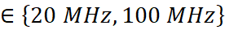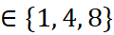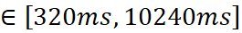

Table Annex 8.5.5-2: Resource overhead for LP-SS

|  |  |  |  |  |  |  |
| --- | --- | --- | --- | --- | --- | --- |
| **System Bandwidth** | **20 MHz** | | | **100 MHz** | | |
| **Number of Beams** | **1** | **4** | **8** | **1** | **4** | **8** |
| **LP-SS Periodicity** |  |  |  |  |  |  |
| **320 ms** | 0.0113% | 0.0450% | 0.0900% | 0.0023% | 0.0090% | 0.0180% |
| **640 ms** | 0.0056% | 0.0225% | 0.0450% | 0.0011% | 0.0045% | 0.0090% |
| **1280 ms** | 0.0028% | 0.0113% | 0.0225% | 0.0006% | 0.0023% | 0.0045% |
| **2560 ms** | 0.0014% | 0.0056% | 0.0113% | 0.0003% | 0.0011% | 0.0023% |
| **5120 ms** | 0.0007% | 0.0028% | 0.0056% | 0.0001% | 0.0006% | 0.0011% |
| **10240 ms** | 0.0004% | 0.0014% | 0.0028% | 0.0001% | 0.0003% | 0.0006% |

Next, the resource overhead for LP-WUS-1 and LP-WUS-2 is evaluated in **Table Annex 8.5.5-3** for IoT use case according to the mMTC usage scenario with a connection density requirement of devices/ as defined in the ITU-R M.2410 report on "Minimum requirements related to technical performance for IMT-2020 radio interface(s)". Additionally, paging arrival is considered according to the traffic model with 1 message/2 hours/device or 1 message/day/device as defined in the ITU-R M.2412 report on "Guidelines for evaluation of radio interface technologies for IMT-2020". Further, a hexagonal network layout with inter-site distance (ISD) of 500m and 3 Transmission Reception Points (TRxPs) per site is considered. The average number of UEs to be simultaneously addressed in a LP-WUS is assumed to be . The results in **Table Annex 8.5.5-2** and **Table Annex 8.5.5-3** suggest that LP-SS/LP-WUS can be supported for IoT use case in urban deployments with coverage close to or exceeding that of PUSCH Msg3 at a resource overhead considering devices/km2 connection density, system bandwidth MHz, number of transmission beams , and per UE paging arrival rate 1 message/2 hours.

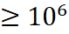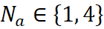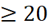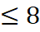

Table Annex 8.5.5-3: Resource overhead for LP-WUS considering devices/km2 connection density

|  |  |  |  |  |  |  |  |  |
| --- | --- | --- | --- | --- | --- | --- | --- | --- |
| **System Bandwidth** | | **20 MHz** | | | | **100 MHz** | | |
| **Number of Beams** | | **1** | **4** | **8** | | **1** | **4** | **8** |
| **Waveform** | **Traffic Model,** |  |  |  | |  |  |  |
| **LP-WUS-1** | **Model-1,** | 0.2165% | 0.8660% | 1.7321% | | 0.0433% | 0.1732% | 0.3464% |
| **Model-1,** | 0.0541% | 0.2165% | 0.4330% | | 0.0108% | 0.0433% | 0.0866% |
| **Model-2,** | 0.0180% | 0.0722% | 0.1443% | | 0.0036% | 0.0144% | 0.0289% |
| **Model-2,** | 0.0045% | 0.0180% | 0.0361% | | 0.0009% | 0.0036% | 0.0072% |
| **LP-WUS-2** | **Model-1,** | 0.1083% | 0.4330% | 0.8660% | | 0.0217% | 0.0866% | 0.1732% |
| **Model-1,** | 0.0271% | 0.1083% | 0.2165% | | 0.0054% | 0.0217% | 0.0433% |
| **Model-2,** | 0.0090% | 0.0361% | 0.0722% | | 0.0018% | 0.0072% | 0.0144% |
| **Model-2,** | 0.0023% | 0.0090% | 0.0180% | | 0.0005% | 0.0018% | 0.0036% |
|  | **Model-1:** 1 message/2 hours/device  **Model-2:** 1 message/day/device | | | |  | | | |

### Annex 8.5.6 [8A-3]

We show network overhead impact with LP-WUS for different cases below. Evaluation details are given in RAN1#113 contribution [4].

- The total available resources are calculated assuming carrier bandwidth of 20 MHz (51 PRBs with 30 kHz SCS) and a TDD pattern with 4:1 ratio for DL:UL

- WUS payload:

- 1bit,8bits,48bits

- WSU Coverage target

- Msg3-PUSCH: {w/o retransmission, w/ two retransmissions}

- PDCCH: {1Rx, AL16}, {2Rx, AL16}

- Note: WUS structure to meet the coverage target is based on results in clause 2.1

- Beam-sweeping assumptions:

- No beam-sweeping

- Beam-sweeping for both RRM and WUS monitoring assuming 8 beams

- Traffic

- R\_E = 0.1% (additional results for R\_E = 1% included in the spreadsheet attached to this document)

- Total 250 idle-mode UEs in a cell

- FAR assumption (FAR\_target, N, T)

- {0.1%, 1, 1.28s}

- Number of UEs per subgroup:

- {1, 4}, 4 only applied for {1, 8} bit WUS payload

- Duty cycled WUS monitoring with 1.28s duty cycle is assumed for the results

- LP-SS overhead of 3slots per 1.28s assumed for case of P\_WUR=0.5, no extra sync signal overhead assumed for P\_WUR = {4, 10}.

Table Annex 8.5.6-1: Network overhead for different cases with 1UE/subgroup

|  |  |  |  |  |  |  |  |  |  |  |  |  |  |
| --- | --- | --- | --- | --- | --- | --- | --- | --- | --- | --- | --- | --- | --- |
| 1UE per  subgroup | Payload | 1bit | | | | 8bit | | | | 48bit | | | |
| R\_E = 0.1% |  | Msg3 0rtx | Msg3 2rtx | PDCCH 1 Rx | PDCCH 2 Rx | Msg3 0rtx | Msg3 2rtx | PDCCH 1 Rx | PDCCH 2 Rx | Msg3 0rtx | Msg3 2rtx | PDCCH 1 Rx | PDCCH 2 Rx |
| No beam sweeping  (single beam) | **PWUR = 0.5** | 0,0427% | 0,0519% | 0,0549% | 0,0885% | 0,0580% | 0,1129% | 0,1434% | 0,2960% | 0,1251% | 0,3845% | 0,4547% | 1,2177% |
| **PWUR = 4** | 0,00066% | 0,00083% | 0,00100% | 0,00183% | 0,00199% | 0,00199% | 0,00199% | 0,00249% |  |  |  |  |
| **PWUR = 10** | 0,00066% | 0,00083% | 0,00100% | 0,00183% | 0,00199% | 0,00199% | 0,00199% | 0,00249% |  |  |  |  |
| Beam sweeping on LP-SS +LP-WUS  (eight beams) | **PWUR = 0.5** | 0,3418% | 0,4150% | 0,4395% | 0,7080% | 0,4639% | 0,9033% | 1,1475% | 2,3682% | 1,0010% | 3,0762% | \*\* | \*\* |
| **PWUR = 4** | 0,00532% | 0,00664% | 0,00797% | 0,01462% | 0,01595% | 0,01595% | 0,01595% | 0,01993% |  |  |  |  |
| **PWUR = 10** | 0,00532% | 0,00664% | 0,00797% | 0,01462% | 0,01595% | 0,01595% | 0,01595% | 0,01993% |  |  |  |  |
| \*\* Due to long WUS duration, beam-sweeping for LP-WUS with 48bits payload will be longer than paging cycle 1.28s  Baseline overhead based on PDCCH, AL16, 2 OFDM symbols with 8 beams is 0.012%. | | | | | | | | | | | | | |

Table Annex 8.5.6-2: Network overhead for different cases with 4UE/subgroup

|  |  |  |  |  |  |  |  |  |  |
| --- | --- | --- | --- | --- | --- | --- | --- | --- | --- |
| 4UE per  subgroup | Payload | 1bit | | | | 8bit | | | |
| R\_E = 0.1% |  | Msg3 0rtx | Msg3 2rtx | PDCCH 1 Rx | PDCCH 2 Rx | Msg3 0rtx | Msg3 2rtx | PDCCH 1 Rx | PDCCH 2 Rx |
| No beam sweeping  (single beam) | **PWUR = 0.5** | 0,0427% | 0,0519% | 0,0549% | 0,0885% | 0,0580% | 0,1129% | 0,1434% | 0,2960% |
| **PWUR = 4** | 0,00066% | 0,00083% | 0,00100% | 0,00183% | 0,00199% | 0,00199% | 0,00199% | 0,00249% |
| **PWUR = 10** | 0,00066% | 0,00083% | 0,00100% | 0,00183% | 0,00199% | 0,00199% | 0,00199% | 0,00249% |
| Beam sweeping on LP-SS +LP-WUS  (eight beams) | **PWUR = 0.5** | 0,3418% | 0,4150% | 0,4395% | 0,7080% | 0,4639% | 0,9033% | 1,1475% | 2,3682% |
| **PWUR = 4** | 0,00532% | 0,00664% | 0,00797% | 0,01462% | 0,01595% | 0,01595% | 0,01595% | 0,01993% |
| **PWUR = 10** | 0,00532% | 0,00664% | 0,00797% | 0,01462% | 0,01595% | 0,01595% | 0,01595% | 0,01993% |
| Baseline overhead based on PDCCH, AL16, 2 OFDM symbols with 8 beams is 0.012%. | | | | | | | | | |

Overall following observations can be made on NW overhead based on the results in this and previous contributions.

For WUS to match PDCCH 2Rx coverage, following overhead values for different WUS candidates (including sync resource overhead) are observed from the evaluations (250 Idle UEs/cell assumed):

- For per UE paging rate of 0.1% (1%)

- Baseline overhead for paging PDCCH is 0.012% (0.12%)

- For OFDM (SSS-sequence-based) WUS with 8-bit payload (4UEs/subgroup): ~1.65x (~1.45x) higher overhead compared to baseline is required

- For OOK-WUS with 8 bit payload (4UEs/subgroup): ~196x (~154x) higher overhead compared to baseline is required

- For OOK-WUS with 48 bit payload (no subgrouping): ~830x higher overhead compared to baseline (for 1% UE paging rate, overhead is prohibitively high)

Following general observations can be made for network overhead from the evaluations.

- Regarding WUR on power (P\_WUR)

- Overhead for OOK-based-WUS (e.g., P\_WUR=0.5) is roughly ~50-100x higher compared to that of OFDM-based-WUS (e.g., P\_WUR=4, 10) as the OOK-based WUS duration required to achieve the same coverage target as OFDM-based WUS is much higher and there is a need for additional periodic LP-SS transmissions.

- Regarding WUS payload

- Overhead for OOK-based WUS with 48-bit payload is significantly higher than that of OOK-based WUS with 1- or 8-bit payload (~ 5x higher for single beam and eight beams).

- Overhead for 8-bit WUS is slightly higher than that of 1-bit WUS.

- Regarding number of UEs per subgroup

- Overhead with 4 UEs per subgroup is similar to that of 1 UE per subgroup as the assumed low paging rate results in low probability of having UEs being paged in the same group in the same paging cycle.

### Annex 8.5.7 [8A-9]

Table Annex 8.5.7-1: System overhead for LP-WUS for RRC IDLE/INACTIVE

|  |  |  |  |  |  |  |  |  |  |  |  |
| --- | --- | --- | --- | --- | --- | --- | --- | --- | --- | --- | --- |
| **Signal** | **# of info bits carried by signal** | **Overhead (%)** | **T resources per beam** | **F resources** | **SCS** | **number of paged UE per second or signal periodicity** | **number of UE per group** | **Number of LP-WUS transmissions per second** | **System configuration, e.g., BW and etc.** | **the target channel** | **Notes** |
| LP-WUS | 48 | 0.0720% | 48 symbols | 5.04MHz | 30kHz | 10 | 1 | 10 | 20MHz, 1beam | Msg.3 | OOK-4 when 8 OFDM symbols are used.  OOK-1 when 64 OFDM symbols are used |
| LP-WUS | 48 | 0.2808% | 48 symbols | 5.04MHz | 30kHz | 39 | 1 | 39 | 20MHz, 1beam | Msg.3 |
| LP-WUS | 48 | 0.3600% | 48 symbols | 5.04MHz | 30kHz | 50 | 1 | 50 | 20MHz, 1beam | Msg.3 |
| LP-WUS | 48 | 0.5760% | 48 symbols | 5.04MHz | 30kHz | 10 | 1 | 10 | 20MHz, 1beam | Msg.3 |
| LP-WUS | 48 | 2.2464% | 48 symbols | 5.04MHz | 30kHz | 39 | 1 | 39 | 20MHz, 1beam | Msg.3 |
| LP-WUS | 48 | 2.8800% | 48 symbols | 5.04MHz | 30kHz | 50 | 1 | 50 | 20MHz, 1beam | Msg.3 |
| LP-WUS | 48 | 0.0144% | 48 symbols | 5.04MHz | 30kHz | 10 | 1 | 10 | 100MHz, 1beam | Msg.3 |
| LP-WUS | 48 | 0.0562% | 48 symbols | 5.04MHz | 30kHz | 39 | 1 | 39 | 100MHz, 1beam | Msg.3 |
| LP-WUS | 48 | 0.0720% | 48 symbols | 5.04MHz | 30kHz | 50 | 1 | 50 | 100MHz, 1beam | Msg.3 |
| LP-WUS | 48 | 0.1152% | 48 symbols | 5.04MHz | 30kHz | 10 | 1 | 10 | 100MHz, 1beam | Msg.3 |
| LP-WUS | 48 | 0.4493% | 48 symbols | 5.04MHz | 30kHz | 39 | 1 | 39 | 100MHz, 1beam | Msg.3 |
| LP-WUS | 48 | 0.5760% | 48 symbols | 5.04MHz | 30kHz | 50 | 1 | 50 | 100MHz, 1beam | Msg.3 |
| LP-WUS | 48 | 0.0072% | 48 symbols | 5.04MHz | 30kHz | 10 | 1 | 1 | 20MHz, 1beam | Msg.3 |
| LP-WUS | 48 | 0.0281% | 48 symbols | 5.04MHz | 30kHz | 39 | 1 | 3.9 | 20MHz, 1beam | Msg.3 |
| LP-WUS | 48 | 0.0360% | 48 symbols | 5.04MHz | 30kHz | 50 | 1 | 5 | 20MHz, 1beam | Msg.3 |
| LP-WUS | 48 | 0.0576% | 48 symbols | 5.04MHz | 30kHz | 10 | 1 | 1 | 20MHz, 1beam | Msg.3 |
| LP-WUS | 48 | 0.2246% | 48 symbols | 5.04MHz | 30kHz | 39 | 1 | 3.9 | 20MHz, 1beam | Msg.3 |
| LP-WUS | 48 | 0.2880% | 48 symbols | 5.04MHz | 30kHz | 50 | 1 | 5 | 20MHz, 1beam | Msg.3 |
| LP-WUS | 48 | 0.0014% | 48 symbols | 5.04MHz | 30kHz | 10 | 1 | 1 | 100MHz, 1beam | Msg.3 |
| LP-WUS | 48 | 0.0056% | 48 symbols | 5.04MHz | 30kHz | 39 | 1 | 3.9 | 100MHz, 1beam | Msg.3 |
| LP-WUS | 48 | 0.0072% | 48 symbols | 5.04MHz | 30kHz | 50 | 1 | 5 | 100MHz, 1beam | Msg.3 |
| LP-WUS | 48 | 0.0115% | 48 symbols | 5.04MHz | 30kHz | 10 | 1 | 1 | 100MHz, 1beam | Msg.3 |
| LP-WUS | 48 | 0.0449% | 48 symbols | 5.04MHz | 30kHz | 39 | 1 | 3.9 | 100MHz, 1beam | Msg.3 |
| LP-WUS | 48 | 0.0576% | 48 symbols | 5.04MHz | 30kHz | 50 | 1 | 5 | 100MHz, 1beam | Msg.3 |

Annex X:   
Change history

|  |  |  |  |  |  |  |  |  |
| --- | --- | --- | --- | --- | --- | --- | --- | --- |
| **Change history** | | | | | | | | |
| **Date** | **Meeting** | **TDoc** | **CR** | **Rev** | **Cat** | **Subject/Comment** | **New version** |
| 2022-10 | RAN1#110bis | R1-2208666 |  |  |  | Baseline TR skeleton | 0.0.0 |
| 2022-10 | RAN1#110bis | R1-2210430 |  |  |  | Baseline TR skeleton after discussion | 0.0.1 |
| 2023-02 | RAN1#112 | R1-2302236 |  |  |  | Update TR and incorporating agreements for evaluation and receiver architecture from RAN1#110bis and RAN1#111 | 0.1.0 |
| 2023-05 | RAN1#113 | R1-2305954 |  |  |  | Update TR and incorporates agreements from RAN1#112 and RAN1#112bis | 0.2.0 |
| 2023-08 | RAN1#114 | R1-2308386 |  |  |  | Implemented all the agreements until RAN1#113  Resolved FFS issues according to the consensus in offline discussion.  Other format and editorial issues. | 0.3.0 |
| 2023-08 | RAN1#114 | R1-2308729 |  |  |  | Incorporates agreements after RAN1#114 | 0.4.0 |
| 2023-09 | RAN#101 | RP-231814 |  |  |  | Submit to RAN Plenary for information | 1.0.0 |
| 2023-10 | RAN1#114bis | R1-2310652 |  |  |  | Incorporating RAN4 agreements, other miscellaneous cleanings | 1.1.0 |
| 2023-10 | RAN1#114bis | R1-2310773 |  |  |  | MCC clean-up | 1.1.1 |
| 2023-12 | RAN1#115 | [R1-2312819](https://www.3gpp.org/ftp/TSG_RAN/WG1_RL1/TSGR1_115/Docs/R1-2312818.zip) / RP-233068 |  |  |  | Incorporates RAN2 and RAN4 TPs. Editorial corrections. | 2.0.0 |
| 2023-12 | RAN#102 | [R1-2312819](https://www.3gpp.org/ftp/TSG_RAN/WG1_RL1/TSGR1_115/Docs/R1-2312818.zip) |  |  |  | Rel-18 TR under change control further to RAN approval | 18.0.0 |